Project | IEEE 802.16 Broadband Wireless Access Working Group <http://ieee802.org/16>
Title | Skeleton of Interference Management Primitives
Date Submitted | 2013-05-10
Source(s) | Eunkyung Kim, Jaesun Cha, Jaejoon Park, Hyun Lee, Kwangjae Lim, Sungcheol Chang  ETRI | E-mail: ekkim@etri.re.kr  *<http://standards.ieee.org/faqs/affiliationFAQ.html>
Re: | In response to Call for Contributions on P802.16q Multi-tier Networks toward IEEE 802.16 Session #85
Abstract | Proposal regarding interference management for IEEE 802.16q on Multi-tier Networks, focusing on the management interface and procedure
Purpose | To discuss and adopt the proposed text in Amendment Working Document (AWD) on IEEE 802.16q Multi-tier Networks
Notice | This document does not represent the agreed views of the IEEE 802.16 Working Group or any of its subgroups. It represents only the views of the participants listed in the “Source(s)” field above. It is offered as a basis for discussion. It is not binding on the contributor(s), who reserve(s) the right to add, amend or withdraw material contained herein.
Release | The contributor grants a free, irrevocable license to the IEEE to incorporate material contained in this contribution, and any modifications thereof, in the creation of an IEEE Standards publication; to copyright in the IEEE’s name any IEEE Standards publication even though it may include portions of this contribution; and at the IEEE’s sole discretion to permit others to reproduce in whole or in part the resulting IEEE Standards publication. The contributor also acknowledges and accepts that this contribution may be made public by IEEE 802.16.
Patent Policy | The contributor is familiar with the IEEE-SA Patent Policy and Procedures:  <http://standards.ieee.org/guides/bylaws/sect6-7.html#6> and <http://standards.ieee.org/guides/opman/sect6.html#6.3>.  Further information is located at <http://standards.ieee.org/board/pat/pat-material.html> and <http://standards.ieee.org/board/pat>.

Skeleton of Interference Management Primitives
Eunkyung Kim, Jaesun Cha, Jaejoon Park, Hyun Lee, Kwangjae Lim, Sungcheol Chang
ETRI

Overview
The 802.16q amendment shall be developed in accordance with the P802.16q project authorization request (PAR) with its accompanying Five Criteria Statement[2]. The scope of the resulting project includes “MAC/PHY protocol enhancements for cooperation among base stations in multi-tier networks to enhance interference mitigation.”All contents regarding interference management included in the 802.16q amendment shall meet requirements in [3]. General description for “interference mangement” in the 802.16q amendment working document (AWD)[4], which includes :
- Resource management
- Multi-BS MIMO
This document provides the skeleton of interference management primitives in 802.16q AWD. Details are TBD based on the 802.16q AWD.

References
- IEEE Std. 802.16TM-2012, IEEE Standard for Air Interface for Broadband Wireless Access Systems, August 2012.
- IEEE 802.16-12-0394-06-Gdoc, PAR and Five Criteria for P802.16q (Amendment to IEEE Std 802.16 for Multi-tier Networks), July 2012.
- IEEE 802.16-12-0020-00-000q, Draft IEEE 802.16q System Requirement Document, January 2013.
- IEEE 802.16-13-0026-00-000q, Draft P802.16q AWD, January 2013.

Proposed Text on Amendment Working Document (AWD) of IEEE 802.16q
[Editorial instruction]
- Black text: the text is existing in the base standard
- Red text: with strike-through: the texts is removed from the amendment standard
- Blue text without underline: the text is added in the amendment standard without underline
- Blue text with underline: the text is added in the amendment standard and underline shall be added under the added text

[-------------------------------------Start of Text Proposal---------------------------------------------------]

[Remedy: Add the following texts in 14. Management interface and procedure on IEEE 802.16q AWD:]

Change 14.1.1 Universal naming schema for SAP service prmitive as indicated:
…..
Function
ACM—Accounting Management
HO—Handover
IMM—Idle Mode Management
LBS—Location Based Services
MBS—Multicast Broadcast Service
NEM—Network Entry Management
RRM—Radio Resource Management
SFM—Service Flow Management
SM—Security Management
SMC—Secondary Management Connection
SSM—Subscriber Station Management
IM—Interference Management
…..

Insert new subclause 14.2.13 as follows:

Interference Management
The IM Primitives are a set of primitives for supporting IM procedure between IEEE 802.16 entity and NCMS, as well as between IEEE 802.16 entities. The IM Primitives include resource management for IM and cooperative transmission primitives.

Figure 14-xxx shows the IM Control Primitives. Further primitive flows are FFS.

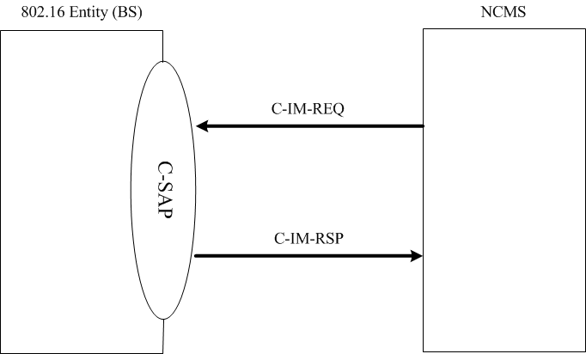
Figure 14-xxx – Primitive flow of C-IM-REQ/RSP

C-IM-REQ
This primimitive is used by NCMS to request the IEEE 802.16 entity to operate interference managenet. The Action_Types for thie primitive are FFS.

C-IM-RSP
This primimitive is used by the IEEE 802.16 entity to respond NCMS, as requested by the C-IM-REQ primitive to operate interfrence mangement. The Action_Types for thie primitive are FFS.

[-------------------------------------End of Text Proposal---------------------------------------------------]

