Project | IEEE 802.16 Broadband Wireless Access Working Group <http://ieee802.org/16>
Title | Functional Description of Cooperative Transmission
Date Submitted | 2013-05-10
Source(s) | Eunkyung Kim, Jaesun Cha, Jae-Joon Park, Hyun Lee, Kwangjae Lim, Sungcheol Chang  ETRI | E-mail: ekkim@etri.re.kr  *<http://standards.ieee.org/faqs/affiliationFAQ.html>
Re: | In response to Call for Contributions on P802.16q Multi-tier Networks toward IEEE 802.16 Session #85
Abstract | Proposal regarding interference management for IEEE 802.16q on Multi-tier Networks, focusing on the multi-BS transmission cooperatively
Purpose | To discuss and adopt the proposed text in Amendment Working Document (AWD) on IEEE 802.16q Multi-tier Networks
Notice | This document does not represent the agreed views of the IEEE 802.16 Working Group or any of its subgroups. It represents only the views of the participants listed in the “Source(s)” field above. It is offered as a basis for discussion. It is not binding on the contributor(s), who reserve(s) the right to add, amend or withdraw material contained herein.
Release | The contributor grants a free, irrevocable license to the IEEE to incorporate material contained in this contribution, and any modifications thereof, in the creation of an IEEE Standards publication; to copyright in the IEEE’s name any IEEE Standards publication even though it may include portions of this contribution; and at the IEEE’s sole discretion to permit others to reproduce in whole or in part the resulting IEEE Standards publication. The contributor also acknowledges and accepts that this contribution may be made public by IEEE 802.16.
Patent Policy | The contributor is familiar with the IEEE-SA Patent Policy and Procedures:  <http://standards.ieee.org/guides/bylaws/sect6-7.html#6> and <http://standards.ieee.org/guides/opman/sect6.html#6.3>.  Further information is located at <http://standards.ieee.org/board/pat/pat-material.html> and <http://standards.ieee.org/board/pat>.

Functional Description of Cooperative Transmission
Eunkyung Kim, Jaesun Cha, Jae-Joon Park, Hyun Lee, Kwangjae Lim, Sungcheol Chang
ETRI

Overview
The 802.16q amendment shall be developed in accordance with the P802.16q project authorization request (PAR) with its accompanying Five Criteria Statement[2]. The scope of the resulting project includes “MAC/PHY protocol enhancements for cooperation among base stations in multi-tier networks to enhance interference mitigation.”All contents regarding interference management included in the 802.16q amendment shall meet requirements in [3]. General description of multi-BS MIMO for “interference management” in the 802.16q amendment working document (AWD)[4], which includes:
- DL multi-BS MIMO
  - DL single-BS precoding with multi-BS coordination
  - DL multi-BS joint processing
  - Channel feedback for closed-loop transmit precoding
    - Sounding-based feedback
    - MIMO-coefficient-based feedback
    - Codebook-based feedback
    - Antenna-selection/grouping-index-based feedback
  - Channel quality measurement and report
  - Trigger conditions
- UL multi-BS MIMO
  - Multi-BS joint processing
- Trigger conditions
This document provides the functional description on the multi-BS transmission cooperatively in 802.16q AWD, focusing on the supporting legacy MSs.

Preliminary Design
- Cooperative transmission (see Figure 1)
  - Multi-BS cooperative transmission including Multi-BS diversity and Multi-BS MIMO techniques improves sector throughput and cell-edge throughput through multi-BS cooperative signaling.
  - Each BS capable of providing cooperative transmission may belong to a certain cooperative transmission set, defined as a set of BS where those BSs may transmit the same data to certain MS(s)
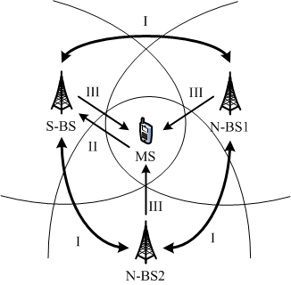
Figure 1 - Cooperative Transmission (I-coordination among BSs; II-channel report from MS to BS; III-data transmission to MS cooperatively from multiple BSs)

- Transmission set (BS grouping, see Figure 2.)
  - Cooperative Transmission capable BS
  - Cooperative Transmission candidate set: a set of CT capable BSs which may be a set of CT
  - Cooperative Transmission set: a set of CT capable BSs which are some of CT candidate set and they are transmitting cooperatively

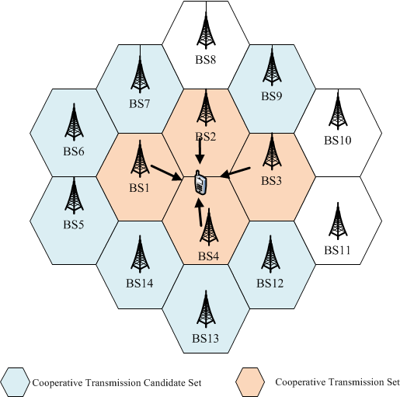
Figure 2 – Multi-BS Cooperative Transmission

- Antenna Grouping/Selection
  - Total N antennas of BSs belonging to a CT set constitute an antenna pool
  - Antenna selection from the antenna pool shall be performed

Procedure to operate cooperative transmission
Figure 3 shows flow chart for cooperative transmission, which includes:
- Step 1. PHY channel measurement and report
  - If S-BS (BS1) requests an MS to perform channel measurement of the candidate transmission set, the MS measures and reports the channel from those BSs
  - Otherwise, the MS measures and reports the channel quality from the S-BS and any neighbor BSs
  - The S-BS reports the results of channel quality to the coordinator (IM-controller)
- Step 2. The IM-controller decides to configure (start/end/change) CT
- Step 3. To configure the CT, interference management is transmitted between IM-controller and CT set BSs
- Step 4. As a result of interference management for IM between IM-controller and CT set BSs, the set of CT BSs transmit data to the same MS cooperatively

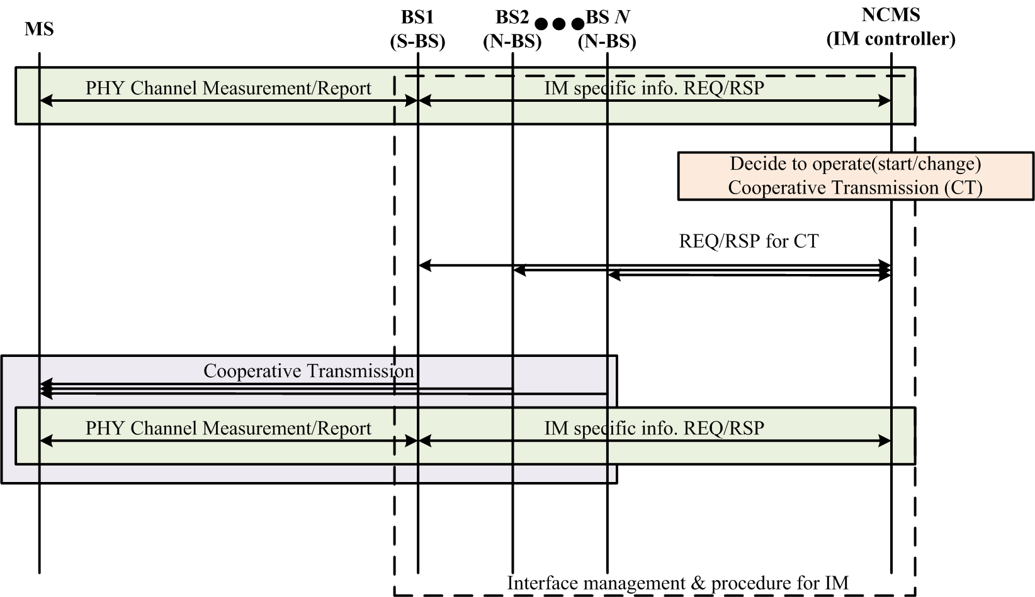
Figure 3 - Flow chart of cooperative transmission

Additional feature using multi-BS MIMO
FFS.

References
- IEEE Std. 802.16TM-2012, IEEE Standard for Air Interface for Broadband Wireless Access Systems, August 2012.
- IEEE 802.16-12-0394-06-Gdoc, PAR and Five Criteria for P802.16q (Amendment to IEEE Std 802.16 for Multi-tier Networks), July 2012.
- IEEE 802.16-12-0020-00-000q, Draft IEEE 802.16q System Requirement Document, January 2013.
- IEEE 802.16-13-0026-00-000q, Draft P802.16q AWD, January 2013.

Proposed Text on Amendment Working Document (AWD) of IEEE 802.16q
[Editorial instruction]
- Black text: the text is existing in the base standard
- Red text: with strike-through: the texts is removed from the amendment standard
- Blue text without underline: the text is added in the amendment standard without underline
- Blue text with underline: the text is added in the amendment standard and underline shall be added under the added text

[-------------------------------------Start of Text Proposal---------------------------------------------------]

[Remedy: Change 17.3.2 in IEEE 802.16q AWD as follows:]

Multi-BS MIMO Multi-BS cooperative transmission

Multi-BS cooperative transmission including Multi-BS diversity and Multi-BS MIMO techniques improves sector throughput and cell-edge throughput through multi-BS cooperative signaling. These Multi-BS MIMO includes DL single-BS precoding with multi-BS coordination and DL/UL multi-BS joint processing.

DL Multi-BS MIMODL Multi-BS cooperative transmission
To ensure proper cooperative transmission, each BS capable of providing cooperative transmission may belong to a certain cooperative transmission candidate set. Within the cooperative transmission candidate set, a set of BS is selected as a cooperative transmission set and a common zone is assigned for those BSs operating cooperative transmission, where those BSs may transmit the same data to certain MS(s), as a result of coordination among BSs. The common zone used by the BSs shall be aligned over the same time-frequency radio resource region.
The total N antennas of Multi-BS cooperative transmission BSs constitute an antenna pool. The coordinator for cooperative transmission shall perform antenna selection/grouping from the antenna pool. The selected antennas are used to transmit data from multi-BS that operates in Multi-BS cooperative transmission. The unselected antennas are set to the null transmission. How to select antennas from the antenna pool is FFS.
When a BS receives the result of physical channel measurement from an MS, the BS reports the channel measurement results to the coordinator (e.g., interference management network entity). The coordinator, which receives the channel measurement results, may (re-)configure a cooperative transmission. Upon deciding the operation the cooperation transmission, management interface and procedure to perform cooperation and to transmit the same data to the same MS cooperatively by multiple BSs shall be supported through C-SAP/M-SAP via backhaul link.

Multi-BS diversity
A DL zone may be a coordinated zone between the serving BS and its neighbor BSs that have the same zone boundary, the same zone permutation type e.g., PUSC, STC PUSC, AMC, and STC AMC, and the same values for the parameters, Use All SC and Dedicated Pilots, defined by STC DL Zone IE as shown in Table 8-123. In the coordinated zone, an MS receives a data transmission from multiple BSs in the same data regions or different data regions. Operation for the data transmission is FFS.

17.3.2.1.1 DL single-BS precoding with multi-BS coordination
When DL single-BS precoding with multi-BS coordination is enabled, interference from adjacent BSs is mitigated by coordinating the precoders applied in the adjacent BSs.

17.3.2.1.2 DL multi-BS joint processing
When DL multi-BS joint processing is enabled, radio resource allocation, data mapping, and pilot pattern allocation shall be aligned among coordinating BSs. The same data packet is transmitted by the coordinating BSs on the same time and frequency resources.

17.3.2.1.3 Channel feedback for closed-loop transmit precoding

17.3.2.13.1 Sounding-based feedback
[Note: In this subclause, operations of sounding-based feedback will be provided to support DL multi-BS MIMO.]

MIMO-coefficient-based feedback 17.3.2.13.2 MIMO-coefficeint-based feedback
[Note: In this subclause, operations of MIMO-coefficient-based feedback will be provided to support DL multi-BS MIMO when MIMO midamble is supported.]

17.3.2.13.3 Codebook-based feedback
[Note: In this subclause, operations of codebook-based feedback will be provided to support DL multi-BS MIMO when MIMO midamble is supported.]

17.3.2.13.4 Antenna-selection/grouping-index-based feedback
[Note: In this subclause, operations of antenna-selection/grouping-index-based feedback will be provided to support DL multi-BS MIMO when MIMO midamble is supported.]

17.3.2.13.4 Channel quality measurement and report
An MS may measure and report the channel quality of the serving BS and its neighbor BS(s). When a BS capable of providing cooperative transmission receives the report of the channel quality from the MS, the BS reports the channel quality the to the coordinator, if certain conditions are met. Reported channel quality by the BS includes the channel quality of the BS itself and the neighbor BS(s).
When anAn S-BS may requests a subordinate MS to scan the neighbor BS(s) which are participating in cooperative transmission. The, the MS scans and reports the channel measurement result to the S-BS, if certain conditions are met.

17.3.2.13.5 Trigger conditions
[Note: In this subclause, trigger conditions for DL multi-BS MIMO will be provided.]

UL Multi-BS MIMO

UL multi-BS joint processing
When UL multi-BS joint processing is enabled, radio resource allocation, data mapping, and pilot pattern allocation shall be aligned among coordinating BSs. The same data packet is received by the coordinating BSs on the same time and frequency resources.

Trigger conditions
[Note: In this subclause, trigger conditions for UL multi-BS MIMO will be provided.]

[-------------------------------------End of Text Proposal---------------------------------------------------]

