Project | IEEE 802.16 Broadband Wireless Access Working Group <http://ieee802.org/16>
Title | Functional Description of Resource Management for Interference Management
Date Submitted | 2013-05-10
Source(s) | Eunkyung Kim, Jaesun Cha, Jae-Joon Park, Hyun Lee, Kwangjae Lim, Sungcheol Chang  ETRI | E-mail: ekkim@etri.re.kr  *<http://standards.ieee.org/faqs/affiliationFAQ.html>
Re: | In response to Call for Contributions on P802.16q Multi-tier Networks toward IEEE 802.16 Session #85
Abstract | Proposal regarding interference management for IEEE 802.16q on Multi-tier Networks, focusing on the resource management
Purpose | To discuss and adopt the proposed text in Amendment Working Document (AWD) on IEEE 802.16q Multi-tier Networks
Notice | This document does not represent the agreed views of the IEEE 802.16 Working Group or any of its subgroups. It represents only the views of the participants listed in the “Source(s)” field above. It is offered as a basis for discussion. It is not binding on the contributor(s), who reserve(s) the right to add, amend or withdraw material contained herein.
Release | The contributor grants a free, irrevocable license to the IEEE to incorporate material contained in this contribution, and any modifications thereof, in the creation of an IEEE Standards publication; to copyright in the IEEE’s name any IEEE Standards publication even though it may include portions of this contribution; and at the IEEE’s sole discretion to permit others to reproduce in whole or in part the resulting IEEE Standards publication. The contributor also acknowledges and accepts that this contribution may be made public by IEEE 802.16.
Patent Policy | The contributor is familiar with the IEEE-SA Patent Policy and Procedures:  <http://standards.ieee.org/guides/bylaws/sect6-7.html#6> and <http://standards.ieee.org/guides/opman/sect6.html#6.3>.  Further information is located at <http://standards.ieee.org/board/pat/pat-material.html> and <http://standards.ieee.org/board/pat>.

Functional Description of Resource Management for Interference Management
Eunkyung Kim, Jaesun Cha, Jae-Joon Park, Hyun Lee, Kwangjae Lim, Sungcheol Chang
ETRI

Overview
The 802.16q amendment shall be developed in accordance with the P802.16q project authorization request (PAR) with its accompanying Five Criteria Statement[2]. The scope of the resulting project includes “MAC/PHY protocol enhancements for cooperation among base stations in multi-tier networks to enhance interference mitigation.”All contents regarding interference management included in the 802.16q amendment shall meet requirements in [3]. General description of resource management for “interference management” in the 802.16q amendment working document (AWD)[4], which includes:
- DL/UL fractional frequency reuse (FFR)
- time-division multiplexed resource scheduling
- DL power control
- Trigger conditions
This document provides the functional description on the resource management for interference management in 802.16q AWD, focusing on the supporting the legacy MSs.

Procedure to operate resource management
Figure 1 shows flow chart for the resource management to mitigate interference, which includes:
- Step 1. RM specific information exchange between IM-controller and BS, and between BS and MS
  - S-BS (BS1) requests an MS to perform channel measurement
  - The MS received request reports CINR of S-BS and N-BSs
  - The S-BS reports the information (such as channel measurement, traffic load, and etc.) to the coordinator (IM-controller), if certain condition is met
- Step 2. The IM-controller decides to operate (start/end/change) RM
- Step 3. To configure the RM, resource information (i.e., freq. usage, zone boundary…) for IM is transmitted between IM-controller and BS(s)
- Step 6. As a result of interference management between IM-controller and BS(s), FFR and/or TDM resource management may be performed by those BS(s)
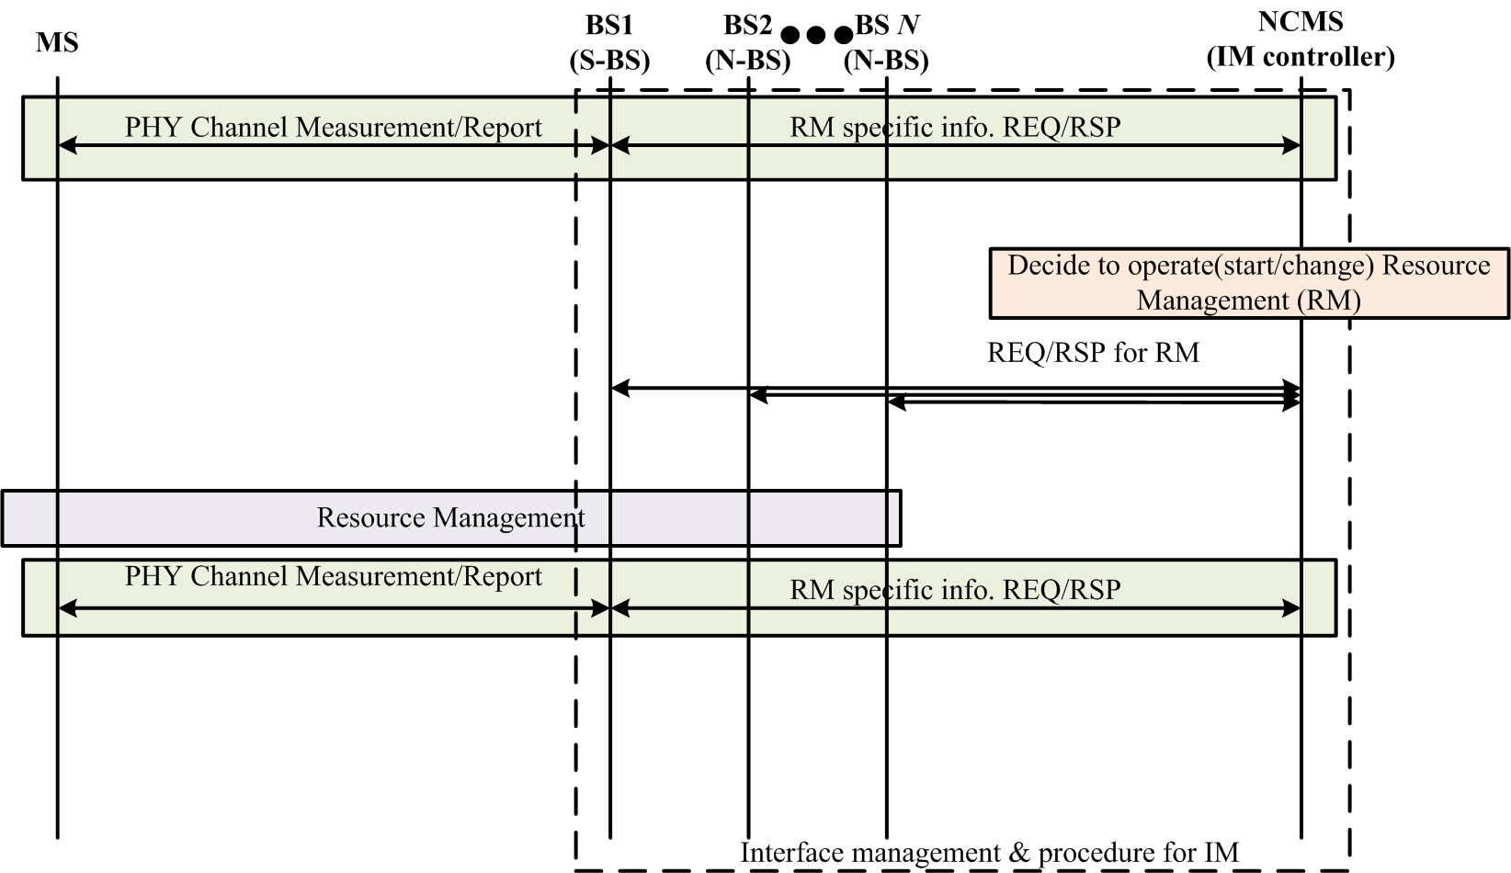
Figure 1 - Flow chart of Resource Management

Fractional frequency reuse
One of the resource management to mitigate interference is FFR by different frequency reuse factors, different frequency partitions for each frequency reuse factor, and different transmit power levels on each frequency partition.
Figure 2 and Figure 3 show the examples of frequency partitioning.
Figure 2 shows that frequency is defined by the “used subchannel bitmap.” Based on the bitmap, some subchannels can be allocated to segment in DL/UL and other subchannels are not be allocated to segment in DL/UL, as a result of cooperation among BSs. Some information (including traffic load of the BS) to cooperate among BSs and the partitioning information (including used subchannel bitmap and etc.) shall be exchanged between the coordinator and BSs through C-SAP/M-SAP via backhaul link.
Figure 3 shows that frequency is not defined by the “used subchannel bitmap” (i.e., all “used subchannel bitmap” shall be set to “1”). In the available subchannels to allocate, the subchannel can be partitioned (using BS’ power control), as a result of cooperation among BSs. Some information (including traffic load of the BS) to cooperate among BSs and the partitioning information (including used/non-used subchannels, limited transmit power, and etc.) shall be exchanged through C-SAP/M-SAP via backhaul link.
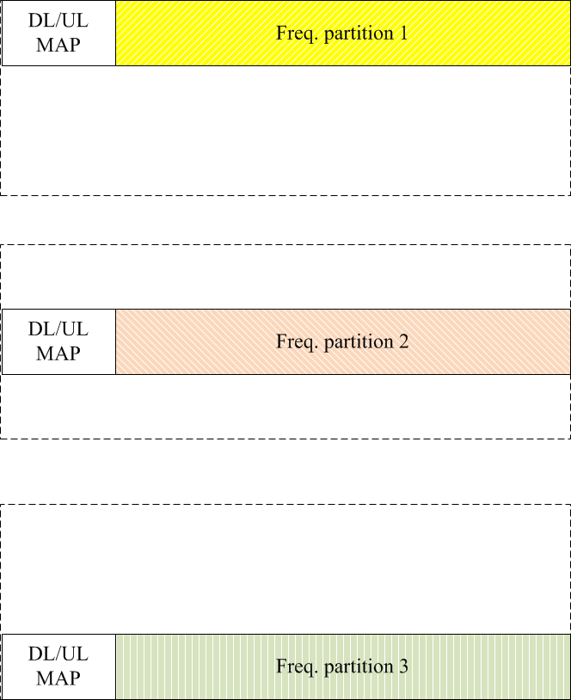
Figure 2 - Example of resource management using freq. partitioning
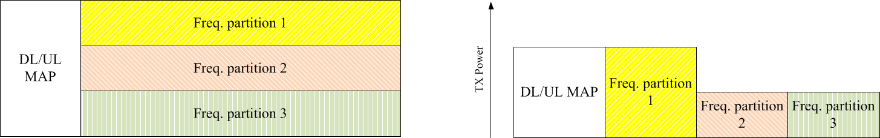
Figure 3 - Example of resource management using FFR

Time-division multiplexed resource scheduling
TDM resource management is a way to mitigate interference by blocking some resource during a give time as the unit of symbols. To block some resource during the given time, coordination among BSs needs to limit the usage of the OFDMA symbols in a frame.
Figure 4 shows that usage of the OFDMA symbols in a frame is limited and the corresponding OFDMA symbols shall not used to allocate resource to subordinate MSs, as a result of cooperative BSs. As shown the example, a frame is partitioned and defined by the zone switch IE. The partitioning information (including used/non-used symbols and etc.) shall be exchanged through C-SAP/M-SAP via backhaul link.
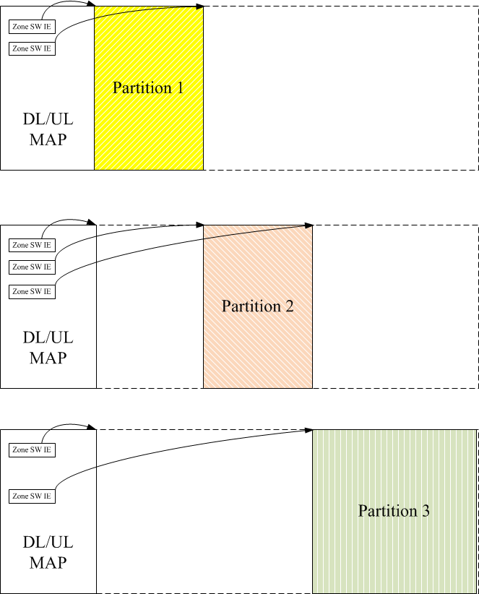
Figure 4 - Example of resource management using TDM partitioning

References
- IEEE Std. 802.16TM-2012, IEEE Standard for Air Interface for Broadband Wireless Access Systems, August 2012.
- IEEE 802.16-12-0394-06-Gdoc, PAR and Five Criteria for P802.16q (Amendment to IEEE Std 802.16 for Multi-tier Networks), July 2012.
- IEEE 802.16-12-0020-00-000q, Draft IEEE 802.16q System Requirement Document, January 2013.
- IEEE 802.16-13-0026-00-000q, Draft P802.16q AWD, January 2013.

Proposed Text on Amendment Working Document (AWD) of IEEE 802.16q
[Editorial instruction]
- Black text: the text is existing in the base standard
- Red text: with strike-through: the texts is removed from the amendment standard
- Blue text without underline: the text is added in the amendment standard without underline
- Blue text with underline: the text is added in the amendment standard and underline shall be added under the added text

[-------------------------------------Start of Text Proposal---------------------------------------------------]

[Remedy: Change 17.3.1 in IEEE 802.16q AWD as follows:]

Resource Management
The interference between small cells, and between macro cells and small cells may be mitigated by radio resource reservation and resource sharing using time-division and/or frequency-division resource management and/or downlink power control.
As a result of physical channel measurement and report by an MS, the BS reports the channel measurement to the coordinator (e.g., interference management network entity), if certain condition is met. In addition, the BS may report the traffic load. The coordinator, which receives the information such as channel measurement and traffic load, may configure the resource usage. Upon deciding the operation the resource management, management interface and procedure to perform cooperation and to manage resource cooperatively by multiple BSs shall be supported through C-SAP/M-SAP via backhaul link.

Fractional Frequency Reuse (FFR)

DL FFR
DL FFR allows different frequency reuse factors, different frequency partitions for each frequency reuse factor, and different transmit power levels on each frequency partition to enhance resource reuse and network throughput.
Based on the channel measurement from MS and report the result from BS to the coordinator, the coordinator may (re-)configure the partitioning information such as used and non-used subchannels, limited transmit power, and etc. If the DL resource is not partitioned currently, the corresponding zone may be partitioned using the partitioning information. Otherwise, the corresponding zone may be re-partitioned using the partitioning information. Configured partitioning information shall be exchanged through C-SAP/M-SAP via backhaul link.
When the usage of the subchannels in a DL zone is limited by a bitmap, all subcarriers including pilot subcarriers in the corresponding zones (i.e., segments in PUSC and physical bands in AMC) shall be boosted as described in 8.4.9.6 and are allocated to the segment in the DL. The bitmaps that limit subcarrier usage are “Used subchannel bitmap” in the FCH that applies to the first DL PUSC zone and to PUSC zones in which Use all SC field is set to ‘0’, “DL AMC allocated physical bands bitmap”, “TUSC1 permutation active subchannels bitmap”, and “TUSC2 permutation active subchannels bitmap” TLVs in the DCD.
When the subchannels in a DL zone are not limited by a bitmap (i.e., all subchannels bitmap is set to “1”), any subchannels in the corresponding zones are allowed to allocate resource to MSs. In addition, PUSC zones with all SC field is set to ‘1’ may be used to allocate resource to MSs. In the corresponding zone, the data to transmit to MSs shall be defined by the DL-MAP IE and/or “DL region definition” TLV in DCD.
In a DL frequency partition zone, the corresponding zone may also be further time-division multiplexed and/or frequency-division multiplexed. How to operate is FFS.

UL FFR
UL FFR allows different frequency reuesreuse factors, different frequency partitions for each frequency reuse factor, and different maximum per-tone power levels on each freqeuencyfrequency partition to enhance resource reuse and network throughput.
When the usage of the subchannels in a UL zone is limited by a bitmap, all subcarriers including pilot subcarriers in the corresponding zones (i.e., segments in PUSC and physical bands in AMC) shall be used to allocate to the segment in the UL. The bitmaps that limit subcarrier usage are “UL allocated subchannels bitmap”, “Optional permutation UL Allocated subchannels bitmap”, and “UL AMC Allocated physical bands bitmap” TLVs in the UCD. The partitioning information (including allowed subchannels bitmap and etc.) shall be exchanged through C-SAP/M-SAP via backhaul link.
When the usage of the subchannels in a UL zone is not limited by a bitmap, any subchannels are allowed to allocate bandwidth to MSs. The partitioning information (including used/not used subchannels, limited per-tone power level, and etc.) shall be exchanged through C-SAP/M-SAP via backhaul link.
In a UL frequency partition zone, the corresponding zone may also be further time-division multiplexed and/or frequency-division multiplexed. How to operate is FFS.

Time-Division Multiplexed Resource Scheduling
A BS may not allocate some OFDMA symbols to any MS based on coordination among BSs.
Based on the channel measurement from MS and report the result from BS to the coordinator, the coordinator may (re-)configure the partitioning information such as used and non-used OFDMA symbols for zone boundary. If the DL resource is not partitioned currently, the corresponding zone may be partitioned using the partitioning information. Otherwise, the corresponding zone may be re-partitioned using the partitioning information. Configured partitioning information shall be exchanged through C-SAP/M-SAP via backhaul link.
When the usage of the OFDMA symbols in a DL/UL frame is limited, as a result of coordination among BSs, the corresponding partition is blocked to allocate resource to subordinate MSs. A DL and UL Zone Switch IE or the start of the DL and UL frame shall indicate the start of DL and UL partition, respectively. The DL and UL corresponding partition shall span continuous OFDMA symbols until terminated by another Zone Switch IE or the end of the DL and UL frame, respectively.
In a TDM partitioned zone, the corresponding zone may also be further time-division multiplexed and/or frequency-division multiplexed.

DL Power Control
The BS may control the transmit power to mitigate interference.

17.3.1.3 Trigger Conditions
A S-BS may send the BS_ID(s) to a subordinate MS and request the MS to scan the corresponding BS(s). The MS scans and reports the channel measurement result to the S-BS, if certain conditions are met. Based on the channel measurement report from the MS, the S-BS and its interfering BS(s) may perform resource management for interference mitigation, as a result of cooperation. How to cooperate among BSs is FFS.
[-------------------------------------End of Text Proposal---------------------------------------------------]

