[Draft Working Document]

IEEE P802.16q System Requirement Document

IEEE 802.16 Working Group
Project P802.16q

Table of Contents
1 Overview 3
2 References 3
3 Definitions 3
4 Abbreviations and Acronyms 3
5 General Requirement 4
5.1 Compatibility with other 802.16 equipment 4
5.2 Complexity 4
5.3 802.16q Protocol and Functional Structure 4
6 Functional Requirement 5
6.1 Interference Management in Multi-tier Networks 5
6.2 Mobility Management in Multi-tier Networks 7
6.3 Base Station Power Management 7
6.4 Support of Large-Scale Antenna Techniques for a Backhaul Link between a Macro BS and a Small BS 7
7 Annex: Reference Model 8

Overview
The 802.16q amendment shall be developed in accordance with the P802.16q project authorization request (PAR) with its accompanying Five Criteria Statement[1]. The scope of the resulting project shall be as follows:

“This amendment specifies MAC/PHY protocol enhancements for cooperation among base stations in multi-tier networks to enhance interference mitigation, mobility management, and base station power management. Enhanced base stations shall support legacy mobile stations. PHY changes to any mobile stations are out of scope. In addition, these protocol enhancements include management messaging between base stations, and between base stations and mobile stations. This amendment shall comply with IEEE Std 802, IEEE Std 802.1D, and IEEE Std 802.1Q.”

This document represents the functional structure and requirements for the 802.16q amendment. All contents included in the 802.16q amendment shall meet these requirements. This document, however, shall be maintained and may evolve. These system requirements embodied herein are defined to ensure competitiveness of the amended standard against other mobile broadband radio access technologies in those areas defined by the PAR and Five Criteria Statement. These system requirements also call for significant gains and improvements relative to the preexisting IEEE 802.16 system that would justify the creation of the amendment. To accelerate the completion and evaluation of the standard, to improve the clarity and reduce complexity of the standard specification, and to further facilitate the deployment of new systems, the number of optional features should be minimized.

References
- IEEE 802.16-12-0394-06-Gdoc, PAR and Five Criteria for P802.16q (Amendment to IEEE Std 802.16 for Multi-tier Networks), July 2012.
- IEEE 802.16-12-0136-00-Gdoc, Hierarchical Network Study Report, January 2012.

Definitions
Multi-tier Network (MN) | A network comprising base stations of varying cell coverage and roles, from small base stations to macro base stations. The multi-tier network is controlled by the same operator.
Macro base station | A base station that may control small base stations that provides connectivity, management, and control of the mobile station, compliant with the IEEE 802.16 WirelessMAN OFDMA specification specified by IEEE 802.16-2012 and amended by IEEE 802.16q.
Small base station | A base station controlled by at least one macro base station or an ASN gateway, with smaller transmission power/cell size than that of the macro base station.

Abbreviations and Acronyms
ASN | access service network
MN | Multi-tier Network
BS | base station
MIMO | multiple input multiple output
MS | mobile station

General Requirement

Compatibility with other 802.16 equipment
IEEE 802.16q shall support provide continuing support and interoperability for WirelessMAN equipment, including MSs and BSs.

Complexity
IEEE 802.16q provides IEEE Std 802.16 medium access control (MAC) enhancements and PHY modifications to provide functionalities for Multi-tier Network, but PHY modifications of mobile stations is not included.

802.16q Protocol and Functional Structure
Figure 1 shows the functional entities within the protocol structure defined in IEEE Std 802.16-2012 and amended by IEEE 802.16q (Note: The MS may not utilize all the blocks shown in Figure 1)
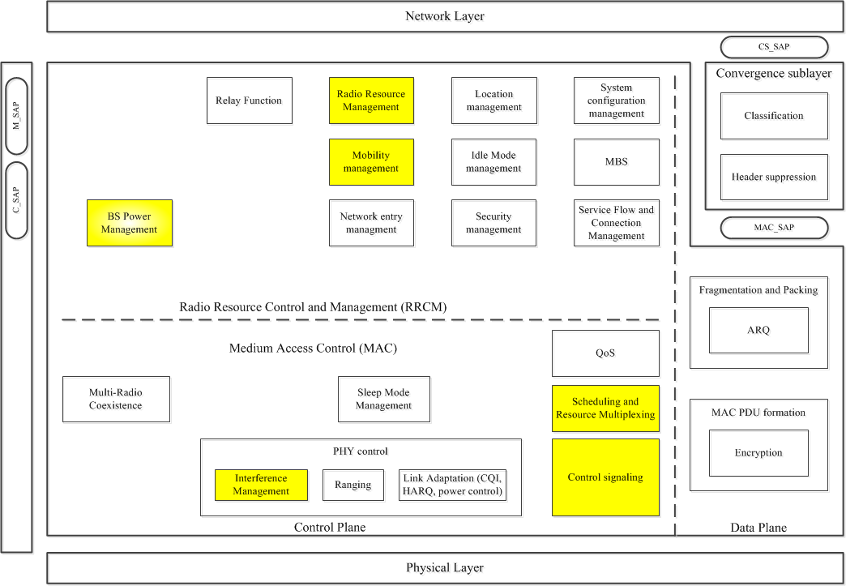
Figure 1 – IEEE 802.16q Functional decompositions within the Protocol Structure

In order to support the IEEE 802.16q Multi-tier Network operations, the following functions of the IEEE 802.16 Standard shall be enhanced.
- Radio Resource Management
- Mobility management
- Interference Management
- Scheduling and Resource Multiplexing
- Control Signaling

“Radio resource management” and “Scheduling and resource multiplexing” are the functions that help to utilize the resources in views of time/frequency/space/power allocation and help to mitigate the interference and/or coordinate transmission among base stations of multi-tiers.
“Mobility management” function assists MS to search for the cells not in the advertized or configured neighboring list without significant searching overhead.
“Interference management” function controls severe inter-cell interference in the present of multiple cells in a multi-tier network and enhances the user throughput.
“Control signal” may be enhanced to support DL/UL control and measurement feedback handling used by base stations of multi-tiers.
In order to support the IEEE 802.16q Multi-tier Network operations, following function shall be included over existing IEEE 802.16 protocol.
- BS Power Management

“BS Power management” is a fuction that supports energy saving of base stations by cooperation among base stations of multi-tiers.

Functional Requirement
This section provides requirements related to features in Multi-tier Networks in accordance with the scope of 802.16q PAR[1].

Interference Management in Multi-tier Networks

The 802.16q system shall support interference management by coordination and cooperation among BSs for multi-tier networks.

The 802.16q system shall provide mechanisms for coordinated resource (time, frequency, power) management to mitigate inter-cell interference between macro cells, between small cells, and between macro cells and small cells.

The 802.16q system shall provide mechanisms for resource(time, frequency) multiplexing, which limits reuse of resource by overlaying/adjacent cells and exclusively dedicates resource to a specific cell among overlaying/adjacent cells.

The 802.16q system shall provide mechanisms for fractional frequency reuse (FFR) with support of varied settings on the number of frequency partition, size of each partition, and (maximum) power of each partition.

The 802.16q system shall provide mechanisms for dynamic coordinated scheduling to alleviate small-scale interference variation.

The 802.16q system shall provide mechanisms for downlink transmit power setting/control of small BS to suppress interference to MSs connected to overlaid/adjacent cells.

The 802.16q system shall provide mechanisms for uplink power control of MSs to suppress interference to BSs in overlaid/adjacent cells.

The 802.16q system shall provide mechanisms for DL cooperative transmission and UL cooperative reception by multiple BSs to enhance cell-edge performance such as cell-edge throughput and client quality of service (QoS) (e.g., coordinated beamforming, collaborative MIMO). When DL cooperative transmission is used, MS’s decoding operations shall be the same as the baseline.

The 802.16q system shall provide mechanisms for synchronization of frames operated by a macro BS and its overlaid small BS(s) to prevent from being impaired by inter-symbol/carrier interference.

The 802.16q system shall provide mechanisms for inter-cell interference channel measurement and report to support interference management with coordination and cooperation among BSs.

The 802.16q system shall provide mechanisms for management information exchange among BSs to support interference management with coordination and cooperation among BSs.

Mobility Management in Multi-tier Networks

Efficient cell discovery shall be supported

Efficient detection of cell ID, cell type and subscription type shall be supported.

Energy efficient and optimized cell search for neighboring small cells on different frequencies shall be supported.

Energy efficient and optimized cell search for neighboring small cells not broadcast by a Macro cell shall be supported.

Efficient cell selection/reselection to a preferred type of cells shall be supported.

Cell selection/reselection based on various factors shall be supported. (e.g., cell type preference, cell load, mobility of a mobile station, etc)

Cell selection/reselection shall differentiate triggering conditions for each cell type

The 802.16q system shall support small base stations with mobility.

The 802.16q system shall support wireless backhaul mobility management for mobile small base stations.

The 802.16q system shall support an advanced sounding mechanism between Macro base station and small base station.

Base Station Power Management

The 802.16q system shall support cooperation of adjacent base stations for energy saving of base stations.

The 802.16q system shall support mangement information exchange among adjacent base stations for power saving.

The 802.16q system shall support coordinated association of users for power saving operation of base stations

The 802.16q system shall support additional operation mode of base stations for power saving of base stations.

The 802 .16q system shall support additional operational mode with minimum impact on operations of mobile stations.

The 802 .16q system shall support duty-cycled operation of base stations.

The 802 .16q system shall support transition to/from inactive period in duty-cycled operation, triggered by adjacent BSs.

The 802.16q system shall support adaptive configuration of power saving operation according to various metric (e.g. number of users).

Support of Large-Scale Antenna Techniques for a Backhaul Link between a Macro BS and a Small BS

This section provides requirements for supporting large-scale antenna techniques for a backhaul link between a macro BS and a small BS in multi-tier networks, which employs large number of antenna elements for high spectral efficiency, high reliability, and reduced interference. [For the macro BS, minimum [TBD] number of transmit and [TBD] number of receive antennas shall be supported. For the small BS, minimum [TBD] number of transmit and [TBD] number of receive antennas shall be supported].

IEEE 802.16q shall support advanced antenna techniques such as MIMO and beamforming/precoding.

IEEE 802.16q shall further support spatial division multiplexing (SDM) MIMO and spatial division multiple access (SDMA) MIMO techiniques [with up to maximum [TBD] streams].

IEEE 802.16q shall support precoded pilots for demodulation.

IEEE 802.16q shall support sounding mechanisms in TDD mode. To compensate imperfect channel reciprocity between DL and UL, calibration mechanisms shall be provided when sounding is used.

7 Annex: Reference Model
This annex provides information on the protocol architecture model and network reference model defined in IEEE Std 802.16-2012. Any management messaging defined in P802.16q to support management information exchanged among BSs shall be developed based on the archtecure model and network reference model defined in IEEE Std 802.16-2012.

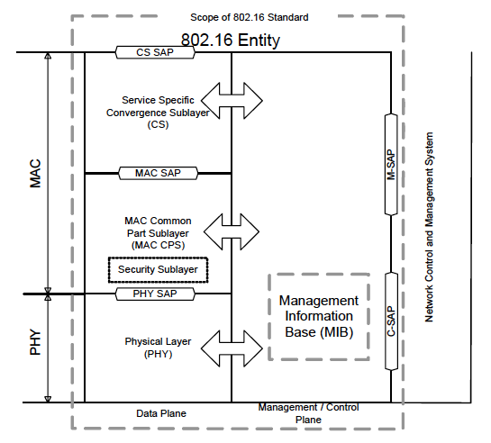
Figure 7-1 – IEEE Std 802.16 Protocol Archtecture Model

The 802.16 devices can include Subscriber Stations (SS) or Mobile Stations (MS), or Base Stations (BS). As the 802.16 devices may be part of a larger network and therefore would require interfacing with entities for management and control purposes, a Network Control and Management System (NCMS) abstraction has been introduced in IEEE Std 802.16-2012 as a "black box" containing these entities. The NCMS abstraction allows the PHY/MAC layers specified in 802.16 to be independent of the network architecture, the transport network, and the protocols used at the backend and therefore allows greater flexibility. NCMS logically exists at BS side and SS/MS side of the radio interface, termed NCMS(BS) and NCMS(SS/MS), respectively. Any necessary inter-BS coordination is handled through the NCMS(BS).
IEEE Std 802.16-2012 includes a Control SAP (C-SAP) and Management SAP (M-SAP) that expose control plane and management plane functions to upper layers. The M_SAP and C-SAP interfaces are described in 7.3.3 and 7.3.4, respectively. The NCMS uses the C-SAP and M-SAP to interface with the 802.16 entity. In order to provide correct MAC operation, NCMS shall be present within each SS/MS. The NCMS is a layer independent entity that may be viewed as a management entity or control entity. General system management entities can perform functions through NCMS and standard management protocols can be implemented in the NCMS.

7.1 802.16 entity
An 802.16 entity is defined as the logical entity in an SS/MS or BS that comprises the PHY and MAC layers of the Data Plane and the Management/Control Plane.

7.2 Network Control and Management System (NCMS)
This abstraction is detailed in Figure 7-2 to show the different functional entities that make up such a Network Control and Management System. These entities may be centrally located or distributed across the network. The exact functionality of these entities and their services is outside the scope of this document but shown here for illustration purposes and to better enable the description of the management and control procedures.

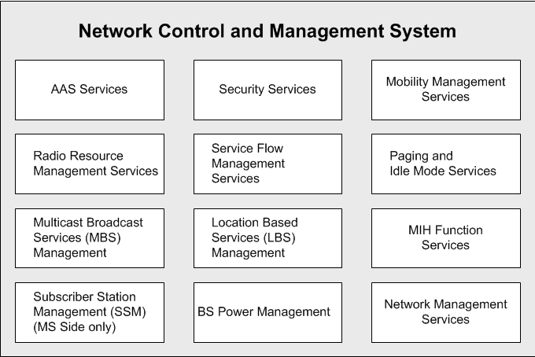
Figure 7-2 – Illustration of the Network Control and Management System (Informational)

NCMS protocols are not specified in IEEE Standard 802.16-2012, however information elements (IEs) and protocol primitives for these IEs are exposed using primitives via SAP. This includes MAC and PHY layer context information used by NCMS protocols to manage and control the air interface. NCMS service manifestations on the SS/MS and BS may have different configurations and functions.

7.3 Network reference model
Figure 7-3 describes a simplified network reference model. Multiple SS or MS may be attached to a BS. SS or MS communicate to the BS over the U interface using a Primary Management Connection, a Basic Connection or a Secondary Management Connection.

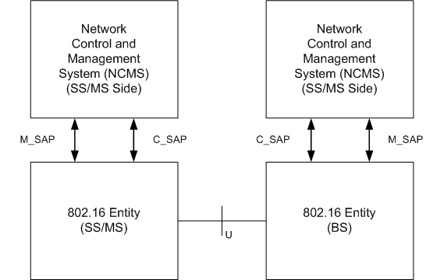
Figure 7-3 – 802.16 Network Reference Model

7.3.1 SS/MS and BS Interface
The correlation between MAC PDU and C-SAP/M-CAP are described in IEEE Std 802.16-2012 as follows:
- MAC management PDUs that are exchanged on the basic management connection trigger or are triggered by primitives that are exchanged over the C-SAP.
- MAC management PDUs that are exchanged on the primary management connection trigger or are triggered by primitives that are exchanged over either the C-SAP or the M-SAP depending on the particular management or control operation.
- Messages that are exchanged over the secondary management connection trigger or are triggered by primitives that are exchanged over the M-SAP.

7.3.2 802.16 entity to NCMS interface
This interface is a set of SAP between an 802.16 entity and NCMS and is represented in Figures 7-3. It is decomposed into two parts: the M-SAP is used for less time sensitive Management plane primitives and the C-SAP is used for more time sensitive Control plane primitives that support handovers, security context management, radio resource management, and low power operations (such as Idle mode and paging functions).

7.3.3 Management SAP (M-SAP)
The Management SAP may include, but is not limited to primitives related to:
- System configuration
- Monitoring Statistics
- Notifications/Triggers
- Multi-mode interface management

7.3.4 Control SAP (C-SAP)
The Control SAP may include, but is not limited to primitives related to:
- Handovers (e.g. notification of HO request from MS, etc.)
- Idle mode mobility management (e.g. Mobile entering idle mode)
- Subscriber and session management (e.g. Mobile requesting session setup)
- Radio resource management
- AAA server signaling (Eg. EAP payloads).
- Media Independent Handover Function Services
- Location detection reporting capability
- detection reporting capability

