### IEEE P802.11 Wireless LANs

|  |  |  |  |  |
| --- | --- | --- | --- | --- |
| GCR Group Address in protected M-BA | | | | |
| Date: 2025-05-09 | | | | |
| Author(s): | | | | |
| Name | Affiliation | Address | Phone | email |
| Li-Hsiang Sun | MediaTek |  |  |  |
| George Kuo |  |  |  |
| Frank Hsu |  |  |  |
| James Yee |  |  |  |

Abstract

This document proposes contents of M-BA frame which is used for GCR acknowledgement.

**Discussion:**

Use of protected M-BA as GCR BA was agreed in 11-25-0260r7.

For similar receiver processing as receiving GCR BA, it is desirable that all fields present in GCR BA frame are also present in the protected M-BA used for GCR acknowledgement. This document proposes a self-contained protected M-BA format as shown below:

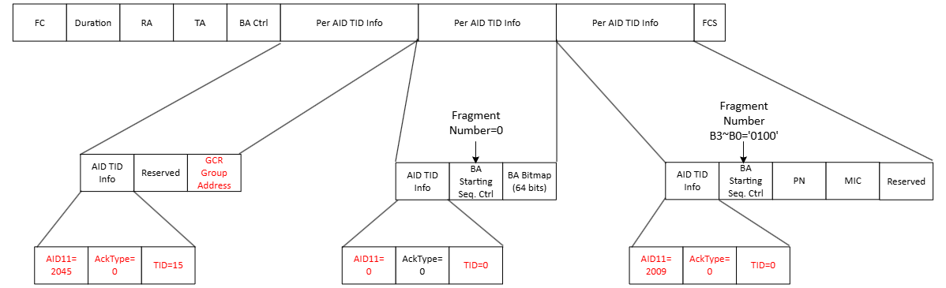

If a STA has multiple GCR BA agreements, the protected GCR Group Address field prevents the replay of a GCR BA of one agreement as a GCR BA of another agreement.

**Interpretation of a Motion to Adopt**

A motion to approve this submission means that the editing instructions and any changed or added material are actioned in the TGmf Draft. This introduction is not part of the adopted material.

***TGmf editor: Modify 9.3.1.8.6 as follows: (Track change on)***

**9.3.1.8.6 Multi-STA BlockAck variant**

……

The AID11 subfield carries the 11 LSBs of the AID of the non-AP STA for which the Per AID TID Info

subfield is intended. The format of the Per AID TID Info subfield depends on the value of the AID11

subfield. If the Multi-STA BlockAck frame is sent to an AP, the AID11 subfield is set to 0. A value of 2045 in the AID11 subfield is used as an identifier for any unassociated STA or for identifying the Multi-STA BlockAck frame is used as a protected GCR BlockAck. If the AID11 subfield is set to 2045, then the Ack Type subfield and TID subfield are set to 0 and 15, respectively.

……

If the AID11 subfield is not 2045, then the context and the presence of each optional subfield in a Per AID TID Info subfield in a Multi-STA BlockAck frame is defined in Table 9-39 (Context of the Per AID TID Info subfield and presence of optional subfields if the AID11 subfield is not 2045(11ax)). If the AID11 subfield is 0 and the Per AID TID Info subfield contains the Block Ack Bitmap for a GCR agreement, then the Ack Type subfield is set to 0, and the TID subfield is set to 0.

……

If the AID11 subfield of the AID TID Info subfield is 2045, then the Per AID TID Info subfield has the

format shown in Figure 9-61 (Per AID TID Info subfield format if the AID11 subfield is 2045(11ax)). When the frame is sent by an AP STA, the RA/GCR Group Address subfield indicates the MAC address of an unassociated STA for which the Per AID TID Info subfield is intended. When the frame is sent by a non-AP STA, the RA/GCR Group Address subfield is set to the RA field in the GCR MU-BAR Trigger frame.

|  |  |  |  |
| --- | --- | --- | --- |
|  |  |  |  |
|  | AID TID Info | Reserved | RA/GCR Group Address |
| Octets: | 2 | 2 | 6 |

Figure 9-61—Per AID TID Info subfield format if the AID11 subfield is 2045

***TGmf editor: Modify the new clause at the end of 12.6 as follows:***

**12.6.xx Protection of Control frames**

This subclause defines rules that shall be followed by an RSNA non-AP STA on a link with an associated AP.

Control frame protection is an optional feature. A STA that supports control frame protection has dot11CIPActivated equal to true and sets the CIP Supported field to 1 in the RSNXE. If both the associated non-AP STA and AP have set the CIP Supported field to 1 in the RSNXE, then control frame protection is negotiated and all Trigger, Compressed BlockAckReq, Multi-TID BlockAckReq and Multi-STA BlockAck frames transmitted between the non-AP STA and AP shall be protected.

Protection of group addressed Control frames that are defined to be protected shall be provided by a service in the MLME as described in 11.xx (Group addressed control frame protection procedures). Protection of individually addressed Control frames that are defined to be protected shall be provided by a service in the MLME (see 12.2.4 (RSNA establishment)).

A non-AP STA indicates in the CIP Capabilities element of (Re)Association Request frames the padding durations of the protected Control frames and PPDUs that solicit protected Control frames. An AP indicates in the CIP Capabilities element of (Re)Association Response frame the padding durations of the protected Control frames and PPDUs that solicit protected Control frames.

A STA shall only use a protected Multi-STA BlockAck frame to provide acknowledgement of individually addressed frames that solicit an acknowledgement to another STA if the STAs have negotiated control frame protection that are defined to be protected.

A protected GCR MU-BAR Trigger frame shall solicit a protected Multi-STA BlockAck frame instead of a GCR BlockAck frame. A non-AP STA that supports GCR and that has negotiated control frame protection shall include a protected Multi-STA BlockAck frame, with AID11 subfield set to 2045 in a Per AID TID info subfield before the Per AID TID info subfield carrying the Block Ack Bitmap instead of a GCR BlockAck frame, in the TB PPDU that is sent in response to a protected GCR MU-BAR Trigger frame (see 9.3.1.22.7). An AP shall not send a GCR BlockAckReq frame to a non-AP STA that supports GCR and that has negotiated control frame protection.

A protected MU-BAR Trigger frame shall solicit a protected Multi-STA BlockAck frame. A non-AP STA that has negotiated control frame protection shall include a protected Multi-STA BlockAck frame in the TB PPDU that is sent in response to a protected MU-BAR Trigger frame (see 9.3.1.22.4).