IEEE P802.11
Wireless LANs
cc50-cid-2697-Spatial Reuse For NPCA Capable STAs
Date: May 15, 2025
Author(s):
Name | Affiliation | Address | Phone | email
Salvatore Talarico | Nokia |  |  | salvatore.talarico@nokia.com
Klaus Doppler
Mika Kasslin
Okan Mutgan
Prabodh Varshney
Behnam Dezfouli
Mikhail Liubogoshchev
Eda Genc
Juhyung Lee
Kerstin Johnsson
Oleg Chistyakov
Mario Costa
Enrico Rantala
Vishnu Ratnam | Samsung |  |  | vishnu.r@samsung.com

Abstract
This submission proposes the resolution to CID 2697 received for CC50 for 802.11bn.

Revisions:
- Rev 0: Initial version of the document.
- Rev 1: Updated text.
- Rev 2: Updated text based on Vishnu Ratnam’s suggestions.
- Rev 3: Updated text based on comments received.
- Rev 4: Updated text based on additional comments received.
- Rev 5: Updated text based on additional comments received.

TGbn editor: The baseline for this document is P802.11bn D0.2 and P802.11REVmeD7.0

TGbn Editor: Editing instructions preceded by “TGbn Editor” are instructions to the TGbn editor to modify existing material in the TGbn draft. As a result of adopting the changes, the TGbn editor will execute the instructions rather than copy them to the TGbn Draft.

Introduction

This submission proposes the resolution to CID 2697 received for CC50 for 802.11bn, which is copied below for convenience:

Comment:

CID | Commenter | Clause | Page.line | Comment | Proposed Change | Resolution
2697 | Salvatore Talarico | 26.10 | 4163, 24 | Behaviour of how STAs should operate when spatial reuse is used by NPCA capable STAs | Backwards compatibility of spatial reuse should be properly handled for NPCA capable STAs | Proposed text is provided which specifies that SR and NPCA are never used jointly.  TGbn editor, please incorporate changes tagged with 2697 in 11-25/0757r0.

The page and line numbers above refer to those in 11REVme_D7.0 [1].

- Discussion
In 11ax [1], the Spatial Reuse (SR) feature was defined, where the concept of BSS coloring and two flavors of interference mitigation techniques were introduced:
- OBSS Packet Detection (PD)-based SR: used mainly for untriggered transmissions and to allow to ignore the transmissions of the OBSS system thereby by choosing properly an OBSS PD thresholds, and consequently reducing the transmit power to minimize the disruptions to the neighboring OBSS when transmitting concurrently
- Parametrized SR (PSR): used for trigger-based transmissions and aims to inform STAs in the neighboring OBSSs how much they can transmit without affecting the reference AP’s ability to properly decode the uplink frames from its own associated STAs
In 11bn [2], the Non-primary channel access (NPCA) feature has been defined. However, when NPCA is jointly enabled with SR, based on the OBSS PD thresholds that STAs may select the ambiguity that NPCA creates when it comes to determining when to switch to the NPCA primary channel is exacerbated. An illustrative example of this issue is provided in Fig. 1. In this example, SR with non-SRG OBSS PD is jointly enabled with NPCA, and within BSS1 all the STAs will accordingly select their OBSS PD values so that to reduce footprint and impact on BSS2. However, while AP1 and STA1 select their non-SRG OBSS PD so that they can ignore transmissions from AP2, STA1* cannot. So, this would lead to AP1 and STA1 continuing to stay on the primary channel, while STA1* will switch to NPCA primary channel.

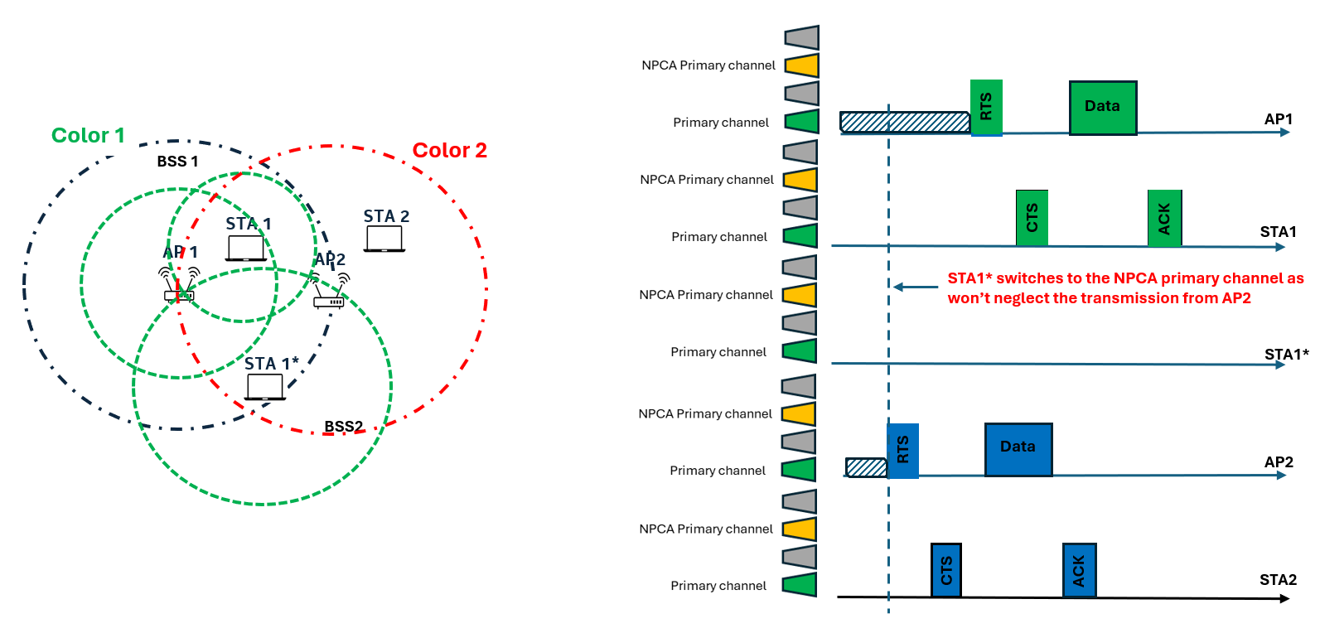
Figure 1 – Illustrative example of the additional ambiguity that SR introduces between AP and STAs in terms of whether to switch to an NPCA primary channel

It is also important to note, that NPCA and SR are two features that address the same issue (i.e., the overlap of OBSS transmissions with BSS transmissions). However,
- SR is preferred when the distance between BSSs is far and a small change in either individual OBSS PD thresholds or PSR values may reduce or eliminate the existing interference and mutual blocking between adjacent BSSs;
- NPCA is preferred when the distance between BSSs is shorter, and the received power of OBSS transmissions is greater, making changes in OBSS PD thresholds and PSR values less effective. In these cases, when the OBSS transmission overlaps the primary channel, there will be no option for mostly all STAs but to switch to the NPCA primary channel.
This implies that SR and NPCA may be operated one at the time depending on interference conditions.
With that said, we propose that NPCA is never used jointly with PSR spatial reuse, while it is left for further discussion on whether NPCA and OBSS PD-Based SR may be operated jointly.

- Proposed Resolution
TGbn editor: Please change the 11bn spec as shown below. The reference version is P802.11REVmeD7.0 (#2697) and IEEE P802.11bn/D0.2 (#2697)

26.10 HE spatial reuse operation(#2389)
26.10.1 General
TGbn editor: Please update following paragraph in this subclause as shown below - P802.11REVmeD7.0, page 4163 line 24 (#2697)
The objective of HE spatial reuse operation is to allow the medium to be reused more often between OBSSs
in dense deployment scenarios by the early identification of signals from overlapping basic service sets
(OBSSs) and interference management.
There are two independent spatial reuse modes: OBSS PD-based spatial reuse and PSR-based spatial reuse.
An HE AP participating in spatial reuse may request an associated non-AP HE STA to gather information
regarding the neighborhood by sending a Beacon request (see 9.4.2.20.7 (Beacon report)) following the
procedure described in 11.11 (DSE procedures). An HE AP shall not set a measurement mode in a Beacon
request to an associated STA to a mode for which the STA has not explicitly indicated support via the RM
Enabled Capabilities element (see 9.4.2.43 (RM Enabled Capabilities element)). An HE AP that sends a
Beacon request for this purpose
- May request that the non-AP HE STA gather information of BSSs matching a particular BSSID and/
- or SSID.
- May request that the non-AP HE STA generate a report that is only for the channel on which the
requesting AP is operating or to which the requesting AP is considering switching.
- Shall request that the non-AP HE STA include the HE Operation element of neighboring HE APs in order to help determine the BSS color information of the neighboring APs.
A non-AP HE STA that performs spatial reuse operation shall have dot11RadioMeasurementActivated set
to true and shall respond to a Beacon request from its associated AP with a Beacon report as described
in 11.11 (DSE procedures).

An AP shall enable PSR spatial reuse only if NPCA operation is disabled as described in 37.11 (Non-primary channel access (NPCA)).

A Class B device as defined in 27.3.15.3 (Precorrection accuracy requirements(M118)) shall not operate
with the procedures defined in this subclause.
…

37.11 Non-primary channel access (NPCA)
TGbn editor: Please update following paragraph in this subclause as shown below - IEEE P802.11bn/D0.2 , page 84 line 44 (#2697)

A STA that supports NPCA operation is called an NPCA STA. An AP that supports NPCA operation is
called an NPCA AP. A non-AP NPCA STA shall set the NPCA Supported field of the UHR MAC Capabilities Information field of the UHR Capabilities element to 1. A non-AP NPCA STA may enable the NPCA
mode only if it is associated with an NPCA AP. It is TBD how the non-AP STA enables NPCA mode.

An NPCA AP that has an operating bandwidth less than TBD (but either 80 or 160 MHz) shall not enable
NPCA operation. An AP of a multiple BSSID set which enables NPCA operation shall indicate the same
NPCA primary channel as all of the other APs of the same multiple BSSID set which have enabled NPCA
operation.

An NPCA AP that has enabled NPCA operation shall include the NPCA Operation Information field in its
UHR Operation element and indicate its NPCA switching delay and NPCA switch back delay respectively
in the NPCA Switching Delay field and NPCA Switch Back Delay field of the TBD frames.

An NPCA AP shall set the TXVECTOR parameter SPATIAL_REUSE to PSR_DISALLOW for PPDUs that it transmits, and shall set the PSR Disallowed subfield in the SR Control field of the Spatial Reuse Parameter Set element to 1 in Management frames it transmits before enabling NPCA operation in its BSS as described in 37.11 (Non-primary channel access (NPCA)) and while NPCA operation remains enabled.
…

- References

[1] IEEE P802.11-REVme™ Draft Standard for Information Technology— Telecommunications and Information Exchange between Systems Local and Metropolitan Area Networks— Specific Requirements
Part 11: Wireless LAN Medium Access Control (MAC) and Physical Layer (PHY) Specifications.
[2] IEEE P802.11bn™/D0.2 Draft Standard for Information technology— Telecommunications
and information exchange between systems Local and metropolitan area networks— Specific requirements
Part 11: Wireless LAN medium access control (MAC) and physical layer (PHY) specifications, Amendment 6: Enhancements for ultra high reliablity (UHR)”, March 2025.

