IEEE P802.11  
Wireless LANs

|  |  |  |  |  |
| --- | --- | --- | --- | --- |
| CC50 CR for Common field for non-OFDMA transmission and Co-BF Transmission | | | | |
| Date: 2025.04.20 | | | | |
| Author(s): | | | | |
| Name | Company | Address | Phone | email |
| Mengshi Hu | Huawei Technologies |  |  | humengshi@huawei.com |
| Edward Au | Huawei Technologies |  |  |  |

Abstract

This submission contains the proposed comment resolutions of CIDs in 25/0296 IEEE 802.11bn CC50 comments on D0.1.

11 comments for subclause 38.3.15.9.4 (Common field for non-OFDMA transmission) and subclause 38.3.15.9.5 (Common field for Co-BF transmission) are resolved.

Resolved CIDs in 38.3.15.9.4: **114, 1350, 1351, 1588, 1637, 2181, and 2289.**

Resolved CIDs in 38.3.15.9.5: **35, 440, 1638, and 1955.**

Revision Notes

|  |  |
| --- | --- |
| R0 | Initial revision |

# CIDs for 38.3.15.9.4 Common field for non-OFDMA transmission

|  |  |  |  |  |  |
| --- | --- | --- | --- | --- | --- |
| CID | Page.  Line | Clause Number | Comment | Proposed Change | Resolution |
| 114 | 171.07 | 38.3.15.9.4 | In Table 38-24, the subfield name "Interference mitigation" should be changed to "Interference Mitigation" (with a capital "M") | Change "mitigation" to "Mitigation" to keep consistency with other subfield names. | REVISED.  Agree that the subfield name “Interference mitigation” should be changed into “Interference Mitigation”. However, the Table number should be 38-25, instead of 38-24 in 802.11bn Draft 0.2.  ***Instructions to the editor:***  **Please make the changes as shown under CID 1955 in 11-25/0686r0.** |
| 1350 | 170.15 | 38.3.15.9.4 | The Spatial Reuse field should be kept the same as that in the EHT following the passed motion as mentioned in the SFD https://mentor.ieee.org/802.11/dcn/24/11-24-0209-09-00bn-specification-framework-for-tgbn.docx | remove "(TBD)" | ACCEPTED.  (Page 180, Line 27) |
| 1637 | 170.15 | 38.3.15.9.4 | Remove TBD for Spatial reuse | as in comment | ACCEPTED.  (Page 180, Line 27) |
| 1351 | 171.33 | 38.3.15.9.4 | the "UHR SU transmission" should include the "DL SU Co-SR transmission" and "non-OFDMA transmision" should include the " DL non-OFDMA Co-BF transmission", but in Table 38-18 and 38-19, it seems that the "UHR SU transmission" does not include the "DL SU Co-SR transmission" and "non-OFDMA transmision" does not include the " DL non-OFDMA Co-BF transmission" it's beter to make this in consistent through the document | see comment | REVISED.  According to some discussions and to be aligned with the transmission types defined in U-SIG, the UHR SU transmission and DL SU Co-SR transmission are two different types. Similarly, DL non-OFDMA MU-MIMO transmission and DL non-OFDMA Co-BF are two different types. The related paragraphs are updated.  ***Instructions to the editor:* Please make the changes as shown under CID 1955 in 11-25/0686r0.** |
| 1588 | 171.07 | 38.3.15.9.4 | There is an indication regarding whether IM(Interference mitigation) is enabled or not in Common field for a UHR SU and non-OFDMA transmission but no related protocol defined in the spec. | Need to define the specific pilot pattern and how to operate for IM. | REJECTED.  The specific pilot pattern and operation are not related to the UHR-SIG. |
| 2181 | 170.07 | 38.3.15.9.4 | It's quite strange that 'IM enabled' is set using bit set to 0 and not 1; I understand that this bit was 'set to 1 and disregard' in 11be, but this is 11bn and a new standard, and here we're designing the common field of a new UHR-SIG signal. | consider replacing values 0 and 1, such that 'IM enabled' is signaled using bit set to 1 (and not zero). | REJECTED.  The original values are related to the 802.11bn Motion #117, which already shows the consensus and preference of majority on how to set the IM bit. |
| 2289 | 170.25 | 38.3.15.9.4 | Change "35.y (UHR Spatial reuse operation)" to "37.y (UHR Spatial reuse operation)". Clause 35 is for EHT MAC. | As in comment | ACCEPTED.  (Page 180, Line 25) |

# CIDs for 38.3.15.9.5 Common field for Co-BF transmission

|  |  |  |  |  |  |
| --- | --- | --- | --- | --- | --- |
| CID | Page.  Line | Clause Number | Comment | Proposed Change | Resolution |
| 35 | 171.43 | 38.3.15.9.5 | Remove the subclause of "Common field for Co-BF transmission". The CoBF transmission is one of the non-OFDMA transmissions and reuse the same common field for non-OFDMA. | Refer to the comment. | REVISED.  Agree with the commenter that this subclause could be removed and merged with the non-OFDMA part.  ***Instructions to the editor:***  **Please make the changes as shown under CID 1955 in 11-25/0686r0.** |
| 440 | 171.43 | 38.3.15.9.5 | I think Co-BF will have same common field as non-OFDMA MU. What is expected to be covered in 38.3.15.9.35? | can merge with section 38.3.15.9.4 | REVISED.  Agree with the commenter that this subclause could be removed and merged with the non-OFDMA part.  ***Instructions to the editor:* Please make the changes as shown under CID 1955 in 11-25/0686r0.** |
| 1638 | 171.46 | 38.3.15.9.5 | Define Common field for Co-BF transmission | as in comment | REVISED.  The Common field for Co-BF transmission is the same as that for non-OFDMA transmission. Thus they are merged together in the updated version.  ***Instructions to the editor:* Please make the changes as shown under CID 1955 in 11-25/0686r0.** |
| 1955 | 171.45 | 38.3.15.9.5 | When describing fields related to "Common field for Co-BF transmission", we may need to clarify that those fields are present for the STAs from both APs to interpret and decode the following preamble/data. | As the comment | REVISED.  Agree with the commenter this could be clarified.  ***Instructions to the editor:* Please make the changes as shown under CID 1955 in 11-25/0686r0.** |

***Instructions to the editor: please make the following changes to Page 180, Line 1 in the subclause 38.3.15.9.4 (Common field for non-OFDMA transmission) in D0.2 as shown below:***

The text in 802.11bn D0.2:

# 38.3.15.9.4 Common field for non-OFDMA transmission

The Common field for a UHR SU transmission, DL SU Co-SR transmission, DL non-OFDMA MU-MIMO transmission, and DL non-OFDMA Co-BF transmission is defined in Table38-25 (Common field for a UHR SU transmission, DL SU Co-SR transmission, DL non-OFDMA MU-MIMO transmission, and DL non-OFDMA Co-BF transmission). (#1351)(#35) (#440) (#1638)

|  |  |  |  |
| --- | --- | --- | --- |
| * (Common field for a UHR SU transmission, DL SU Co-SR transmission, DL non-OFDMA MU-MIMO transmission, and DL non-OFDMA Co-BF transmission | | | |
| Bit | Subfield | Number of bits | Description |
| B0–B3 | Spatial Reuse | 4 | Indicates whether or not spatial reuse modes are allowed during the transmission of this PPDU.  Set to a value from Table 27-23 (Spatial Reuse field encoding for an HE SU PPDU, HE ER PPDU, and HE MU PPDU). Note that Table 27-23 (Spatial Reuse field encoding for an HE SU PPDU, HE ER PPDU, and HE MU PPDU) also applies to UHR MU PPDU. See 37.x (SPATIAL_REUSE) and 37.y (UHR Spatial reuse operation). (#2289)  (#1350, #1637) |
| B4–B5 | GI+LTF Size | 2 | Indicates the GI duration and UHR-LTF size:  Set to 0 to indicate 2´ LTF + 0.8 µs GI.  Set to 1 to indicate 2´ LTF + 1.6 µs GI.  Set to 2 to indicate 4´ LTF + 0.8 µs GI.  Set to 3 to indicate 4´ LTF + 3.2 µs GI. |
| B6–B8 | Number Of UHR-LTF Symbols | 3 | Indicate the number of UHR-LTF symbols:  Set to 0 to indicate 1 UHR-LTF symbol.  Set to 1 to indicate 2 UHR-LTF symbols.  Set to 2 to indicate 4 UHR-LTF symbols.  Set to 3 to indicate 6 UHR-LTF symbols.  Set to 4 to indicate 8 UHR-LTF symbols.  Values 5–7 are Validate. |
| B9 | LDPC Extra Symbol Segment | 1 | Indicates the presence of the LDPC extra symbol segment:  Set to 1 if an LDPC extra symbol segment is present.  Set to 0 if an LDPC extra symbol segment is not present. |
| B10–B11 | Pre-FEC Padding Factor | 2 | Indicates the pre-FEC padding factor:  Set to 0 to indicate a pre-FEC padding factor of 4.  Set to 1 to indicate a pre-FEC padding factor of 1.  Set to 2 to indicate a pre-FEC padding factor of 2.  Set to 3 to indicate a pre-FEC padding factor of 3. |
| B12 | PE Disambiguity | 1 | Indicates PE disambiguity as defined in 38.3.17 (Packet extension). |
| B13 | Interference Mitigation (#114) | 1 | Indicates whether IM is enabled or not in the Data field.  A value of 0 indicates the PPDU is sent with IM enabled.  A value of 1 indicates the PPDU is sent with IM disabled. |
| B14–B15 | Disregard | 2 | Set to all 1s. |
| B16–B18 | Number Of Non-OFDMA Users | 3 | Indicates the total number of non-OFDMA users. Set to *n* to indicate *n*+1 non-OFDMA users.  For a non-OFDMA transmission to a single user, set to 0 to indicate a UHR SU transmission.  For a non-OFDMA transmission to multiple users, set to a value larger than 0 to indicate more than one non-OFDMA users for non-OFDMA transmission to multiple users. |

B0–B15 of Table38-25 (Common field for a UHR SU transmission, DL SU Co-SR transmission, DL non-OFDMA MU-MIMO transmission, and DL non-OFDMA Co-BF transmission) are U-SIG Overflow bits for a UHR SU transmission, DL SU Co-SR transmission, DL non-OFDMA MU-MIMO transmission, and DL non-OFDMA Co-BF transmission. Both the U-SIG Overflow bits and Number Of Non-OFDMA Users subfields are duplicated in each content channel.

For a UHR SU transmission using BCC or a DL SU Co-SR transmission using BCC, the LDPC Extra Symbol Segment field is set to 0 to indicate that an LDPC extra symbol segment is not present. (#1351)(#35) (#440) (#1638)

For a DL non-OFDMA Co-BF transmission, the Common fields of the UHR-SIG sent from the shared AP and the sharing AP are the same. (#1955)

***Instructions to the editor: please insert the following paragraphs to Page 171, Line 51 in the subclause 38.3.15.9 (UHR-SIG) in D0.2 as shown below:***

The text in 802.11bn D0.2:

**38.3.15.9 UHR-SIG**

# 38.3.15.9.1 General

The UHR-SIG field provides additional signaling to the U-SIG field for STAs to interpret a UHR MU PPDU. In a UHR MU PPDU, the UHR-SIG field contains U-SIG overflow bits that are common to all users. The UHR-SIG field further contains resource allocation information to allow the STAs to look up the corresponding resources to be used in the UHR modulated fields of the PPDU. The integer fields of the UHR-SIG field are transmitted in unsigned binary format, LSB first, where the LSB is in the lowest numbered bit position.

For a DL non-OFDMA Co-BF transmission, the UHR-SIG field carries information for the corresponding two Co-BF BSSs.

# 38.3.15.9.2 UHR-SIG content channels

The UHR-SIG field of a 20 MHz UHR MU PPDU contains one UHR-SIG content channel. For OFDMA transmission, DL non-OFDMA MU-MIMO transmission, and DL non-OFDMA Co-BF transmission, the UHR-SIG field of a UHR MU PPDU that is 40 MHz or 80 MHz contains two UHR-SIG content channels. For OFDMA transmission, DL non-OFDMA MU-MIMO transmission, and DL non-OFDMA Co-BF transmission, the UHR-SIG field of a UHR MU PPDU that is 160 MHz or wider contains two UHR-SIG content channels per 80 MHz frequency subblock. The UHR-SIG content channels per 80 MHz frequency subblock are allowed to carry different information when UHR MU PPDU bandwidth for OFDMA transmission is wider than 80 MHz. The UHR-SIG field of a UHR SU transmission and DL SU Co-SR transmission contains one UHR-SIG content channel and it is duplicated in each non-punctured 20 MHz subchannel when the UHR PPDU is equal to or wider than 40 MHz.

For a DL non-OFDMA Co-BF transmission, the above one content channel in a 20 MHz UHR MU PPDU and two content channels in a UHR MU PPDU with a wider bandwidth of the UHR-SIG field carry information for the corresponding two Co-BF BSSs.

The figures of content channel formats described in EHT-SIG also apply to UHR-SIG (See 36.3.12.8.2 (EHT-SIG content channels)). Note that there is no UHR sounding NDP. For a UHR MU PPDU, each UHR-SIG content channel consists of a Common field followed by a User Specific field.

Discussion:

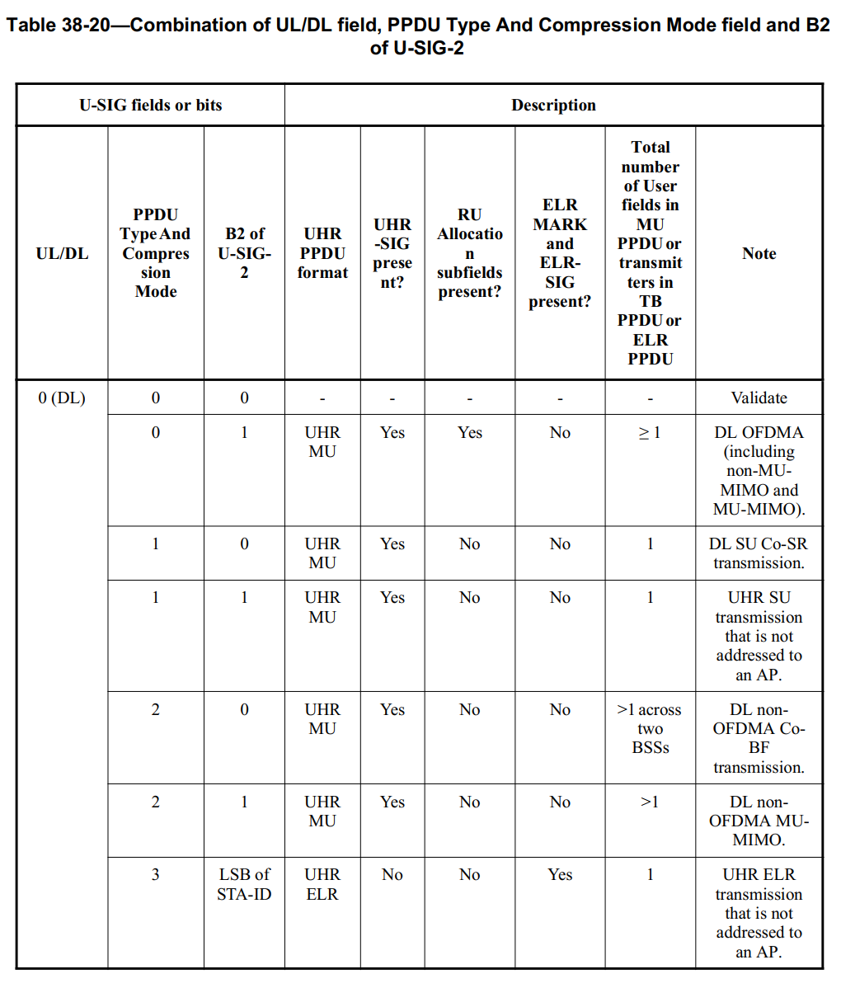

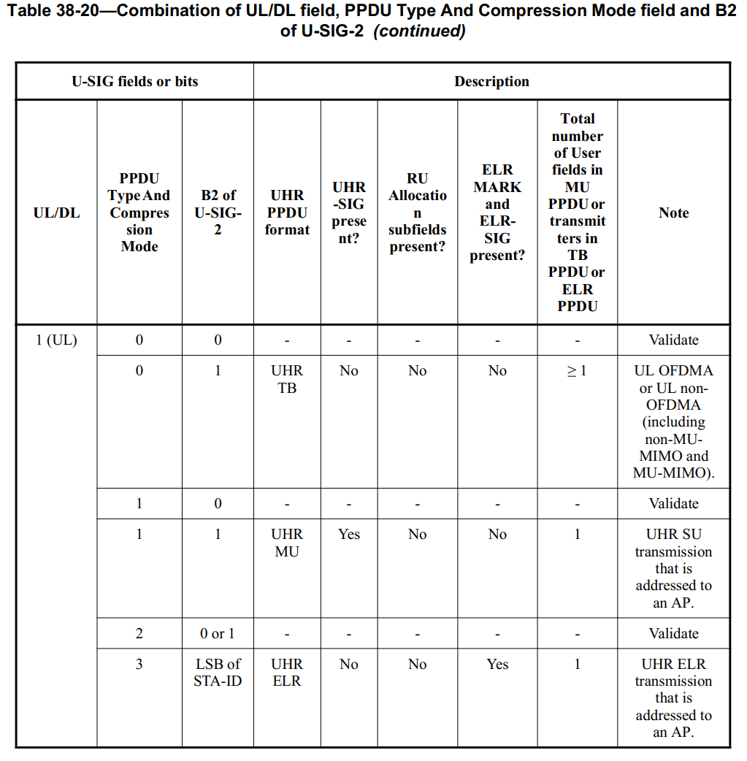

Discussion ends.