IEEE P802.11
Wireless LANs
LPI with Puncturing
Date: 2025-5-15
Author(s):
Name | Affiliation | Address | Phone | email
Pelin Salem | Cisco Systems | San Jose, CA |  | pmohamed@cisco.com
Brian Hart | Cisco Systems | San Jose, CA |  | brianh@cisco.com

Abstract
This submission proposes text update to implement 6GHz low power indoor PPDU puncturing AP signaling:

NOTE – Set the Track Changes Viewing Option in the MS Word to “All Markup” to clearly see the proposed text edits.

Revision History:

R0: Initial version.
R1: Adding proposed “punctured transition band” and “punctured passband” definitions to "3.2 Definitions specific to IEEE Std 802.11"
R2: Changed definition, identified Word track changes, editorial items

Background
The Simultaneous Composite AP is expected to support all client classes and enable the full suite of 802.11 features, including PPDU puncturing. Under current FCC regulations, PPDU puncturing is not permitted in LPI BSSs as a mechanism to protect incumbent users. Consequently, when an incumbent occupies the upper or lower half of an 80 MHz or 160 MHz channel, the available LPI BSS bandwidth is reduced to 40 MHz or 80 MHz, respectively. There is, however, strong potential for the FCC to allow PPDU puncturing in LPI BSSs of Simultaneous Composite APs, provided the AFC response for the punctured channel(s) supports power levels above those used by LPI APs and clients. This enhancement would not require protocol changes—only updates to AP behavior and the contents of the TPE element.
Reference:
- https://mentor.ieee.org/802.11/dcn/24/11-24-1071-04-00bn-lpi-ppdu-puncturing-follow-up.pptx

Figures referenced in the text
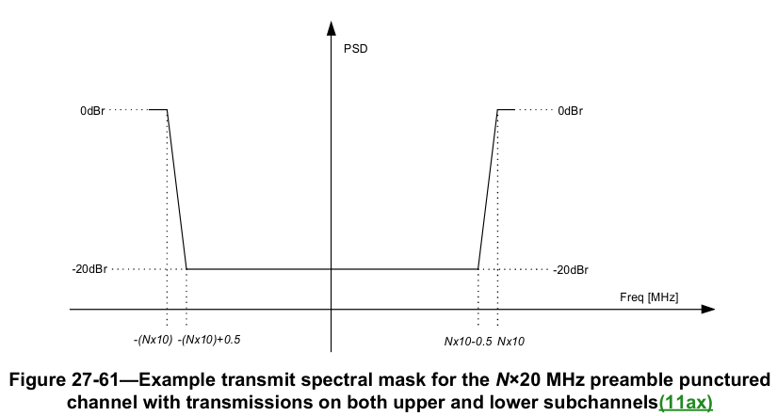
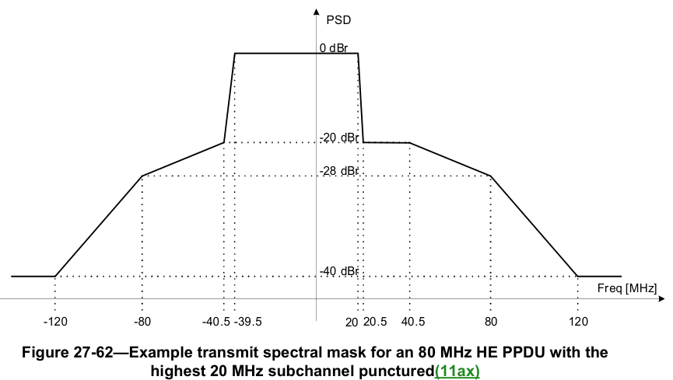

Proposed Text Update
Instruction to TGmf Editor: Edit the TGmf draft as shown below.

3.2 Definitions specific to IEEE Std 802.11
(normative)

TGmf editor: Please insert the following text to this section (on page 242, starting at line 17):

Punctured passband: For a set of contiguous punctured 20 MHz subchannels, the portion of the bandwidth that has minimum power spectral density.

NOTE – For a first example, illustrated in Figure 27-61, a punctured passband at -20dBr starts at –(Nx10)+0.5 and ends at Nx10-0.5 for N contiguous 20 MHz preamble punctured channels with unpunctured subchannels above and below. For a second example, for an 80MHz HE PPDU with the highest 20 MHz subchannel punctured as shown in Figure 27-62, the punctured passband is between 20.5 and 40 MHz.

Punctured transition band: For a set of contiguous punctured 20 MHz subchannels, each contiguous portion of the bandwidth after excluding the punctured passband.

NOTE – For a first example, illustrated in Figure 27-61, a punctured transition band is the band that starts at –(Nx10) and ends at –(Nx10)+0.5 and is also the band that starts at Nx10-0.5 and ends at Nx10 for N contiguous 20 MHz preamble punctured channels with unpunctured subchannels above and below. For a second example, for an 80MHz HE PPDU with the highest 20 MHz subchannel punctured as shown in Figure 27-62, the punctured transition band is between 20 and 20.5 MHz.

Annex E
(normative)

E.2 Band-specific operating requirements

E.2.7.1 General

TGmf editor: please move all content from E.2.7 to this section, then apply the following edits marked by Word track changes:

(#6076) A regulatory client EIRP PSD value advertised by an AP that is an indoor standard power AP shall be set to the higher of the following two values:
- The highest value that meets the authorized client transmit power limits for the corresponding cate-
gory obtained from the external system required by the regulatory rules, such as an AFC system, and
any other client PSD regulatory rules for the corresponding 20 MHz channel.
- The highest value that meets the LPI only client transmit power limits authorized by the regulatory
rules for the corresponding category for the corresponding 20 MHz channel if LPI operation is permitted, and otherwise negative infinity.

NOTE <TGmf editor to assign a NOTE number (e.g., 4) and renumber subsequent notes in this clause accordingly> – An example of where LPI operation might be restricted is when the channel is punctured and regulatory requirements such as for channel access are not met. See also E.2.7.2.
Instruction to TGmf Editor: Add the following new subclause

E.2.7.2 Puncturing with Low Power Indoor APs
In the following, an informative procedure is described for certain regulatory domains that:
- define indoor APs, standard power APs, and composite device operation, and
- restrict indoor APs (and their associated STAs) from using preamble puncturing to avoid incumbents, and
- permit standard power APs, under external system control, to utilize preamble puncturing.
In such domains, an indoor standard power AP can be a composite device with separate certifications as an indoor AP and as a standard power AP. The indoor standard power AP can operate as a standard power AP while conditions are more favorable for this mode, and can operate as an indoor AP while conditions are more favorable for this mode.
The following procedure enables use of preamble puncturing regardless of the AP’s operating mode.
The external system control imposes power spectral density conditions. The maximum power spectral density permitted for non-AP STAs not certified for standard power operation is defined as P dBm per MHz. The resolution by which the external system expresses power spectral density is defined as R MHz (such as R = 1). For the punctured transmit spectral masks defined in this standard, the minimum power spectral density reduction within the punctured 20 MHz channels, except for any punctured transition bands next to a punctured passband, is defined as D dB. For such a punctured transition band, the width of the portion of the punctured transition band within a punctured 20 MHz channel is defined as W MHz. In 27.3.21.1 (Transmit spectral mask) and 36.3.20.1.2 (Additional restrictions for puncturing in EHT PPDU), D is equal to 20 dB and the maximum W is 0.5 MHz.
The AP can enable preamble puncturing on candidate punctured channels when the following conditions are met:
- the transmit power spectral density allowed by the external system equals or exceeds P over the candidate unpunctured bandwidth up to and including the 20 MHz boundaries of the candidate punctured channels, and
- R/2 (or R if appropriate) equals or exceeds W for each of the transition bands, and
- the transmit power spectral density allowed by the external system exceeds P – D throughout the candidate punctured passbands, excluding the punctured transition bands, and
- the regulatory client EIRP PSD value(s) for the punctured channel(s) advertised by the AP are set to the highest value that meets the authorized client transmit power limits for the corresponding category obtained from the external system required by the regulatory rules, such as an AFC system, and any other client PSD regulatory rules for the corresponding 20 MHz channel.

For example, for an 80 MHz bandwidth comprising a lower 40 MHz and upper 20 MHz and an uppermost 20 MHz, P is -1 dBm/MHz, R is 1 MHz, and the external system’s response permits no more than 5 dBm/MHz over the 41 frequencies that encompass the lower 40 MHz and the 21 frequencies that encompass the uppermost 20 MHz, but permits no more than -20 dBm/MHz for the 19 frequencies within the upper 20 MHz channel. A candidate puncturing is to puncture the upper 20 MHz channel, with D equal to 20 dB, and W equal to 0.5 MHz at each of the lower and upper edges. This candidate puncturing is permitted since:
- 5 dBm/MHz exceeds -1 dBm/MHz over the entirety of the unpunctured bandwidth including the 20 MHz boundaries of the punctured upper 20 MHz channel
- R/2 = 0.5 MHz equals W = 0.5 MHz
- For the punctured 20 MHz subchannel, P - D = -1 - 20 = -21 dBm/MHz which falls below than the maximum -20 dBm/MHz permitted by the external system.
- The AP advertises a regulatory client EIRP PSD value of -20 + 10×log₁₀(20/1) = -7 dBm for the upper 20 MHz channel

[End of File]

