IEEE P802.11
Wireless LANs
IEEE 802.11 AIML TIG Technical Report use case Dynamic Spectrum Sharing via signal and protocol classification
Date: 2023-07-10
Author(s):
Name | Affiliation | Address | Phone | email
Marco Hernadez | YRP-IAI, Japan; CWC Oulu Univ. Finland, NICT, Japan |  |  | Marco.Hernandez@ieee.org
Abstract
This document contains a contribution to the technical report of the IEEE 802.11 AIML TIG.

Table of Contents

- Introduction

- AIML Use cases for IEEE 802.11
Note: use cases potentially can be organized into different categories
Note: use cases potentially can identify KPIs

  - Use case: Dynamic spectrum sharing via AIML-based signal and protocol classification
Use case description

The wireless spectrum is getting ever more crowded with an increasing number of devices and services. In the unlicensed spectrum case, the situation is more challenging with the incorporation of IoT, unlicensed cellular network, and new transmission requirements in 802.11 applications for example 802.11be. The situation requires efficient utilization of the spectrum in a shared ecosystem, where devices from different vendors and with different priority levels share a common set of spectrum bands.

AIML spectrum sensing, and signal classification infer the presence of other wireless systems sharing the same spectrum, reacting by manipulating system parameters according to a given policy (deep reinforcement learning) under a collaborative or uncollaborative scheme for interference mitigation and avoidance. The proposed use case will improve performance and coexistence of 802.11 deployments in the presence of inter-interference and intra-interference.

The motivation for AIML-based signal classification is to facilitate spectrum sharing (SS) of heterogenous wireless systems for coexistence.

Figure 1 shows an example of spectrum sharing over the 5 GHz band, illustrating the coexistence of different radio access technologies (RAT), protocols, bandwidth usage, etc. The situation is more critical in dense scenarios where interference cannot be handled with a single 802.11 specification. Moreover, there is a similar for the 6 GHz band, where future Wi-Fi standards will be sharing the spectrum with unlicensed 5G.
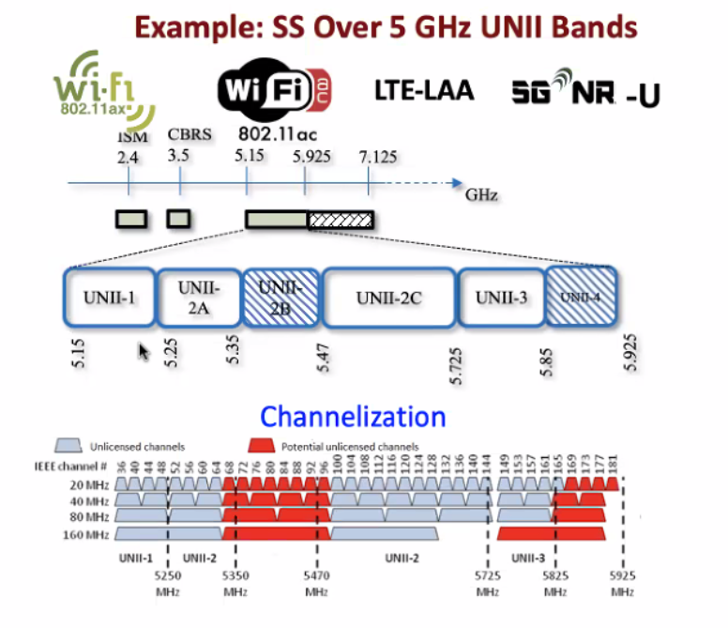
Figure 1⸺Spectrum sharing over the 5 GHz band.

Figure 2 shows examples of spectrum sharing models known as horizontal coexistence.

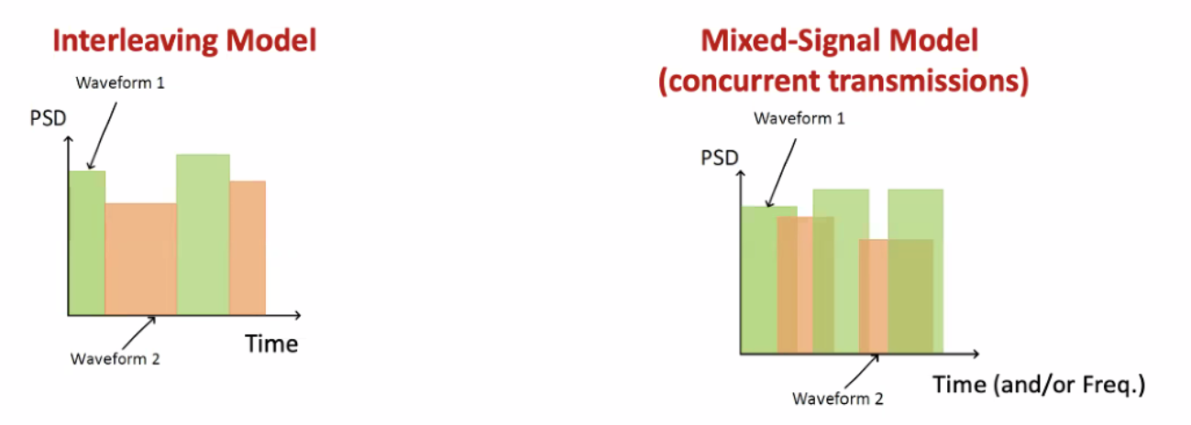
Figure 2⸺ Spectrum sharing models.

Another example is vertical or hierarchy coexistence. The best example is Citizens Broadband Radio Service (CBRS) based on a three-tiered spectrum authorization framework to accommodate a variety of commercial uses on a shared basis without requiring an exclusive spectrum license neither license-exempt.

The three tiers are: incumbent access, priority access, and general authorized access. The idea is that wireless systems subscribe to a dynamic spectrum access system (SAS), such that such wireless systems share spectrum based on access, geographic location, demand, and interference resilience, all managed by the SAS.

Signal classification is a technology that helps identify what wireless system produces the most harmful interference for a given scenario and act upon by the SAS.

Another way to see signal classification is to detect and classify adversarial (interference) transmissions and anomalies without decoding.

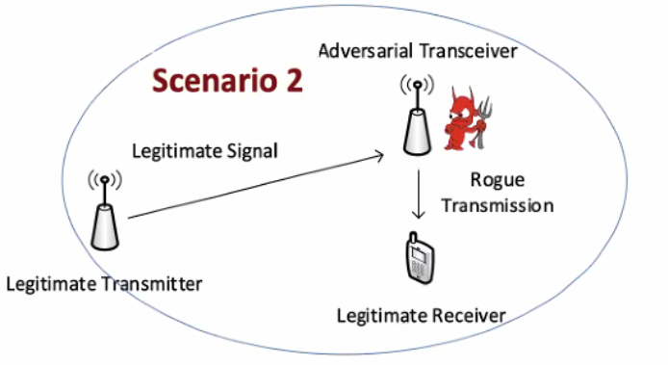
Figure 3⸺Example of coexistence with AIML.

The legitime Wi-Fi receiver does not need to have an adversarial 5G or (or other BSS) front-end. An AIML model will identify the rogue transmission protocol (or signal type) and use it in an AIML-based dynamic spectrum access system.

Example of modulation classifier using a cascade of convolutional neural networks (CNN). It can be extended to a Deep Neural Network (DNN) and consequently no need for retraining.

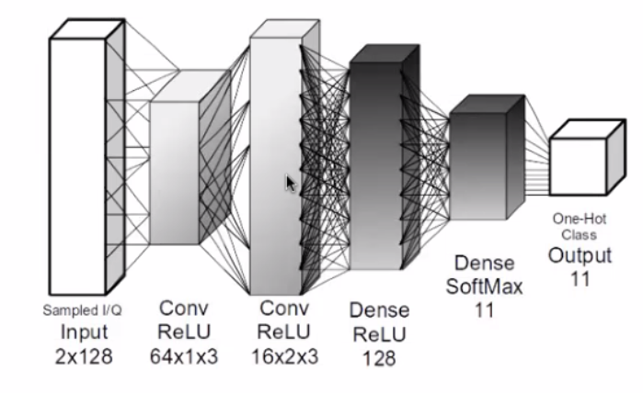
Figure 4⸺modulation classifier using CNN.

Another example using bidirectional recurrent neural network (BRNN). The training phase allow the RNN to receive information backwards (past) and forward (future), connecting hidden layers of opposite directions. Bidirectional long-short term memory (BiLSTM) RNN.

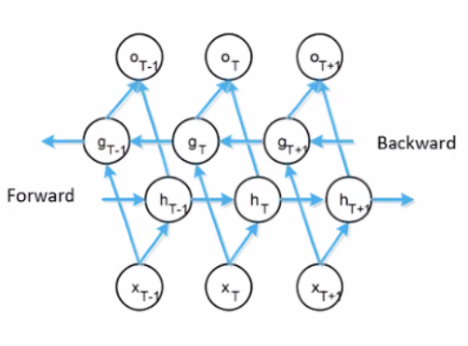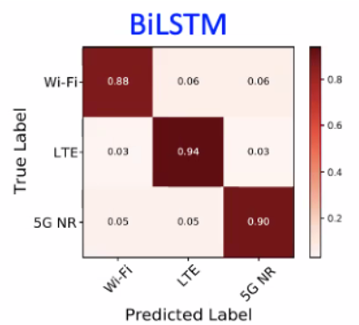

Figure 5⸺protocol classifier with BiLSTM.

Another example combined time/frequency domain classification.

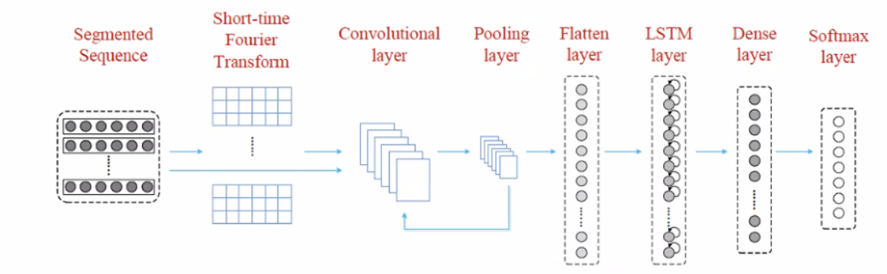

Figure 6⸺time, frequency domain classification.

Another example: automatic optimization of classifier parameters:

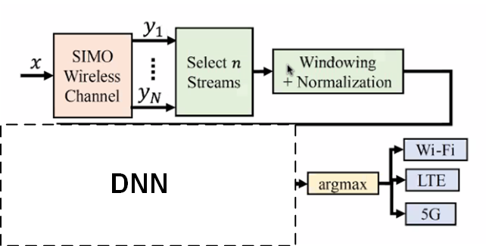

Figure 7⸺Deep learning optimizer of classifier parameters.

- Preprocessing parameters: RF chains (I/Q streams), window size.
- Learning parameters: choice of optimizer, batch size, learning rate, etc.
- Data collection parameters: filter size, etc.

- KPIs

The requirement to enable an AIML model is the availability of performance metrics (KPIs) along with historical data as inputs to the AIML model.

- Continuous throughput, low latency and jitter measured at the MAC-SAP in high density scenarios (overlapping BSSs and other wireless systems such as unlicensed 5G devices).

- Network energy efficiency (how efficiently the network converts power into data. It is calculated by dividing the data throughput by the power consumption).

- Computational complexity introduced by AIML.

- Requirements
- Backward compatibility with legacy 802.11. The use case is compatible with the different flavors of 802.11 specs.
- Performance should follow the guidance below:
  - Continuous throughput, latency and jitter measured at the MAC-SAP in the above scenarios.
  - Minimize the additional computation complexity required by AIML.

- Technical Feasibility Analysis
  - Standard Impact
The introduction of AIML requires the specification of the signaling for data collection and AIML model management.

  - Technical feasibility
The following metrics will be studied:

- Performance (as above) and energy efficiency by AIML models deployed in a STA or AP or aided cloud service (one-sided).
- Performance (as above) and energy efficiency by AIML models deployed in both STA and AP (two-sided).
- Potential additional signaling required to support AIML models management.
- Hardware requirements (cost, processing power) to support AIML processing.

