IEEE P802.11  
Wireless LANs

|  |  |  |  |  |
| --- | --- | --- | --- | --- |
| D1.0 CRs on 36.2.6 Support for non-HT, HT, VHT, and HE formats | | | | |
| Date: 2022-02-06 | | | | |
| Author(s): | | | | |
| Name | Affiliation | Address | Phone | email |
| Bo Gong | Huawei |  |  | [gongbo8@huawei.com](mailto:gongbo8@huawei.com) |
| Jian Yu | Huawei |  |  | [ross.yujian@huawei.com](mailto:ross.yujian@huawei.com) |
| Bo Sun | ZTE |  |  | [sun.bo1@ZTE.COM.CN](mailto:sun.bo1@ZTE.COM.CN) |

This submission shows

* Resolution for 4 comments received from TGbe comment collection (based on TGbe Draft D1.0)
* The proposed changes are based on 11be D1.4.

The submission provides resolutions to the following CIDs

4634, 4902, 4645, 7993

# Revision Notes

|  |  |
| --- | --- |
| R0 | Initial revision |
|  |  |
|  |  |
|  |  |
|  |  |

## CID 4634

|  |  |  |  |  |
| --- | --- | --- | --- | --- |
| Page. Line | Clause Number | Comment | Proposed Change | Resolution |
| 337.29 | 36.2.6.5 | In this clause we mostly see plain "TXVECTOR" and "RXVECTOR", and we also see this at P337L40. However at P337L29/30/42, we see "PHY TXVECTOR"/"PHY RXVECTOR" which is inconsistent | Change "PHY TXVECTOR" or "PHY RXVECTOR" to plain "TXVECTOR"/"RXVECTOR", 3x in this clause. | Revised  Agreed in principle. Reflect the detailed explaintation.  **Instructions to the editor**  **Please make the changes as shown in 11/22-0324r0** |

**Instructions to the editor:**

Please change ‘PHY TXVECTOR’ to ‘TXVECTOR’ in the following placesin TGbe Draft D1.4:

* Line 29, Page 481
* Line 5, Page 483
* Line 42, Page 483
* Line 14, Page 484
* Line 15, Page 484

Please change ‘PHY RXVECTOR’ to ‘RXVECTOR’ in the following placesin TGbe Draft D1.4:

* Line 53, Page 482
* Line 33, Page 484

## CID 4902

|  |  |  |  |  |
| --- | --- | --- | --- | --- |
| Page. Line | Clause Number | Comment | Proposed Change | Resolution |
| 337.43 | 36.2.6.5 | Add the following text after the last text in this paragraph. "A 20 MHz-only non-AP EHT STA supports HE reception only on 20 MHz channel width in the 2.4 GHz, 5 GHz" | As in comment | Rejected  A 20 MHz-only non-AP EHT STA may support reception of 242-tone RU in the primary 20 MHz channel within 40 MHz, 80 MHz, and 160 MHz PPDU. |

**Discussion:**

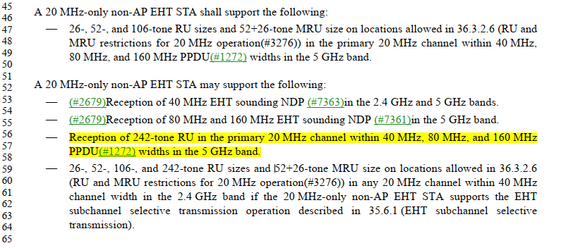

## CID 4645

|  |  |  |  |  |
| --- | --- | --- | --- | --- |
| Page. Line | Clause Number | Comment | Proposed Change | Resolution |
| 334.35 | 36.2.6.2 | References to clause 21 at L35 (and probably L38) do not account for 320MHz | Update these references to EHT clauses | Revised  Agreed in principle. Reflect the detailed explaintation.  **Instructions to the editor**  **Please make the changes as shown in 11/22-0324r0** |

**Discussion:**

Table—Metrics on transmition for non-HT/non-HT Duplicate PPDU in different clauses

|  |  |  |  |  |
| --- | --- | --- | --- | --- |
|  | Clause 17 | Clause 21 | Clause 27 | Clause 36 |
| Transmit spectral mask | For bandwidth 5/10/20MHz | For bandwidth  20/40/80/160/80+80MHz | Have no discussion about non-HT/non-HT Duplicate PPDU | For bandwidth 320MHz |
| Transmit center frequency and symbol clock frequency tolerance | For 5G with bandwidth 5/10/20MHz | For 5G with bandwidth  20/40/80/160/80+80MHz | For 5G/6G/2.4G with bandwidth 20/40/80/160/80+80MHz | For 5G/6G/2.4G with bandwidth 20/40/80/160/320MHz |
| Transmit center frequency leakage | For bandwidth 5/10/20MHz | For bandwidth  20/40/80/160/80+80MHz | Update the requirements | For bandwidth  20/40/80/160/320MHz |
| Spectral flatness | For bandwidth 10/20MHz | For bandwidth  40/80/160/80+80MHz | Have no discussion about non-HT/non-HT Duplicate PPDU | For bandwidth  40/80/160/320MHz |
| Transmitter constellation error | Provided | Same as Clause 17 | Have no discussion about non-HT/non-HT Duplicate PPDU | Have no discussion about non-HT/non-HT Duplicate PPDU |

**Instructions to the editor:**

Please make the following changes in Line 1, Page 481in TGbe Draft D1.4:

**36.2.6.2 Support for non-HT format**

The behavior of the EHT PHY on receipt of a PHY-TXSTART.request(TXVECTOR) primitive with the FORMAT parameter equal to NON_HT and the NON_HT_MODULATION parameter not equal to NON_HT_DUP_OFDM is defined in Clause 15 (DSSS PHY specification for the 2.4 GHz band designated for ISM applications), Clause 16 (High rate direct sequence spread spectrum (HR/DSSS) PHY specification), Clause 17 (Orthogonal frequency division multiplexing (OFDM) PHY specification), and Clause 18 (Extended Rate PHY (ERP) specification) and depends on the parameter NON_HT_MODULATION. If the parameter NON_HT_MODULATION is OFDM or NON_HT_DUP_OFDM, then the following additional requirements apply:

— The requirements in 21.3.9.1 (Transmission of 20 MHz NON_HT PPDUs with more than one transmit chain)

— The requirements in 21.3.17.1 (Transmit spectrum mask) and 36.3.19.1 (Transmit spectral mask) instead of the requirements in 17.3.9.3 (Transmit spectrum mask)

— The requirements in 36.3.19.3 (Transmit center frequency and symbol clock frequency tolerance) instead of the requirements in 17.3.9.5 (Transmit center frequency tolerance) and 17.3.9.6 (Symbol clock frequency tolerance)

—The requirements in 36.3.19.4.2 (Transmit center frequency leakage) instead of the requirements in 17.3.9.7.2 (Transmitter center frequency leakage)

—The requirements in 36.3.19.2 (Spectral flatness) and the requirements in 17.3.9.7.3 (Transmitter spectral flatness)

— (#1278)(#2991)(#3040)The requirements in 36.3.19.1.3 (Additional restrictions of preamblepuncturing for non-HT duplicate PPDU)

## CID 7993

|  |  |  |  |  |
| --- | --- | --- | --- | --- |
| Page. Line | Clause Number | Comment | Proposed Change | Resolution |
| 335.59 | 36.2.6.2 | Per P331L17, PHYCONFIG_VECTOR has CENTER_FREQUENCY_SEGMENT, not CENTER_FREQUENCY_SEGMENT_0 or CENTER_FREQUENCY_SEGMENT_1 | At P335L59 and P336L37, change  "CHANNEL_WIDTH, CENTER_FREQUENCY_SEGMENT_0, and CENTER_FREQUENCY_SEGMENT_1."  to  "CHANNEL_WIDTH and CENTER_FREQUENCY_SEGMENT." | Revised  Agreed in principle.  Note to the Editor:  The changes has been reflected in Draft1.4. Please refer to CID4624. No futher changes are needed. |