IEEE P802.11
Wireless LANs
CC36 CR on Annex Z EHT-SIG examples
Date: 2021.07.02
Author(s):
Name | Company | Address | Phone | email
Ross Jian Yu | Huawei Technologies | F3-6-A120, Huawei Base, Bantian, Longgang, Shenzhen, Guangdong, China, 518129 |  | ross.yujian@huawei.com
Ming Gan | Huawei Technologies
Abstract
This submission contains proposed comment resolutions to comments on P802.11be D1.0. The changes are based on P802.11be D1.01.

6 comments are resolved.
CID 4915, 4916, 5433, 6473, 6474, 6475

Revision Notes

R0 | Initial revision

CID 4915
Page.  Line | Clause Number | Comment | Proposed Change | Resolution
620.36 | Z.6 | In the common field of EHT-SIG, LDPC Extra symbol segment is set to 1. and, this is commonly applied to484+242-tone MRU 2 and 242-tone RU 2 in table z-9. therefore, BCC for 242 tone RU 2 should be modified as LDPC. | As in comment | REJECTED  If STA with STA-ID 1441 meets the condition of having an LDPC extra symbol segment, then LDPC Extra symbol segment is set to 1, even STA with STA-ID 1442, uses BCC.

Discussion:
In P802.11be D1.0, page 482, it includes the description regarding when LDPC extrea symbol segment is set to 1:
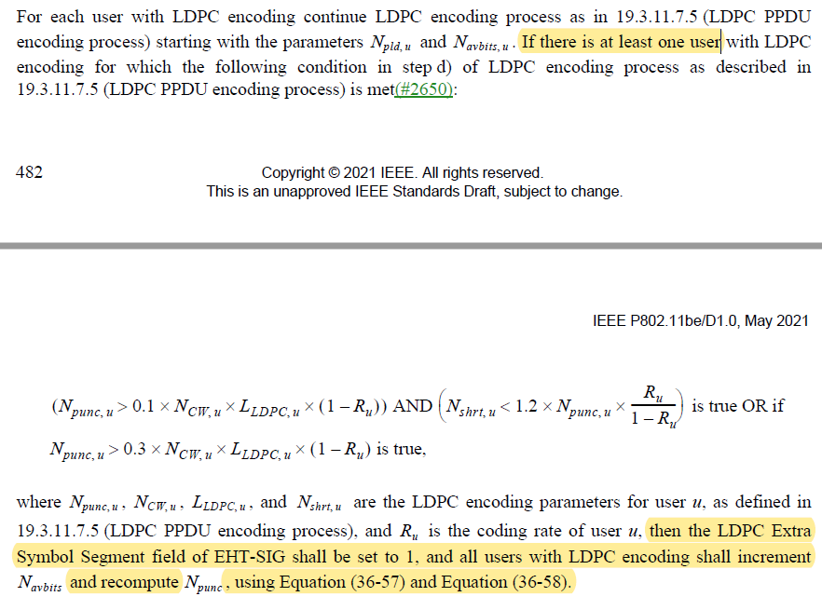

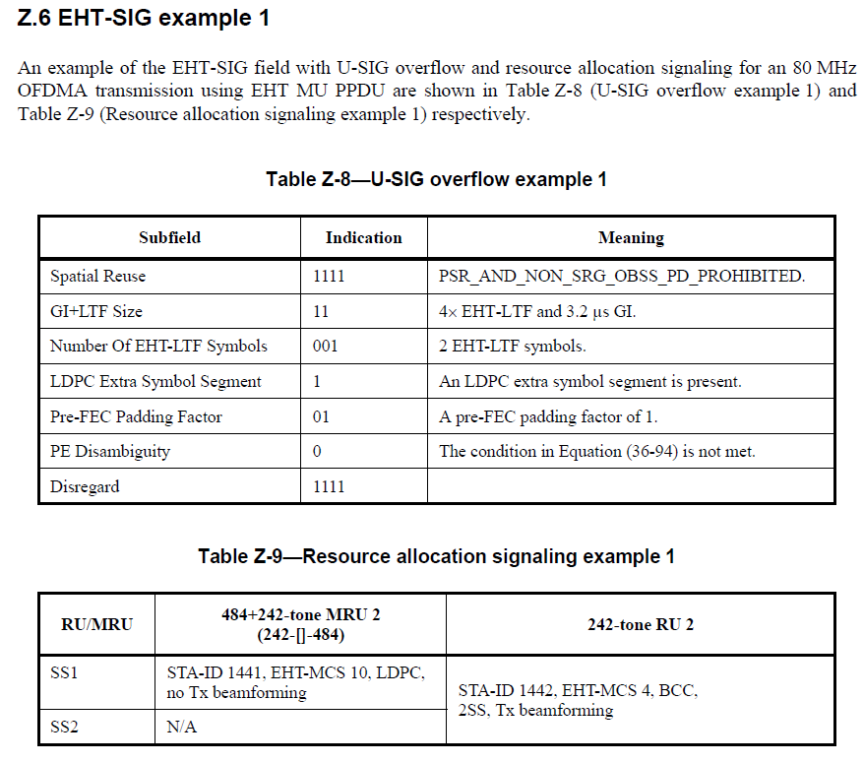

CID 4916
Page.  Line | Clause Number | Comment | Proposed Change | Resolution
622.11 | Z.7 | In the common field of EHT-SIG, LDPC Extra symbol segment is set to 1. and, this is commonly applied to 484+242-tone MRU 2 and 242-tone RU2 in table z-13. therefore, BCC for 242 tone RU 2 should be modified as LDPC. | As in comment | REJECTED  If STA with STA-ID 1441/1443/1445 meets the condition of having an LDPC extra symbol segment, then LDPC Extra symbol segment is set to 1, even STA with STA-ID 1442, uses BCC.

CID 5433
Page.  Line | Clause Number | Comment | Proposed Change | Resolution
624.30 | Annex Z | The EHT-SIG contents shall be the same per 80MHz for non-OFDMA transmission. | Remove "and for non-OFDMA transmission" | ACCEPTED

CID 6473
Page.  Line | Clause Number | Comment | Proposed Change | Resolution
620.41 | Z.6 | Change "a RU/MRU" to "an RU/MRU" | as in comment | REVISED  Agreed in principle.  Intstruction to the editor:  Change “a RU Allocation subfield” to “an RU Allocation subfield”. in page 642, L41, page 644, L20, page 646, L1, and page 649, L1 of P802.11be D1.01.

CID 6474
Page.  Line | Clause Number | Comment | Proposed Change | Resolution
624.01 | 624.01 | Change "a RU/MRU" to "an RU/MRU" | as in comment | REVISED  Agreed in principle.  Intstruction to the editor:  Change “a RU Allocation subfield” to “an RU Allocation subfield”. in page 642, L41, page 644, L20, page 646, L1, and page 649, L1 of P802.11be D1.01.

CID 6475
Page.  Line | Clause Number | Comment | Proposed Change | Resolution
627.01 | Z.23 | Change "a RU/MRU" to "an RU/MRU" | as in comment | REVISED  Agreed in principle.  Intstruction to the editor:  Change “a RU Allocation subfield” to “an RU Allocation subfield”. in page 642, L41, page 644, L20, page 646, L1, and page 649, L1 of P802.11be D1.01.

