IEEE P802.11
Wireless LANs
802.11
SA1 - Proposed Resolutions for EDITOR adhoc
Date: 2020-02-02
Author(s):
Name | Company | Address | Phone | email
Emily Qi | Intel Corporation |  |  | Emily.h.qi@intel.com
Abstract

This document contains proposed resolutions to SA1 editorial comments for the EDITOR ad hoc that require TG’s feedback.

R00: Initial proposal. Provided resolutions for CID 4312(EDITOR2), 4202(EDITOR2), 4117, 4601, and 4533
R01: Discussed and approved CIDs included in R00.
R02: Provided resolutions for 3 items raised in D3.1 candidate draft review.

7101 | 1706.09 | 11.11.10.3 | "the reporting AP has dot11LciCivicInNeighborReport and the neighbor AP has LCI MeasurementCapability (RM Enabled Capabilities element with the LCI Measurement Capability Enabled fieldset to 1) dot11RMLCIMeasurementActivated equal to true"-- this has at least two errors "has dot11LciCivicInNeighborReport" and"Measurement Capability (...) dot11RMLCIMeasurementActivated equal to true"Note that " (RM Enabled Capabilities element with the LCI Measurement Capability Enabled field set to 1)" is also a informal way of anonymously referencing a transmission by the AP)." this can also be improved. This informality occurs in a number of places in this subclause. The proposed changes addresses two of these. | Change cited text to:"the reporting AP has dot11LciCivicInNeighborReport equal to true and the neighbor AP indicates support for LCI measurement(the neighbor AP has transmitted an RM Enabled Capabilities element with the LCI Measurement Capability Enabled field equal to true)"Make matching changes at 1706.32.

CID | Clause | Page | Line | Comment | Proposed Change
4312  (EDITOR2) |  |  |  | The names of the following fields should have all initials upper-case, to avoid confusion: "Number of Channel Measurement Info" should be "Of". Also "Number of RX DMG Antennas", "Number of Channels", "Number of Time Blocks", "Normal Number of Frames per Channel", "Number of ANQP OIs", "OI #1 and #2 Lengths" | As it says in the comment
4202 (EDITOR2) |  |  |  | The name of fields should start with uppercase letters for each word, to avoid confusion (especially with fields with "And" or "Or" in their name). | As it says in the comment

Discussion

The commenter lists the following in CID 4312:
- Number of Channel Measurement Info
- Number of RX DMG Antennas
- Number of Channels
- Number of Time Blocks
- Normal Number of Frames per Channel
- Number of ANQP OIs
- OI #1 and #2 Lengths
I am sure there are more instances as CID 4202 comments on the same issue without the locations.

Obviously, it is a broad issue, not specific to TGmd.

We brought up this issue in the editor meeting this week.

Here is summary of the discussion from the Editor meeting.
- Moving forward, in future amendments, Editors shall use all upper case for the (sub)field names and (sub)element names, including preposition and conjunction words, e.g. Of, And, Or, etc ....... The Editor Style guide will be updated accordingly.
- The new style guide will apply to the new amendments (the amendments haven't done MDR).
- This new guidance has no intention to update the existing amendments/revisions. Due to legacy issue, changing Grandfathered terms where were widely used is considered excessive.
WG Editor updated 802.11 style guide (09/1034r16 draft) by adding the following paragraph in 2.6 Capitalization

… …
For proper names, all words in the name should be capitalized, including prepositions and conjunctions. This is to avoid ambiguity where the preposition or conjuction might be misinterpreted as part of the sentence. For example, “HT And VHT Trigger Frame RX Support subfield.” This rule does not apply to legacy text; these remain unchanged since the effort involved in changing all instances is substantial and no harm has been demonstrated.

Therefore, my proposal is to reject these two comments, or revised.

Proposed Resolution:

Rejected.

Rejec Reason: WG editor will update 802.11 Editorial Style guide 09/1034 to add a new rule including preposition and conjunction capitalization in the (sub)field and (sub)element names. This rule applies for new amendments. As stated in the style guide, “This rule does not apply to legacy text; these remain unchanged since the effort involved in changing all instances is substantial and no harm has been demonstrated.”

4117 (DeLaOlivaDelgado, Antonio) | 9.4.5.1 | 1473.37 | Third column of Table 9-330 shows the first letter of each ANQP Element in upper case but the ones of element Local MAC Address Policy | Change "Local MAC address policy ANQP element" in the third column of Table 9-330 to "Local MAC Address Policy ANQP element"

Discussion

This comment was original included in the trivial comment tab.
My proposed resolution is:

REVISED (EDITOR: 2020-01-08 20:26:03Z). At 1494.16, change "Local MAC address policy" to "Local MAC Address Policy". Note to the commenter, when the text in 1494.16 is changed, the text in 1473.37 will be changed automatically.

Mark R suggested other locations to be changed, such as: "Advice of Charge ANQP-element" and
"Network Authentication Type with Timestamp ANQP-element" should become "…Of…" and "…With…" too.

Therefore, this comment is here for discussion.
My receommendation is to reject additional changes as proposed by Mark R, with the reason:
- Additional suggestions are out of scope of the original comment.
- Preposition and conjunction capitalization is a new rule and does not apply to legacy text.

Proposed Resolution:

REVISED.
At 1494.16, change "Local MAC address policy" to "Local MAC Address Policy". Note to the commenter, when the text in 1494.16 is changed, the text in 1473.37 will be changed automatically.

Note to the commenter: this change resolved the comment in the direction suggested by the commenter.

4601 (RISON, Mark) | 3.2 | 193.19 | "and a temporal key, which" should be "and a temporal key that" | As it says in the comment.

Discussion

Cited text:
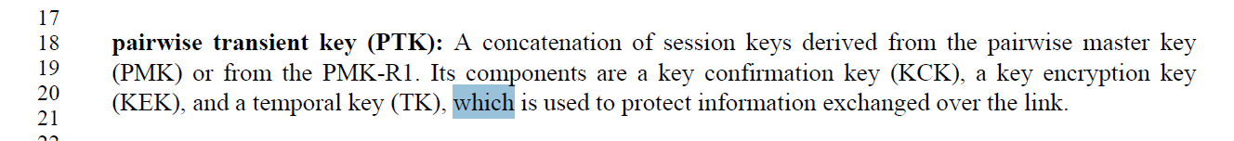

A temporal key (TK) is used to pretet information exchanged over the link.

My recommendation is to accept it.

Proposed Resolution:

Revised.

Delete “, which is used to protect information exhcnaged over the link”.

========================================================

4533 (RISON, Mark) | 9.4.2.21.9 | 1059.25 | The text describing the fields shown in Figure 9-236--Measurement Report field format for STA Statistics report are not described with "field" | Add missing "field"s

Discussion

There are multiple locations.

Here is the Figure 236:

 | Measurement Duration | Group Identity | Statistics Group Data | Optional  Subelements
Octets: | 2 | 1 | variable | variable
- Measurement Report field format for STA Statistics report

Proposed Resolution:

Revised.

Change text from 1059.39 to 1059.59 as follows:

The STA Statistics report reports the change in, or current values of, the requested statistics group data measured within the measurement duration.
The Measurement Duration field is set to the duration over which the change in statistics group data was measured and reported, in units of TUs. (MDR2) A Measurement Duration field set to 0 indicates a report of the current values of the statistics group data.
The Group Identity field indicates the requested statistics group describing the Statistics Group Data field according to Error: Reference source not found.
The Statistics Group Data field contains the requested statistics from the MIB in Annex C related to the interface on which the request was received according to Error: Reference source not found. Units used for reporting a statistic or change in statistic are the units used to define the statistic in Annex C. When the Measurement Duration field is nonzero, the reported data values for statistics that are not counters are the current values of the statistics data at the end of the measurement duration. When the Measurement Duration field is zero the current values of the requested statistics group data are reported, rather than the change.

<< Trival Editorial Corrections >>

These changes raised during TGmd Draft D3.1-0500 review.

Item D3.1-1:

 | Related comments |  |  | Comments | Proposed Changes
Mark RISON | 4461 | C.3 |  | The DESCRIPTION of dot11WirelessMGTEventPeerSTATxPower and dot11WNMEventPeerRprtStaTxPower say "peer-to-peer link" but don't mention "event" anywhere, unlike similar DESCRIPTIONs | As it says in the comment

Discussion:

For dot11WirelessMGTEventPeerSTATxPower, at 3925.40 (D3.1), it states “peer-to-peer link”. At 3925.27, it states “peer-topeer
event report”, see:

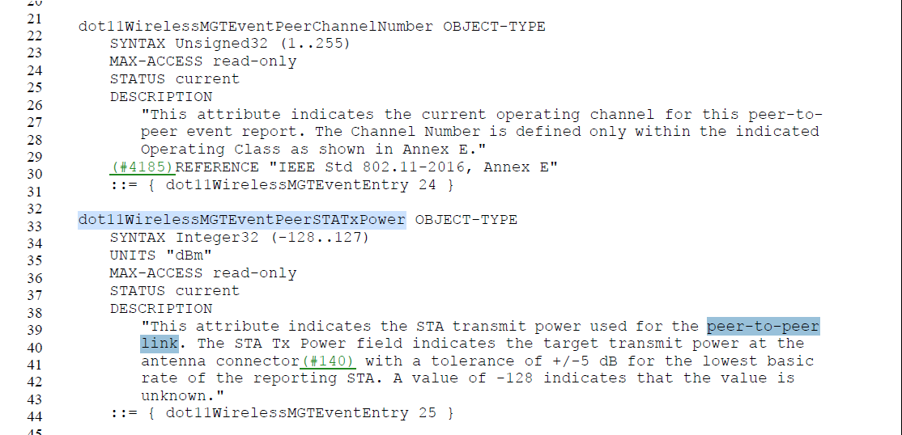

Proposed to change to “peer-to-peer link event report” at 3925.40.

For dot11WNMEventPeerRprtStaTxPower, at 4063.32, it states “peer-to-peer
Link”. At 4063.17, it states “peer-to-peer link event report”.

Proposed to change to “peer-to-peer link event report” at 4063.32.

Proposed changes for Item D3.1-1:

Note that the changes are based on D3.1.

At 3925.40 and 4063.32, change “peer-to-peer link” to “peer-to-peer link event report”.

=======
Item D3.1-2:
 | Related comments |  |  | Comments | Proposed Changes
Mark H | 4595 | 9.4.5.22 | 1491.1 | There are 12 more of these in the Draft, 7 "is a 2-octet field"s, 1 "is a 3-octet field", 1 "is a 5-octet field", and 1 "is a 6-octet field". Should we fix all of these (Editorial correction), so it doesn't come back next time as another comment? | As it says in the comment

Discussion:
Agreed with Mark H that we need to fix them.

I searched for “octet field” through out the draft. There are 29 instances of “octet field” in D3.1.
I believe 23 instances in clause 9 and clause 12 need to be fixed.

Proposed changes for Item D3.1-2:

Note that the changes are based on D3.1.

At 937.32, change “The Venue Info field is a 2-octet field. It contains Venue Group and Venue Type subfields.” To “The Venue Info field contains Venue Group and Venue Type subfields.”

At 1197.37 change “The Frequent Transition Count Threshold field is a 1-octet field containing the number of transitions ...” to “The Frequent Transition Count Threshold field contains the number of transitions ...”

At 1211.8, change “The BSSID field is a 6-octet field, as described in 9.2.4.3.4 (BSSID field), that identifies the BSS indicated in the AP Descriptor subelement.” To “The BSSID field identifies the BSS indicated in the AP Descriptor subelement, as described in 9.2.4.3.4 (BSSID field).”

At 1211.30, change “The Antenna Count field contains a 1-octet field indicating the number of antennas of the indicated antenna type and antenna gain pair.” To “The Antenna Count field contains the number of antennas of the indicated antenna type and antenna gain pair.”

At 1211.60, change “The Collocated Radio Type subelement contains a 1-octet field indicating the type of collocated radio” to “The Collocated Radio Type subelement indicates the type of collocated radio”

At 1212.50, change “The Device Type field is a 1-octet field indicating the category of device.” to “The Device Type field indicates the category of device.”

At 1261.14, change “The Alert Identifier Hash (AIH) is an 8-octet field. It is a unique value used to indicate an instance of an EAS message.” To “ The Alert Identifier Hash (AIH) field contains a unique value used to indicate an instance of an EAS message.”

At 1366.3, change “The Association Delay Info field(M101) is a 1-octet field whose value is an unsigned integer indicating the minimum association response delay in number of TUs.” To “The Association Delay Info field(M101) contains an unsigned integer indicating the minimum association response delay in number of TUs.”

At 1476.23, change “The Venue Info field is a 2-octet field and is defined in 9.4.1.34 (Venue Info field).” To “The Venue Info field is defined in 9.4.1.34 (Venue Info field).”

At 1476.30, change “The Length field is a 1-octet field whose value is equal to 3 plus the number of octets in the Venue Name field.” To “The Length field is equal to 3 plus the number of octets in the Venue Name field.”

At 1477.21, change “The Length of Emergency Call Number field is a 1-octet field whose value is set to the length of the Emergency Call Number field.” To “The Length of Emergency Call Number field is set to the length of the Emergency Call Number field.”

At 1478.1, change “The Network Authentication Type Indicator field is a 1-octet field and has one of the values shown in Table 9-331” to “The Network Authentication Type Indicator field is set to one of the values shown in Table 9-331.”
Also, at 1478.24, 1478.29, 1478.34, 1478.37, change “if the Network Authentication Type Indicator” to “if the Network Authentication Type Indicator field”.

At 1478.42, change “The Redirect URL Length field is a 2-octet field whose value is the length of the Redirect URL.” To “The Redirect URL Length field contains the length of the Redirect URL.”

At 1481.10, change “The NAI Realm Count field is a 2-octet field that specifies the number of NAI realms included in the NAI Realm ANQP-element.” To “The NAI Realm Count field specifies the number of NAI realms included in the NAI Realm ANQP-element.”

At 1488.33, change “The Length field is a 1-octet field whose value is set to 1 plus the number of octets in the Venue URL field.” To “The Length field is set to 1 plus the number of octets in the Venue URL field.”.

At 1489.13, change “The Length field is a 2-octet field whose value is set to 3 plus the number of octets in the NAI Realm and Plan Information Tuples fields.” to “The Length field is set to 3 plus the number of octets in the NAI Realm and Plan Information Tuples fields.”

At 1489.17, change “The Advice of Charge Type field is a 1-octet field with the values defined in Table 9-337.”. “the Advice of Charge Type field is set to one of the values defined in Table 9-337”

At 1489.52, change “The Length field is a 2-octet field whose value is set to the number of octets in the Language, Currency Code, and Plan Information fields.” to “The Length field is set to the number of octets in the Language, Currency Code, and Plan Information fields.”

At 1490.34, change “The Length field is a 1-octet field whose value is set to 2(#2203) plus the number of octets in the Local Content URL, Label Length and Label fields.” to “The Length field is set to 2(#2203) plus the number of octets in the LocalContent URL, Label Length and Label fields.”

At 1490.39, change
“The State field is a 1-octet field whose value is defined in Table 9-338” to
“The State field is defined in Table 9-338” .

At 1492.32, change
“The AP List Length (#8)field is a 1-octet field whose value indicates the length of the BSSIDs field” to
“The AP List Length (#8)field indicates the length of the BSSIDs field”.

At 1497.47, change
“The Length field is a 2-octet field that indicates the number of octets in the Information field.(#1462)” to
“The Length field indicates the number of octets in the Information field.(#1462)”.

At2606.1, change
“QoS Control field, if present, a 2-octet field that includes the MSDU priority.” To
“QoS Control field contains the MSDU priority, if present.”

Item D3.1-3:
 | Related comments |  |  | Comments | Proposed Changes
Mark H | 4140 |  | 1710.33 | I know I’m not supposed to judge the Resolution at this time, just whether it was Edited correctly. However, I believe the Resolution is just wrong here. There are two parts to this sentence, for then the NDP BllockAck is used during a BlockAck session, and for when the NDP BlockAck is used during a fragment BA session. Each of needs to cite how the field is defined for that particular case, the first one was missing the reference, and that was the error in the D3.0 text. It should not have been changed to word around having the reference. This error was in the published 802.11ah, so it's hard to know what the correct cross-reference text is, but it appears that subclause 10.24.7.5 (802.11ah numbering) was intended. That subclause is now 10.25.6.5 in REVmd D3.1 | Change the text back, and add the reference, to say, "This field is defined in 10.25.6.5 when the NDP BlockAck is used during a BlockAck session …"  Confirm this change with the TG, since it goes against the agreed Resolution and will require updating the Resolution.

Discussion:

We discussed on TGmd teleconference on Jan 31st.
TGmd agreed on the following changes.

Updated the resolution CID 4140 with follows:

Revised. Change text in D3.0
"This field is defined in when the NDP BlockAck is used during a BlockAck session and is defined in 10.3.2.12 (Fragment BA procedure(11ah)) when it is used during a fragment BA session." to

"This field is defined in 10.25.6.5 (Generation and transmission of BlockAck frames by an HT STA, DMG STA, or S1G STA(11ah)) when the NDP BlockAck is used during a BlockAck session and is defined in 10.3.2.12 (Fragment BA procedure(11ah)) when it is used during a fragment BA session."

Note that the cited text in D3.0 was changed to “ This field is (#4140)used when the NDP BlockAck is used
during a BlockAck session and is defined in 10.3.2.12 (Fragment BA procedure(11ah)) when it is used
during a fragment BA session.” in D3.1

Therefore, we need to change D3.1 text instead.

Proposed resolutions for Item D3.1-3(#4140):
- Change the status of CID 4140 to “Revised”.
- At 1710.33 (D3.1), change
“This field is (#4140)used when the NDP BlockAck is used
during a BlockAck session and is defined in 10.3.2.12 (Fragment BA procedure(11ah)) when it is used
during a fragment BA session.” to
"This field is defined in 10.25.6.5 (Generation and transmission of BlockAck frames by an HT STA, DMG STA, or S1G STA(11ah)) when the NDP BlockAck is used during a BlockAck session and is defined in 10.3.2.12 (Fragment BA procedure(11ah)) when it is used during a fragment BA session."

