IEEE P802.11
Wireless LANs
Adding Dialog Token in Ranging Trigger Frames
Date: 2019-07-01
Author(s):
Name | Company | Address | Phone | email
Qi Wang | Apple, Inc. |  |  | qi_wang2@apple.com
Tianyu Wu | Apple, Inc. |  |  | tianyu@apple.com

Abstract
For the TB ranging operation specified in 802.11az, this submission proposes to add the dialog token value in the ranging trigger frame of subvariant Passive Location Sounding.

Introduction

Discussion

For the TB ranging operation specified in 802.11az, this submission proposes to add the dialog token value to the ranging trigger frames.

For TB ranging, an RSTA can transmit multiple trigger sounding frames to trigger the UL NDP transmissions, followed by a single DL NDPA frame and DL NDP, as depicted by Figure 11-36e in 11az_D1.0 [1] and shown below:

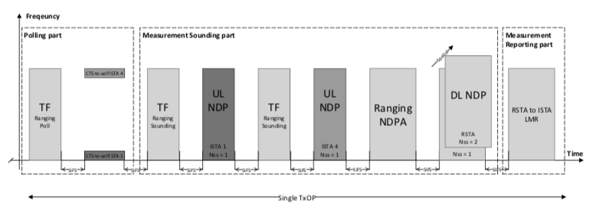
Figure 11-36e TB Ranging availability window with multiple TF Ranging Sounding

In 11az_D1.0 [1], a dialog token value is included in the DL NDPA frame to identify one measurement round.

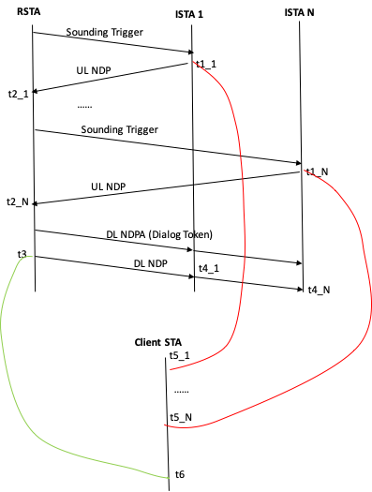

Figure 1. TB Ranging Timing Illustration

However, for TB ranging in general, it is helpful that, at the time of timestamping the departure time of the UL NDP transmission (t1), an ISTA knows the dialog token so it can relate t1 to a particular t4 identified by the dialog token. And, for TB passive ranging, because a client STA needs to listen to multiple UL NDP transmissions from multiple ISTAs, it’s helpful for the client STA to link a t5 from a particular ISTA with the corresponding t6 at the time of timestamping t5.

Proposed 11az spec modification:

Instruction to the editor: The proposed modifications are in reference to the text in IEEE P802.11az_D1.0, and are indicated by the change marks as follows:

TGaz Editor: Change the text in 9.3.1.23.9 of P802.11_D1.0 as shown below:

9.3.1.23.9 Ranging Trigger variant

The format of the Trigger Dependent User Info field for the Ranging Trigger frame is dependent on the Trigger Subtype field value in the Trigger Dependent Common Info field of the Ranging Trigger frame (Table 9-25k Ranging Trigger subtype field encoding).

The format of the Trigger Dependent Common Info field of Ranging Trigger frame of subvariant Poll, Sounding, Secure Sounding and Report is shown in Figure 9-61d.x, and the size of this field is one octet.

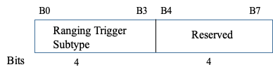
Figure 9-61d.x - Trigger Dependent Common Info field of Ranging Trigger frame of subvariant Poll, Sounding, Secure Sounding and Report
The format of the Trigger Dependent Common Info field of Ranging Trigger frame of subvariant Passive Location Sounding is shown in Figure 9-61d.y, and the size of this field is two octets. The Sounding Dialog Token Number subfield contains a value in the range of 0 to 63 which identifies a Measurement Sounding Part (UL NDP frame and DL NDP frame announced by a Sounding Trigger frame and the Ranging NDP Announcement frame, respectively), and the same value is included in the Sounding Dialog Token field of the Ranging NDP Announcement frame transmitted within the same Availability Window (see 9.3.1.19).

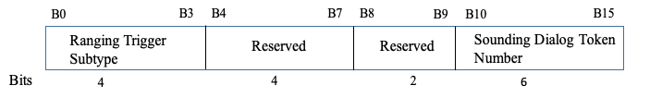

Figure 9-61d.y - Trigger Dependent Common Info subfield of Ranging Trigger frame of subvariant Passive Location Sounding

The Value of the Ranging Trigger Subtype for the Ranging Trigger frame variant is defined in Table9-25k.

Table 9-25k — Ranging Trigger Subtype field encoding

Ranging Trigger Subtype field value | Ranging Trigger frame variant
0 | Poll
1 | Sounding
2 | Secure Sounding
3 | Report
4 | Passive Location Sounding
5-15 | Reserved

References:

1. IEEE Draft P802.11az_D1.0, Draft standard for information technology – telecommunications and information exchange between systems – local and metropolitan area networks – specific requirements – Part 11: Wireless LAN medium access control (MAC) and physical layer (PHY) specifications, Amendment 8: Enhancements for locationing

