IEEE P802.11  
Wireless LANs

|  |  |  |  |  |
| --- | --- | --- | --- | --- |
| ARC SC Meeting Minutes March 2019 | | | | |
| Date: 2019-03-12 | | | | |
| Author(s): | | | | |
| Name | Affiliation | Address | Phone | email |
| Joseph LEVY | InterDigital Communication, Inc. | 2 Huntington Quadrangle  4th floor, South Wing Melville, NY 11747 | +1.631.622.4139 | [joseph.levy@interdigital.com](mailto:joseph.levy@interdigital.com) |

Abstract

This document contains the minutes of the IEEE 802.11 ARC SC meeting sessions held on 12 March 2019 at 16:00 PDT, 13 March 2019 at 8:00 PDT, and 13 March 2019 at 16:00 PDT in Vancouver, Vancouver, Canada.

Note: Highlighted text are action items.

**Contents:**

Tuesday, 12 March 2019, PM2 3

Wednesday, 13 March 2019, AM1 6

Wednesday, 13 March 2019, PM2 7

# Tuesday, 12 March 2019, PM2

**Administration:**

**Chair: Mark Hamilton, Ruckus/Arris**

**Vice Chair/Secretary Joseph Levy, InterDigital**

**Meeting call to order in ARC meeting room by Chair 16:02 PDT,**

Agenda slide deck: [11-19/0241r1](https://mentor.ieee.org/802.11/dcn/19/11-19-0241-01-0arc-arc-sc-agenda-mar-2019.pptx) , proposed agenda copied here for reference:

**Tuesday, March 12, PM2**

* **Administrative: Minutes**
  + **IEEE 1588 mapping to IEEE 802.11/802.1ASrev and use of FTM**
  + **IEEE 802 activities relevant to 802.11: 802.11aq, 802.1CQ and LAAP:** [11-18/1934r0](https://mentor.ieee.org/802.11/dcn/18/11-18-1934-00-0arc-mac-address-assignment-in-ieee-802-11.pptx)
  + **MAC randomization – follow-ups for 802.11**
    - **Consider formation of a TIG:** [11-19/0439r0](https://mentor.ieee.org/802.11/dcn/19/11-19-0439-00-0arc-proposed-tig-on-random-mac-addresses.pptx)
  + **IETF/802 coordination**
  + **IETF SAVI draft:** <https://datatracker.ietf.org/doc/draft-bi-savi-wlan>
  + **New topic (from REVmd)?: “What is a STA?” (See:** [11-19/0106r0](https://mentor.ieee.org/802.11/dcn/19/11-19-0106-00-000m-sta-and-ap.docx)**)**

**Wednesday, March 13, AM1**

* + **“What is an ESS?”:** [11-18/1051r5](https://mentor.ieee.org/802.11/dcn/18/11-18-1051-05-0arc-what-is-an-ess.pptx)
* **MLME-RESET, versus MLME-JOIN and MLME-START (and MLME-SCAN?)**

**Wednesday, March 13, PM2**

* + **Future sessions / SC activities**
  + **Consider IETF DetNet/time-sensitive networking input (potential relationship to RTA TIG?)**
  + **Multiple MAC Addresses (and IPv6), “Multiple radios”**
  + **System architecture views for common use scenarios**
  + **AP/DS/Portal architecture and 802 and GLK concepts -** [11-17/0136r2](https://mentor.ieee.org/802.11/dcn/17/11-17-0136-02-0arc-bridging-architecture-considerations.docx)**,** [11-16/1512r0](https://mentor.ieee.org/802.11/dcn/16/11-16-1512-00-0arc-glk-802-1q-bridge.pptx)**,** [11-16/0720r0](https://mentor.ieee.org/802.11/dcn/16/11-16-0720-00-0arc-stacked-architecture-discussion.pptx)**,** [11-15/0454r0](https://mentor.ieee.org/802.11/dcn/15/11-15-0454-00-0arc-some-more-ds-architecture-concepts.pptx)**,** [11-14/1213r1](https://mentor.ieee.org/802.11/dcn/14/11-14-1213-01-0arc-ap-arch-concepts-and-distribution-system-access.pptx) **(slides 9-11)**
  + **Continue the other items (previous slide), as needed**

**Administration:**

The Chair reviewed the Administrative information in slides 5-10 in Agenda document,

**Call for Patents:**

The Chair reviewed the Patent policy and called for potentially essential patents – there was no response to the call.

**Approval of the Agenda:**

The Chair reviewed the agenda and called for comments or amendments to the agenda – there was no response to the call.

The proposed agenda was approved by unanimous consent.

**January face-to-face minutes:** [11-19/0165r0](https://mentor.ieee.org/802.11/dcn/19/11-19-0165-00-0arc-arc-sc-meeting-minutes-january-2019.docx)

The 11/19/0165r0 was approved by unanimous consent.

**IEEE 1588 mapping to IEEE 802.11/802.1ASrev and use of FTM**

Ganesh Venkatesan (Intel) was tasked with getting an update on 802.1ASrev – the ballot passed, but they had 421 comments. There were 192 comments addressing the use of “master/slave” – there may be difficulty because 1588 also uses “master/slave” phrasing.

There are no 802.11 open issues.

Chair called for any other issues related to 802.1AS – none were heard.

**IEEE 802 activities relevant to 802.11: 802.11aq, 802.1CQ and LAAP:** [11-18/1934r0](https://mentor.ieee.org/802.11/dcn/18/11-18-1934-00-0arc-mac-address-assignment-in-ieee-802-11.pptx)

Moved to Wednesday AM2.

**MAC randomization – follow-ups for 802.11**

Chair reviewed slide 16 of the agenda deck. Discussed that there are use cases that require the ability to identify a device, if the device is willing to share it and it should be able to do so. This “work” is being discussed in 802.11 TGmd – see documents: [11-19/0179r0](https://mentor.ieee.org/802.11/dcn/19/11-19-0179-00-0arc-idquery-query-message-proposal.pptx) **and** [11-19/0286r3](https://mentor.ieee.org/802.11/dcn/19/11-19-0286-03-000m-mac-address-policy-anqp-and-beacon-element.docx);

**Consider formation of a TIG:** [11-19/0439r0](https://mentor.ieee.org/802.11/dcn/19/11-19-0439-00-0arc-proposed-tig-on-random-mac-addresses.pptx)

Chair presented 11-19/0439r0 – to have review and discussion – he intends to use these slides to propose the formation of a TIG to address MAC randomization issues.

Comment – there is quite a bit of normative language on the use of random MAC addresses:

The use of a random MAC address requires that when a random MAC address is used during association, the STA must continue to use that MAC address for the duration of that association and if a STA wants to reassociate with the security/roaming identification it obtained using a particular random MAC address it must use that particular random MAC address when it reassociates.

Comment – interesting proposal – well crafted – in a lot of cases randomization is only one way the problem is solved – addresses are temporary – the issue is really changeable addresses. I would prefer to change the scope to include generic variable addresses be addressed.

Comment – This is an issue that spans the whole wired/wireless space – it is an issue we need to address, but it is too big an issue for us (802.11) to deal with. Maybe this should be dealt with at a higher level.

Comment – I was in 802.1 meeting where there were only 4 people in the room, here there are multiple people that are interested in this issue here in 802.11. So maybe it does belong here.

Comment – 802.11 is a successful air interface and the work in IETF related to identifiers and privacy has been directed at 802.11.

Comment – change the MAR acronym – suggest it be changed to MARC – MAC address randomization and changing.

Comment – there are specs for randomization in DSRC – that dictate how to change MAC addresses up/down the stack at the same time. DSRC treated it outside of 802.11, it is standardized in IEEE 1609 or ETSI specifications.

Question – Why do you propose we do this in a TIG – and not in ARC?

Chair – It is too big a topic to do in ARC – I think it may need several meetings a session.

Comment – even in IETF, IETF would look for a solution form 802.11 and then move expand it to cover the big picture.

Comment – I didn’t intend to say we shouldn’t do anything, just that this is a big problem.

Chair – to the slide deck:

1. Change to bring general changeability into the scope of the TIG
2. Clarify that there are existing specified requirements for random MAC address use.

Chair – called for a chair volunteer – Amelia Andersdotter (Article 19) may be interested, but can’t commit at this time.

**IETF/802 coordination**

IETF Liaison - Peter Yee – reporting on a conference coordination call. There will be a “deterministic” networking group: SPAWN.

**IETF SAVI draft:** <https://datatracker.ietf.org/doc/draft-bi-savi-wlan>

Slide 18 – SAVI – is trying to stop spoofing addresses and how nodes can be identified against a MAC address. There have been objections raised regarding SAVI related to what 802.11 specifies and some IETF members have asked us to comment on the impacts of SAVI on 802.11. This was also discussed in at the St. Louis meeting – be IETF Liaison is unaware of anyone doing anything about this.

Chair – do you know if this relates to random MAC addresses?

IETF Liaison – they do allow for multiple MAC addresses from the same device.

Chair – I’m not sure how to proceed. We don’t know the goals of this work.

IETF Liaison – this draft group has shut down – so it is now a private draft – the area director is trying to make a decision on what to do with this draft – to move it along or let it drop. The current draft is now in its 16 version. It is currently floating in IETF. It would be nice if folks who understand IETF protocol would evaluate it.

Chair – we could take a very narrow view: reviewing what they said and see if there is an 802.11 issue or we could try to understand. Is there a volunteer.

Juan Carlos Zuniga (SIGFOX) volunteered.

Later during the meeting, via email, Juan Carlos Zuniga provided the following information:

“This is the feedback I could gather about <https://datatracker.ietf.org/doc/draft-bi-savi-wlan>

The draft has some inconsistencies with respect to the latest 802.11 standards:

- Wrong assumptions about MAC address usage (e.g. static and protected)

- Concepts not up to date (e.g. 802.11i).

Some other comments that could be relevant:

- Same results can be achieved with other less intrusive means (e.g. no need for spoofing if there is access to binding tables)

- Not aware of existing implementations.”

Chair – the link is in the agenda deck – if anyone want to look and comment this week or next session.

Comment – looking a 3.2 – seems to assume MAC addresses are fixed and unchanging – which is not true.

Chair – Well nothing says it is not changing – but doesn’t really say it is not random to start with.

Comment – The MAC address does not change once the STA has associated, as far as encryption is concerned the MAC address is unchanging, hence the keys are bound to the MAC address. RCA110 addresses some of this.

Chair – asking people to look at it before tomorrow, if not we will look at it at the May meeting.

**New topic (from REVmd): “What is a STA?” (See:** [11-19/0106r0](https://mentor.ieee.org/802.11/dcn/19/11-19-0106-00-000m-sta-and-ap.docx)**)**

Menzo Wentink (Qualcomm) presented 11-19/0106r0:

Comment – I think you should think about not using STA during the process of changing the specification – and use ST – because it will be hard to do this to keep track of what has changed and what has not.

Comment - It not clear this will be able to be done.

Comment. – So, there are two radios (80+80) which is a STA – this is an issue.

Comment – there is an issue with existing terms being redefined. This may cause more confusion than clarity, as these terms are used by other standards and reference our standard.

Ans – my rational – is in the world I work in there is STA and AP STA.

Comment – from IETF – they only talk about AP and STA –

Chair – AP and STA are used by WFA. We have to sort out what to do mesh STAs and STAs outside a BSS. So, we have to sort all this.

Comment – I agree this term is too much overloaded. Our terms mean nothing any more – we have created an issue with the non-AP non-… STA nomenclature. We have created a monster and we will have problems clearing this up. I think the separation of ax was a good move to make it clear what is new – the constant reuse makes things very complex – how can we move into the future.

Chair – I will point out that the comment on non-…. Has been discussed in REVmd –

Comment – I would be happy to clear this – Gig Ethernet and Fast Ethernet – are broken apart, with terms are redefined in each section. This is a possible way out. We should launch a new set of terms – leave clauses 1-40 as is and start a new spec at clause 41 and onward.

Chair – in .3 they can get away with the clean slice – because the devices use different media. In .11 we have all the devices in the same media.

Chair – are we solving chaos or just creating different chaos.

Comment – you don’t want to have this be happen without notifying the whole working group.

Comment – supporting doing this at the plenary.

Comment – before you go further it should be discussed at a plenary.

Chair reviewed the plan for Wednesday. The reason I said this a light agenda as no one has championed any of these topics, so we have not had significant discussion on these items. Chair requested people take on these issues, so we can have meaningful discussions on these topics.

Comment – multi APs cooperating is it in the scope of this group.

Chair – we should keep an eye on this.

**Recessed:** 17:35 ICT.

# Wednesday, 13 March 2019, AM1

**Call to order 8:06 PDT**

**Agenda document:** 11-19/0241r2

The Chair reviewed the agenda. No comments or additions to the agenda.

**Administration:**

The Chair reviewed the Administrative information in slides 5-10 in Agenda document,

**Call for Patents:**

The Chair reviewed the Patent policy and called for potentially essential patents – there was no response to the call.

* **“What is an ESS?”:** [11-18/1051r5](https://mentor.ieee.org/802.11/dcn/18/11-18-1051-05-0arc-what-is-an-ess.pptx)

Reviewing 11-18/1051r5: slide 3 review, 7 examples (slides 4-11), of the 7 we decided 3 were interesting/useful

Discussion on LPD and the LLC layer.

Suggestion to remove 802.2 spec references from the 802.11 Standard (as 802.2 is deprecated) – there is a suggestion that the 802 spec should be an adequate reference. But there are issues, as some 802.2 concepts which carry over the 802.11 specification are not in the 802 spec. Note: 802.11 B.2, also 802.1Q discusses the UNITDATA, but there is a potential problem because we do some 802.1D behaviors in 802.11, which are not in 802.1Q. This begs the question of can we eliminate the 802.1D references and correct everything to be 802.1Q compatible. Also annex M of 802.11 (REVmd2.1). The UNITDATA stuff is defined in 802.1AC. Cross checking the definitions in 802.2 1998, the result is that the definition in 802.2 and 802.1AC do not match, 802.1AC deals with this issue by creating a “shim layer” in the “convergence functions” define 802.1AC, Annex B. Propose to clean up the 802.11 specification with the 802.1Q definition and a cleanup of the mapping layer so everything works without the 802.2 definitions. Hence, we need to change annex B.1 in 802.1AC and in 802.11 cleanup 5.2 (changing the reference to 802.2 to 802.1AC – and remove the 802.2 references from 802.11 everywhere – but this needs to be checked everywhere).

* **MLME-RESET, versus MLME-JOIN and MLME-START (and MLME-SCAN?)**

**Recessed:** 10:00 PDT.

# Wednesday, 13 March 2019, PM2

**Call to order:** 16:06 PDT

* **Future sessions / SC activities**
* **IEEE 802 activities relevant to 802.11: 802.11aq, 802.1CQ and LAAP:** [11-18/1934r0](https://mentor.ieee.org/802.11/dcn/18/11-18-1934-00-0arc-mac-address-assignment-in-ieee-802-11.pptx)
* **Consider IETF DetNet/time-sensitive networking input (potential relationship to RTA TIG?)**
* **Multiple MAC Addresses (and IPv6), “Multiple radios”**
* **System architecture views for common use scenarios**
* **AP/DS/Portal architecture and 802 and GLK concepts -** [11-17/0136r2](https://mentor.ieee.org/802.11/dcn/17/11-17-0136-02-0arc-bridging-architecture-considerations.docx)**,** [11-16/1512r0](https://mentor.ieee.org/802.11/dcn/16/11-16-1512-00-0arc-glk-802-1q-bridge.pptx)**,** [11-16/0720r0](https://mentor.ieee.org/802.11/dcn/16/11-16-0720-00-0arc-stacked-architecture-discussion.pptx)**,** [11-15/0454r0](https://mentor.ieee.org/802.11/dcn/15/11-15-0454-00-0arc-some-more-ds-architecture-concepts.pptx)**,** [11-14/1213r1](https://mentor.ieee.org/802.11/dcn/14/11-14-1213-01-0arc-ap-arch-concepts-and-distribution-system-access.pptx) **(slides 9-11)**
* **Continue the other items (previous slide), as needed**

**Approval of the Agenda:**

The Chair reviewed the agenda and called for comments or amendments to the agenda – there was no response to the call.

The proposed agenda was approved by unanimous consent.

**Administration:**

The Chair reviewed the Administrative information in slides 5-10 in Agenda document,

**Call for Patents:**

The Chair reviewed the Patent policy and called for potentially essential patents – there was no response to the call.

Chair reviewed slide 24 – the list of ARC Future Activities and sessions (copied below for reference).

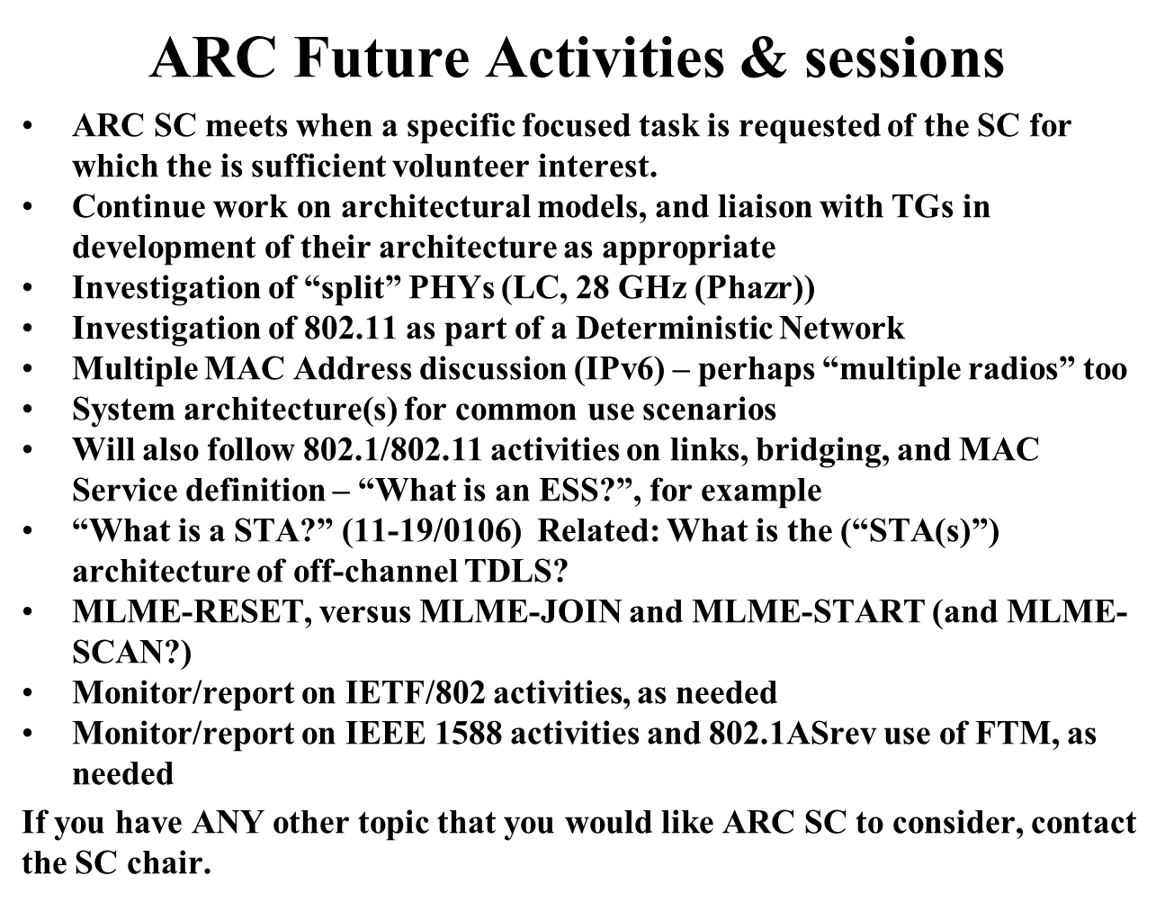

**Planning:**

Future sessions / SC activities

* Plan for three individual meeting slots
* Usual slot on Wed AM1
* Another 2 slots for standalone ARC work
* Teleconferences: None planned.

**IEEE 802 activities relevant to 802.11: 802.11aq, 802.1CQ and LAAP: 11-18/1934r0:**

Stephen McCann (Blackberry) presented: 11-19/0493r0 and an overview of 802.1CQ – looking at schemes for MAC addressing, and is trying to be compatible with 802.11 MAC addressing.

Discussed how the ANQP information get to an ANQP server in the network or in the AP device.

Chair – we could share the server device between the wired and wireless devices?

Answer: LAAP as a service for 802.11aq – Antonio has proposed a solution for this.

Question: Is this a protocol that I can use to receive a MAC address for this local server?

Comment: I found IEEE 1722 and there is an annex that had been proposed in 802.1, but it wasn’t appropriate at the time for 802.1 and 1722 developed annex M (*Annex B MAC Address Acquisition Protocol)* [1]– a protocol for multi-stream MAC addresses. But this seems to be useful for P2P also. I gave a presentation to the TSN group, where the people who developed this protocol were present, so an LS was developed to 802.1 proposing including this in 802.1. This is not just for audio/visual, the industrial application group was also interested.

Chair – can 802.11 be added as a cc to the LS?

Answer: Yes.

Comment: It looks like a stateless version of DHCP, but it is a claiming mechanism and also allows for defense of your address if some tries to claim it.

Comment: OmniRAN will not be meeting at either the wireless or wired interim – the will next meet at the next plenary, they plan on having CC instead.

**DetNet and other time-sensitive networking:**

Ganesh Venkatesan (Intel) – provided an update – regarding IETF TSN adding 802.11 to the document so that it is in line with how 802.15 is in the document. But it was “too late” to update the document. But, there was interest in adding 802.11 so there was a proposal to start a PAW BOF. BoF will happen later this month (March). The scheduled/trigger-based capabilities was submitted to DetNet, they are looking a managed network, the networks do not have competing traffic on the DetNet resources.

**Proposed TIG on Random MAC addresses:**

Call for additional input to the TIG proposal: 11-19/0483r0 (note: header is incorrect), which was presented at the mid-week. (which was based 11-19/439r0).

Discussion on should we have a TIG or not.

Comment: I have concern that we don’t have a spec problem and therefore we don’t need a TIG.

Comment: I want a TIG to make sure we are all on the same page.

Comment: I think we should have discussion.

Chair – if we create a forum to discuss this when there is no problem – things could go off the rails and things could get worse.

Comment: I don’t think that not discussing things is the correct way.

Chair – I understand this fear, but I think we need to discuss this to get us all on the same page.

**IETF SAVI -**

Chair – does anyone have any new information or anything to discuss about this?

Comment: There is concern regarding the SAVI draft – it is not exclusive (there may be better/other ways of achieving the goals of this). There are issues with the way MAC addresses are used and how they are defined. This is IETF business – IETF is asking for feedback on SAVI to decide what to do it.

Comment: SAVI is a DSRC protocol for wireless LAN –

Comment: There are errors that we could comment on. I think we should say no to this.

**Adjourned 16:53 PDT**

Note: final agenda slide deck is: [11-19/0241r3](https://mentor.ieee.org/802.11/dcn/19/11-19-0241-03-0arc-arc-sc-agenda-mar-2019.pptx) and closing report is: [11-19/0498r0](https://mentor.ieee.org/802.11/dcn/19/11-19-0498-00-0arc-arc-closing-report-mar-2019.pptx)

1. After the close of the meeting the Secretary reviewed IEEE STD 1722-2016 and found no annex M, but believes the correct reference is annex B “MAC Address Acquisition Protocol”.