IEEE P802.11
Wireless LANs
CC17 MAH assigned comments
Date: 2014-11-2
Author(s):
Name | Affiliation | Address | Phone | email
Mark Hamilton | Spectralink, Corp | 2560 55th St.  Boulder, CO 80301 | +1-303-441-7553 | Mark.hamilton@spectralink.com

Abstract
Recommended resolutions to assigned comments from CC17.
Revision History
R0 – First revision.

CID 26

26 | pg8.16 | 4.3.21.4.3 | Figure 4-12b, and the language here, are inaccurate. A GLK AP only offers a single MSAP, but that MSAP Service does include the vector of destinations parameter as mentioned here. The logical entities represented by this vector could be discussed, but they are not MSAPs. Current thinking is actually leaning toward having that discussion in 802.1AC in the convergence function, instead of in 11ak, though. | Reword the text here, and redraw Figure 4-12b to show only one MSAP. Optionally (depending on the 802.1AC discusion outcome) this text could discuss (and the figure could show) moltiple logical entities of some other type (ISS SAPs?). Language in 4.5.3 needs to use alternate language (or this alternate logical entity concept), too.

Discussion:

Considerable progress has been made on this already in D0.03, with the Figure (now numbered r-14b) already significantly improved through other comment resolutions. The current Figure is:
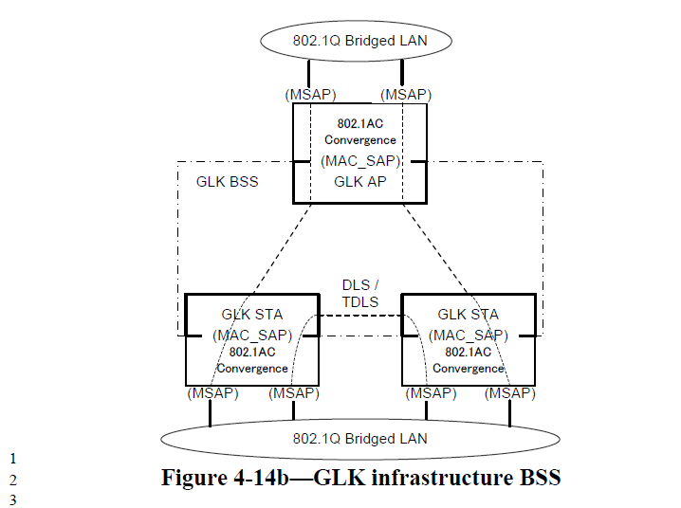
The text currently is:
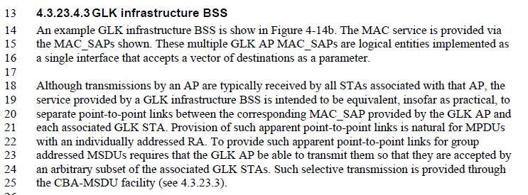

It might be more clear if the multiple MSAPs were labelled something else (they are actually ISSs, per the “baggy pants” model and 802.1AC draft). So, we can have just one point which is a MAC_SAP, and that is at the “top” of the STA, where the 802.1AC convergence function attaches. This MAC_SAP offers the vector of destinations, so at the point of this SAP, the dotted lines should show that they are flowing through a single SAP.

Further, being very pedantic, the SAP at the “top” of an AP is not actually a MAC_SAP. The difference is subtle, but especially in the context of 802.1AC concepts, it becomes important.

Lastly, Figure 4-14c, in addition to needing to remove the term “GLK BSS” also needs to have the “AP” label fixed (the AP contains the STA, it isn’t the box “on top of” the STA).

Proposed resolution: Revised.
Modify the text of 4.3.23.4.3 as follows:
An example GLK infrastructure BSS is show in Figure 4-14b. The MAC service to the bridge ports is provided via the MAC_ISS SAPs shown. These multiple GLK AP MAC_ISS SAPs are logical entities implemented as using a single 802.11 GLK SAP interface that accepts a vector of destinations as a parameter, by a convergence function specified in 802.1AC-<year>.

Although transmissions by an AP are typically received by all STAs associated with that AP, the service provided by a GLK infrastructure BSS is intended to be equivalent, insofar as practical, to separate point-to-point links between the corresponding MAC_ISS SAPs provided by the GLK AP and convergence function, and each associated GLK STA. Provision of such apparent point-to-point links is natural for MPDUs with an individually addressed RA. To provide such apparent point-to-point links for group addressed MSDUs requires that the GLK AP be able to transmit them so that they are accepted by an arbitrary subset of the associated GLK STAs. Such selective transmission is provided through the CBA- GLK SYNRA MSDU facility (see 4.3.23.3).

A GLK ESS can be constructed from BSSs that support GLK BSSes links, for example as shown in the middle of Figure 4-14c. There is no portal in a GLK ESS. The concept of the DS is roughly replaced, for a GLK ESS, by an 802.1Q conformant network; however, the GLK ESS topology is more general. For example, as shown in Figure 4-14c, a GLK ESS can be formed of GLK BSSes STAs connected by 802.1Q Bridged LANs connected in some cases to an MAC_ISS SAP provided by a GLK AP and in other cases provided by a GLK non-AP STA.

Replace Figure r-14b with:

Replace Figure 4-14c with:

CID 34

34 | Pg15.6 | 6.3.2.2 | Should we disallow a GLK STA from going into power save state? If it does, the group-addressed frames (likely common in a GLK BSS for much of the bridging traffic) will all be jittered up to a DTIM interval. Maybe we should just disallow it...? | Consider disallowing a GLK STA from entering POWER_SAVE state.

Discussion:

As long as multicast is used to deliver any GLK MSDUs, no non-AP STA supporting a GLK Link can go into power save, or it will cause one of:
1) All multicast MSDUs will be buffered, as per current Standard, resulting in delays of multicast traffic through GLK Link enabled bridges
2) The above could perhaps be divided into GLK and non-GLK MSDUs, but would still apply to all GLK MSDUs, so really not any better
3) GLK-capable APs could be required to not buffer multicast GLK traffic to DTIMs like other traffic, but then there is no point to the non-AP STA going into power save.

Thus, as long as multicast delivery is still a part of the GLK architecture, GLK non-AP STAs should be required to stay in Active mode.

Proposed resolution: Revised.
Add text to 10.2 (Power management), before 10.2.1:
A GLK STA shall remain in Awake state at all times.

CID 36

36 | Pg16.38 | 6.3.11 | While it seems technically accurate that the CapabilityInformation carries enough information to determine if an MLME-START is for a GLK BSS or not, indicating it only this way is not consistent with other BSS types. Others are also indicated in the BSSType parameter. I think we want to be consistent, even if a bit redundant, perhaps. | Remove the Note about MLME-START, and instead modify MLME-START to have a GLK BSS type added to the BSSType parameter enumeration.

Discussion:

In the time since D0.01 was prepared, the TGak draft has evolved to support mixed-mode BSSs, with each non-AP STA associating as either GLK or non-GLK. Thus, there is no “BSSType” of GLK. Rather, GLK is a capability of the AP, and non-AP STAs use the capability on a link-by-link basis.

Proposed resolution: Rejected.
There is no longer a mutually exclusive GLK BSS type or BSS mode of operation. GLK capability is just a capability, on a link-by-link basis, for a GLK-capable AP and its BSS.

CID 64

64 | Pg6.28 | 4.3.21.1 | [for David Kloper] I don't think we should be adding capability bits to existing Info Elements vs creating a new GLK IE. This will allow negotiation of other GLK related options. | Replace reference to those 2 IE, and add a reference to a new IE section we should create.

Discussion:

In the time since D0.01 was prepared, the TGak draft has evolved to add a GLK IE. The only capability indicated in the existing capabilities element is EPD.

Proposed resolution: Revised.
Agree in concept. Changes already done as part of other resolutions. See D0.04.

CID 72

72 | Pg10.1 | 4.3.21.4.3 | [for David Kloper] Update fig 4-12c | Might be informative to show a 2 hop GLK network where there are 2 hops over GLK links between 802.1Q Bridged LAN. We are certainly not limiting this to just single hop connections between wired networks.

Discussion:

The figure currently shows (across the middle) multiple BSSs with GLK Links being used, all interconnected with bridges. Is that the multiple hop example requested?

Proposed resolution: Rejected.
The Figure already shows multiple hop possibilities.

CID 33

33 | Pg14.17 | 5.2 | Since the real problem is that the non-GLK 802.11 MAC Service does not meet all the requirements of a MAC Service that can support 802.1Q Bridging. | Add text to 5.2 the describes two different MAC Service semantics - GLK and non-GLK. The non-GLK MAC Service supports LPD, does not prevent group-addressed frame reflection, ability to carry SA and DA that do not match either end of the WM link (through the use of four address format), etc. The GLK MAC Service supports EPD, does prevent reflected group-addressed frames, etc. Then, there is yet another MAC Service for GLK APs, which adds the port-vector parameter. So, there are three different MAC Services in 802.11.  The effects of this impact language in clause 4 that talks about the MAC Service. For example, in 4.3.21.4.2, the difference between a GLK IBSS and a non-GLK IBSS is this difference in the service provided. Review clause 4 (and perhaps other parts of the document) for such places where the MAC Service differences should be discussed.

Discussion:

TBD

Proposed resolution: Rejected.
TBD

