IEEE P802.11
Wireless LANs
Spectrum Mask Descriptor in TLV Format
Date: 2012-03-12
Author(s):
Name | Company | Address | Phone | Email
Chen Sun | NICT | 3-4, Hikarino-oka, Yokosuka, Kanagawa, Japan, 239-0847 | +81 45 847 5062 | sun@nict.go.jp
Zhou Lan | NICT | 3-4, Hikarino-oka, Yokosuka, Kanagawa, Japan, 239-0847 |  | lan@nict.go.jp
Yohannes Alemseged | NICT | 3-4, Hikarino-oka, Yokosuka, Kanagawa, Japan, 239-0847 |  | yohannes@nict.go.jp
Hiroshi Harada | NICT | 3-4, Hikarino-oka, Yokosuka, Kanagawa, Japan, 239-0847 |  | harada@nict.go.jp
Jens Tingleff | CSR |  |  | jt@csr.com
Abstract

This document presents the spectrum mask descriptor in TLV format to address the spectrum mask issue mentioned in the comments received in the first letter ballot and also address the latest development of regulations with regard to unlicensed operation in TV band, especially in UK. The document proposes modifications of the spectrum mask descriptor in P802.11af_D1.06.

Discussion

The ECC Report 159 Section 9.3.3 Technical information to be communicated to the geo-location database stated "Providing information about the type of device, such as the device class will allow information to be returned according to device capabilities and interference characteristics. The database could then take into account its known transmission parameters in returning appropriate frequencies and allowed maximum transmission power. Different classes of devices, with different technical characteristics, can exhibit different interference characteristics (e.g. antenna type, antenna height, type of technology and modulation) allowing different EIRP limits. For example, devices classes which would have good out-of-band emission characteristics might be able to transmit with higher power levels on some frequencies and/or locations. Defining device classes and their characteristics is a topic for standardization."

This allows the database (or its proxy if allowed by regulation) to generate a tailored list of available channels based on the device's spectrum mask. Thus, the spectrum mask information shall be provided to the database. Comment 1183 addresses this issue.

In OFCOM "Implementing Geolocation--Summary of consultation responses and next steps" published in Sep. 1, 2011, it says
"3.31 Compliance with the R&TTE Directive and related issues. One respondent commented on our approach towards the emissions mask where there are no “hard” values set in the specification. Instead, manufacturers are required to supply, or otherwise refer to, typical masks for each device type which are then taken into account by the database algorithms. The respondent felt this would not work because manufacturers cannot be obliged to provide such a mask and there is no way to check that what they provide is accurate.

3.32 We have considered this point and agree that we cannot oblige manufacturers to provide a mask. However, we do not believe that such action will be necessary. It is our belief that manufacturers will be incentivised to provide accurate device masks on a voluntary basis as the most efficient way to ensure that their devices have access white space spectrum."

To address this OFCOM approach and to make the 11af standard suitable also for European market, we propose to allow the devices to give their spectrum mask information as defined in the TLV format called Spectrum Mask Descriptor. Note that, although the FCC regulation does not have such operation, the concept of calculating the constrained maximum transmit power can be extended to the RLSS or GDC enabling STA to allow them to optimize the spectrum usage based on the devices' emission mask.

The previous spectrum mask descriptor specifies the PSD at fixed frequency points, i.e., the frequency removed from the center frequency between 45-50%, between 50-55%, between 55-100%, between 100-150%, and above 150% of the channel bandwidth. To give the flexibility in representing the spectrum mask, the descriptor given in 11-11/1292r0 is modified by giving multiple duplets of power and variable frequency break point in staircase shape.

Explanation of the information element in the Spectrum Mask Descriptor is given in the following picture

Examples of spectrum mask is given in the following two figures and tables

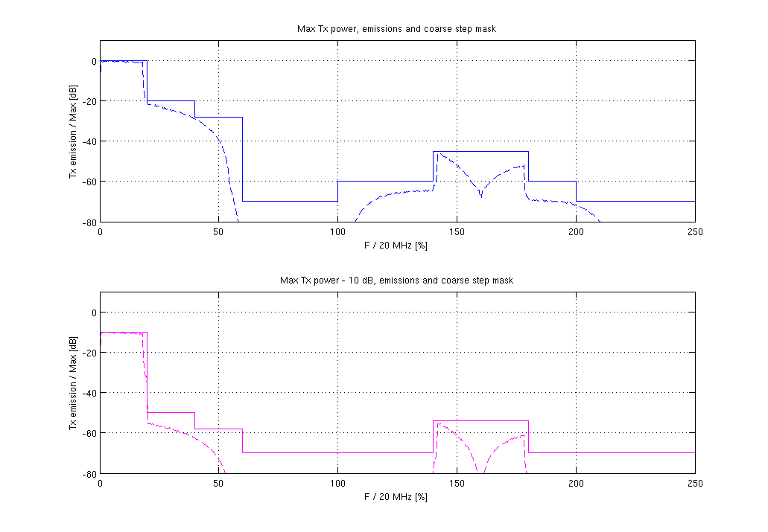
Caption: (Half of) 40 MHz downclocked by 5 signal, MCS7 of 11ac, two power levels

Freq  [MHz] | F / 20 MHz  [%] | Mask, max EIRP  [-dB] | Mask, max – 10 dB  [-dB]
0 | 0 | 0 | 0
4 | 20 | 20 | 40
8 | 40 | 28 | 48
12 | 60 | 70 | 60
20 | 100 | 60 | 60
28 | 140 | 45 | 44
36 | 180 | 60 | 60
40 | 200 | 70 | 60

Caption: Frequency step mask, relative to 20 MHz. Two power levels (max and 10 dB backoff)

An example of communicating the above spectrum mask, (EIRP=100mw, start frequency=515 MHz, Stop frequency=605 MHz) using the TLV format given in 8.2.6 is as follows.

<ANA>, 0x31, 0x01, 0x01, 0x28, 0x02, 0x01, 0x64, 0x03, 0x01, 0x67, 0x04, 0x01, 0x79, 0x05, 0x08, 0x00, 0x04, 0x08, 0x0C, 0x14, 0x1C, 0x24, 0x28, 0x06, 0x08, 0x00, 0x28, 0x38, 0x8C, 0x78, 0x5A, 0x78, 0x8C

Editing Instructions

8.2.6 TLV Values

TGaf Editor: Revise Table 8-14f as follows.
Table 8-14f – Spectrum Mask Descriptor value fields
Name | Subtype  (1 octet) | Length (octets) | Value | Scope
Mask Reference Bandwidth | 1 | 1 | Mask Reference Bandwidth gives the reference bandwidth of the spectrum mask description. The field is coded as an unsigned integer in units of 0.5 0.2 MHz. | UK
Maximum Total Transmit Power EIRP | 2 | 1 | Maximum Total Transmit Power field EIRP gives the maximum transmit total power EIRP of the transmitter for which the mask is valid. The field is coded as a signed integer in units of dBm. | UK
Spectrum Mask | 3 | 5 | The Spectrum Mask field describes the transmit spectrum of a device by giving five unsigned integers (each byte for each integer) representing power spectral density of the emissions, measured in dB below the maximum output power, of the transmitter for any frequency removed from the center frequency between 45-50%, between 50-55%, between 55-100%, between 100-150%, and above 150% of the channel bandwidth, respectively. | UK
Start Frequency | 3 | 1 | Start Frequency field gives the starting frequency from which the spectrum mask is valid. The field is coded as an unsigned integer in units of 5 MHz. | UK
Stop Frequency | 4 | 1 | Stop Frequency field gives the stopping frequency until which the spectrum mask is valid. The field is coded as an unsigned integer in units of 5 MHz. | UK
Mask Frequency Points | 5 | variable | The Mask Frequency Points field gives a list of frequency break points from the center frequency by specifying the percentages of the value given in the Mask Reference Bandwidth field. The field is coded as a sequence of unsigned integers in units of 5%. | UK
Mask Power Points | 6 | variable | The Mask Power Points filed represents the spectrum mask in dB below the maximum output power of the transmitter at the frequency range, from each frequency break point to the next frequency break point or infinity. The field is coded as a sequence of unsigned integers in units of 0.5 dB. | UK

TGaf Editor: insert text in NOTE as follows:
NOTE—an example of communicating the above spectrum mask, with EIRP=100mw, start frequency=515 MHz, Stop frequency=605 MHz, is as follows.
<ANA>, 0x31, 0x01, 0x01, 0x28, 0x02, 0x01, 0x64, 0x03, 0x01, 0x67, 0x04, 0x01, 0x79, 0x05, 0x08, 0x00, 0x04, 0x08, 0x0C, 0x14, 0x1C, 0x24, 0x28, 0x06, 0x08, 0x00, 0x28, 0x38, 0x8C, 0x78, 0x5A, 0x78, 0x8C

