IEEE P802.11
Wireless LANs
Spectral Mask Clarification – CID 3037
Date: 2011-06-29
Author(s):
Name | Affiliation | Address | Phone | email
Christopher Hansen | Broadcom Corporation | 190 Mathilda Place, Sunnyvale, CA 94086 USA | +1 408 543 3378 | chansen@broadcom.com
Abstract
As part of CID 3037, a clarification to the spectral mask definition is provided.

Instruct the editor to modify Section 21.3.2. as follows. New text is shown in red.

Transmit Mask
The transmitted spectrum shall adhere to the transmit spectrum mask shown in the Figure 150. The transmit spectrum shall have a 0dBr (dB relative to the maximum spectral density of the signal) bandwidth not exceeding 1.88GHz, -20dBr at an 1.2GHz offset, -25dBr at an 1.8GHz offset and -30dBr at a 2.2GHz offset and above, inside the channels allowed for the regulatory domain in which the device is transmitting. For transmit mask measurements, the resolution bandwidth shall be set to 1MHz and the frequency range fc +/- 1 MHz (where fc is the center frequency) shall be ignored.

The Transmit Mask shall be measured on data packets longer than 10 µs without training fields.

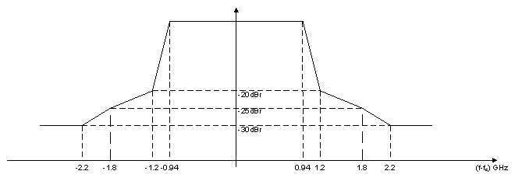
Figure 150 Transmit Mask

