IEEE P802.11
Wireless LANs
Text for Low Rate Enabler
Date: 2011-03-14
Author(s):
Name | Affiliation | Address | Phone | email
Steve Shellhammer | Qualcomm | 5775 Morehouse Drive  San Diego, CA | 858-658-1875 | shellhammer@ieee.org
Santosh Abraham | Qualcomm | 5775 Morehouse Drive  San Diego, CA | 858-651-6107 | sabraham@qualcomm.com
Rahul Tandra | Qualcomm | 5775 Morehouse Drive  San Diego, CA | 858-845-7576 | rtandra@qualcomm.com
Menzo Wentink | Qualcomm | Breukelen, the Netherlands | +31-65-183-6231 | mwentink@qualcomm.com
Richard Van Nee | Qualcomm | Breukelen, the Netherlands |  | rvannee@qualcomm.com
Abstract
This document provides text for the low rate enabler. This text is the recommendation to resolve a letter ballot on 802.11af D1.
3.1 Definitions

Insert new definitions retaining alphabetical order

Low rate enabler: A STA that enables personal/portable APs and STAs on one or more channels, using a low data rate PHY, in the TVWS

LRE Base channel: The channel on which a low rate enabler transmits the geodatabase inband enabling signal element

3.3 Abbreviations and acronyms

Insert the following new acronyms in alphabetical order:

LRE Low rate enabler

CVS Contact verification signal

4.3.9.1 Dynamic STA enablement (DSE) in licensed bands

Insert the following text at the end of clause 4.3.9.1

A low-rate enabler (LRE) shall use DSE procedures to enable a dependent AP/STA. The LRE shall transmit the Geodatabase Inband Enabling Signal element in a beacon on the LRE base channel. The LRE shall transmit the white space map (WSM) to a dependent AP/STA on the LRE base channel. The LRE may provide a list of channels being used by the set of AP/STA currently under the control of the LRE. A dependent STA may use this list of channels to reduce the search time needed to identify the operating channel of an AP. A dependent AP/STA shall notify the LRE of its selected channel of operation so the LRE can keep a record of which channel is used by each of the AP/STA that have been enabled by the LRE.

The LRE shall notify the dependent AP of the schedule on which the LRE will transmit a CVS message to the dependent AP on the operating channel of the AP.

An LRE shall send a CVS information element to a dependent AP/STA on the operating channel of the AP/STA on a regular schedule. A dependent AP may quiet the medium using a CTS-to-self prior to the scheduled CVS transmission time so that all AP/STA can receive the CVS message.

The LRE may use the super long-range DSSS PHY (Clause 20) to provide long range coverage so that the LRE can enable multiple STAs in a given geographic area.

8.4.2 Information Elements
TGaf editor: Insert the following row in table 8-50, and renumber the reserved values accordingly:

Table 8-50—Element IDs
Information element | Element ID | Length (in octets) | Extensible
LRE Base Channel and MAC Address (see 8.4.2.af-lre1) | < ANA > | 8 | No
LRE CVS Channel Schedule | < ANA > | variable | Yes

TGaf editor: Insert the following new sub clause after 8.4.2.af??, as shown:
8.4.2.af-lre1 LRE Channel and Address
The LRE Channel and Address IE carry the LRE MAC address and the LRE base channel. This element is sent by an AP in the beacon or probe response frames

 | Element ID | Length | LRE MAC Address | LRE Channel
Octets: | 1 | 1 | 6 | 2
Figure 8-42af?—LRE Base Channel and MAC Address IE

The Element ID field is equal to the LRE Base Channel and MAC Address Information value in Table 8-50.
The Length is a 1-octet field whose value is equal to 8.
The LRE MAC Address field is set to the 6 byte MAC address of the LRE.
The LRE Base Channel is set to the index of the channel that LRE listens for enablement requests.

8.4.2.af-lre2 LRE CVS Channel Schedule

 | Element ID | Length | Channel | Offset | Interval |  | Channel | Offset | Interval
Octets: | 1 | 1 | 2 | 2 | 2 |  | 2 | 2 | 2
The LRE CVS Channel Schedule is an IE that is sent by an LRE to inform dependent APs and STAs of the time at which the LRE will transition to each channel to transmit the CVS and other information.
The Element ID field is equal to the LRE CVS channel schedule information Table 8-50.
The Length is a 1-octet field whose value is set depending on the number of channels.
The Channel field is 1 octet field that indicates the channel.
The offset time is the time to the first visit of the channel from the message in TUs.
The interval gives the time between successive visits to the channel in TUs.

10.af2-lre1 Operation with a Low Rate Enabler
TGaf editor: Insert the sub clause after 10.af??? as follows:

An enabling STA operating as an LRE broadcasts a beacon with a geodatabase inband signaling IE (8.4.2.af5) on the LRE base channel. The beacon from an LRE should be sent using a low rate PHY.
In addition an LRE should also include the LRE Channel Schedule IE (8.4.2.af-lre2) in some of the beacons on the base channel. The LRE should also transmit the LRE Channel Schedule when it is operating in a channel other than the LRE base channel, for example when the LRE transitions to another channel to transmit CVS.

A LRE provides enablement to dependent APs and dependent STAs over a large area. An enabled dependent AP broadcasts the LRE MAC address and the channel used by the LRE for enablement using a LRE Channel and address IE in the beacon (8.4.2.af-lre2).

A dependent STA that requires enablement moves to the LRE base channel executes the enablement procedure (10.12). A dependent STA may obtain the LRE base channel from beacons transmitted from dependent APs or by searching the channels. Once enabled, the dependent STA chooses a channel according to the WSM and available APs. Once associated in a channel, the STA temporarily transitions to the LRE base channel to send current operating channel information to the LRE using an unsolicited Operation Channel Status Query/Response Action Frame (8.5.8.af5).

The LRE switches to the operating channel of each of the STAs enabled by the LRE to send the CVS according to the schedule sent in the LRE Channel Schedule.

A dependent AP should schedule blank out intervals corresponding to the time that the LRE visits the channel that the AP operates in. The blank out intervals can be created by transmitting CTS to self. The dependent AP determines the blank out periods from the information in the LRE Channel Schedule IE.

Insert the following text after clause 19

20 Super Long Range DSSS PHY

20.1 General
The DSSS-based SLR PHY is described in this clause. The SLR PHY provides a WLAN with a 62.5 kb/s data rate capability for a 5 MHz channel. The DSSS based SLR PHY uses baseband modulations of differential binary phase shift keying (DBPSK) to provide the 62.5 Kb/s.

The SLR PHY is obtained by clocking down the DSSS PHY given in clause 15 by 4, and a bit-level repetition of the resulting clocked-down waveform by 4.

20.2 SLR PHY PLCP sublayer

20.2.1 Overview

This subclause provides a convergence procedure in which MPDUs are converted to and from PPDUs.
During transmission, the MPDU shall be prepended with a PLCP preamble and header to create the PPDU.

At the receiver, the PLCP preamble and header are processed to aid in demodulation and delivery of the
MPDU.

20.2.2 PLCP frame format
Figure 20-1 (PLCP frame format) shows the format for the PPDU including the DSSS PLCP preamble, the DSSS PLCP header, and the MPDU. The PLCP preamble contains the following fields: SYNC and SFD.

The PLCP header contains the following fields: IEEE 802.11 Signaling (SIGNAL), IEEE 802.11 Service
(SERVICE), length (LENGTH), and CRC-16 (CRC). Each of these fields is described in detail in 15.2.3
(PLCP field definitions).

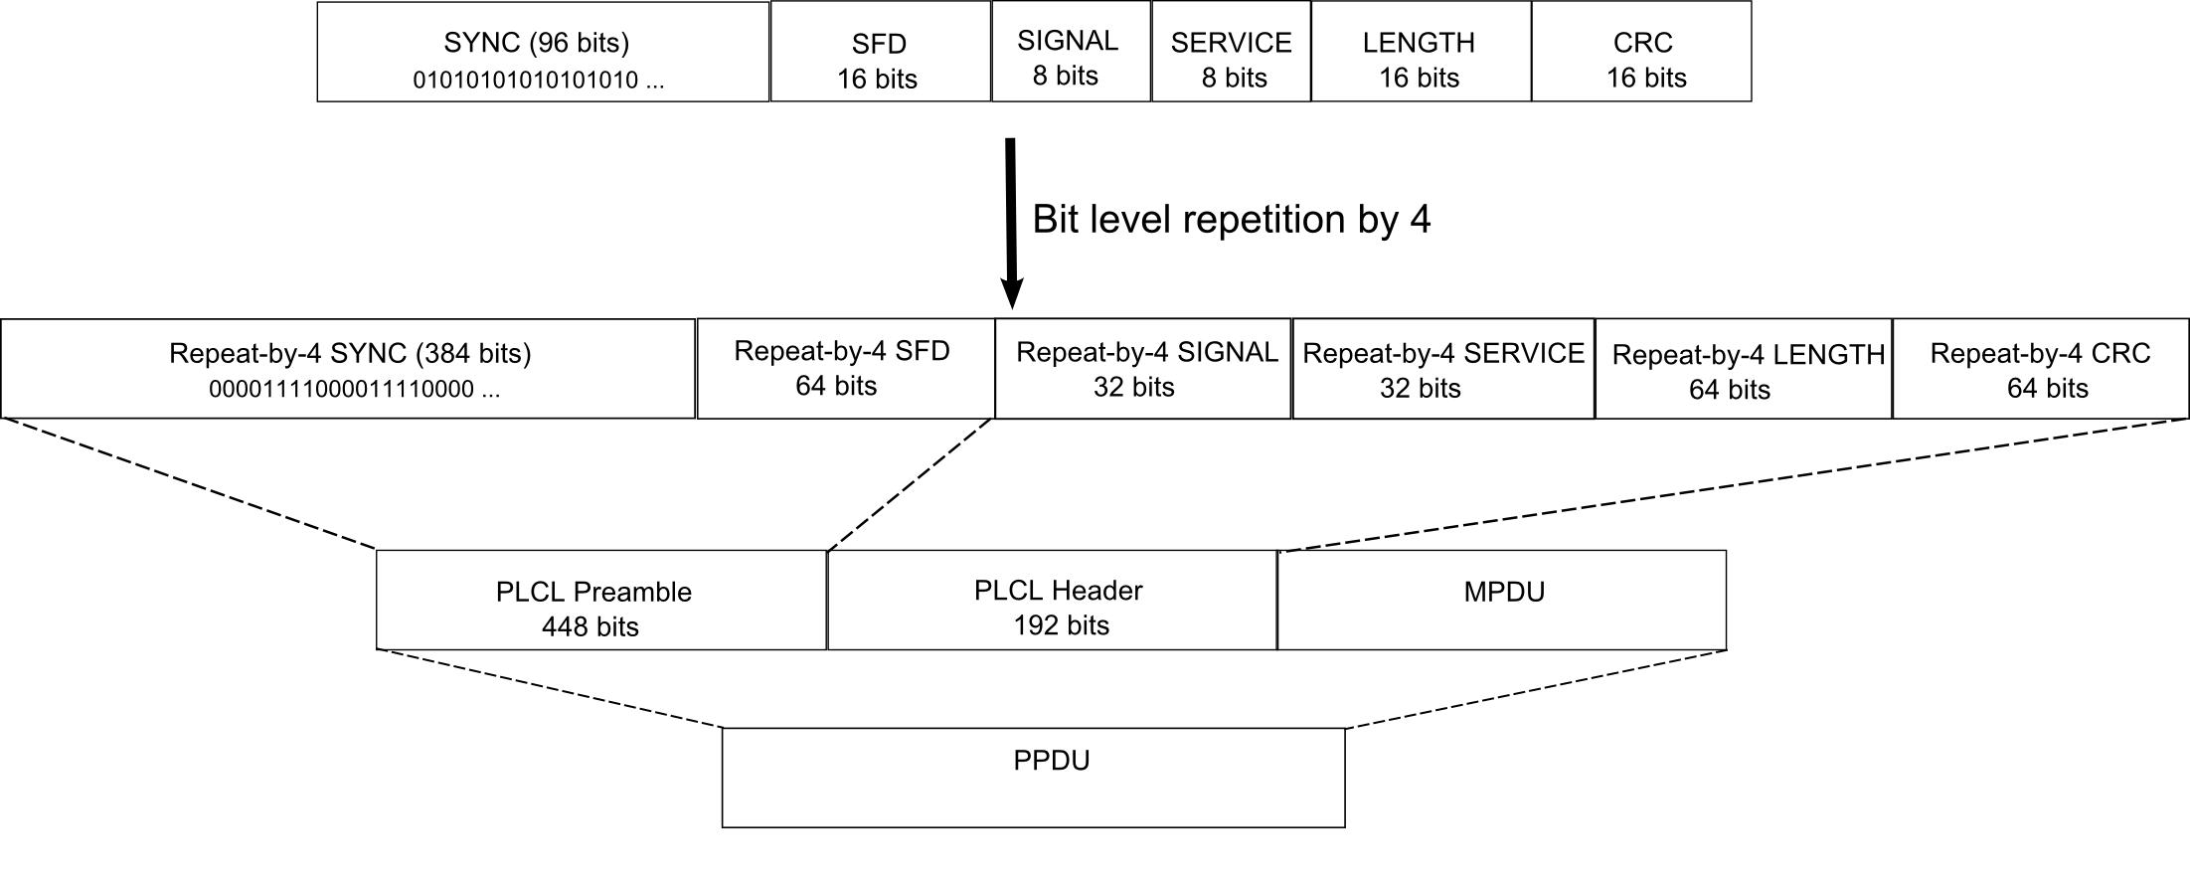

Figure 20-1—PLCP SLR PHY frame format

20.2.3 PLCP field definitions

20.2.3.1 General

The entire PLCP preamble and header shall be transmitted using the 250 kb/s DBPSK modulation, which is obtained by down-clocking the 1 Mb/s DBPSK modulated packet described in 15.4.7. All transmitted bits shall be scrambled using the feed-through scrambler described in 20.2.4 (PLCP/DSSS PHY data scrambler and descrambler).
All the bits in the packet are repeated four times to give an additional 6 dB link budget.

20.2.3.2 PLCP SYNC field

The SYNC consists of 96 bits of alternating zeros and ones, i.e., a bit pattern of the form 010101010 … This field shall be provided so that the receiver can perform the necessary operations for synchronization, as well as to distinguish between the SLR PHY mode and the regular DSSS PHY mode.

20.2.3.3 PLCP SFD

The SFD shall be provided to indicate the start of PHY-dependent parameters within the PLCP preamble.
The SFD shall be an 8-bit field, X'F3A0' (MSB to LSB). The LSB shall be transmitted first in time.

20.2.3.4 PLCP SLR SIGNAL field

The 8-bit SLR SIGNAL field indicates to the PHY the modulation that shall be used for transmission (and reception) of the MPDU. The data rate shall be equal to the signal field value multiplied by 100 kb/s.

20.2.3.5 PLCP SLR PHY SERVICE field

The 8-bit ``SLR PHY” SERVICE FIELD shall be reserved for future use. The LSB shall be transmitted first in time. This field shall be protected by the CRC-16 FCS described in 20.2.3.7 (PLCP CRC field).

15.2.3.6 PLCP SLR PHY LENGTH field

The PLCP ``SLR PHY” length field is an unsigned 16-bit integer that indicates the number of microseconds (16 to 2¹⁶–1 as defined by a MPDUMaxLength) required to transmit the MPDU. The transmitted value shall be determined from the LENGTH parameter in the TXVECTOR issued with the PHY-TXSTART.request primitive described in 7.3.5.5 (PHY-TXSTART.request). The LENGTH field provided in the TXVECTOR is in octets and is converted to microseconds for inclusion in the PLCP LENGTH field. The LSB shall be transmitted first in time. This field shall be protected by the CRC-16 FCS described in 20.2.3.7 (PLCP CRC field).

The actual length of the packet is the length in micro seconds calculated from the PLCL LENGTH field multiplied by four.

20.2.3.7 PLCP SLR PHY CRC field

The SIGNAL, SERVICE, and LENGTH fields shall be protected with a CRC-16 FCS given by the 16-bit sequence. The CRC-16 FCS shall be the ones complement of the remainder generated by the modulo 2 division of the protected PLCP fields (before repetition by four) by the polynomial:
x¹⁶ + x¹² + x⁵ + 1

The protected bits shall be processed in transmit order. All FCS calculations shall be made prior to data scrambling.

20.2.4 PLCP/DSSS PHY data scrambler and descrambler

The polynomial G(z) = z^{–7} + z^{–4} + 1 shall be used to scramble all bits transmitted by the SLR PHY. The feed-through configuration of the scrambler and descrambler is self-synchronizing, which requires no prior knowledge of the transmitter initialization of the scrambler for receive processing. Figure 20-2 (Data scrambler) and Figure 20-3 (Data descrambler) show typical implementations of the data scrambler and descrambler, but other implementations are possible.

The scrambler should be initialized to any state except all ones when transmitting.

Figure 20-2—Data scrambler

Figure 20-3—Data descrambler

20.2.5 Bit repetition block

Each bit of the packet is repeated by a factor of 4 to given an additional 6 dB link budget gain. The bit level repetition is done before applying the 11-chip Barker sequence.

For example, if b₀, b₁, b₂, b₃, ….., b_{N} is the original bit sequence, then after repetition by 4, the output sequence will be
b₀, b₀, b₀, b₀, b₁, b₁, b₁, b₁, b₂, b₂, b₂, b₂, b₃, b₃, b₃, b₃,….., b_{N}, b_{N}, b_{N}, b_{N}

20.2.5 Spreading sequence

The following 11-chip Barker sequence shall be used as the PN code sequence:
+1, –1, +1, +1, –1, +1, +1, +1, –1, –1, –1

The leftmost chip shall be output first in time. The first chip shall be aligned at the start of a transmitted symbol. The symbol duration shall be exactly 11 chips long.

