IEEE P802.11
Wireless LANs
TGad Coexistence Assurance Document
Date: 2010-09-13
Author(s):
Name | Affiliation | Address | Phone | Email
Eldad Perahia | Intel Corporation | 2111 NE 25th Ave  Hillsboro, OR 97124 | 503-712-8081 | eldad.perahia@intel.com
James Yee | MediaTek, Inc. | No. 1, Dusing 1st Road, Hsinchu Science Park, Hsinchu, Taiwan | +886-3-567-0766 | james.yee@mediatek.com
Abstract
This serves as the coexistence assurance document for TGad in meeting the requirement of the 5 criteria.

Introduction
This document addresses coexistence of IEEE 802.11ad per the PAR and 5C’s [2]. The relevent sections of each are outlined below:
- PAR scope:
  - Provides mechanisms that enable coexistence with other systems in the band including IEEE 802.15.3c systems.
- 5C’s:
  - The working group will create a CA document as part of the WG balloting process. The definition for coexistence is as defined in 802.15.2, with the shared environment being the 60 GHz band in home and enterprise.

In 802.11ad [1], clause 11.35 provides an overview of the features available in the specification that address coexistence with other mmWave technologies, including 802.15.3c [3]. These features will be highlighted in the sections below.

Channelization
To enhance coexistence, 802.11ad adopts the same common channelization as what is defined in other mmWave standards and specifications.

STAs compliant with the physical layer defined in clause 21 of 802.11ad [1] operate in the channels defined in the additional rows introduced into the tables in Annex J of [1] (see below), and shall support at least channel number 2.

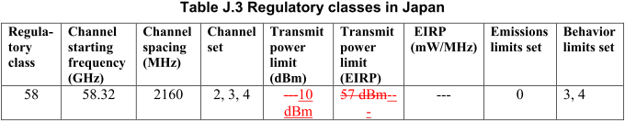

The transmitted spectrum shall adhere to the transmit spectrum mask shown below from subclause 21.3.2 of [1]:
0dBr
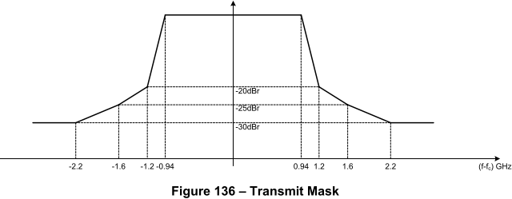

In regulatory domains where 2 or more channels are allowed to be used, an mSTA should support at least 2 channels and the channels are used as per regulatory constraints. This enables 802.11ad devices to change channels to avoid interference with other systems

Preamble Design for Coexistence

The 802.11ad preamble design supports coexistence with 802.15.3c, as follows.
- 802.11ad
  - SC/OFDM
    - Short training field (beginning of preamble) consists of 15 repetitions of a 128 sample Golay sequence
  - Control
    - Short training field (beginning of preamble) consists of 39 repetitions of a 128 sample Golay sequence
- 802.15.3c
  - CMS, HSI (long preamble)
    - SYNC field (beginning of preamble) consists of 48 repetitions of a 128 sample Golay sequence
  - SC PHY, HSI (short preamble)
    - SYNC field (beginning of preamble) consists of 14 repetitions of a 128 sample Golay sequence
As is shown, 802.11ad uses repetitions of the same sized Golay codes as 802.15.3c. Furthermore, 802.11ad adopts the same SC chip rate as that of 802.15.3c CMS. This enables simple correlators to significantly enhance detection of either system. This concept is used to enhance the BSS establishment rules in 802.11ad beyond those typical in 802.11.

BSS Establishment
To minimize interference to other systems, in 802.11ad an AP should not start an infrastructure BSS on a channel where the signal level is at or above -48dBm or upon detecting a valid IEEE 802.15.3c CMS preamble at a receive level equal to or greater than -60 dBm. As previously described, commonalities in the preamble design of 802.11ad and 802.15.3c enable detection with tighter thresholds.
- In 802.11a/n, MCS 0 (BPSK, R=1/2) receive sensitivity is -82dBm and non-802.11 detection level is -62 dBm → 20 dB difference
- In 60GHz, SC MCS 1 receive sensitivity is -68 dBm → 8 dB difference with respect to required 802.15.3c CMS preamble detection threshold
- Requirement of detection of 802.15.3c CMS preamble is 12dB more stringent than 802.11a/n and non-802.11 detection!

Channel Measurements
If an mSTA is capable of performing directional channel measurements (11.33) to detect the transmission from a device of a mmWave technology on a channel, it can report the results of the measurements to the mSTA‘s PCP/AP.

Interference Mitigation
In 802.11ad, if an mSTA detects a transmission from a device of a mmWave technology or if the PCP/AP receives a report from an mSTA on the transmission from a device of a mmWave technology, they may use mechanisms such as the following to mitigate interference with that device:
- Change operating channel (11.9)
- Beamforming (9.25)
- Reduce transmit power (11.8)
- Move the BTT (11.32.1), and thus the BI, in case of an AP or PCP
- Change the schedule of SPs and CBPs in the BI (7.3.2.95) in case of an AP or PCP
- Defer transmission for a later time
- For periods of time in the BI where the mSTA experiences poor channel quality, the mSTA can use the TSCONST field within the Extended mmWave TSPEC element (7.3.2.97) to request its PCP/AP to avoid scheduling an SP for that mSTA during those periods of time in the BI
- QAB mechanism (11.38 Quieting adjacent BSS operation) in case of an AP

Acronyms
- BTT Beacon Transmission Time
- BI Beacon Interval
- AP Access Point
- PCP PBSS Control Point
- SP Service Period
- CBP Contention-Based Period
- TSCONST TS Scheduling Constraint
- STA Station
- mSTA millimeter-wave STA
- SC Single Carrier
- CMS Common Mode Signaling
- HSI High Speed Interface
- BSS Basic Service Set
- MCS Modulation and Coding Scheme

References

[1] Draft P802.11ad D1.0
[2] 11-08-0806-07-0vht-60-ghz-par-nescom-form-plus-5Cs
[3] IEEE Std 802.15.3c-2009

