IEEE P802.11
Wireless LANs
Resolving SAE Comments
Date: 2010-05-10
Author(s):
Name | Affiliation | Address | Phone | email
Dan Harkins | Aruba Networks | 1322 Crossman avenue, Sunnyvale, CA, USA | +1 408 227 4500 | dharkins at arubanetworks dot com
Abstract
This document contains changes to the draft to address CIDs 3063, 3082, 3083, 3084, 3085, 3086, 3215, 3216, 3220, 3296, 3298, 3300,

Modify section 8.2a.3 as indicated
- Representation of a password
Passwords are used in SAE to deterministically compute a secret element in the negotiated group, called a “password element”. The input to this process must be in the form of a binary string. For the protocol to successfully terminate, it is necessary for each side to produce identical binary strings for a given password, even if that password is in character format. There is no canonical binary representation of a character and ambiguity exists when the password is a character string. To eliminate this ambiguity a compliant STA shall represent a character-based password as an ASCII string. Representation of a character-based password in another character set or use of a password pre-processing technique (to map a character string to a binary string) may be agreed upon, in an out-of-band fashion, prior to beginning SAE. If the password is already in binary form (e.g. it is a binary pre-shared key) no character set representation is assumed.
Modify section 8.2a.4 as indicated
- Finite Cyclic Groups
SAE uses discrete logarithm cryptography to achieve authentication and key agreement. Each party to the exchange derives ephemeral public and private keys with respect to a particular set of domain parameters that define a finite cyclic group. Groups can be based on either Finite Field Cryptography (FFC) or on Elliptic Curve Cryptography (EEC). Each component of a group is referred to as an “element”. Groups are negotiated using an identifying number from a repository maintained by IANA as “Group Description” attributes for RFC 2409 (IKE). The repository maps an identifying number to a complete set of domain parameters for the particular group. For the purpose of interoperability, conformant STAs shall support group nineteen (19), an ECC group defined over a 256-bit prime order field.
SAE uses two arithmetic operators defined for both FFC and ECC groups, an operation that takes two elements to produce a third (called the “element operation”), and an operation that takes one element and one scalar value to produce another element (called the “scalar operation”). The convention used here is to represent group elements in upper-case and scalar values in lower-case. The element operation takes two elements and is denoted elem-op(X,Y) while the scalar operation takes an element and a scalar and is denoted scalar-op(x,Y).
scalar-op(x,Y) can be defined as x interations of elem-op(Y, Y). That is, it is possible to define scalar-op(1, Y) = Y and for x > 1, scalar-op(x, Y) = elem-op(scalar-op(x-1, Y), Y). The specific definition of elem-op(Y,Y) depends on the type of group, either ECC or FFC.

Modify section 8.2a.4.1.1 as indicated
- ECC Group definition
ECC groups used by SAE are defined by a curve equation, y² = x³ + ax + b modulo p, for a defined a and b and a prime p. Domain parameters for ECC groups have a generator G, a prime p, an order r, and a co-factor h. Elements in ECC groups are points on the elliptic curve defined by their coordinates—(x,y). The identity element of an ECC group is known as the “point at infinity”.
NOTE— the IANA registry used to map negotiated numbers to group domain parameters includes definitions of some EEC groups defined over a characteristic 2 finite field. These groups shall not be used with SAE. In addition, some elliptic curves have a co-factor greater than one (1). These groups shall not be used with SAE. Only EEC groups defined over an odd prime finite field with a co-factor equal to one (1) shall be used with SAE.
The element operation in an ECC group is addition of two points on the curve resulting in another point on the curve. For example, point X is added to point Y to produce point Z:
Z = X + Y = elem-op(X,Y)
The scalar operation in an ECC group is multiplication of a scalar value by a point on the curve, or the repetitive addition of a point on the curve with itself a certain number of times, resulting in another point on the curve. For example, the point G is multiplied by the scalar q to derive the point Q:
Q = q * G = scalar-op(q,G)

Modify section 8.2a.4.2.1 as indicated
- FFC Group definition
Domain parameters for FFC groups include a generator G, a prime p, and an order r. Elements in an FFC group are represented as numbers less than the prime modulus. The identity element for an FFC group is the value one (1).
The element operation in a prime modulus group is modular multiplication of two elements:
Z = (X •Y) modulo p = elem-op(X,Y)
The scalar operation of prime modulo groups is exponentiation of one number by another modulus the prime:
Q = G^{q} modulo p = scalar-op(q,G)

Some FFC groups in the repository are based on safe primes and do not have an order as part of their definition. A prime, p, is a safe prime if p = 2q – 1, where q is also a prime. The order of these groups, while not part of the domain parameter set in the repository, is (p – 1)/2, where p is the prime modulus. For these groups, and these groups only, the order, r, used in SAE shall be (p-1)/2 where p is the prime modulus from the domain parameter set. For other groups in which an order is defined, that value shall be used as the order r.
SAE requires an additional operation, inverse(), to produce the inverse of an element in an FFC group. An element is the inverse of a different element if their product modulo the group prime is one (1). In other words: (Q * inverse(Q)) modulo prime = 1.
FFC groups do not need a mapping function to convert element to integer (they are already integers less than the prime, p) but for sake of protocol definition, function F with FFC groups can be treated as the identity function, that is F(x) = x.

Modify the section 8.2a4.2.2 as indicated
- Generation of the Password Element with FFC Groups
The Password Element of an FFC group (PWE) shall be generated in a random hunt-and-peck fashion similar to the technique for an ECC group. A counter, represented as a single octet and initially set to one (1), is used with the password to generate a password seed. The password seed shall then be stretched using the KDF function from 8.5.1.5.2 to the bit length of the prime number from the group definition with the Label of “SAE Hunting and Pecking” and the Content being the prime. If the resulting password value is greater than or equal to the prime the counter shall be incremented, a new password seed shall be derived and the hunting-and-pecking shall continue. If the password value is less than the prime it shall be exponentiated to the value(p-1)/r (where p is the prime and r.is the order) modulo the prime to produce a candidate PWE.

Modify 8.2a.5.2 as indicated
- Construction of a Commit
Upon discovery of a peer, the most preferred group shall be selected and a secret element shall be derived based on the identities of the two STAs and the PWE created for that group.

m = H(MAX(STA-A-MAC, STA-B-MAC) || MIN(STA-A-MAC, STA-B-MAC))
N = scalar-op(m, PWE)
Each STA shall generate its-own secret value, rand, and temporary secret value, mask, each of which shall be chosen randomly such that 1 < rand, mask < r, the order of the group. A Commit Message consists of a scalar and an element that shall be produced as follows:

commit-scalar = (rand + mask) modulo r
commit-element = inverse(scalar-op(mask, N))

Modify 8.2a.8.3.2 as indicated:
- Protocol Instance Events and Output
The protocol instance receives events from the parent SAE process.
- Com — indicates receipt of a Commit Message (Authentication transaction sequence number 1) with a status of zero (0).
- Con — indicates receipt of a Confirm Message (Authentication transaction sequence number 2) with a status of zero (0)..
- Init — indicates that the protocol instance should begin negotiation with a specified peer.
- Rej(N) — indicates receipt of a rejected Commit Message with status N.
In addition protocol instances can receive fire(X) events indicating expiry of timer X. Upon expiry of a timer and generation of a fire() event the expired timer is not reset.
The protocol instance generates output from the following events:
- 1(N) — indicates generation of a Commit Message (Authentication transaction sequence number 1) with status N.
- 2 — indicates generation of a Confirm Message (Authentication transaction sequence number 2)

Modify 8.2a.8.4 as indicated:
- Timers
The parent SAE process does not use timers. Each protocol instance can set timers that result in fire() events to be sent to itself. The following timers can be set:
- t0 — a retransmission timer.
- t1 — a PMK expiry timer.
Timers are set by the protocol instance issuing a set() for the particular timer.

Modify 8.2a.8.5.2 as indicated:
- Protocol Instance Variables
Each protocol instance maintains three variables:
- Sync — the number of state resynchronizations that have occurred.
- Sc — the number of Confirm messages that have been sent. This is the send-confirm counter used in the construction of Confirm messages (see Error: Reference source not found.
- Rc — the received value of the send-confirm counter in the last received Confirm Message.
- In other words, this is the value of the peer’s send-confirm counter.
Function zero(X) assigns the value zero (0) to the variable X, inc(X) increments the variable X, and big(X) indicates that the variable X has exceeded a maximum value.
In addition, protocol instances maintain six indicators that are not maintained as state variables but, instead, indicate the cause of certain behavior.
- BadGrp — the group specified in a Commit Message is not supported.
- DiffGrp — the group specified in a Commit Message is supported but differs from the one offered.
- BadConf — the contents of a confirm frame were incorrect.
- highmac — the peer identity is numerically less than the local identity
- lowmac — the peer identity is numerically greater than the local identity.
- moregroups — there are finite cyclic groups in the configuration that have not been offered to the peer.
A negative indication is shown with an exclaimation point (!)—e.g. “the group specified in a Commit Message is supported” would be !BadGrp which can be read as “not BadGrp”.

Replace figure s49 with the following:

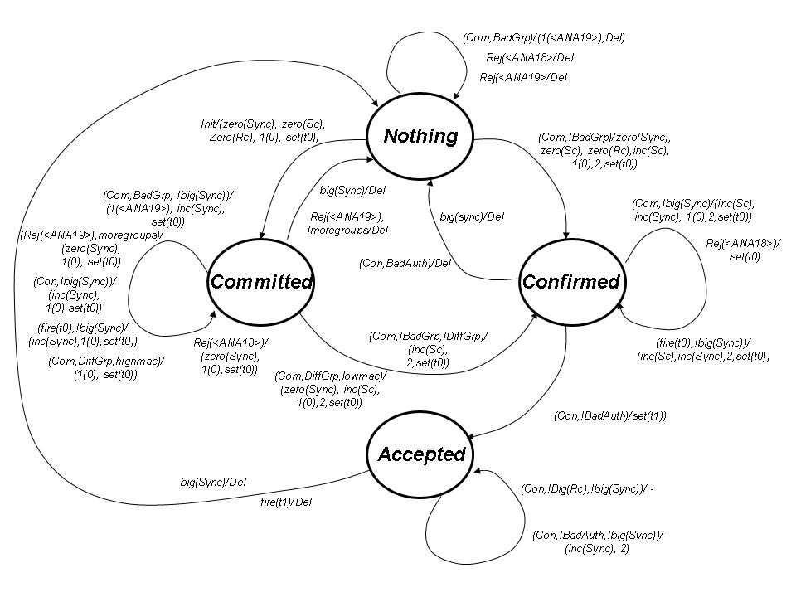
Figure s49—SAE Finite State Machine

Modify 8.2a.8.6.2a as indicated
- General
State machine behavior is illustrated in Error: Reference source not found. The protocol instance receives events from the parent process and from itself. It generates SAE messages that are transmitted to a peer and sends events to itself and the parent process.
The semantics of the state diagram are “occurance/behaviour” where “occurance” is a comma-separated list of events and/or indicators, or the special symbol “-” indicating no occurance; and, “behaviour” is a comma-separated list of outputs and/or functions, or the special symbol “-” indicating no behaviour.
When the state machine calls for the t0 (retransmission) timer to be set, it shall be set to the value of dot11SAERetransPeriod. When the state machine calls for the t1 (key expiry) timer to be set, it shall be set to the value of dot11RSNAConfigPMKLifetime.

Modify section 8.2a.8.6.2b as indicated
- Nothing State
In Nothing state a protocol instance has just been allocated.
Upon receipt of an Init event the protocol instance shall zero its Sync variable, Rc, and Sc variables, select a group from local configuration, and generate a Commit Message (see Error: Reference source not found) and sets it t0 (retransmission) timer. The protocol instance transitions into Committed state.
Upon receipt of a Com event the protocol instance shall check the Status of the Authentication frame. If the Status code is non-zero, the frame shall be silently discarded and a Del event shall be sent to the parent process.Otherwise, the frame shall be processed by first checking the finite cyclic group field to see if the requested group is supported. If not, BadGrp shall be set and the protocol instance shall construct and transmit a Rejection, an Authentication frame with Status Error: Reference source not found and the finite cyclic group field set to the rejected group, and shall send the parent process a Del event. If the group is supported the protocol instance shall zero the Sc and Rc counters, process the received Commit Message (see Error: Reference source not found), construct and transmit a Commit Message (see Error: Reference source not found) followed by a Confirm Message (see Error: Reference source not found). The Sync counter shall be set to zero and the t0 (retransmission) timer shall be set. The protocol instance transitions to Confirmed.
Note—A protocol instance in Nothing state will never receive a Confirm Message due to state machine behavior of the parent process.

Modify 8.2a.8.6.2c as indicated:
- Committed State
In Committed state a protocol instance has sent its peer a Commit Message but has yet to receive (and accept) anything.
Upon receipt of a Com event the t0 (retransmission) timer shall be cancelled. Then the following is performed:
- The protocol instance shall check the Status of the Authentication frame. If the Status is Error: Reference source not found a new Commit Message shall be constructed with the Anti-Clogging Token from the received Authentication frame, and the commit-scalar and commit-element previously sent. The new Commit Message shall be transmitted to the peer, Sync shall be zeroed, and the t0 (retransmission) timer shall be set.
- If the Status is Error: Reference source not found the protocol instance shall check the finite cyclic group field being rejected. If the rejected group matches the last offered group the protocol instance shall choose a different group, it then generates and transmits a new Commit Message to the peer, zeros Sync, sets the t0 (retransmission) timer, and remains in Committed state. If there are no other groups to choose the protocol instance shall send a Del event to the parent process and transitions back to Nothing.
- If the Status is some other non-zero value the frame shall be silently discarded and the t0 (retransmission) timer shall be set.
References:

