IEEE P802.11
Wireless LANs
PHY Simulations and Methodology
Date: 2010-05-02
Author(s):
Name | Company | Address | Phone | email
Abu-Surra, Shadi | Samsung |  |  | sasurra@sta.samsung.com
Ban, Koichiro | Toshiba |  |  | koichiro.ban@toshiba.co.jp
Banerjea, Raja | Marvell |  |  | rajab@marvell.com
Basson, Gal | Wilocity |  |  | gal.basson@wilocity.com
Blanksby, Andrew | Broadcom |  |  | andrew.blanksby@broadcom.com
Borges, Daniel | Apple |  |  | drborges@apple.com
Borison, David | Ralink |  |  | david_borison@ralinktech.com
Chang, Kapseok | ETRI |  |  | kschang@etri.re.kr
Chu, Liwen | STMicroelectronics |  |  | Liwen.chu@st.com
Chung, Hyun Kyu | ETRI |  |  | hkchung@etri.re.kr
Coffey, Sean | Realtek |  |  | coffey@realtek.com
Cordeiro, Carlos | Intel |  |  | Carlos.Cordeiro@intel.com
Dorsey, John | Apple |  |  | jdorsey@apple.com
Elboim, Yaron | Wilocity |  |  | yaron.elboim@wilocity.com
Fischer, Matthew | Broadcom |  |  | mfischer@broadcom.com
Giraud, Claude | NXP |  |  | claude.giraud@nxp.com
Golan, Ziv | Wilocity |  |  | Ziv.golan@wilocity.com
Gong, Michelle | Intel |  |  | Michelle.x.gong@intel.com
Grieve, David | Agilent |  |  | david_grieve@agilent.com
Grodzinsky, Mark | Wilocity |  |  | Mark.grodzinsky@wilocity.com
Hansen, Christopher | Broadcom |  |  | chansen@broadcom.com
Hart, Brian | Cisco |  |  | brianh@cisco.com
Hassan, Amer | Microsoft |  |  | amerh@microsoft.com
Hong, Seung Eun | ETRI |  |  | iptvguru@etri.re.kr
Hosoya, Kenichi | NEC |  |  | k-hosoya@ce.jp.nec.com
Hosur, Srinath | Texas Instruments |  |  | hosur@ti.com
Hsu, Alvin | MediaTek |  |  | alvin.hsu@mediatek.com
Hsu, Julan | Samsung |  |  | Julan.hsu@samsung.com
Hung, Kun-Chien | MediaTek |  |  | kc.hung@mediatek.com
Jain, Avinash | Qualcomm |  |  | avinashj@qualcomm.com
Jauh, Alan | MediaTek |  |  | alan.jauh@mediatek.com
Jeon, Paul | LGE |  |  | bjjeon@lge.com
Jin, Sunggeun | ETRI |  |  | sgjin@etri.re.kr
Jones, VK | Qualcomm |  |  | vkjones@qualcomm.com
Joseph, Stacy | Beam Networks |  |  | stacy@beamnetworks.com
Jun, Haeyoung | Samsung |  |  | Haeyoung.jun@samsung.com
Kaaja, Harald | Nokia |  |  | harald.kaaja@nokia.com
Kafle, Padam | Nokia |  |  | padam.kafle@nokia.com
Kakani, Naveen | Nokia |  |  | naveen.kakani@nokia.com
Kasher, Assaf | Intel |  |  | Assaf.kasher@intel.com
Kasslin, Mika | Nokia |  |  | mika.kasslin@nokia.com
Kim, Hodong | Samsung |  |  | hodong0803.kim@samsung.com
Kim, Yongsun | ETRI |  |  | doori@etri.re.kr
Kreifeldt, Rick | Harman International |  |  | rick.kreifeldt@harman.com
Kwon, Edwin | Samsung |  |  | cy.kwon@samsung.com
Kwon, Hyoungjin | ETRI |  |  | kwonjin@etri.re.kr
Kwon, Hyukchoon | Samsung |  |  | hyukchoon.kwon@samsung.com
Laine, Tuomas | Nokia |  |  | tuomas.laine@nokia.com
Lakkis, Ismail | Tensorcom |  |  | ilakkis@tensorcom.com
Lee, Hoosung | ETRI |  |  | hslee@etri.re.kr
Lee, Keith | AMD |  |  | keith.lee@amd.com
Lee, Wooyong | ETRI |  |  | wylee@etri.re.kr
Liu, Yong | Marvell |  |  | yongliu@marvell.com
Lou, Hui-Ling | Marvell |  |  | hlou@marvell.com
Majkowski, Jakub | Nokia |  |  | jakub.majkowski@nokia.com
Marin, Janne | Nokia |  |  | janne.marin@nokia.com
Maruhashi, Kenichi | NEC |  |  | k-maruhashi@bl.jp.nec.com
Matsumoto, Taisuke | Panasonic |  |  | matsumoto.taisuke@jp.panasonic.com
Meerson, Yury | Wilocity |  |  | Yury.meerson@wilocity.com
Mese, Murat | Broadcom |  |  | mesem@broadcom.com
Montag, Bruce | Dell |  |  | bruce_montag@dell.com
Myles, Andrew | Cisco |  |  | amyles@cisco.com
Nandagopalan, Saishankar | Broadcom |  |  | nsai@broadcom.com
Ngo, Chiu | Samsung |  |  | Chiu.ngo@samsung.com
Nikula, Eero | Nokia |  |  | eero.nikula@nokia.com
Park, DS | Samsung |  |  | dspark@samsung.com
Park, Minyoung | Intel |  |  | Minyoung.park@intel.com
Pi, Zhouyue | Samsung |  |  | zpi@sta.samsung.com
Ponnampalam, Vish | MediaTek |  |  | vish.ponnampalam@mediatek.com
Prasad, Narayan | NEC |  |  | prasad@nec-labs.com
Prat, Gideon | Intel |  |  | Gideon.prat@intel.com
Ramachandran, Kishore | NEC |  |  | kishore@nec-labs.com
Raymond, Yu Zhan | Panasonic |  |  | Raymond.Yuz@sg.panasonic.com
Ronkin, Roee | Wilocity |  |  | Roee.ronkin@wilocity.com
Rozen, Ohad | Wilocity |  |  | Ohad.rozen@wilocity.com
Sachdev, Devang | NVIDIA |  |  | dsachdev@nvidia.com
Sadri, Ali | Intel |  |  | Ali.S.Sadri@intel.com
Sampath, Hemanth | Qualcomm |  |  | hsampath@qualcomm.com
Sanderovich, Amichai | Wilocity |  |  | Amichai.sanderovich@wilocity.com
Sankaran, Sundar | Atheros |  |  | Sundar.Sankaran@Atheros.com
Scarpa, Vincenzo | STMicroelectronics |  |  | vincenzo.scarpa@st.com
Seok, Yongho | LGE |  |  | yongho.seok@lge.com
Shao, Huai-Rong | Samsung |  |  | hr.shao@samsung.com
Shen, Ba-Zhong | Broadcom |  |  | bzshen@broadcom.com
Sim, Michael | Panasonic |  |  | Michael.Simhc@sg.panasonic.com
Singh, Harkirat | Samsung |  |  | har.singh@sisa.samsung.com
Soffer, Menashe | Intel |  |  | Menashe.soffer@intel.com
Song, Seungho | SK Telecom |  |  | shsong@sktelecom.com
Sorin, Simha | Wilocity |  |  | Simha.sorin@wilocity.com
Smith, Matt | Atheros |  |  | matt.smith@atheros.com
Stacey, Robert | Intel |  |  | Robert.stacey@intel.com
Sutskover, Ilan | Intel |  |  | Ilan.sutskover@intel.com
Taghavi, Hossain | Qualcomm |  |  | mtaghavi@qualcomm.com
Takahashi, Kazuaki | Panasonic |  |  | takahashi.kazu@jp.panasonic.com
Trachewsky, Jason | Self |  |  | jtrachewsky@gmail.com
Trainin, Solomon | Intel |  |  | Solomon.trainin@intel.com
Usuki, Naoshi | Panasonic |  |  | usuki.naoshi@jp.panasonic.com
Varshney, Prabodh | Nokia |  |  | prabodh.varshney@nokia.com
Vertenten, Bart | NXP |  |  | bart.vertenten@nxp.com
Vlantis, George | STMicroelectronics |  |  | george.vlantis@st.com
Wang, Chao-Chun | MediaTek |  |  | chaochun.wang@mediatek.com
Wang, Homber | TMC |  |  | homber@emcite.com
Wang, James | MediaTek |  |  | james.wang@mediatek.com
Yee, James | MediaTek |  |  | james.yee@mediatek.com
Yucek, Tevfik | Atheros |  |  | Tevfik.Yucek@Atheros.com
Yong, Su Khiong | Marvell |  |  | skyong@marvell.com
Zhang, Hongyuan | Marvell |  |  | hongyuan@marvell.com

Abstract

This document is part and is in support of the complete proposal described in 802.11-10/432r0 (slides) and 802.11-10/433r0 (text).

This document contains physical layer (PHY) simulation results for the complete proposal.

Simulation Conditions

Except as noted below, the following general conditions were employed for the PHY simulations.

Packet Lengths

8192 bytes for data frames and 256 bytes for control frames (MCS 0 Control PHY only) were employed.

Channel Models

- Additive White Gaussian Noise (AWGN) model
- 802.11ad Channel Models
  - Channel 1: Conference room, omni TX, omni RX, LOS
  - Channel 2: Conference room, omni TX, directional RX, NLOS
  - Channel 3: Conference room, directional TX, directional RX, NLOS
  - Channel 4: Living room, omni TX, omni RX, LOS
  - Channel 5: Living room, omni TX, directional RX, NLOS
  - Channel 6: Living room, directional TX, directional RX, NLOS

Hardware Impairments

Phase Noise

The phase noise in the simulation follows 802.11-09/0296r16. An example plot of the phase noise from the simulation is given below.

PA Non-linearity

The power amplifier (PA) non-linearity model from 802.11-09/0296r16 was employed. The proper back off from saturation was selected to meet the both the TX spectral mask and TX EVM requirements of the proposal.

The following PA output backoffs (with respect to PA saturation power) were used for the packet error rate (PER) simulations:
- MCS 1-5 (SCM/BPSK) 5.2 dB
- MCS 6-9 (SCM/QPSK) 6.7 dB
- MCS 10 (SCM/16QAM) 6.8 dB
- MCS 11-12 (SCM/16-QAM) 7.0 dB
- MCS 13-14 (OFDM/SQPSK) 10.0 dB
- MCS 15-17 (OFDM/QPSK) 10.0 dB
- MCS 18-21 (OFDM/16-QAM) 12.0 dB
- MCS 22-24 (OFDM/64-QAM) 14.0 dB

Frequency offset
Carrier frequency and symbol timing were offset by -13.675ppm at the receiver

Control PHY Simulations

From the complete proposal, 802.11-10/0433r0, section 21.4.

Simulation Conditions

Frame size 256 bytes.

Simulation Results
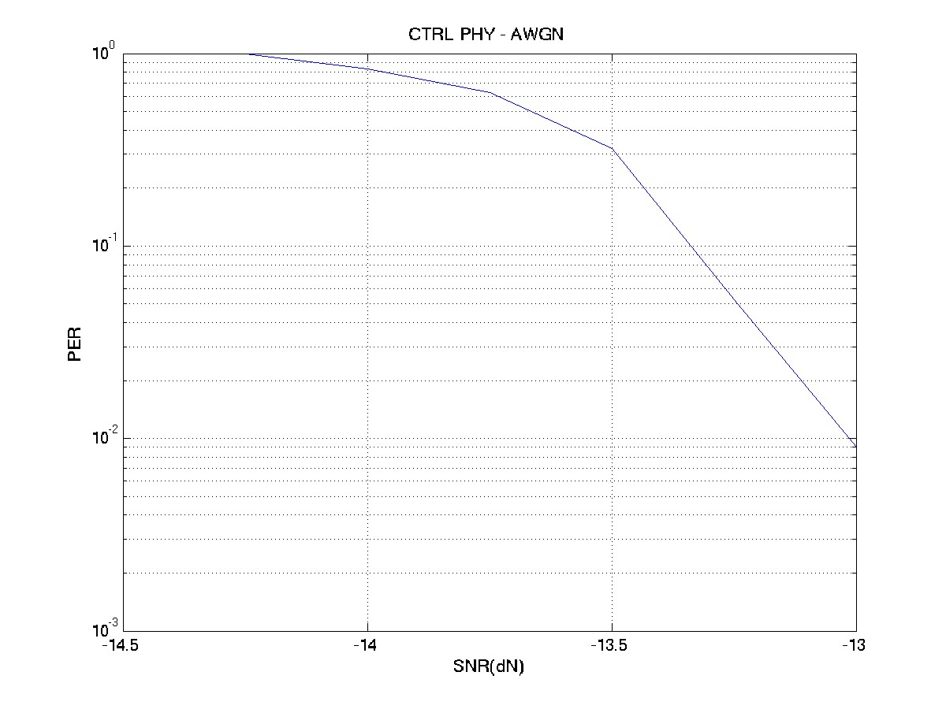

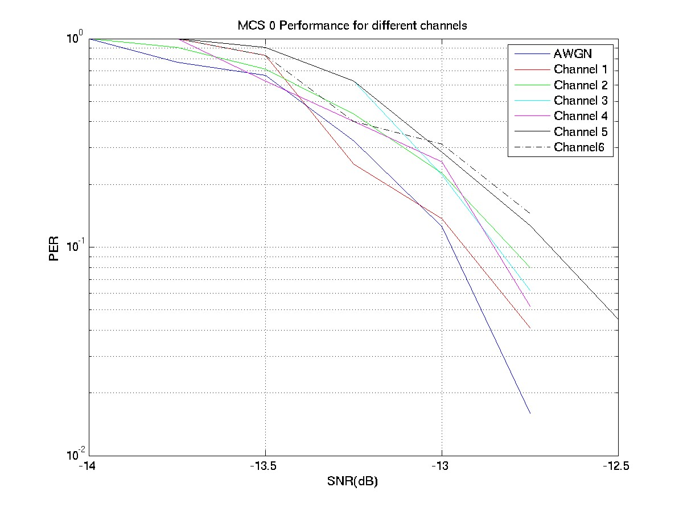

OFDM MCS Simulations

OFDM Modulation and Coding Sets

From the complete proposal, 802.11-10/0433r0, section 21.5.

MCS index | Modulation | Code Rate | NBPSC | NCBPS | NDBPS | Data Rate (Mbps)
13 | SQPSK | 1/2 | 1 | 336 | 168 | 693.00
14 | SQPSK | 5/8 | 1 | 336 | 210 | 866.25
15 | QPSK | 1/2 | 2 | 672 | 336 | 1386.00
16 | QPSK | 5/8 | 2 | 672 | 420 | 1732.50
17 | QPSK | 3/4 | 2 | 672 | 504 | 2079.00
18 | 16-QAM | 1/2 | 4 | 1344 | 672 | 2772.00
19 | 16-QAM | 5/8 | 4 | 1344 | 840 | 3465.00
20 | 16-QAM | 3/4 | 4 | 1344 | 1008 | 4158.00
21 | 16-QAM | 13/16 | 4 | 1344 | 1092 | 4504.50
22 | 64-QAM | 5/8 | 6 | 2016 | 1260 | 5197.50
23 | 64-QAM | 3/4 | 6 | 2016 | 1512 | 6237.00
24 | 64-QAM | 13/16 | 6 | 2016 | 1638 | 6756.75

Simulation Results

OFDM MCSs 13-24 on AWGN

OFDM MCSs 13-24 on Channel Model #1 - Conference room, omni TX, omni RX, LOS

OFDM MCSs 13-24 on Channel Model #2 - Conference room, omni TX, directional RX, NLOS

OFDM MCSs 13-24 on Channel Model #3 - Conference room, directional TX, directional RX, NLOS

OFDM MCSs 13-24 on Channel Model #4 - Living room, omni TX, omni RX, LOS

OFDM MCSs 13-24 on Channel Model #5 - Living room, omni TX, directional RX, LOS

OFDM MCSs 13-24 on Channel Model #6 - Living room, directional TX, directional RX, LOS

Single Carrier MCS Simulations

Modulation and Coding Sets

From the complete proposal, 802.11-10/0433r0, section 21.6.

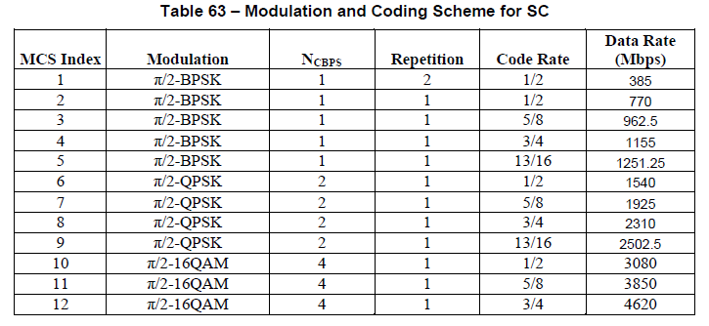

Power Amplifier Backoff Justification

Examples of the transmit mask and EVM are given below to justify the choice of power amplifier backoff employed in the single carrier simulations,

BSPK Spectral Mask Results

QPSK Spectral Mask Results

16-QAM Spectral Mask Results

QPSK EVM Results

16-QAM EVM Results

Simulation Results

SC MCSs 1-12 AWGN

SC MCSs 1-12 Channel Model #1

SC MCSs 1-12 Channel Model #2

SC MCSs 1-12 Channel Model #3

SC MCSs 1-12 Channel Model #4

SC MCSs 1-12 Channel Model #5

SC MCSs 1-12 Channel Model #6

Low Power Single Carrier MCS

Simulation Conditions

- AWGN
  - Uncoded Packet length = 4K octets
  - Stop after finding 250 frames in error
- Multipath
  - RMS delay spread ~ 1 ns (maximum delay spread = 5 ns)
  - Uncoded Packet length = 4K octets
  - Stop after finding 250 frames in error
- No non-linear impairments

AWGN Simulation Results

Multipath Simulation Results

