IEEE P802.11
Wireless LANs
More SAE Comment Resolution
Date: 2009-09-16
Author(s):
Name | Affiliation | Address | Phone | email
Dan Harkins | Aruba Networks | 1322 Crossman ave, Sunnyvale, CA | +1 408 227 4500 | dharkins at arubanetworks dot com
Abstract
This document proposes changes to Draft P802.11s_D3.03 to resolve the following comments:
408, 417, 474, 746, 748, 749, 750, 751, 753
Instructions to the editor are in bold italic font (like this) and removed text is shown with a strikethrough while new text is shown underlined.

Modify section 8.2A.1 as indicated:
- Overview
SAE uses a finite cyclic group in which group membership (elements) and operations made on members of the group are well-defined field cryptography. A finite field is referred to here as a group which is comprised of elements. Arithmetic operations on elements in the group produce other elements in the group. This groupGroups can be based on elliptic curves or on more traditional exponentiation modulus a prime number.

Modify section 8.2A.2 as indicated:
- Assumptions on SAE
SAE uses various functions to accomplish its task and assumes certain properties about each function. These are:
- H is a “random oracle” whose output is indistinguishable from a random source by an attacker that is given access to the input to and output from H.
- H is a one-way function such that given the output it is computationally infeasible to determine the input.
- H maps an input string of indeterminate length onto a fixed string—i.e., H: (0,1)* → (0,1)^{k}
- For any given input to H each of the 2^{k} possible outputs are all equiprobable.
- Solving the discrete logarithm problem in the finite cyclic group is computationally infeasible.
- In addition, finite cyclic groups based on an elliptic curve make use of a mapping function, F, that maps an element from the group to a scalar value.Function F shall be instantiated by returning the x-coordinate of a point—i.e., if P = (x,y) then F(P) = x. Finite cyclic groups based on exponentiation modulo a prime do not use need a mapping function but for sake of protocol definition, for such groups function F will be the identity function, that is F(x) = x.

Modify section 8.2A.3.1 as indicated:
- General
The parties involved will be called STA-A and STA-B. They are identified by their MAC addresses, STA-A-MAC and STA-B-MAC, respectively. Upon configuration of a password a “password element” is derived using the finite cyclic group. STAs begin the protocol when they discover a peer through beacons and probe responses, or when they receive an 802.11 authentication SAE frame indicating SAE authentication from a peer.

Append the following to section 8.2A.3.1

SAE uses two arithmetic operators defined for finite fields, an operation that takes two elements to produce a third (called the “element operation”), and an operation that takes one element and one scalar value to produce another element (called the “scalar operation”). The convention used here is to represent group elements in upper-case and scalar values in lower-case. The element operation takes two elements and is denoted elem-op(X,Y) while the scalar operation takes an element and a scalar and is denoted scalar-op(x,Y)

- General
Elliptic curves for use in SAE are based on finite fields over a prime number, p, that is comprised of the set of integers {0, 1, 2, …, p-1}. Each such integer in the set is represented by a binary string that is the equal to the bit length of p, prepending the integer with 0 bits, if necessary, until the required length is achieved. Points on the curve are represented by an x-coordinate and a y-coordinate. The curve is represented by an equation, y² = x³ + ax + b, for some fixed value of a and b, a prime, p, and a co-factor h. Each elliptic curve has a special point called the “point-at-infinity”. The convention used herein represents a point with an upper-case name and a scalar value with a lower-case name.
The group scalar operation in an elliptic curve group is multiplication of a scalar value by a point on the curve resulting in another point on the curve. For example, the point G is multiplied by the scalar q to derive the point Q:
Q = q * G = scalar-op(q,G)
The element operation in an elliptic curve group is addition of two points on the curve resulting in another point on the curve. For example, points X is added to point Y to produce point Z:
Z = X + Y = elem-op(X,Y)
SAE requires an additional operation, inverse(), to produce the inverse of a point on an elliptic curve. A point on an elliptic curve is the inverse of a different point if their sum is the “point at infinity”. In other words: Q + inverse(Q) = “point at infinity”
Modify 8.2A.3.2.2 as indicated:
- Generation of the Password Element
The Password Element of an elliptic curve group is called PWE and shall be generated in a random hunt-and-peck fashion. A counter is used with the password to generate a seed value. This counter, represented as a single octet, shall be initially set to one (1). Password seed shall then be stretched using the KDF function from section 8.8.3 to the length of the prime number from the group definition with the Label of “SAE Hunting and Pecking” and the Content being the prime. The resulting password value shall then be reduced modulo the prime. If the resulting password value is greater than or equal to the prime the counter shall be incremented, a new password seed is derived and the hunting-and-pecking shall continue. If the The reduced password value is less than the prime it shall then be used as the x-coordinate of a curve and the equation for the curve shall be checked to see if a solution for y exists. If no solution exists, the counter shall be incremented, a new password-seed is derived and the hunting-and-pecking shall continue. If a solution exists, there will be two possible values for y. The password seed is used to determine which one to use. If the LSB of the password seed is equal to the LSB of y returned as the solution to the quadratic equation then the candidate PWE shall be (x, y) otherwise the candidate PWE shall be (x, p-y). The candidate PWE shall be then multiplied by the co-factor of the curve to produce a test point. If the test point is “the point-at-infinity” the counter shall be incremented, a new password seed is derived and the hunting-and-pecking process shall continue. If it does not equal the “point-at-infinity” the candidate PWE shall become the PWE.

NOTE—The test point - the co-factor of the curve multiplied by the candidate PWE - does not become the PWE.
Algorithmically this process can be described as follows:

found = 0;
counter = 1
z = len(prime)
do {
pwd-seed = H(password || counter)
pwd-value = KDF-z(pwd-seed, “SAE Hunting and Pecking”, prime)
modulo prime
if (pwd-value < prime)
then
x = pwd-value
if there exists y: y² = x³ + ax + b
then
if LSB(pwd-seed) = LSB(y)
then
PWE = (x,y)
else
PWE = (x, p-y)
fi
T = h * PWE
if T != “point-at-infinity”
then
found = 1
fi
fi
fi
counter = counter + 1
} while (found=0)
This process is performed once for each defined and supported finite cyclic group. The resulting PWE for each group shall be maintained for subsequent use in creating and processing SAE frames.

Remove sections 8.2A.3.2.3 through 8.2A.3.2.7 inclusive

Modify section 8.2A.3.3.1 as indicated:
- General
Elements in a prime modulus finite cyclic group are represented as numbers less than the prime modulus.
Since elements in the group are numbers there is no need for a mapping function with prime modulus groups. The group scalar operation of prime modulus field groups is exponentiation of one number by another modulus the prime:
yQ = g^{x} G^{q} modulo p = scalar-op(q,G)
The element operation in an elliptic curve is multiplication of two numbers modulo the prime:
Z = (X * Y) modulo p = elem-op(X,Y)
Some prime modulus groups do not have an order as part of their definition. For these groups the order, r, willshall be computed as (p – 1)/2, where p is the prime modulus.
SAE requires an additional operation, inverse(), to produce the inverse of an element in a prime modulus group. An element is the inverse of a different element if their product modulo the group prime is one (1). In other words: (qQ * inverse(qQ)) modulo prime = 1.

Remove sections 8.2A.3.3.3 through 8.2A.3.3.7 inclusive

Add new section 8.2A4

- SAE Protocol
8.2A.4.1 Construction of a Commit
Upon discovery of a peer, a supported group shall be selected and a secret element shall be derived based on the identities of the two STAs and the PWE created for that group by the process in 8.2A.3.2.2 or 8.2A.3.3.2 (Generation of the Password Element), depending on whether the gropu is based on an elliptic curve or a prime field, respectively.

m = H(MAX(STA-A-MAC, STA-B-MAC) || MIN(STA-A-MAC, STA-B-MAC))
N = scalar-op(m, PWE)
Each STA shall generate its-own secret value, rand, and temporary secret value, mask, which shall be chosen randomly between 1 and the order, r, of the group produced by the defined generator. A Commit Message consists of a scalar and an element which shall be generated as follows:

commit-scalar = (rand + mask) modulo r
commit-element = inverse(scalar-op(mask, N))

These messages shall be transmitted to the peer as described in section 8.2A.6 (Framing of SAE)
8.2A.4.2 Processing of a Peer’s Commit
Upon receipt of a peer’s Commit Message a shared secret value, k, shall be derived using the scalar and element (peer-commit-scalar and peer-commit-element, respectively) from the peer’s Commit Message and the STA’s secret value:

K = scalar-op(rand, (elem-op(scalar-op(peer-commit-scalar, N), peer-commit-element)))
k = F(K)
8.2A.4.3 Construction of a Confirm
A peer generates a Confirm Message by passing the shared secret value concatenated with the send-confirm counter (see Error: Reference source not found) and the messages exchanged in the Commit Messages to the random function H.

confirm = H(k || send-confirm || commit-scalar || commit-element || peer-commit-scalar ||
peer-commit-element)
The message shall be transmitted to the peer as described in section 8.2A.6 (Framing of SAE).
8.2A.4.4 Processing of a Peer’s Confirm
Upon receipt of a peer’s Confirm Message a verifier is computed which is the expected value of the peer’s confirmation, peer-confirm.
verifier = H(k || send-confirm || peer-commit-scalar || peer-commit-element || commit-scalar ||
commit-element)
If the verifier equals peer-confirm the STA shall accept the peer’s authentication. If the verifier differs from the peer-confirm the STA shall reject the peer’s authentication.

8.2A.4.5 Generation of a PMK
If the STA accepts the peer’s authentication a PMK shall be derived using the random function H and the order of the group, r:

PMK = H(k || (commit-scalar + peer-commit-scalar) modulo r ||
F(elem-op(commit-element, peer-commit-element)))

The lifetime of the PMK is the same as the lifetime of the password element used in 8.2A.3.3.2 and 8.2A.3.3.3 (Generation of the Password Element).

PMKName = L(H(commit-scalar + peer-commit-scalar) modulo r, 0, 128)

Increment 8.2A.4 so it becomes 8.2A.5, increment 8.2A.5 and all subsections so they become 8.2A.6, increment 8.2A.6 and all subsections so they become 8.2A.7

Modify section 8.2A.6.1 as indicated.
- General
The protocol is instantiated by the finite state machine in figure s49 (SAE finite state machine). Each instance of the protocol is identified by the peer MAC address. The model in which SAE is defined consists of a parent process, managed by the SME, which receives messages, and dispatches them to the appropriate protocol instance, also managed by the SME. The parent process manages a database of protocol instances indexed by the peer identity. Protocol instances maintain state, receive events from the parent process, send events to itself, and output data.
Note: figure s49 does not show all state machine transitions. A full description of the SAE Finite State Machine is in section 8.2A.6.6.2.

Modify section 8.2A.6.3.2 as indicated:
- Protocol Instance Events and Output
In addition protocol instances can receive fire(X) events indicating expiry of timer X. Upon expiry of a timer and generation of a fire() event the expired timer is not reset.

Modify section 8.2A.6.5.2 as indicated:
- Protocol Instance Variables
In addition, protocol instances maintain six indicators that are not maintained as state variables but, instead, indicate the cause of certain behavior.
- BadAlgBadGrp —the algorithm group specified in a Commit Message is not supported.
- DiffAlg DiffGrp—the algorithm group specified in a Commit Message is supported but differs from the one offered.

Replace figure s49 with the following:
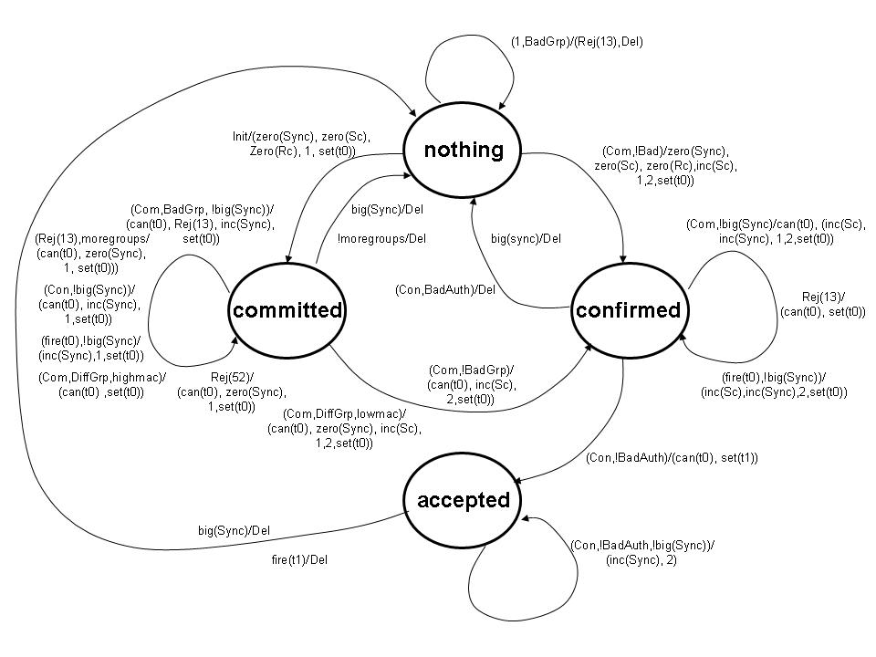

Modify 8.2A.6.6.2b as indicated:
- Nothing State
Upon receipt of an Init event the protocol instance shall zero its sync variable, Rc, and Sc variables, select a group from local configuration, and generate a Commit Message (see 8.2A.3.2.3 (Construction of a Commit) and 8.2A.3.3.3 (Construction of a Commit)) and sets it t0 (retransmission) timer. The protocol instance transitions into Committed state.

Upon receipt of a Com event the protocol instance shall check the Status of the Authentication frame. If the Status is zero, or fifty-two (52), the protocol instance shall begin processing the frame. If the Status is any other value the frame shall be silently discarded and a Del event shall be sent to the parent process. The frame shall be processed by first checking the Algorithm identifier finite cyclic group field to see if the requested Algorithm group is supported. If not, BadAlgGrp shall be set and the protocol instance shall construct and transmit a Rejection, an Authentication frame with Status thirteen (13) and the Authentication algorithm identifier finite cyclic group field set to the rejected algorithm identifier group, and shall send the parent process a Del event. If the Algorithm group is supported the protocol instance shall zero the Sc and Rc counters, construct and transmit a Commit Message (see 8.2A.3.2.3 (Construction of a Commit) and 8.2A.3.3.3 (Construction of a Commit)) followed by a Confirm Message (see 8.2A.3.2.5 (Construction of a Confirm) and 8.2A.3.3.5 (Construction of a Confirm)). The Sync counter shall be set to zero and the t0 (retransmission) timer shall be set.

Modify section 8.2A.6.6.2c as indicated:
- Committed State
Upon receipt of a Com event the t0 (retransmission) timer shall be cancelled. Then the following is performed:
- The protocol instance shall check the Status of the Authentication frame. If the Status is fifty-two (52) a new Commit Message shall be constructed with the Anti-Clogging token from the received Authentication frame, and the commit-scalar and commit-element previously sent. The new Commit Message shall be transmitted to the peer, Sync shall be zeroed, and the t0 (retransmission) timer shall be set.
- If the Status is thirteen (13) the protocol instance shall check the protocol finite cyclic group field being rejected. If it is not the last algorithm group offered the frame shall be discarded and the t0 (retransmission) timer shall be set. If the rejected algorithm group matches the last offered algorithm group the protocol instance shall choose a different group, generates and transmits a new Commit Message to the peer, zeros Sync, and remains in Committed state. If there are no other groups to choose the protocol instance shall send a Del event to the parent process and transitions back to Nothing.
- If the Status is some other non-zero value the frame shall be silently discarded and the t0 (retransmission) timer shall be set.
- If the Status is zero the Algorithm identifier finite cyclic group field is checked. If the Algorithm identifier group is not supported BadAlgGrp shall be set and the value of Sync shall be checked.

- If the Algorithm identifier group is supported but does not match that used when the protocol instance constructed its Commit Message DiffAlgGrp shall be set and the local identity and peer identity shall be checked.
- The numerically greater of the two drops the received Commit Message, shall transmit its previously transmitted Commit Message, shall set the t0 (retransmission) timer and remain in Committed state.
- The numerically lesser of the two zeros Sync, shall increment Sc, choose the group from the received Commit Message generate a new Commit Message and Confirm Message, and shall transmit the new Commit and Confirm to the peer. It shall then transition to Confirmed state.
- If the Algorithm identifier group is supported and matches that used when the protocol instance constructed its Commit Message, the protocol instance checks the peer-commit-scalar and peer-commit-element from the message. If they match those sent as part of the protocol instance’s own Commit Message the frame shall be silently discarded (because it is evidence of a reflection attack) and the t0 (retransmission) timer shall be set. If the received element and scalar differ from the element and scalar offered the Sc counter shall be incremented (thereby setting its value to one), the protocol instance shall then construct a Confirm Message, transmit it to the peer, set the t0 (retransmission) timer. It shall then transition to Confirmed state.

Modify section 8.2A.6.6.2d as indicated:
- Confirmed State
Upon receipt of a Com event the t0 (retransmission) timer shall be cancelled. If the Status is non-zero the frame shall be silently discarded, the t0 (retransmission) timer set, and the protocol instance shall remain in Confirmed state. If Sync is greater than dot11SAESync the protocol instance shall send the parent process a Del event and transitions back to Nothing. If Sync is not greater than dot11SAESync the protocol instance shall verify that the Algorithm identifier finite cyclic group field is the same as the previously received Commit frame. If not the frame shall be silently discarded. If so, the protocol instance shall increment Sync, increment Sc, and transmit its Commit and Confirm (with the new Sc value) messages. It then shall set the t0 (retransmission) timer.

Modify sections 10.3.65.1.1, 10.3.65.1.2 and 10.3.65.1.3 as indicated:

- Function
This primitive requests that the MAC entity send an SAE 802.11 authentication frame indicating SAE authentication to a specified peer MAC entity.
- Semantics of the service primitive
The primitive parameters are as follows:

MLME-SAE.request(
peerMAC,
Content of SAE 802.11 authentication frame

)

Name | Type | Valid range | Description
peerMAC | MAC Address | Valid individual MAC address | Specifies the address of the peer MAC entity with which to perform SAE authentication and key establishment.
Content of SAE 802.11 authentication frame | Sequence of octets | As defined in 7.4.12.2 (Mesh Peering Open frame format), 7.4.12.3 (Mesh Peering Confirm frame format), of 7.4..12.4 Mesh Peering Close frame format) | The content of the SAE Commit Message or SAE Confirm Message.

- When generated
This primitive is generated by the SME to request that an SAE 802.11 authentication frame indicating SAE authentication be sent to the specified peer.
References:

