IEEE P802.11
Wireless LANs
More SAE Comment Resolution
Date: 2009-09-16
Author(s):
Name | Affiliation | Address | Phone | email
Dan Harkins | Aruba Networks | 1322 Crossman ave, Sunnyvale, CA | +1 408 227 4500 | dharkins at arubanetworks dot com
Abstract
This document proposes changes to Draft P802.11s_D3.03 to resolve the following comments:
408, 417, 746, 748, 749, 750, 751, 753
Instructions to the editor are in bold italic font (like this) and removed text is shown with a strikethrough while new text is shown underlined.

Modify section 8.2A.3.1 as indicated:
- General
The parties involved will be called STA-A and STA-B. They are identified by their MAC addresses, STA-A-MAC and STA-B-MAC, respectively. Upon configuration of a password a “password element” is derived using the finite cyclic group. STAs begin the protocol when they discover a peer through beacons and probe responses, or when they receive an 802.11 authentication SAE frame indicating SAE authentication from a peer.

Modify section 8.2A.6.1 as indicated.
- General
The protocol is instantiated by the finite state machine in figure s49 (SAE finite state machine). Each instance of the protocol is identified by the peer MAC address. The model in which SAE is defined consists of a parent process, managed by the SME, which receives messages, and dispatches them to the appropriate protocol instance, also managed by the SME. The parent process manages a database of protocol instances indexed by the peer identity. Protocol instances maintain state, receive events from the parent process, send events to itself, and output data.
Note: figure s49 does not show all state machine transitions. A full description of the SAE Finite State Machine is in section 8.2A.6.6.2.

Modify section 8.2A.6.3.2 as indicated:
- Protocol Instance Events and Output
In addition protocol instances can receive fire(X) events indicating expiry of timer X. Upon expiry of a timer and generation of a fire() event the expired timer is not reset.

Modify section 8.2A.6.5.2 as indicated:
- Protocol Instance Variables
In addition, protocol instances maintain six indicators that are not maintained as state variables but, instead, indicate the cause of certain behavior.
- BadAlgBadGrp —the algorithm group specified in a Commit Message is not supported.
- DiffAlg DiffGrp—the algorithm group specified in a Commit Message is supported but differs from the one offered.

Replace figure s49 with the following:
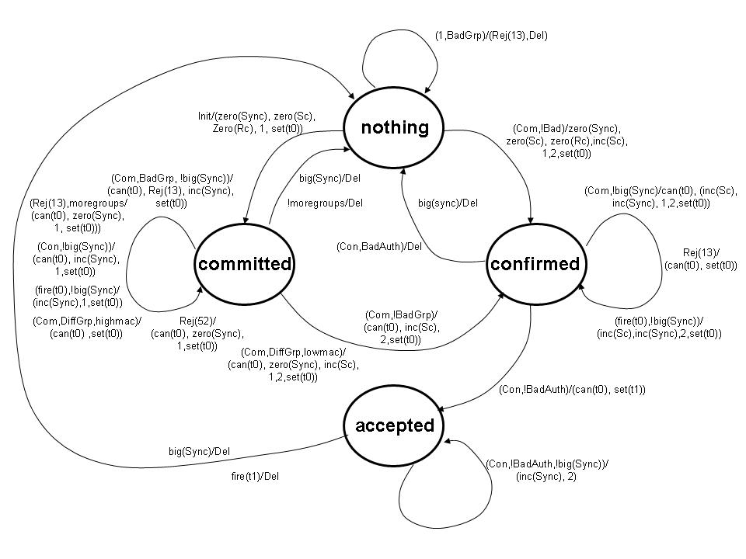

Modify 8.2A.6.6.2b as indicated:
- Nothing State
Upon receipt of an Init event the protocol instance shall zero its sync variable, Rc, and Sc variables, select a group from local configuration, and generate a Commit Message (see 8.2A.3.2.3 (Construction of a Commit) and 8.2A.3.3.3 (Construction of a Commit)) and sets it t0 (retransmission) timer. The protocol instance transitions into Committed state.

Upon receipt of a Com event the protocol instance shall check the Status of the Authentication frame. If the Status is zero, or fifty-two (52), the protocol instance shall begin processing the frame. If the Status is any other value the frame shall be silently discarded and a Del event shall be sent to the parent process. The frame shall be processed by first checking the Algorithm identifier finite cyclic group field to see if the requested Algorithm group is supported. If not, BadAlgGrp shall be set and the protocol instance shall construct and transmit a Rejection, an Authentication frame with Status thirteen (13) and the Authentication algorithm identifier finite cyclic group field set to the rejected algorithm identifier group, and shall send the parent process a Del event. If the Algorithm group is supported the protocol instance shall zero the Sc and Rc counters, construct and transmit a Commit Message (see 8.2A.3.2.3 (Construction of a Commit) and 8.2A.3.3.3 (Construction of a Commit)) followed by a Confirm Message (see 8.2A.3.2.5 (Construction of a Confirm) and 8.2A.3.3.5 (Construction of a Confirm)). The Sync counter shall be set to zero and the t0 (retransmission) timer shall be set.

Modify section 8.2A.6.6.2c as indicated:
- Committed State
Upon receipt of a Com event the t0 (retransmission) timer shall be cancelled. Then the following is performed:
- The protocol instance shall check the Status of the Authentication frame. If the Status is fifty-two (52) a new Commit Message shall be constructed with the Anti-Clogging token from the received Authentication frame, and the commit-scalar and commit-element previously sent. The new Commit Message shall be transmitted to the peer, Sync shall be zeroed, and the t0 (retransmission) timer shall be set.
- If the Status is thirteen (13) the protocol instance shall check the protocol finite cyclic group field being rejected. If it is not the last algorithm group offered the frame shall be discarded and the t0 (retransmission) timer shall be set. If the rejected algorithm group matches the last offered algorithm group the protocol instance shall choose a different group, generates and transmits a new Commit Message to the peer, zeros Sync, and remains in Committed state. If there are no other groups to choose the protocol instance shall send a Del event to the parent process and transitions back to Nothing.
- If the Status is some other non-zero value the frame shall be silently discarded and the t0 (retransmission) timer shall be set.
- If the Status is zero the Algorithm identifier finite cyclic group field is checked. If the Algorithm identifier group is not supported BadAlgGrp shall be set and the value of Sync shall be checked.

- If the Algorithm identifier group is supported but does not match that used when the protocol instance constructed its Commit Message DiffAlgGrp shall be set and the local identity and peer identity shall be checked.
- The numerically greater of the two drops the received Commit Message, shall transmit its previously transmitted Commit Message, shall set the t0 (retransmission) timer and remain in Committed state.
- The numerically lesser of the two zeros Sync, shall increment Sc, choose the group from the received Commit Message generate a new Commit Message and Confirm Message, and shall transmit the new Commit and Confirm to the peer. It shall then transition to Confirmed state.
- If the Algorithm identifier group is supported and matches that used when the protocol instance constructed its Commit Message, the protocol instance checks the peer-commit-scalar and peer-commit-element from the message. If they match those sent as part of the protocol instance’s own Commit Message the frame shall be silently discarded (because it is evidence of a reflection attack) and the t0 (retransmission) timer shall be set. If the received element and scalar differ from the element and scalar offered the Sc counter shall be incremented (thereby setting its value to one), the protocol instance shall then construct a Confirm Message, transmit it to the peer, set the t0 (retransmission) timer. It shall then transition to Confirmed state.

Modify section 8.2A.6.6.2d as indicated:
- Confirmed State
Upon receipt of a Com event the t0 (retransmission) timer shall be cancelled. If the Status is non-zero the frame shall be silently discarded, the t0 (retransmission) timer set, and the protocol instance shall remain in Confirmed state. If Sync is greater than dot11SAESync the protocol instance shall send the parent process a Del event and transitions back to Nothing. If Sync is not greater than dot11SAESync the protocol instance shall verify that the Algorithm identifier finite cyclic group field is the same as the previously received Commit frame. If not the frame shall be silently discarded. If so, the protocol instance shall increment Sync, increment Sc, and transmit its Commit and Confirm (with the new Sc value) messages. It then shall set the t0 (retransmission) timer.

Modify sections 10.3.65.1.1, 10.3.65.1.2 and 10.3.65.1.3 as indicated:

- Function
This primitive requests that the MAC entity send an SAE 802.11 authentication frame indicating SAE authentication to a specified peer MAC entity.
- Semantics of the service primitive
The primitive parameters are as follows:

MLME-SAE.request(
peerMAC,
Content of SAE 802.11 authentication frame

)

Name | Type | Valid range | Description
peerMAC | MAC Address | Valid individual MAC address | Specifies the address of the peer MAC entity with which to perform SAE authentication and key establishment.
Content of SAE 802.11 authentication frame | Sequence of octets | As defined in 7.4.12.2 (Mesh Peering Open frame format), 7.4.12.3 (Mesh Peering Confirm frame format), of 7.4..12.4 Mesh Peering Close frame format) | The content of the SAE Commit Message or SAE Confirm Message.

- When generated
This primitive is generated by the SME to request that an SAE 802.11 authentication frame indicating SAE authentication be sent to the specified peer.
References:

