IEEE P802.11
Wireless LANs
Implementation of 60 GHz WLAN Channel Model
Date: 07-12-2009
Author(s):
Name | Affiliation | Address | Phone | email
Roman Maslennikov | Intel | Turgeneva str., 30, Nizhny Novgorod, 603024, Russia | +78312969444 | roman.maslennikov@  intel.com
Artyom Lomayev | Intel | Turgeneva str., 30, Nizhny Novgorod, 603024, Russia | +78312969444 | artyom.lomayev@  intel.com
Abstract
Description of the source code implementing 60 GHz WLAN channel model proposed in [1].

Revision History

- July 2009 – Initial version.

Channel Model Source Code

The channel model source code is in the zip file embedded below.

Table of Contents

1 Channel Model Code Description 3
1.1 General Code Structure 3
1.2 Description of Data Structures Used in Channel Model 4
1.3 Directory Tree for Channel Model Source Code 6
1.4 Channel Model Test Script 8
2 Appendix - Beamforming Algorithms 10
2.1 Exhaustive Search Beamforming Algorithm 10
3 References 11

Channel Model Code Description

General Code Structure
This document describes a structure of the software code developed for the conference room channel model described in [1]. The channel model source code is a combination of Matlab software functions and C-code routines that are integrated to Matlab through MEX (Matlab Executable) interface.
The functional block diagram describing general code organization and relations between different high-level functions is shown in Figure 1 below.
Figure 1. General code structure implementing CR channel model
As it can be seen from Figure 1 the top function of the conference room channel model is cr_ch_model.m. It subsequently calls the initialization function cr_ch_cfg.m, two functions gen_cr_ch.m and beamforming.m, and a simple subroutine ct2dt.m implementing analog to discrete time conversion of channel impulse response in accordance with the target sample rate.
Both the channel realization generation and beamforming algorithm functions have very many input parameters. In the Matlab implementation of the channel model these parameters were organized into data structures so that to simplify the interfaces of these functions.
The diagram in Figure 1 illustrates the order in which software functions are executed during cr_ch_model.m function call. The first function in this pipeline is cr_ch_cfg.m. This is a configuration function where all input channel model parameters are set. It returns configuration structure cfg containing all channel model settings. Configuration structure includes common parameters used by the top function and two substructures cfg.cr and cfg.bf providing input parameters for gen_cr_ch.m and beamforming.m functions.
Function gen_cr_ch.m implements generation of space-time channel impulse response realization for the conference room environment including angular, temporal, amplitude and phase characteristics. This function has the following interface:
ch = gen_cr_ch(cfg.cr,cfg.bf.ps,cfg.bf.pol),
where ch is an output channel structure keeping all space-time characteristics listed above.
Function beamforming.m implements a reference beamforming algorithm with the exhaustive search procedure that is described in the Appendix. The output of this function is a channel impulse between the transmitter and receiver with antenna patterns optimally steered by the beamforming algorithm. The provided channel impulse is in the continued time. The interface of the beamforming function is:
[imp_res,toa] = beamforming(cfg.bf,ch),
where output arrays imp_res and toa provide complex amplitudes of rays after beamforming and their relative time values. Exhaustive search subroutine was realized in both Matlab and C languages. The user has an option to choose between Matlab or C subroutine by setting a special flag in the cfg.bf structure. exhaustive_search_mex.c gateway routine is provided to integrate C-code into Matlab environment through MEX interface. Note that C subroutines fully duplicate Matlab subfunctions that are executed during beamforming.m call. They have the same names and the same functionality except for negligible details relating to C-code realization aspects. The main reason to provide C-code version is to accelerate computations related to exhaustive search (especially for the search with a great number of space positions) and therefore to reduce the amount of time for the channel realizations generation.

Description of Data Structures Used in Channel Model
This section provides description of the configuration structure cfg and channel impulse response structure ch used in the developed channel model.
Table 1 shows all fields of cfg structure, provides short description for every field and gives default values of the fields.
Table 1. Description of cfg structure fields
# | Structure Field | Field Description | Default Value
Common Parameters
1 | cfg.Pnorm | Normalization parameter: 0 - w/o normalization, 1 - apply normalization for output channel impulse response. | 1
2 | cfg.sample_rate | Sample rate in [GHz] applied for continuous time to discrete time channel impulse response conversion. | 2.56
cfg.cr substructure
3 | cfg.cr.ap_sp | Parameter selects subscenario, permitted values: 0 – STA-STA subscenario, 1 - STA-AP subscenario. | 0
4 | cfg.cr.D | Distance in meters between transmitter and receiver sides. Note that for the STA-AP subscenario D is set in projection to horizontal plane. | 2
5 | cfg.cr.Plos | LOS (Line-of-Sight) parameter, permitted values: 0 – corresponds to NLOS scenario, 1 – corresponds to LOS scenario. | 0
6 | cfg.cr.Psta_1st_c | Probability that the cluster is present (i.e. not blocked) by 1st order reflections from ceiling for STA-STA subscenario. | 0.9
6 | cfg.cr.Psta_1st_w | Probability that the cluster is present (i.e. not blocked) by 1st order reflections from walls for STA-STA subscenario. | 0.6
7 | cfg.cr.Psta_2nd_wc | Probability that the cluster is present (i.e. not blocked) by 2nd order wall-ceiling (ceiling-wall) reflections for STA-STA subscenario. | 0.7
8 | cfg.cr.Psta_2nd_w | Probability that the cluster is present (i.e. not blocked) by 2nd order reflections from walls for STA-STA subscenario. | 0.2
9 | cfg.cr.Pap_1st | Probability that the cluster is present (i.e. not blocked) by 1st order reflections from walls for STA-AP subscenario. | 0.7
10 | cfg.cr.Pap_2nd | Probability that the cluster is present (i.e. not blocked) by 2nd order reflections from walls for STA-AP subscenario. | 0.4
cfg.bf substructure
11 | cfg.bf.matlab_c | This flag selects Matlab or C function to perform exhaustive search in beamforming procedure: 0 - use Matlab function, 1 - use C function. | 0
12 | cfg.bf.ant_type | Antenna type parameter selects antenna type applied in beamforming search procedure, permitted values: 0 – isotropic radiator, 1 - basic steerable directional antenna, 2 - planar phased array. | 1
13 | cfg.bf.sec_bound | Spherical sector bound for antenna beam search in beamforming procedure. | 90
14 | cfg.bf.hpbw | Half-power antenna beam width in [deg] applied for basic steerable directional antenna model. | 30
15 | cfg.bf.Nx | The number of radiators along x-dimension in planar phased array. | 6
16 | cfg.bf.dx | The space between radiators along x-dimension in planar phased array. | 0.5λ
17 | cfg.bf.Ny | The number of radiators along y-dimension in planar phased array. | 6
18 | cfg.bf.dy | The space between radiators along y-dimension in planar phased array. | 0.5λ
19 | cfg.bf.ps | Polarization support parameter, permitted values: 0 – w/o polarization, 1 – include polarization effects. Note that modeling of polarization effects is unsupported in the case of isotropic radiator and phased antenna array. | 0
20 | cfg.bf.pol | 1x2 vector sets polarization types for TX and RX antennas. | [0, 0]
21 | cfg.bf.paa_tx_az | Azimuth angle in [deg] specifying Phased Antenna Array spatial position relatively to the main (associated with the LOS direction) system of coordinates on TX side. | 0
22 | cfg.bf.paa_tx_el | Elevation angle in [deg] specifying Phased Antenna Array spatial position relatively to the main (associated with the LOS direction) system of coordinates on TX side. | 0
23 | cfg.bf.paa_tx_sr | Self rotation angle in [deg] specifying Phased Antenna Array spatial position relatively to the main (associated with the LOS direction) system of coordinates on TX side. | 0
24 | cfg.bf.paa_rx_az | Azimuth angle in [deg] specifying Phased Antenna Array spatial position relatively to the main (associated with the LOS direction) system of coordinates on RX side. | 0
25 | cfg.bf.paa_rx_el | Elevation angle in [deg] specifying Phased Antenna Array spatial position relatively to the main (associated with the LOS direction) system of coordinates on RX side. | 0
26 | cfg.bf.paa_rx_sr | Self rotation angle in [deg] specifying Phased Antenna Array spatial position relatively to the main (associated with the LOS direction) system of coordinates on RX side. | 0
27 | cfg.bf.tx_az | Array of azimuth angles specifying angles grid for exhaustive beamsearch procedure on TX side – generated during configuration based on other parameters. | N/A
28 | cfg.bf.tx_el | Elevation of azimuth angles specifying angles grid for exhaustive beamsearch procedure on TX side – generated during configuration based on other parameters. | N/A
29 | cfg.bf.rx_az | Array of azimuth angles specifying angles grid for exhaustive beamsearch procedure on RX side – generated during configuration based on other parameters. | N/A
30 | cfg.bf.rx_el | Elevation of azimuth angles specifying angles grid for exhaustive beamsearch procedure on RX side – generated during configuration based on other parameters. | N/A

Table 2 shows all fields of ch structure and provides a short description for every field.
Table 2. Description of ch structure fields
# | Structure Field | Field Description
1 | ch.am | Complex amplitudes corresponding to LOS/NLOS rays existing between transmitter and receiver parts.
2 | ch.toa | Times of arrival (in [ns]) of rays calculated relatively to time of arrival of LOS component.
3 | ch.tx_az | Transmit azimuth angles for different rays.
4 | ch.tx_el | Transmit elevation angles for different rays.
5 | ch.rx_az | Receive azimuth angles for different rays.
6 | ch.rx_el | Receive elevation angles for different rays.
7 | ch.am | Complex amplitudes corresponding to LOS/NLOS rays existing between transmitter and receiver parts.
8 | ch.toa | Times of arrival (in [ns]) of rays calculated relatively to time of arrival of LOS component.
9 | ch.tx_az | Transmit azimuth angles for different rays.

Directory Tree for Channel Model Source Code
The directory tree and all files for the channel model source code are shown in Figure 2.
Figure 2. Directory tree for the channel model source code
To start up channel simulations it is necessary to run startup.m script. This script adds the specified in Figure 2 directories to the top of the current Matlab search path and changes current directory to /work folder. After that the cr_ch_model.m function may be used to generate channel impulse response realizations.

Channel Model Test Script
The /work folder contains also test.m file developed for a simple check that the channel model functions are working normally. Figure 3 and Figure 4 show examples of the figures obtained by running test.m script with default settings of the configuration file for initial seed value equal to zero in randn/rand generators (Matlab 7.6.0 R2008a) for the STA-STA and STA-AP sub-scenarios correspondingly.
Figure 3. Example of the figure obtained by running test.m script with default parameters for STA-STA subscenario

Figure 4. Example of the figure obtained by running test.m script with default parameters for the STA-AP subs-cenario

Appendix - Beamforming Algorithms
Beamforming algorithms are required in order to use the developed channel model for the simulations of communication systems. This version of the channel model includes one exhaustive search beamforming algorithm that is described below.

Exhaustive Search Beamforming Algorithm
An exhaustive search beamforming algorithm was implemented to demonstrate effects of beamforming in application to the developed channel model.
The exhaustive search algorithm first defines a set of antenna pointing positions for TX and RX antennas so that to cover the given spherical sector with some minimum gain level (e.g. ≥ -3 dB relatively to maximum antenna gain) and minimize the number of positions at the same time. After that the measurements of the received signal power is performed for all combinations of TX and RX antennas positions and the combination providing the maximum received power is selected.
To define a set of antenna pointing positions the method was developed that covers the given spherical sector with circles of equal radius providing a structure similar to hexagonal coverage of a plain surface.
An example of the set of antenna positions obtained using the specified method is shown in Figure 5 for the case when antenna beamwidth is equal to 30⁰ and the given spherical sector is limited by 70⁰ elevation angle.
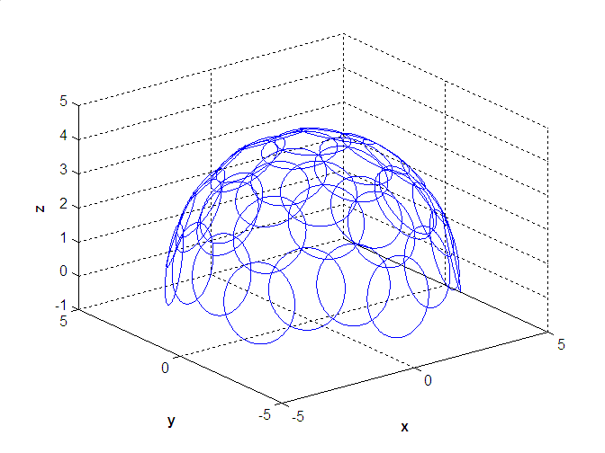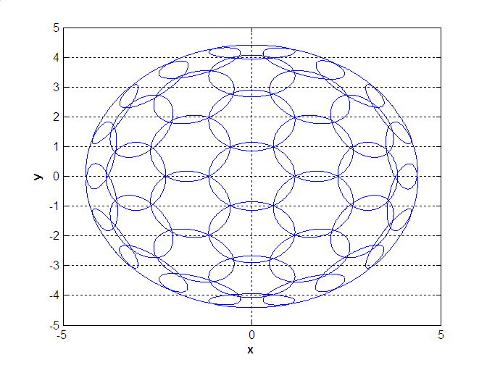
Figure 5. Example of the set of antenna positions for spherical sector coverage in reference beamforming algorithm

The used method allows obtaining a set of antenna pointing positions for arbitrary values of the antenna beamwidth and the required spherical sector.

References
- A. Maltsev et al. “Channel Models for 60 GHz WLAN Systems,” IEEE doc. 802.11-09/0334r3, July, 2009.

