IEEE P802.11
Wireless LANs
LB151 Comment Resolution for CID175
Date: 2009-06-26
Author(s):
Name | Affiliation | Address | Phone | email
Jeremy Landt | Transcore | 8600 Jefferson St. NE  Albuquerque, NM 87113 | 505-856-8015 | jerry.landt@transcore.com

Abstract
Discussion, resolution and instructions to editor for comment CID 175, LB151, IEEE P802.11p/D7.0

1. Comment 175, LB151, IEEE P802.11p/D7.0 (page and line number refer to P802.11p\D7.0 redline):

175 | Ecclesine, Peter | Annex I | 33 | 47 | TR | The measurement density sentence here does not apply to the US 4.94 GHz band (see 47 CFR 90.1215), and should be changed and moved to the end of the next insertion, which follows the end of baseline I.2.3 | Delete first inserted sentence in I.2.3, add final sentence to end of I.2.3 text "The measurements of transmit spectral density are made  using a 100 kHz resolution bandwidth and a 30 kHz video bandwidth."

Note that FCC 47 CFR 90.1215 is referenced in Table I.1—Regulatory requirement list.
2. Text cited, P802.11p/D7.0 redline document (page 33, lines 47-48, highlighted in blue):

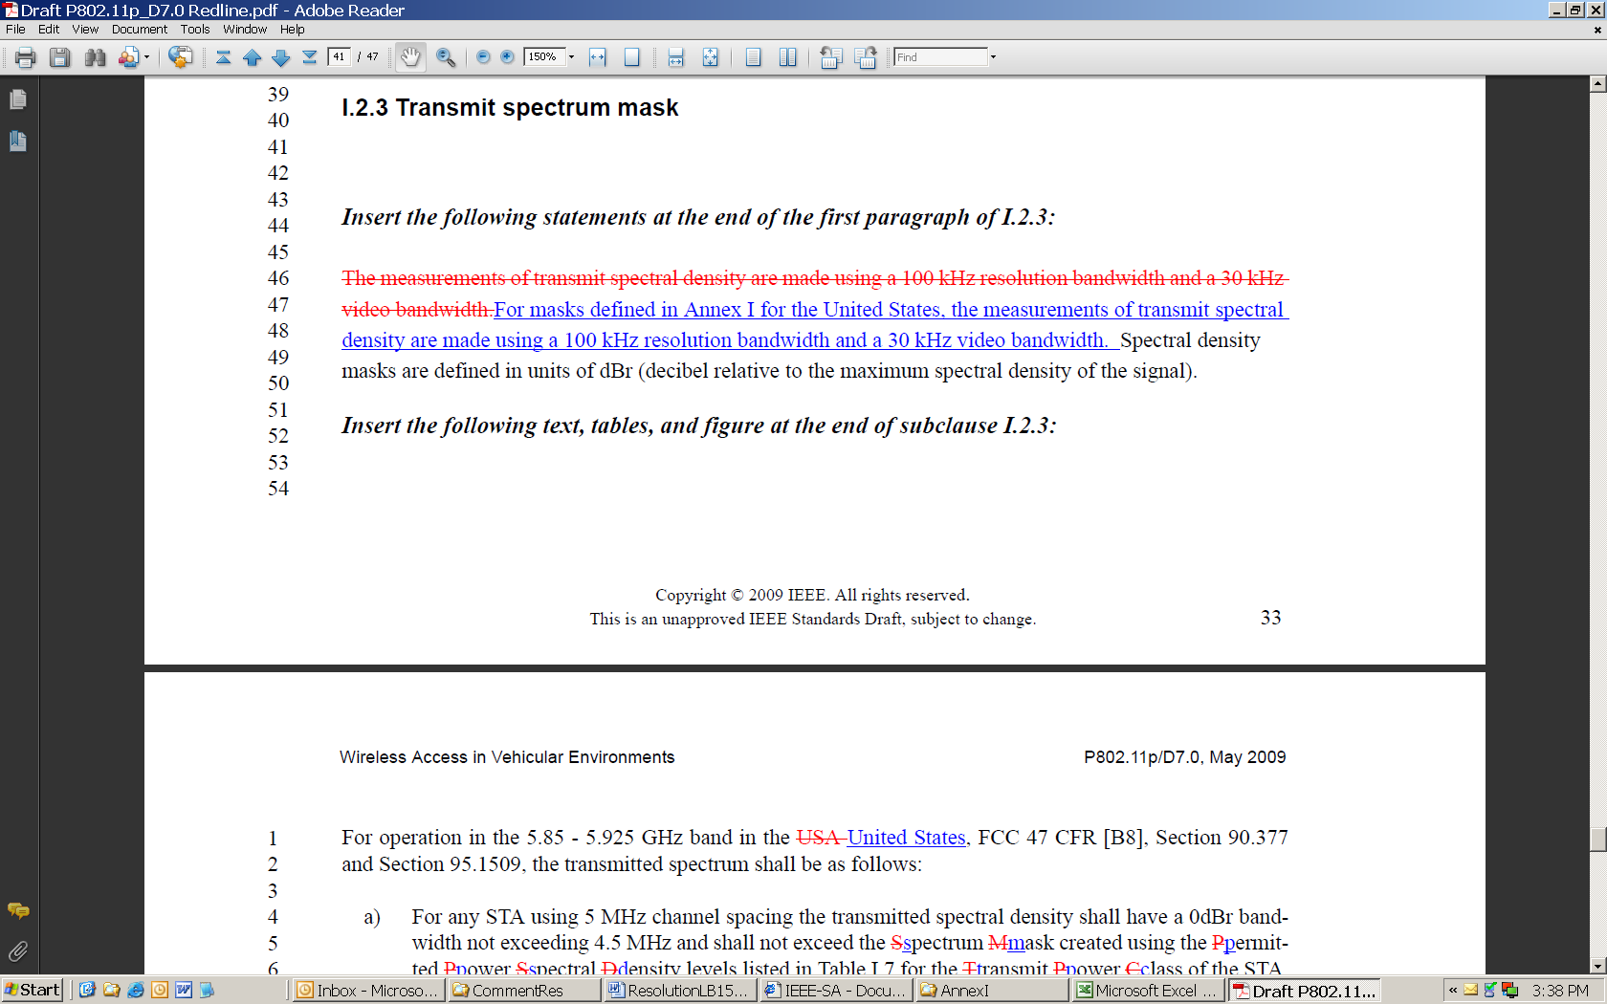

Relevant text enlarged:

The measurements of transmit spectral density are made using a 100 kHz resolution bandwidth and a 30 kHz
video bandwidth.For masks defined in Annex I for the United States, the measurements of transmit spectral
density are made using a 100 kHz resolution bandwidth and a 30 kHz video bandwidth. Spectral density
masks are defined in units of dBr (decibel relative to the maximum spectral density of the signal).
3. Text cited in corresponding P802.11p/D7.0 (page 30, lines 28-29, the first sentence):

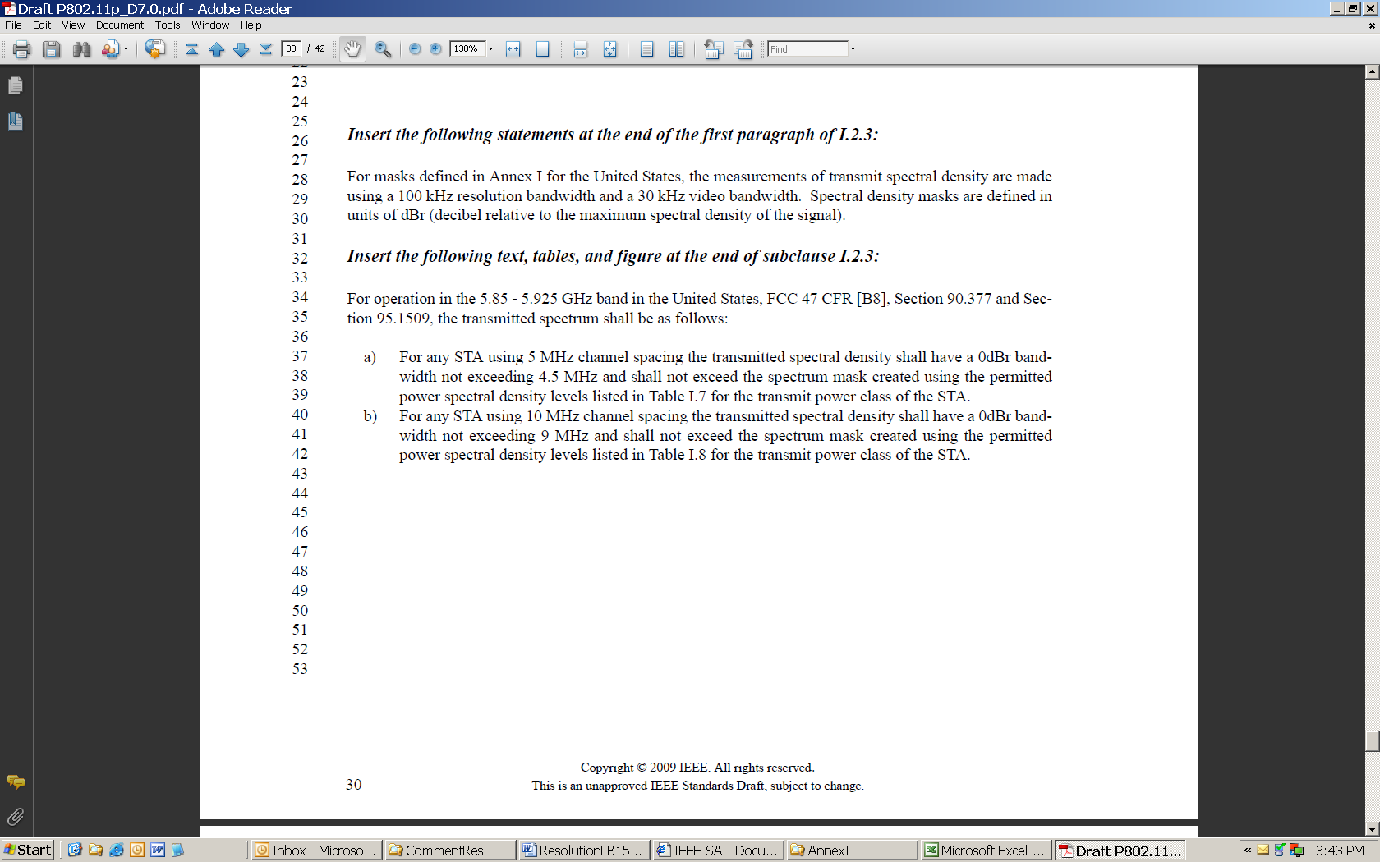

Relevant text enlarged:

Insert the following statements at the end of the first paragraph of I.2.3:
For masks defined in Annex I for the United States, the measurements of transmit spectral density are made
using a 100 kHz resolution bandwidth and a 30 kHz video bandwidth. Spectral density masks are defined in
units of dBr (decibel relative to the maximum spectral density of the signal).

4. 47 CFR 90.1215 (in part):

§ 90.1215 Power limits.
The transmitting power of stations
operating in the 4940–4990 MHz band
must not exceed the maximum limits
in this section. . . .
. . . .
High power devices are also limited
to a peak power spectral density of 21
dBm per one MHz. High power devices
using channel bandwidths other than
those listed above are permitted; however,
they are limited to a peak power
spectral density of 21 dBm/MHz. . . .
. . . .
(b) Low power devices are also limited
to a peak power spectral density of
8 dBm per one MHz. Low power devices
using channel bandwidths other than
those listed above are permitted; however,
they are limited to a peak power
spectral density of 8 dBm/MHz.
. . . .
Measurements are made over a bandwidth
of one MHz or the 26 dB emission
bandwidth of the device, whichever is
less. A resolution bandwidth less than
the measurement bandwidth can be
used, provided that the measured
power is integrated to show total
power over the measurement bandwidth.
If the resolution bandwidth is
approximately equal to the measurement
bandwidth, and much less than
the emission bandwidth of the equipment
under test, the measured results
shall be corrected to account for any
difference between the resolution bandwidth
of the test instrument and its actual
noise bandwidth.
[70 CFR 28467, May 18, 2005]
VerDate Aug<

5. Pre P802.11p contents of paragraph I.2.3 summary:

Subclause I.2.3 presently contains Transmit spectrum masks for Japan and the US band of 4.94-4.99 GHz (both high and low power). P802.11p adds the US band of 5.85-5.925 GHz.
6. Conclusion:
The text proposed to be added to the first paragraph of P802.11p/D7 subclause I.2.3 is inconsistent with the regulations governing the US band 4.94-4.99 GHz and does not apply to Japan. Thus, Comment 175 is correct and should be accepted. The spectrum masks of the US band 5.85-5.925 GHz are to be added to the end of subclause I.2.3 by P802.11p. Thus, the commenter’s proposed resolution to move the cited text to the end of subclause I.2.3 is acceptable. Comment 175 addresses only the first sentence of the proposed first insertion (which is a change from Draft 6 to Draft 7). The second sentence is an integral part of the specification and should be moved along with the first sentence to the appropriate location at the end of subclause I.2.3. However the second sentence appears to be redundant with the text in the existing insertion at the end of subclause I.2.3, and thus may be deleted.

7. Resolution and editors instructions:

7.1 Delete lines 26-30 of P802.11p/D7.0 which read:
“Insert the following statements at the end of the first paragraph of I.2.3:
For masks defined in Annex I for the United States, the measurements of transmit spectral density are made using a 100 kHz resolution bandwidth and a 30 kHz video bandwidth. Spectral density masks are defined in units of dBr (decibel relative to the maximum spectral density of the signal.”

7.2 Insert the following text at the end of the text to be inserted in subclause I.2.3 of P802.11p/D7.0, without additional editorial instructions:
“The measurements of transmit spectral density are made using a 100 kHz resolution bandwidth and a 30 kHz video bandwidth.”

8. Motion : It is moved to accept Comment 175 to P802.11p/D7.0 and instruction the editor to make the changes in P802.11p/D7.0 as provided herein above in Item 7.

Moved by __________________________________ Seconded by ________________________________________

For ________ Against _________ Abstain __________

References:

1. 11-09-0688-01-000p-lb151-tgp-comment-resolution-master.xls

2. IEEE Std 802.11TM-2007

3. IEEE Std 802.11kTM-2008

4. IEEE Std 802.11rTM-2008

5. IEEE Std 802.11yTM-2008

6. Draft P802.11wTM/D11.0

7. Draft P802.11nTM/D11.0

8. Draft P802.11zTM/D5.0

9. Draft P802.11pTM/D7.0

10. FCC 47 CFR Section 90.1215

Appendix A: Existing text of P802.11p/D7.0 subclause I.2.3

I.2.3 Transmit spectrum mask

Insert the following statements at the end of the first paragraph of I.2.3:

For masks defined in Annex I for the United States, the measurements of transmit spectral density are made
using a 100 kHz resolution bandwidth and a 30 kHz video bandwidth. Spectral density masks are defined in
units of dBr (decibel relative to the maximum spectral density of the signal).

Insert the following text, tables, and figure at the end of subclause I.2.3:

For operation in the 5.85 - 5.925 GHz band in the United States, FCC 47 CFR [B8], Section 90.377 and Section
95.1509, the transmitted spectrum shall be as follows:

a) For any STA using 5 MHz channel spacing the transmitted spectral density shall have a 0dBr bandwidth
not exceeding 4.5 MHz and shall not exceed the spectrum mask created using the permitted
power spectral density levels listed in Table I.7 for the transmit power class of the STA.
b) For any STA using 10 MHz channel spacing the transmitted spectral density shall have a 0dBr bandwidth
not exceeding 9 MHz and shall not exceed the spectrum mask created using the permitted
power spectral density levels listed in Table I.8 for the transmit power class of the STA.

The transmit spectral mask is created and applied as shown in Figure I.2 about the channel center frequency
(Fc) defined by the channel starting frequency and channel number from the regulatory class. The 0 dBr
level is the maximum power spectral density measured in the channel.

Appendix B: Proposed text of P802.11p/D7next, redline shown (applying Resolution and editors instructions of #7 above):

Insert the following statements at the end of the first paragraph of I.2.3:

For masks defined in Annex I for the United States, the measurements of transmit spectral density are made
using a 100 kHz resolution bandwidth and a 30 kHz video bandwidth. Spectral density masks are defined in
units of dBr (decibel relative to the maximum spectral density of the signal).

Insert the following text, tables, and figure at the end of subclause I.2.3:

For operation in the 5.85 - 5.925 GHz band in the United States, FCC 47 CFR [B8], Section 90.377 and Section
95.1509, the transmitted spectrum shall be as follows:

a) For any STA using 5 MHz channel spacing the transmitted spectral density shall have a 0dBr bandwidth
not exceeding 4.5 MHz and shall not exceed the spectrum mask created using the permitted
power spectral density levels listed in Table I.7 for the transmit power class of the STA.
b) For any STA using 10 MHz channel spacing the transmitted spectral density shall have a 0dBr bandwidth
not exceeding 9 MHz and shall not exceed the spectrum mask created using the permitted
power spectral density levels listed in Table I.8 for the transmit power class of the STA.

The transmit spectral mask is created and applied as shown in Figure I.2 about the channel center frequency
(Fc) defined by the channel starting frequency and channel number from the regulatory class. The 0 dBr
level is the maximum power spectral density measured in the channel. The measurements of transmit spectral density are made
using a 100 kHz resolution bandwidth and a 30 kHz video bandwidth.

Note that the tables and figures remain unmodified from P802.11p/D7.0.

