IEEE P802.11
Wireless LANs
TGn SB2 PHY Comments
Date: 2009-04-22
Author(s):
Name | Company | Address | Phone | Email
Vinko Erceg | Broadcom | 16340 W. Bernardo Dr.  San Diego, CA 92127 | +1 858 521 5885 | verceg@broadcom.com
Matthew Fischer | Broadcom |  |  | mfischer@broadcom.com
Hongyuan Zhang | Marvell
Peter Loc | Ralink

Abstract
This submission suggests resolutions of SB2 PHY comments. The following CIDs are addressed: CID 2001, 2005, 2017, 2027, and 2028.

The changes marked in this document are based on TGn Draft 9.0

Revision History:

Rev 0: Initial version.
Rev 1: Proposed resolution to CID 2017 was changed and resolutions to CID 2027 and 2028 updated.
Rev 2: Proposed resolution to CID 2017 was changed.
Rev 3: Proposed resolution to CID 2017 was changed.
Rev 4: Proposed resolution to CID 2017 was changed.
Rev 5: Proposed resolution to CID 2017 was changed.
Rev 6: Proposed resolution to CID 2017 was changed.

CID Sec. Pg. Ln. Comment Proposal Proposed Resolution

2001 |  |  |  | Include option for protocol-assisted switched diversity to enable single-stream handheld devices (e.g. phones) to use multiple antennas and concatenated spread-coded bursts to achieve reduced packet loss using simple receiver and transmitter archtectures. Handheld devices are more likely to experience fades during packets because of local movement. These devices will also be more challenged on power use and cost, mandating simpler processing architectures. | See November 2007 contribution regarding PASD. Include implementation language and capability bit to allow multiple bursts of same MSDU to be sent, but received using different antennas with intermediate storage of soft symbols between bursts separated by RIFs using the same space-time coding as 2x2 MIMO implementation, but with diversity switch action between 1st and 2nd burst. The bursts received using two switched antennas emulate reception of a single burst with reception at two simultaneous antennas. The PASD option is to be applied only to a single-stream mobile device, not to the AP (except that the AP provides additional packet redundancy to such devices). This allows the mobile device to use its two antennas more effectively than would be the case with simple switched diversity. The increased overhead that results from redundant transmission is compensated for by the reduction in repeat overhead to achieve transmission success, which uses more radio resource than PASD. The technique also reduces dropouts (timeouts) and latency for VoIP clients, which are inherently challenged by their streaming media focus, operation while users are moving, battery life limitations, and poorer antenna performance.  Note: The PASD option may be invoked only when a device declares that it  has the capability and that its PER has become unacceptable. | Disagree. Explanation: TGn specification mandates support of 2 spatial streams at an AP and 1 spatial stream at a STA. As a result, all TGn specification compliant APs must have at least two antennas for the reception/transmission. This means that STBC or Beamforming may be used during the transmission. Therefore, it is not necessary to mandate alternate diversity techniques as proposed in the comment that require buffering at the receiver, an additional antenna and a switch. In addition, the proposed technique may yield overhead since the same burst has to be transmitted twice when compared to the STBC transmissions (STBC transmissions at the two transmit AP antennas are simultaneous, no overhead). In the presentation 07/2796r0 no comparison was shown to alternate techniques such as STBC and Beamforming, and also overhead due to retransmissions was not accounted for in the results. The STBC and Beamforming techniques do not require an additional STA antenna, an antenna switch and burst buffering at STAs. To add PASD option on the top of STBC and Beamforming may not be trivial, and uplink/downlink transmissions may become unbalanced (possibly 4th order diversity on the downlink and 2 order diversity on the uplink direction) assuming 2 AP antennas and 2 switched diversity STA antennas employing PASD.

CID Sec. Pg. Ln. Comment Proposal Proposed Resolution

2005 |  |  |  | STBC modes should be mandatory, as they improve range and robustness | Remove TxSTBC from the HT Capabilities element, and change to "Reserved" the value 0 of RxSTBC in the HT Capabilities element. Change the statement regarding STBC in 20.1.1 (page 245 line 37) from being optional to mandatory. | Disagree. For the complexity reasons, STBC technique was defined as optional. Same was defined for other features like Beamforming and LDPC, for example. Some of the implementations may require only basic set of features because of the power, cost and chip area optimization reasons. After reviewing this comment the committee has decided to decline the suggestion of the commenter.

CID Sec. Pg. Ln. Comment Proposal Proposed Resolution

2017 | 9.21.2 | 192 | 41 | There is no need to limit MM NDPs to two or more spatial streams. I can see why it is needed for GF NDPs, simply because then the signal fields need to be processed very fast to be able to see that no symbols are following the signal fields. For MM NDPs with 1 spatial stream, the HT-STF and HT-LTF are following the signal fields so there is enough time there to decode and parse the signal fields. | Change "MCS shall indicate two or more spatial streams" to "When the TXVECTOR parameter FORMAT is set to HT_GF, MCS shall indicate two or more spatial streams". | Agree in principle.

Proposed Resolution: Agree in principle.

Discussion: Restriction that “MCS shall indicate two or more spatial streams” in the case of NDP transmissions was established becase of the GF transmissions when data follows immediately after the SIG field (single stream devices). This may not allow enough time for parsing of the SIG field. This creates a problem during the calibration procedure with the proposed solution below.

TGn Editor: on page 79, line 8, modify Table 7-43o, 3rd column of “Transmit NDP Capable” as follows:

“Set to 0 if not supported
Set to 1 if supported
If the Receive NDP Capable is supported and
the value of Calibration field is set to 1 or 3,
value of this field is set to 1

TGn Editor: at the end of clause 9.19.2.4.2 Calibration Capabilities, insert the following sentence:

If the Receive NDP Capable field is set to 1, and the value of the Calibration field is set to 1 or 3, and if the device supports transmitting sounding PPDUs for which two or more channel dimensions can be estimated (two or more columns of the MIMO channel matrix), then transmission of NDPs shall be supported (which causes the Transmit NDP Capable bit to be set to 1).

TGn Editor: on page 181, line 60, modify the Figure 9-34 as follows:

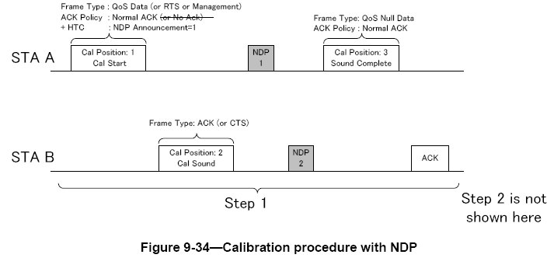

TGn Editor: on page 181, add new Figure 9-34a and modify the text following Figure 9-34 of D9.0 as:

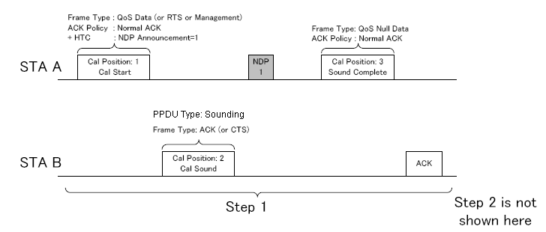
Figure 9-34a—Calibration procedure with NDP in the case STA B supports transmitting sounding PPDUs for which only one channel dimension can be estimated (i.e., a single column of the MIMO channel matrix)

The calibration procedure begins with a calibration sounding PPDU exchange sequence, shown as Step 1 in
Figure 9-34 (Calibration procedure with NDP), and Figure 9-34a (Calibration procedure with NDP in the case STA B supports transmitting sounding PPDUs for which only one channel dimension can be estimated (i.e., a single column of the MIMO channel matrix)) when STA B supports transmitting sounding PPDUs for which only one channel dimension can be estimated (i.e., a single column of the MIMO channel matrix). The Calibration Sequence subfield in the HT Control field shall be incremented each time a new calibration procedure is started.

TGn Editor: on page 182, from line 8, modify text as follows:

“If the frame that signals the calibration start requires an immediate MAC response, STA B shall transmit a
frame that signals calibration sounding response (i.e., with the Calibration Position field set to 2) a SIFS
interval after the received calibration start frame. If STA B supports transmitting sounding PPDUs for which only one channel dimension can be estimated (i.e., a single column of the MIMO channel matrix), this calibration sounding response is sent with the SOUNDING parameter of the TXVECTOR set to SOUNDING (see Figure 9-34a).

As determined by NDP rules a) or b) in 9.21.1 (NDP Rules), STA A sends the first NDP as a sounding PPDU
a SIFS after receiving the frame that signals calibration sounding response or a SIFS after transmitting the
frame that signals calibration start if a MAC response is not implied by the frame that signals calibration start.
This allows STA B to estimate the MIMO channel from STA A to STA B. In the frame that signals calibration
sounding response, the Calibration Sequence subfield in HT Control field shall be set to the same value that
is contained in the frame that signals calibration start. The frame that signals calibration sounding response
shall contain an HT Control field and the type and subtype of the frame are determined by the frame that signals
the calibration start.

As determined by NDP rule d), STA B, might transmit a second NDP as a sounding PPDU a SIFS interval after receiving the first NDP. This second NDP allows STA A to estimate the MIMO channel from STA B to STA A. Any second NDP shall be followed by a +HTC frame that signals calibration sounding complete (i.e., with the Calibration Position field set to 3) a SIFS after the NDP from STA B.
NOTE--If STA B supports transmitting sounding PPDUs for which only one channel dimension can be estimated (single column of the MIMO channel matrix), this second NDP is not be transmitted (see Figure 9-34a).

Otherwise, (i.e. - if STA B supports transmitting sounding PPDUs for which only one channel dimension can be estimated (single column of the MIMO channel matrix)), the transmission of the sounding PPDU in Calibration Position 2 allows STA A to estimate the channel from STA B to STA A. The first NDP shall be followed by a +HTC frame that signals calibration sounding complete (i.e., with the Calibration Position field set to 3) a SIFS after the NDP from STA B.

In the frame……”

TGn Editor: on page 192, line 7, modify the NDP rule text as follows:

“d) A SIFS interval after receiving an NDP from a STA whose NDP announcement contained one or more +HTC frames with the Calibration Position field set to 1, when the receiving STA supports transmitting sounding PPDUs for which more than one channel dimensions can be estimated (i.e., more than one column of the MIMO channel matrix).”

TGn Editor: on page 80, lines 39-42, modify NOTE at the bottom of table 7-43o as follows:

“NOTE—The maximum number of space time streams for which channel coefficients can be simultaneously estimated during the data portion of using the HT long training fields corresponding to the data portion of the packet is limited by 1) the Rx MCS Bitmask subfield of the Supported MCS Set field and 2) the Rx STBC subfield, both of the HT Capabilities element.”

TGn Editor: on page 172, lines 6-8, modify NOTE as follows:

“NOTE—The maximum number of space time streams for which channel coefficients can be simultaneously estimated during the data portion of using the HT long training fields corresponding to the data portion of the packet is limited by 1) the Rx MCS Bitmask subfield of the Supported MCS Set field and 2) the Rx STBC subfield, both of the HT Capabilities element.”

TGn Editor: on page 528, lines 40-55, modify text as follows:

"The HT channel estimation capability indicates the maximum number
of space time streams for which channel dimensions can be
simultaneously estimated when receiving an NDP sounding PPDU or the
extension portion of the HT long training fields in a staggered
sounding PPDU. The maximum number of space time streams for which
channel coefficients can be simultaneously estimated during the
data portion of the HT long training fields is limited by 1) the Rx
MCS Bitmask subfield of the Supported MCS Set field and 2) the Rx
STBC subfield, both of the HT Capabilities element. Set to 0 for 1
space time stream, set to 1 for 2 space time streams, set to 2 for
3 space time streams, set to 3 for 4 space time streams. See
7.3.2.56.6 (Transmit Beamforming Capabilities)"

CID Sec. Pg. Ln. Comment Proposal Proposed Resolution

2027 | 20.3.22.6 | 335 | 20 | RCPI specification indicates +/- 5dB accuracy. This extremely poor measurement accuracy is used in PHY clauses 15, 17, 18 and 19 in order to permit older (circa 2003) PHY chip implementations to provide a standardized power measurement. The +/- 5db accuracy specified in 2003 was based on the limited and antiquated capabilities of these older legacy PHY chips. Many older implementations only measured signal power during preamble acquisition. When frame power measurement is extended over much longer periods much more accuracy may be achieved. RCPI has been defined to measure power over the data portion of the received frame and over all the active receive chains; this greatly improves RCPI measurement accuracy. For newer PHYs, like 11n, with recent chip level implementations (2007 and later), a more reasonable and more useful accuracy specification is needed. Since most manufacturers already have first generation 11n chips on the market, this improved RCPI accuracy should be optional. | P335L20 change " range of the receiver." to " range of the receiver. RCPI measurement may be made with improved accuracy (see Annex A)." | Disagree. PICS is not intended for providing performance measures, it indicates conformance and should not be used otherwise. In addition, preamble and other fields of 2003 devices in many cases are very similar to 2007 and later devices.

CID Sec. Pg. Ln. Comment Proposal Proposed Resolution

2028 | Annex A | 399 | 59 | TGn must specify improved RCPI accuracy as an option. Optional accuracy is specified over a limited power range. | Insert 4 new rows in table as follows:  HTP2.12.3 | RCPI improved accuracy: +/-4dB in range -30dBm to -90dBm | 20.3.22.6 | CF16:O  HTP2.12.4 | RCPI improved accuracy: +/-3dB in range -30dBm to -90dBm | 20.3.22.6 | HTP2.12.3:O  HTP2.12.5 | RCPI improved accuracy: +/-2dB in range -30dBm to -90dBm | 20.3.22.6 | HTP2.12.4:O  HTP2.12.6 | RCPI improved accuracy: +/-1dB in range -30dBm to -90dBm | 20.3.22.6 | HTP2.12.5:O | Disagree. PICS is not intended for providing performance measures, it indicates conformance and should not be used otherwise. In addition, preamble and other fields of 2003 devices in many cases are very similar to 2007 and later devices.

