IEEE P802.11
Wireless LANs
Channel Models for 60 GHz WLAN Systems
Date: 2009-11-16
Author(s):
Name | Affiliation | Address | Phone | email
Alexander Maltsev | Intel | Turgeneva str., 30,  Nizhny Novgorod, 603024, Russia | +7-831-2969461 | alexander.maltsev@  intel.com
Vinko Erceg | Broadcom |  |  | verceg@broadcom.com
Eldad Perahia | Intel |  |  | eldad.perahia@intel.com
Chris Hansen | Broadcom |  |  | chansen@broadcom.com
Roman Maslennikov | University of Nizhny Novgorod |  |  | roman.maslennikov@  wcc.unn.ru
Artyom Lomayev | Intel |  |  | artyom.lomayev@  intel.com
Alexey Sevastyanov | Intel |  |  | alexey.sevastyanov@  intel.com
Alexey Khoryaev | Intel |  |  | alexey.khoryaev  @intel.com
Abstract
Description of channel models for 60 GHz Wireless Local Area Networks (WLANs) systems based on the results of experimental measurements.

Revision History

- Mar 2009 – Initial version describing the channel model between two STAs on the table in the conference room.
- May 2009 – Updated with an introduction of the path loss model for the conference room scenario.
- May 2009 – Editorial changes.
- July 2009 – Updated with introduction of polarization characteristics support and addition of the second conference room scenario for the channel model between a STA on the table and an AP near the ceiling.
- November 2009 – Section 5 updated to include inter cluster parameters for the home living room scenario. New Section 6.1 describing the application of transmit and receive antennas to the channel model is added.
Table of Contents

1 Introduction 3
2 General Characteristics of Channel Model 3
2.1 Requirements for Channel Model 3
2.2 General Structure of Channel Model 3
2.3 Model Development Methodology 5
2.4 Polarization Characteristics Support 5
2.5 Usage of Channel Model in Simulations 9
3 Conference Room Channel Model 11
3.1 Measurements and Modeling Scenarios 11
3.2 Model Development Methodology 11
3.3 Inter Cluster Parameters for STA-STA Sub-scenario 14
3.4 Polarization Impact Modeling for STA-STA Sub-scenario 24
3.5 Inter Cluster Parameters for STA-AP Sub-scenario 31
3.6 Polarization Impact Modeling for STA-AP Sub-scenario 37
3.7 Intra Cluster Parameters 40
4 Channel Model for Cubicle Environment 42
5 Living Room Channel Model 42
5.1 Modelling Scenario 42
5.2 Model Development Methodology 43
5.3 Inter Cluster Parameters 45
5.4 Polarization Impact Modelling 63
5.5 Intra Cluster Parameters 63
6 Antenna Models and Beamforming Algorithms 64
6.1 Application of Transmit and Receive Antennas to Channel Model 64
6.2 Isotropic Radiator 65
6.3 Basic Steerable Directional Antenna Model 65
6.4 Phased Antenna Array 70
7 Path Loss 75
7.1 Path Loss Modeling 75
7.2 Path Loss Model for Conference Room 75
7.3 Path Loss Model for Cubicle Environment 82
7.4 Path Loss Model for Living Room 82
7.5 Path Loss Model Summary 82
8 Interference Environment Modeling 83
9 References 84

Introduction
This document describes the channel models for 60 GHz Wireless Local Area Networks (WLANs) systems based on the results of experimental measurements. The goal of the channel modeling is to assist 60 GHz WLAN standardization process.
The document proposes a general structure of a new channel model which takes into account important properties of 60 GHz electromagnetic waves propagation. This model is then applied to different channel modeling scenarios by using appropriate model parameters. The current revision of this document presents a detailed description and parameters of the channel model for a conference room scenario. The channel model allows for generating a channel realization that includes space, time, amplitude, phase, and polarization characteristics of all rays comprising this channel realization. The space characteristics of rays include azimuth and elevation angles for both transmit and receive sides.
Three basic channel modeling scenarios are proposed in accordance with the proposal for the TGad Evaluation Methodology (EVM) document [1]. These are conference room, cubicle and living room scenarios.
Reference antenna models that may be applied to the generated space-time channel realizations are implemented in the channel model and are described. Three types of antenna models are proposed to be used together with the channel model. These are isotropic antenna, basic steerable directional antenna and phased antenna array models.

General Characteristics of Channel Model

Requirements for Channel Model
The following are requirements of channel models for 60 GHz WLAN systems [2], [3] taking into account properties of 60 GHz channels and applications of 60 GHz WLAN technology:
- Provide accurate space-time characteristics of the propagation channel (basic requirement) for main usage models of interest;
- Support beamforming with steerable directional antennas on both TX and RX sides with no limitation on the antenna technology (i.e. non-steerable antennas, sector-switching antennas, antenna arrays);
- Account for polarization characteristics of antennas and signals;
- Support non-stationarity characteristics of the propagation channel arising from people motion around the area causing time-dependent channel variations.

General Structure of Channel Model
The current version of the document proposes a channel structure model that provides accurate space-time characteristics and supports application of any type of directional antenna technology. The model allows for generating channel impulse responses with and without polarization characteristics support. For the sake of description simplicity, this section first gives a structure of the channel model without polarization characteristics and then shows how the model is extended to account for polarization characteristics.
The channel impulse response function for the channel model without polarization characteristics support may be written using a general structure as:
$$\begin{aligned}h\left(t,ϕ_{\text{tx}},θ_{\text{tx}},ϕ_{\text{rx}},θ_{\text{rx}}\right)=\sum_{i}{A^{(i)}C^{(i)}\left(t−T^{(i)},ϕ_{\text{tx}}−Φ_{\text{tx}}^{(i)},θ_{\text{tx}}−Θ_{\text{tx}}^{(i)},ϕ_{\text{rx}}−Φ_{\text{rx}}^{(i)},θ_{\text{rx}}−Θ_{\text{rx}}^{(i)}\right)} \\ C^{(i)}\left(t,ϕ_{\text{tx}},θ_{\text{tx}},ϕ_{\text{rx}},θ_{\text{rx}}\right)=\sum_{k}{α^{(i,k)}δ\left(t−τ^{(i,k)}\right)δ\left(ϕ_{\text{tx}}−ϕ_{\text{tx}}^{(i,k)}\right)δ\left(θ_{\text{tx}}−θ_{\text{tx}}^{(i,k)}\right)δ\left(ϕ_{\text{rx}}−ϕ_{\text{rx}}^{(i,k)}\right)δ\left(θ_{\text{rx}}−θ_{\text{rx}}^{(i,k)}\right)}\end{aligned}$$ | ()
where:
- h is a generated channel impulse response.
- t, j_{tx}, _{tx}, j_{rx}, _{rx} are time and azimuth and elevation angles at the transmitter and receiver, respectively.
- A^{(i)} and C^{(i)} are the gain and the channel impulse response for i-th cluster respectively.
- ( )- is the Dirac delta function.
- T^{(i)}, F_{tx}^{(i)}, Q_{tx}^{(i)}, F_{rx}^{(i)}, Q_{rx}^{(i)} are time-angular coordinates of i-th cluster.
- a^{(i,k)} is the amplitude of the k-th ray of i-th cluster
- ^{(i,k)}, j_{tx}^{(i,k)}, _{tx}^{(i,k)}, j_{rx}^{(i,k)}, _{rx}^{(i,k)} are relative time-angular coordinates of k-th ray of i-th cluster.
The proposed channel model adopts the clustering approach with each cluster consisting of several rays closely spaced in time and angular domains. In a real environment, time and angular parameters of different clusters and rays are time varying functions due to a non-stationary environment. However, the rate of these variations is relatively slow. In this document all time and angular parameters of the model were treated as virtually time-invariant random variables. The support of time varying channel model will be provided later. The main source of non-stationarity is envisaged to be the people motion.
As it is further described in Section 2.4, support of polarization characteristics requires the channel impulse response to be a 2x2 channel matrix rather than just a scalar as in (). A 2x2 matrix is required to describe the propagation channel between two orthogonal orientations of the electric field vector E on the transmit and receive sides.
Based on experimental results and theoretical analysis of the phenomenon, the polarization characteristics of the model were introduced at the cluster level, assuming that all rays comprising one cluster have (approximately) the same polarization characteristics. Therefore, extending the channel structure for polarization support requires changing scalar cluster gain coefficients A^{(i)} in () by 2x2 cluster polarization matrices H^{(i)}, and the channel impulse responses realization to be described by matrix h:
$$h\left(t,ϕ_{\text{tx}},θ_{\text{tx}},ϕ_{\text{rx}},θ_{\text{rx}}\right)=\sum_{i}{H^{(i)}C^{(i)}\left(t−T^{(i)},ϕ_{\text{tx}}−Φ_{\text{tx}}^{(i)},θ_{\text{tx}}−Θ_{\text{tx}}^{(i)},ϕ_{\text{rx}}−Φ_{\text{rx}}^{(i)},θ_{\text{rx}}−Θ_{\text{rx}}^{(i)}\right)}$$ | ()
The structure of the model for intra cluster channel impulse response C^{(i)} is kept unchanged from (). More details on support of polarization characteristics are elaborated in Section 2.4. Simulation of the channel model without support of polarization characteristics corresponds (approximately) to the case of both antennas having horizontal linear polarization as was the case in the measurement setup used to collect the data for the conference room scenario.
The same general structure of the channel model () and () was used for all three considered modeling scenarios. However, statistical characteristics of different time and angular parameters of the channel model are specific for each scenario. To further improve the accuracy of the propagation channel prediction, two additional channel modeling mechanisms are introduced. First, the clusters within each scenario are classified into different types (e.g. first and second order reflections from walls are different types of clusters) with specific statistical characteristics of inter cluster parameters. Second, some of parameters of individual clusters within the same cluster type are described by taking into account their statistical dependence. These approaches improve the accuracy of the propagation channel modeling. This was verified by directly comparing the channel model with experimental data and ray-tracing simulations.

Model Development Methodology
As it follows from the proposed general model structure (), (), the inter cluster and intra cluster temporal and spatial parameters need to be specified to define the channel model for some scenario. It was verified by several experimental measurements ([4]-[7]) that 60 GHz propagation channel is clustered and the clusters correspond with a good accuracy to signal propagation paths predicted by ray-tracing techniques. This fact was taken into account in the used channel model development methodology.
The amount of experimental data was limited and to generate the inter cluster characteristics (clusters time of arrival, azimuth and elevation angles of arrival and departure) ray-tracing was used. Exploitation of ray-tracing approach allowed for significant increase in available channel clusters realizations used to derive the statistical channel model parameters. For example in the conference room scenario, the application of ray tracing approach allowed to increase the number of channel realizations from about 15 experimental realizations to 100 000 ray-tracing realizations.
However, intra cluster parameters cannot be predicted using ray-tracing and the intra cluster structure was derived from available measurement data. The intra cluster model development was facilitated by the fact that each experimental realization includes several (typically about 10) channel clusters to average over.
Special considerations are required to support polarization characteristics. The approach used to account for polarization impact is described in Section 2.4.

Polarization Characteristics Support

Polarization Impact for 60 GHz WLAN Systems
Polarization is a property of EM waves describing the orientation of electric field E and magnetic intensity H orientation in space and time. The vector H due to properties of EM waves can always be unambiguously found if E orientation and the direction of propagation are known. So the polarization properties are usually described for E vector only.
Due to properties of 60 GHz propagation channel, the impact of polarization characteristics is significant and is substantially higher than for below 6 GHz WLAN bands. The physical reason for the high impact of polarization characteristics is that even NLOS (reflected) signals remain strongly polarized (i.e. coupling between orthogonal polarization modes is low) and cross-polarization discrimination (XPD) is high even for NLOS signals. The polarization of signals is changed by reflections and different types of antenna polarizations provide different received signal power for various types of clusters (e.g., LOS, first-order reflection, second-order reflection). Experimental proof of the strong polarization impact on 60 GHz WLAN systems was given in [8]. It was demonstrated that a mismatch in polarization characteristics of the transmit and receive antennas can result in a degradation of 10-20 dB. Therefore, accurate account for polarization characteristics in the 60 GHz WLAN channel models is necessary.
To support polarization impact in the channel model, polarization characteristics of antennas and polarization characteristics of the propagation channel should be introduced. An approach to introduce polarization characteristics into the 60 GHz WLAN channel models was proposed in [9]. This approach was used as a basis for the development of the polarization model used in this document. The next sections provide details of this approach.

Antenna Polarization Properties
In order to develop a polarization impact mode, the description of the polarization properties of antennas should be agreed upon.
In the far field zone of the EM field radiated by the antenna, the electric vector E is a function of the radiation direction (defined by the azimuth angle  and elevation angle  in the reference coordinate system) and decreases as r⁻¹ with increase of the distance r. An illustration of the transmitted E vector in the far field zone is shown in Figure 1.
Figure 1. Transmitted E vector in the far field zone
Vector E is perpendicular to the propagation direction k and can be decomposed into two orthogonal components: E and E_{φ} that belong to the planes of constant φ and constant  angles respectively. Knowledge of E and E_{φ} of the radiated signal (which may be functions of φ and ) fully describes polarization characteristics of the antenna in the far field zone.

Polarization Properties Description Using Jones Vector
Wave polarization can be described using Jones calculus introduced in optics for description of the polarized light. In the general case, a Jones vector is composed from two components of the electric field of the EM wave. The Jones vector e is defined as the normalized two-dimensional electrical field vector E. The first element of the Jones vector may be reduced to a real number. The second element of this vector is complex and, in the general case, defines phase difference between orthogonal components of the E field.
For antenna polarization model used in this document, the orthogonal components of Jones vector are defined for E and E_{φ} components respectively. Examples of antennas polarization description using Jones vector are shown in Table 1.
Table 1. Examples of antennas polarization description using Jones vector
Antenna polarization type | Corresponding Jones vector
Linear polarized in the q-direction | $$\left(\begin{matrix}1 \\ 0\end{matrix}\right)$$
Linear polarized in the φ-direction | $$\left(\begin{matrix}0 \\ 1\end{matrix}\right)$$
Left hand circular polarized (LHCP) | $$\frac{1}{\sqrt{2}}\begin{aligned}\left(1 | \right) \\ \end{aligned}$$
Right hand circular polarized (RHCP) | $$\frac{1}{\sqrt{2}}\begin{aligned}\left(1 | \right) \\ \end{aligned}$$

Polarization Characteristics of Propagation Channel
With the selected E field bases (E and E_{φ} components) for the TX and RX antennas, the polarization characteristics of each ray of the propagation channel may be described by channel polarization matrix H.
In this case, the transmission equation for a single ray channel may be written as:
$$y=e_{\text{RX}}^{H}{\text{He}}_{\text{TX}}x$$ | ()
where x and y are the transmitted and received signals, e_{TX} and e_{RX} are the polarization (Jones) vectors for the TX and RX antennas respectively. Components of polarization matrix H define gain coefficients between the E and E_{φ} components at the TX and RX antennas.
For the LOS signal path, matrix H_{LOS} is close to the identity matrix (non-diagonal components may be non-zero but significantly smaller than diagonal elements) multiplied by the corresponding gain coefficient due to path loss. LOS propagation does not change polarization characteristics of the signals. However, polarization characteristics of the signals are changed upon reflections. The change of the polarization characteristics upon reflection is defined by the type of the surface and the incident angle. Thus, polarization characteristics may be different for different clusters but are similar for the rays comprising one cluster. For this reason, the polarization impact was modeled at the cluster level with all rays inside one cluster having the same polarization properties. Modeling polarization impact at the level of individual rays would unnecessary complicate the model and would not provide any essential increase of the model accuracy. Account for polarization at the cluster level is included in the general structure of the model with polarization characteristics support given in ().

Polarization Channel Matrix for First and Second Order Reflections
It is known that reflection coefficients are different for E field components parallel and perpendicular to the plane of incidence and depend on the incident angle. Theoretical coupling between parallel and perpendicular components of the reflected signal is zero for plane media interfaces (boundaries). But due to non-idealities (roughness) of the surfaces some coupling always exists in the real channels.
An example of a first order reflected signal path is shown in Figure 2.
Figure 2. First order reflected signal path
The polarization matrix for the first order reflected signal path may be found as a product of the matrix that rotates E vector components from the coordinate system associated with the TX antenna to the coordinate system associated with the incident plane. Next, reflection matrix R with reflection coefficients and cross-polarization coupling coefficients is applied, followed by a rotation to the coordinate system associated with the RX antenna. Thus, the channel propagation matrix for the case of the first order reflected signals may be defined as:
$$H_{\text{ref}1}=\left[\begin{matrix}\text{cos}\left(ψ_{\text{rx}}\right) & \text{sin}\left(ψ_{\text{rx}}\right) \\ −\text{sin}\left(ψ_{\text{rx}}\right) & \text{cos}\left(ψ_{\text{rx}}\right)\end{matrix}\right]underbracealignl\underset{\text{of} \text{polarization}}{\underbrace{\begin{aligned}\text{recalculation}\end{aligned}}}\text{vector} \text{from} \text{the}\text{plane}\text{of}\text{incidence} \text{basis} \text{to} \text{RX}\text{coordinates}×\left[\begin{matrix}R_{}\left(α_{\text{inc}}\right) & ξ_{1} \\ ξ_{2} & R_{||}\left(α_{\text{inc}}\right)\end{matrix}\right]underbracealignc\underset{\text{matrix}}{\underbrace{\begin{aligned}\text{reflection}\end{aligned}}}R×\left[\begin{matrix}\text{cos}\left(ψ_{\text{tx}}\right) & \text{sin}\left(ψ_{\text{tx}}\right) \\ −\text{sin}\left(ψ_{\text{tx}}\right) & \text{cos}\left(ψ_{\text{tx}}\right)\end{matrix}\right]underbracealignl\underset{\text{of} \text{TX} \text{polarization}}{\underbrace{\begin{aligned}\text{recalculation}\end{aligned}}}\text{vector} \text{to} \text{the}\text{plane}\text{of incidence} \text{basis}$$ | ()
The reflection matrix R includes the reflection coefficients R^ and R|| for the perpendicular and parallel components of the electric field E ^ and E || respectively. Elements x₁ and x₂ in the matrix R are cross-polarization coupling coefficients.
Note that the structure of matrix H given in () does not include the propagation loss along the corresponding reflected path, which should be taken into account in the final model, but does not impact polarization properties.
Similar to (), the structure of polarization matrix H for a second order reflection is given in () and includes additional rotation and reflection matrices.
$$\begin{aligned}\underset{1\text{st} \text{reflection}}{\underbrace{H_{\text{ref}2}=\underset{2\text{nd} \text{reflection}}{\underbrace{\left[\begin{matrix}\text{cos}\left(ψ_{\text{rx}}\right) & \text{sin}\left(ψ_{\text{rx}}\right) \\ −\text{sin}\left(ψ_{\text{rx}}\right) & \text{cos}\left(ψ_{\text{rx}}\right)\end{matrix}\right]×\left[\begin{matrix}R_{}\left(α_{2\text{inc}}\right) & ξ_{1} \\ ξ_{2} & R_{||}\left(α_{2\text{inc}}\right)\end{matrix}\right]}}××\left[\begin{matrix}\text{cos}\left(ψ_{p}\right) & \text{sin}\left(ψ_{p}\right) \\ −\text{sin}\left(ψ_{p}\right) & \text{cos}\left(ψ_{p}\right)\end{matrix}\right]×\left[\begin{matrix}R_{}\left(α_{1\text{inc}}\right) & ξ_{1} \\ ξ_{2} & R_{||}\left(α_{1\text{inc}}\right)\end{matrix}\right]}}×\left[\begin{matrix}\text{cos}\left(ψ_{\text{tx}}\right) & \text{sin}\left(ψ_{\text{tx}}\right) \\ −\text{sin}\left(ψ_{\text{tx}}\right) & \text{cos}\left(ψ_{\text{tx}}\right)\end{matrix}\right]\end{aligned}$$ | ()
To obtain statistical models for different types of reflected clusters, the following methodology was proposed. First, (statistical) models for the elements of the reflection matrix R are defined. This may be accomplished by using available experimental data (e.g. [10]) or theoretical Fresnel formulas. Then ray-tracing of interesting environments (conference room, cubicle environment, and living room) is performed with taking into account geometry and polarization characteristics of the propagation channel. After that multiple realizations of the channel polarization matrices H for different types of clusters are found and their statistical models are derived by approximation of the calculated empirical distributions.
Note that there are generally two mechanisms for depolarization (coupling between orthogonal components of the E vector at the TX and RX sides). These are reflection coupling (coupling between parallel and perpendicular E vector components at the reflection) and geometrical coupling (coupling because of the different relative orientations of the TX and RX antennas). It may be seen that the proposed approach allows accounting for both mechanisms to create an accurate polarization impact model.

Usage of Channel Model in Simulations
This subsection gives a brief description of the channel realization generation process that is implemented in the channel model. The whole process of the channel realization generation is schematically shown in Figure 3.
Figure 3. Process of channel realization generation
The generation of the channel impulse response begins with selecting model input parameters.
The next step is generation of all possible channel clusters between the transmitter and receiver. Amplitude, time, and angular and polarization characteristics for all clusters are generated.
In a real environment not all the clusters are available for communication, some of the clusters are blocked by people, furniture, and other objects. To take this into account, a part of the clusters is blocked in the channel model. The blocked part of the clusters is selected randomly. Each cluster has an individual probability of being blocked. This probability is independent from the blockage probabilities of other clusters.
After a subset of non-blocked clusters is defined the intra cluster parameters for each non-blocked cluster are generated. Each cluster consists of multiple rays and the output of this step includes amplitude, phase, time, and angular parameters for all rays of the given channel realization. After this step the generation of channel realization is completed. But in order to be used a simulation, antenna models must be applied to the generated realization and it must be converted from continuous to discrete time.
Reference antenna models and beamforming algorithms are included, which may be applied in the next step of the channel realization generation process. The beamforming algorithms may have input from the baseband, for example, setting the weight vector of antenna array.
In the last step the channel impulse is converted from continuous time to discrete time with the specified sample. After this step the generation of the discrete time channel impulse response is completed and useable in simulations.

Conference Room Channel Model

Measurements and Modeling Scenarios
The channel model for the conference room environment is based on the experimental results that were partially presented in [4].
Several sets of measurements have been carried out in three similar office conference rooms with dimensions equal approximately to 3 m x 4.5 m x 3 m (W x L x H). All the conference rooms have a big table in the middle and chairs around the table. The capacity of the rooms is about 8 to 10 people. More details on the measurements scenario and exploited setup may be found in [4]. The floor plan of the conference rooms used in the experiments is the same as for the conference room simulation scenario description in the EVM [1]. For all the conference rooms, the window wall is an outer concrete wall with surface covered by plasterboard. The other three walls are typical interior walls made of two plasterboard sheets with an air gap between them.
The EVM defines the conference room simulation scenario where communications are done either between two STAs located in the table (STA-STA sub-scenario) or between a STA on the table and the AP on the ceiling (STA-AP sub-scenario). Two sets of parameters for the general channel model were defined for these two sub-scenarios.
For both sub-scenarios, communications between devices may be done using LOS link and/or first and second order reflections from walls and ceiling. Reflections from the table were not considered. The reflections from the table in the STA-STA sub-scenario may lead to very deep flat fading due to interference of two strong rays (LOS and reflected rays) with a small separation in the time domain and angular domains. The impact of the table reflections may be taken into account in the STA-STA scenario by introducing the fading effect into the LOS path.
The rest of the conference room channel model description is organized as follows. Section 3.2 explains the model development methodology. Section 3.3 defines temporal and spatial inter cluster parameters for the STA-STA sub-scenario. Section 3.4 describes polarization characteristics modeling for the STA-STA sub-scenario. Section 3.5 specifies inter cluster parameters for the STA-AP sub-scenario. Polarization characteristics for the STA-AP are given in Section 3.5.6. Intra cluster parameters are common for both sub-scenarios and are described in Section 3.7.

Model Development Methodology
This section describes the methodology used to develop a channel model for the conference room environment.
The experimental results [4] demonstrate that the propagation channel is clustered and that time and angular positions of clusters correspond (with low deviations) to the first and second order reflections predicted by the geometrical optics (ray tracing). The clustering phenomenon of the propagation channel has been taken into account in the channel model structure as shown in Section 2.
The inter cluster parameters include amplitude of the cluster, time of arrival, azimuth and elevation angles for TX and RX. As it was described above, good matching of time and angular characteristics between measurements and ray tracing has been obtained experimentally.
Since the experimental set of parameters values was limited, time and angular inter cluster parameters were obtained from ray tracing simulations. A ray tracing model of the conference room with dimensions 4.5 x 3 x 3 m has been used to generate multiple realizations of 1st and 2nd order reflected clusters.
Two sub-scenarios were considered as it is explained in Section 3.1. For the STA-STA sub-scenario, communicating STAs were assumed to be located at the table in a center of the room. TX and RX pairs were randomly placed in a flat layer with the height equal to 1m and the horizontal dimensions equal to 2.5 x 1 m. The TX and RX positions were distributed uniformly within this layer. For the STA-AP sub-scenario, the AP had a fixed position near the ceiling defined by the EVM and the STA had the same distribution of its geometrical position as in the first sub-scenario.
The first and second order reflections from walls and ceiling were considered for the STA-STA sub-scenario. The 3D model of the room for the STA-STA sub-scenario is shown in Figure 4.
Figure 4. 3D model of the conference room used for ray tracing in the STA-STA sub-scenario

For the STA-AP sub-scenario, only first and second reflections from the walls were modeled because the AP was fixed near the ceiling and thus could not receive signals reflected from the ceiling. The 3D model of the room for the STA-AP sub-scenario is shown in Figure 5. The reflections from the floor were not taken into account in both sub-scenarios as they were assumed to be blocked by the table.
Figure 5. 3D model of the conference room used for ray tracing in the STA-AP sub-scenario
Statistical time and angular characteristics of the first and second order reflections were calculated from ray tracing simulations results and then used to derive the corresponding inter cluster time and angular parameters for the CR channel model.
The probability density functions (PDFs) for amplitudes of the clusters were estimated using an approximation of the experimental statistical distribution.
For the purposes of channel modeling all clusters are divided into several groups where clusters in the same group have similar properties. There are five groups of clusters for the STA-STA sub-scenario and three groups of clusters for the STA-AP sub-scenario. The total number of clusters in each group is constant for both sub-scenarios and is given in Table 2.
Table 2. Number of clusters in the cluster groups for the STA-STA and STA-AP sub-scenarios
Type of clusters | Number of clusters for STA-STA sub-scenario | Number of clusters for STA-AP sub-scenario
LOS path | 1 | 1
First order reflections from walls | 4 | 4
Second order reflections from two walls | 8 | 8
First order reflection from ceiling | 1 | -
Second order reflections from the walls and ceiling* | 4 | -
* - Chosen geometrical positions of the TX and RX guarantee that there are four such clusters in total – one cluster for every wall with either reflection from the wall and then ceiling or the ceiling and then the wall.
Different groups of clusters have different characteristics (e.g. reflections from walls for the first sub-scenario only have zero elevation angles) and this was taking into account in the simulation model. The PDFs of parameters for different clusters have been obtained from ray tracing and their approximations were used for the channel model development.
As mentioned in Section 2.5, not all available clusters are included in the generated channel realization as some clusters are blocked. The probabilities of clusters blockage for different clusters groups of the conference room channel model are described for the STA-STA sub-scenario in Section 3.3.8 and for the STA-AP sub-scenario in Section 3.5.7.
With perfect mirror reflections each cluster will consist of exactly one ray. But taking into account the roughness and heterogeneity of the surfaces as well as the presence of additional small different reflectors each cluster may include several rays closely spaced with each other in time and angular domains. In the channel model the intra cluster parameters were identified based on the processing of experimental data. The description of the intra cluster parameters modeling is provided below in Section 3.7. The intra cluster model is the same for both conference room sub-scenarios.
Details on the polarization impact modeling for the conference room scenario are given in Section 3.4.1 because the material is partially based on the results given in Section 3.3.

Inter Cluster Parameters for STA-STA Sub-scenario
This section gives description of the statistical models for inter cluster parameters of the STA-STA sub-scenario.

LOS Ray
The first type of cluster is the LOS path, which is modeled as a single ray with the gain equal to:
A⁽⁰⁾ = λ/(4d) | ()
where λ is a wavelength, and d is a separation between TX and RX. Parameters λ and d are input parameters of the channel model.
Relationship () is derived from the Friis transmission equation, which sets the signal receive power P_{rx} as:
$$P_{\text{rx}}=G_{\text{tx}}G_{\text{rx}}{\left(\frac{λ}{4πd}\right)}^{2}P_{\text{tx}}$$ | ()
where G_{tx} and G_{rx} are TX and RX antennas gains respectively and P_{tx} is the transmitted power. The antenna gain coefficients are taken into account when an antenna model is applied and so the LOS amplitude gain is given by ().
The LOS component has zero TX and RX azimuth and elevation angles and also zero time of arrival (TOA). The TX and RX elevation and azimuth angles, as well as times for arrival for other clusters, are defined relatively to the LOS path in the STA-STA sub-scenario.

Time of Arrival Distribution for Different NLOS Clusters
TOA of different clusters is calculated relatively to the LOS path time of arrival. Empirical distributions of the TOA for different cluster groups have been obtained by ray tracing simulations. Then piecewise linear approximations of the empirical probability density functions (PDFs) were used to develop statistical models for the TOA parameters.
The empirical PDF obtained from ray tracing simulations and their approximations are shown for different groups of clusters in Figure 6.
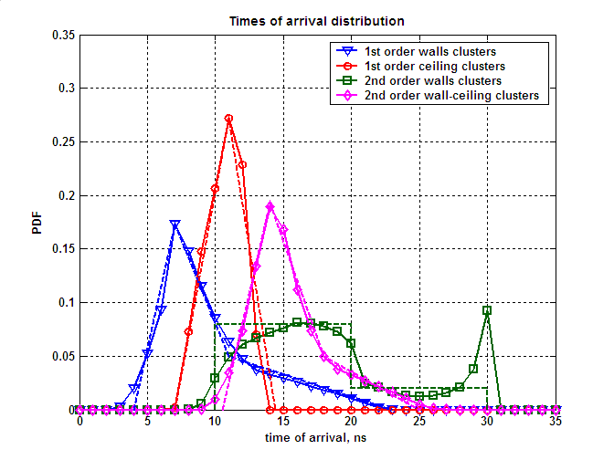
Figure 6. TOA empirical distributions obtained from ray tracing (solid curves) and approximations used in the channel model (dashed curves)
The following equations are used for approximations of TOA PDFs for different clusters groups (time unit is ns):
First order reflections from walls
$$W_{t}(t)=\left\{\begin{matrix}0 \\ 0\text{.}\text{0577}⋅\text{t-0}\text{.}\text{2307} \\ \text{-0}\text{.}\text{0307}⋅t+0\text{.}\text{3882} \\ \text{-0}\text{.}\text{0042}⋅t+0\text{.}\text{0958} \\ 0\end{matrix}\right.\begin{matrix} \\ \\ \\ \\ \begin{matrix}t<4 \\ 4≤t<7 \\ 7≤t<\text{11} \\ \text{11}≤t<\text{23} \\ t≥\text{23}\end{matrix}\end{matrix}$$ | ()
First order reflections from ceiling
$$W_{t}(t)=\left\{\begin{matrix}0 \\ 0\text{.}\text{0677}⋅t\text{-0}\text{.}\text{4741} \\ \text{-0}\text{.}\text{0797}⋅t+1\text{.}\text{1473} \\ 0\end{matrix}\right.\begin{matrix} \\ \\ \\ \begin{matrix}t<7 \\ 7≤t<\text{11} \\ \text{11}≤t<\text{14}\text{.}4 \\ t≥\text{14}\text{.}4\end{matrix}\end{matrix}$$ | ()
Second order reflections from walls and ceiling
$$W_{t}(t)=$$ | ()
Second order reflections from walls
$$W_{t}(t)=$$ | ()

Angular Characteristics for First Order Reflection from Walls
There are four clusters corresponding to four first order reflections from walls (one reflection per wall).
An example of four clusters corresponding to the first order reflections from walls is shown in Figure 7.
Figure 7. Example of four clusters corresponding to the first order reflections from walls
The example illustrated in Figure 7 demonstrates that angular parameters of the four clusters are dependent upon each other. If angular parameters of the four clusters were generated independently, there may be a case of overlapping of multiple clusters. Such overlapping is not encountered in practice and will impact simulation results.
The model for generating the clusters corresponding to the first order wall reflections take into account the following properties:
- Elevation angle is equal to zero for all clusters at both TX and RX;
- There are always two positive and two negative angles when considering TX azimuth angles of all four clusters. For example, in Figure 7 _{1TX} and _{4TX} are positive, but _{2TX} and _{3TX} are negative.
- At the RX side there are also two positive and two negative azimuth angles. In Figure 7 _{2TX} and _{3TX} are positive, but _{1TX} and _{4TX} are negative.
- Every cluster has either positive TX and negative RX azimuth angles, or, vise versa, negative TX and positive RX azimuth angles. For example, cluster 1 and 4 in Figure 7 have positive TX azimuth angles but negative RX azimuth angles. Clusters 2 and 3 in Figure 7 have negative TX azimuth angles but positive RX azimuth angles.
- Considering a pair of clusters with positive TX and negative RX azimuth angles (e.g. clusters 1 and 4 in Figure 7), a cluster with the larger absolute value of TX azimuth angle (e.g. cluster 1 in Figure 7) will have a smaller (than other cluster) absolute value of the RX azimuth angle (cluster 1). Correspondingly the cluster with smaller absolute TX azimuth angle (cluster 4) will have a larger absolute RX azimuth angle. The same is true for the other pair of clusters with negative TX and positive RX azimuth angles (e.g. clusters 2 and 3 in Figure 7).
Taking into account the described properties, the azimuth angles were generated simultaneously for pairs of clusters with the same signs of azimuth angles (e.g. clusters 1 and 4 from Figure 7). The TX and RX angles for a given pair were generated independently but with taking account property V described above.
The joint distribution (histogram) for angle pairs is shown in Figure 8 for pairs with positive and negative angles. The pair of angles for cluster A (_{A}) and angles for cluster B (_{B}) in Figure 8 may be two positive TX angles and two negative for clusters 1 and 4 from Figure 7. Also the distribution from Figure 8 is valid for two positive RX angles and two negative TX angles for clusters 2 and 3 from Figure 8.
Figure 8. Joint distribution (histogram) of azimuth angles with the same sign for two clusters corresponding to first order reflections
As it was mentioned above the main reason for using the joint distribution of a pair of clusters azimuth angles is to maintain necessary relationships between angular characteristics of different clusters. It can be seen from Figure 8 that there are no first order clusters which are closely spaced in angular domain.
The joint distribution shown in Figure 8 has a complex form and an approximation of this distribution for the channel model is used for simplicity. The distribution shown in Figure 9 (uniform in the marked trapezoidal sectors) was used in the conference room channel model for approximation of the joint distribution for clusters azimuth angles shown in Figure 8.
Figure 9. Approximation of the joint distribution of azimuth angles with the same sign for two clusters corresponding to first order reflections
Analytically, the proposed approximation for clusters with positive azimuth angles is described as a two dimensional distribution function that is uniform in the trapezoidal areas 1 and 2.
Trapezoidal area 1 is defined by the following equations (all conditions are met simultaneously):
$$\left\{\begin{matrix}ϕ_{B}≥\left(\frac{\text{140}}{\text{90}}\right)⋅ϕ_{A}+{\text{62}}^{0} \\ ϕ_{B}≤\left(\frac{\text{140}}{\text{90}}\right)⋅ϕ_{A}+{\text{82}}^{0} \\ ϕ_{B}≤{\text{180}}^{0} \\ ϕ_{A}≥0^{0}\end{matrix}\right.$$ | ()
where all angles are measured in degrees.
Trapezoidal 2 area is symmetrical to area 1 and is defined by the following equations (all conditions are met simultaneously):

$$\left\{\begin{matrix}ϕ_{B}≤\left(\frac{\text{140}}{\text{90}}\right)⋅ϕ_{A}−{\text{62}}^{0} \\ ϕ_{B}≥\left(\frac{\text{140}}{\text{90}}\right)⋅ϕ_{A}−{\text{82}}^{0} \\ ϕ_{B}≥−{\text{180}}^{0} \\ ϕ_{A}≤0^{0}\end{matrix}\right.$$ | ()

Angular Characteristics for First Order Reflections from Ceiling
A single cluster corresponding to the 1st order reflection from the ceiling takes into account the following properties:
- all azimuth angles are equal to zero;
- elevation angles for TX and RX are equal to each other.
The empirical PDF of the elevation angle obtained from ray tracing simulations and an approximation are shown below in Figure 10.
The approximation for the PDF of the elevation angle is given by the following equations:
$$W_{θ}(θ)=$$ | ()
where all angles are measured in degrees.

Angular Characteristics for Second Order Reflections from Walls and Ceiling
The model for the second order reflections from walls and ceiling take into account the following properties:
- There are in total four second order clusters corresponding to reflection from wall and then ceiling or from ceiling and then wall for the chosen distributions of TX and RX positions.
- There is always exactly one reflection for each wall (either wall and then ceiling or ceiling and then wall).
- The azimuth angles for these clusters are equal to the azimuth angles of the clusters from first order reflections from walls.
- The elevation angles of the same cluster are equal for TX and RX.
The empirical PDFs and approximations for elevation of second order walls and ceiling reflections are plotted in Figure 10.
The elevation angles are generated using the following equation:
$$W_{θ}(θ)=$$ | ()
where all angles are measured in degrees.
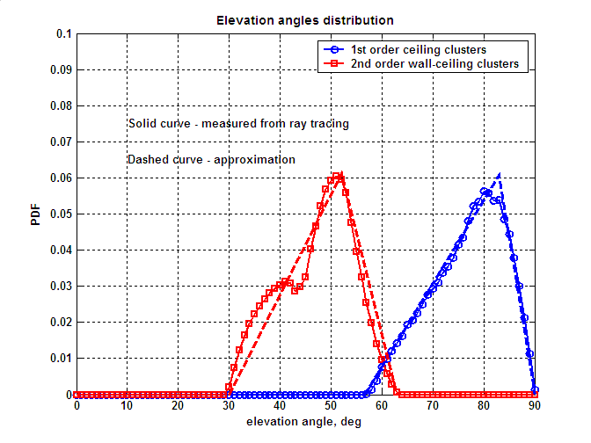
Figure 10. Empirical PDF and approximations for elevation angles of first order reflections from ceiling and second order reflections from walls and ceiling

Angular Characteristics for Second Order Reflections from Walls
This group of clusters has the following main properties:
- There are in total eight clusters corresponding to the second order reflections from walls.
- These clusters have elevation angles equal to zero.
- The TX azimuth angles for these clusters are equal to either the RX azimuth angle or RX azimuth angle +/– 180⁰.
- There are four regions in the joint distribution of TX and RX azimuth angles and there are always two clusters in each region.
The joint distribution (histogram) of TX and RX azimuth angles for second order reflections from walls is shown in Figure 11. It can be seen that there are in total four different regions, as mentioned above, and two clusters were generated for each region. The uniform distribution in the range of [-180⁰,0⁰] or [0⁰,180⁰] was used for an approximation of the azimuth angle distribution function.

Figure 11. Joint distribution (histogram) for TX and RX Azimuth angles for second order wall reflections
TX and RX azimuth angles _{tx1,} _{rx1, …,} _{tx8}, _{rx8} for the eight second order reflections from walls are calculated as:

$$\begin{aligned}\left\{ϕ_{\text{tx}1}={\text{180}}^{∘}⋅u_{1} | \right.\end{aligned}$$ | $$\begin{aligned}\left\{ϕ_{\text{tx}2}={\text{180}}^{∘}⋅u_{2} | \right.\end{aligned}$$ | ()
$$\begin{aligned}\left\{ϕ_{\text{tx}3}={\text{180}}^{∘}⋅\left(u_{3}−1\right) | \right.\end{aligned}$$ | $$\begin{aligned}\left\{ϕ_{\text{tx}4}={\text{180}}^{∘}⋅\left(u_{4}−1\right) | \right.\end{aligned}$$ | ()
$$\begin{aligned}\left\{ϕ_{\text{tx}5}={\text{180}}^{∘}⋅\left(u_{5}−1\right) | \right.\end{aligned}$$ | $$\begin{aligned}\left\{ϕ_{\text{tx}6}={\text{180}}^{∘}⋅\left(u_{6}−1\right) | \right.\end{aligned}$$ | ()
$$\begin{aligned}\left\{ϕ_{{\text{tx}}_{7}}={\text{180}}^{∘}⋅u_{7} | \right.\end{aligned}$$ | $$\begin{aligned}\left\{ϕ_{\text{tx}8}={\text{180}}^{∘}⋅u_{8} | \right.\end{aligned}$$ | ()

where u₁, …, u₈ – are independent random variables uniformly distributed in the interval [0,1].

Gain of Clusters
As it was mentioned above the gain for LOS is predicted by the Friis transmission equation (or free space propagation law). For NLOS first and second order reflected clusters the gain is calculated as:
A^{(i)} = g^{(i)} λ / (4 (d + R)); R = c  t | ()
where g^{(i)} is a reflection loss, λ is a wavelength (5 mm), d is a distance between TX and RX (along LOS path), R is a total distance along the cluster path decreased by d, R is calculated as a product of TOA relatively LOS and the speed of light.
Figure 12 shows histograms of measured reflection losses the first (a) and second (b) order reflection clusters and their approximations by Gaussian distributions. The model for g^{(i)} obtained from experimental distributions of the first and second order reflections is given by a log-normal distribution (normal in dB). The parameters of distribution for the first order reflection clusters is given in Figure 12a and the parameters of distribution for the second order reflection clusters is given in Figure 12b.
Figure 12. Histograms of measured reflection losses for the first (a) and second (b) order reflection clusters and approximations by Gaussian distributions
As explained in Section 2.4, the gain of clusters depend on their polarization characteristics and the polarization characteristics of the used antennas. The statistical models of the cluster gains presented in this section are a fit to the experimental data obtained with both TX and RX antennas having linear horizontal polarizations. Thus, the models may be directly used in the simulation case where polarization characteristics are not supported. However, then simulation is done with support of polarization characteristics, these models are not directly applicable and polarization matrices need to be used instead as it is explained below in Section 3.4.

Probabilities of Clusters Blockage
In a real environment not all clusters that occur in an empty conference room may be used for communication. Part of the clusters may be blocked by people sitting or moving in the conference room and also by other objects. This effect is taken into account in the channel model by the introduction of the cluster blockage probability associated with each type of cluster. In reality, different objects and people blocking signal propagation paths may have more complicated effect on the channel structure. For example, additional reflected clusters may appear. But, in order to keep the channel model complexity low, this effect was modeled by simple cluster blockage.
Table 3. Probabilities of clusters blockage for the STA-STA sub-scenario
Cluster type | Probability of cluster blockage
LOS | 0 or 1 (set as a model parameter)
First order reflections from walls | 0.4
First order reflections from ceiling | 0.1
Second order reflections from wall and ceiling | 0.3
Second order reflections from walls | 0.8

The values of probabilities for cluster blockage are selected based on the consideration that in a conference room reflections from walls have a higher probability of being blocked by humans in a conference room than reflections from the ceiling. Reflections from the ceiling should be available most of the time.
The situation for NLOS simulations when all clusters are blocked has a small but non-zero probability. If all generated clusters are blocked then the empty channel realization is discarded and a new cluster blockage realization is generated.

Polarization Impact Modeling for STA-STA Sub-scenario

Polarization Impact Model Development
Section 2.4 described the approach that is proposed for developing polarization impact model. In this approach, the ray-tracing simulations accounting for polarization impact are used to generate empirical distributions of cluster polarization matrices and these distributions are then approximated to create statistical models. However, the unsolved problem in Section 2.4 was how to define coefficients of the reflection matrix R (needed to simulate reflections in ray-tracing):
$$R=\left[\begin{matrix}R_{} & ξ_{1} \\ ξ_{2} & R_{||}\end{matrix}\right]$$ | ()
where R^ and R|| are reflection coefficients for perpendicular and parallel (relatively to the plane of incidence) components of the E vector and x₁ and x₂ are cross-coupling coefficients.
This section describes the approach adopted for the reflection matrix R modeling in the conference room scenario. The next sections use this approach to develop statistical models for the cluster polarization matrices H.
Development of a statistical model for the R matrix can be divided into two separate tasks of first finding models for the diagonal coefficients R^ and R|| and then for the non-diagonal cross-coupling coefficients x₁ and x₂. The cross-coupling coefficients x₁ and x₂ are equal to zero for reflections from the ideal flat media interface and though these coefficients are non-zero for reflections from real surfaces, their values are significantly below than for the R^ and R|| coefficients. Therefore, accurate prediction of the diagonal coefficients is much more important for developing an overall accurate model.
One simple approach to create a model for the diagonal R^ and R|| coefficients may be to use Fresnel formulas providing the laws of reflection coefficients vs. incident angle dependence for parallel and perpendicular reflection coefficients R^ and R|| for the flat interface between regions with the refraction indices n₁ and n₂:
$$R_{}=\frac{\text{sin}\left(α_{0}−α_{\text{inc}}\right)}{\text{sin}\left(α_{0}+α_{\text{inc}}\right)}$$ | $$R_{||}=\frac{\text{tg}\left(α_{\text{inc}}−α_{0}\right)}{\text{tg}\left(α_{\text{inc}}+α_{0}\right)}$$ | $$α_{0}=\text{arcsin}\left(\frac{n_{1}}{n_{2}}\text{sin}\left(α_{\text{inc}}\right)\right)$$ | ()
where a_{inc} is the incident angle.
Figure 13 shows the reflection coefficients dependence on the incident angle calculated with the Fresnel formulas for n₁ = 1 and n₂ = 1.8. The value of the refraction index n₂ = 1.8 corresponds to the plasterboard, which is one of the most widely used office material.
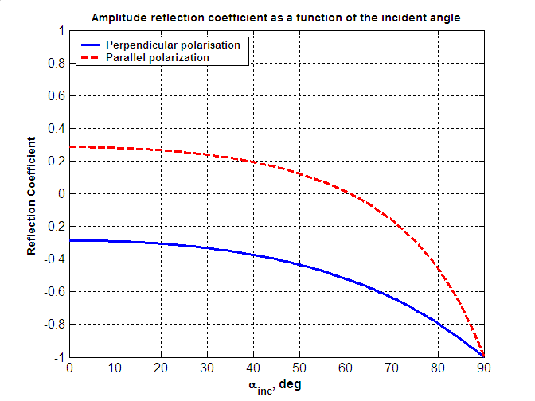
Figure 13. Reflection coefficients dependence on the incident angle calculated with the Fresnel formulas
for n₁ = 1 and n₂ = 1.8
Figure 13 shows that the absolute value of the R^ constantly grows with the increase of the incident angle. However, the absolute value of the R|| first decreases with the increase of the incident angle and after achieving the incident angle ₀ (Brewster angle, for the given case ₀ = 61⁰) the absolute value of the reflection coefficient starts growing and is equal to the unity at the grazing incidence. For incidence angles below ₀, the change of the parallel E field component phase by  happens. This phase shift is responsible for the change of the circular polarization handedness upon reflection at the incident angles below ₀. For the incidence angles larger than ₀, no additional phase shift happens for the parallel component of the E field vector and the circular polarized reflected wave keeps the same handedness of polarization as for the incident wave.
Experimental investigations of the reflection coefficients vs. the incident angles may be found, for example, in [10], where measurements results for typical office surfaces (walls and ceiling) are presented. Since most of the office structures are not uniform (but composed of multiple material layers with different refractive indices), the experimental reflection coefficients have more complex dependence of the absolute value vs. the incident angle than it is predicted by the Fresnel laws for a flat boundary of uniform media.
Taking the considerations above into account, the statistical models for the absolute values of the R^ and R|| coefficients were proposed to be independent of the incident angle. The R^ and R|| coefficients were generated using log-normal (normal in dB distribution) with the mean equal to -10 dB and the standard deviation equal to 4 dB. The same distribution is used for clusters gain simulations in Section 3.3.7. The motivation for using the same statistical law is that the distribution for the clusters gain in Section 3.3.7 is based on empirical data of cluster gains averaged over the first order reflections from walls and ceiling. The measurements were done using antennas with linear horizontal polarizations. The geometry of the TX and RX placement for the STA-STA measurements is such that for the first order reflections from walls, elevation angles of departure and arrival are equal to zero, and for the first order reflections from ceiling the azimuth angles of departure and arrival are equal to zero. As a result, the measured cluster gain values for these cases are directly realizations of the R^ and R|| coefficients. Therefore, the model used to describe the cluster gain values can be used to generate realizations of the absolute values of the reflection coefficients R^ and R||.
As it follows from the considerations above, the absolute values of the R^ and R|| are generated as independent statistical variables. This assumption is not quit correct for Fresnel laws but is reasonable when considering experimental dependencies for real surfaces (e.g., [10]). However, both the Fresnel laws and the experimental data demonstrate that the handedness of the circularly polarized reflection signal is changed for the incident angles below the Brewster angle and does not change for the incident angles above the Brewster angle. This dependence has to be addressed in the channel modeling methodology to be able predict valid polarization impact results. To accomplish this, the signs of the reflection coefficients R^ and R|| were generated in the ray-tracing model as the signs of the reflection coefficient provided by the Fresnel laws for the given incident angle and n₁ = 1.0 (air) and n₂ = 1.8 (plasterboard). After performing multiple ray-tracing experiments, the probabilities for the coefficients R^ and R|| to have different combinations of the arithmetic signs were calculated and further used in the development of the statistical models for the polarization matrix H. These probabilities are different for different types of the clusters and the problem of accounting for statistics of the incident angles in the different types of clusters is addressed.
Cross-coupling coefficients x₁ and x₂ for the matrix R were modeled as random variables with a fixed absolute value of -20 dB and a random arithmetic sign. The absolute value of -20 dB was estimated from the available experimental results [8]. No statistical dependencies between x₁ and x₂, or between x₁ and x₂ and diagonal elements R^ and R|| were considered because of the relatively small impact provided by the cross-coupling coefficients.
The approach to develop polarization matrices model for the second order reflections is described in Section 2.4. This approach is similar to the methodology used for the first order reflections and calculates the realization of the polarization matrix H as a product of three rotational and two reflection matrices (see eq. ()). It is straightforward to use the model for the matrix R of the first order reflections for both reflection matrices R₁ and R₂ of the second order reflections. In this case, the average reflection loss of the second order reflection would be two times larger (in dB) than the reflection loss of the first order reflections. However, the average experimental reflection loss for the second order reflections was measured with two linear co-polarized antennas as -16 dB.
Such discrepancy may be due to different factors. Two times increase of the reflection loss for the second order vs. first order reflections assumes that the reflections follow the laws of the geometrical optics. However, this assumption may become invalid due to relatively small dimensions of the conference room and not very narrow beam width of the used antennas.
In the developed channel model, it is proposed to keep the parameters of the first reflection matrix R₁ in () the same as for the first order reflection matrix R (mean value equal to -10 dB and standard deviation equal to 4 dB) but to adjust the parameters of the second reflection matrix R₂ in order for the overall polarization matrix H of the second order reflection to match the experimental distributions given in Section 3.3.7 when using two linear co-polarized antennas. As a result, the R^ and R||coefficients of the R₂ were chosen to have the log-normal distribution with the mean equal to -6 dB and the standards deviation equal to 3 dB. The resulting distributions of the simulated cluster gains for two linear co-polarized antennas are well matched to the distributions obtained experimentally in Section 3.3.7.
The next sections describe statistical models developed for the polarization matrix H of different types of clusters of the STA-STA sub-scenario.

Polarization Characteristics of LOS Ray
Polarization characteristics of the LOS ray are modeled by the polarization matrix H_{LOS}:
$$H_{\text{LOS}}=\left[\begin{matrix}1 & ξ_{1} \\ ξ_{2} & 1\end{matrix}\right]$$ | ()
The polarization characteristics of the signal are not altered by the free space propagation. Hence in the general case, the polarization matrix H_{LOS} will be a rotation matrix of transformation between the polarization bases of the TX and RX antennas. In the conference room channel model, the polarization bases of the TX and RX antennas are the same and the rotation matrix is reduced to the identity matrix.
Additionally, cross-coupling coefficients x₁ and x₂ are taken with -20 dB absolute value and equally probable arithmetic sign. In the ideal case, the LOS path does not have any cross-polarization coupling since the polarization of EM wave is not altered by the free space propagation. However, some level of the cross-polarization is always present in practical systems, mainly due to antennas imperfections. The used value of the cross-polarization coupling (or cross-polarization discrimination – XPD) in the LOS path is in a good accordance with measured results presented in [8].
For the sake of description simplicity, the matrix H given in () does not include the propagation loss factor that should be additionally applied in the simulations as it is described in Section 3.3.1.

Polarization Characteristics of First Order Reflections from Walls
For first order reflections from walls, multiple realizations of the polarization matrix H were obtained with the ray-tracing using the methodology proposed in Section 2.4 and Section 3.4.1. The obtained empirical realizations are shown in Figure 14.
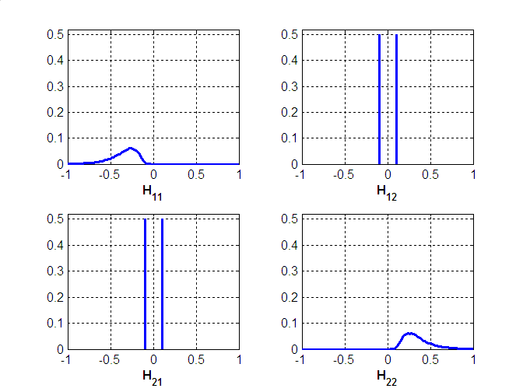
Figure 14. Distributions of the polarization matrix H components for the first order reflections from walls
It may be seen that due to geometrical properties of the first order reflections from walls (zero elevation angles of departure and arrival), rotation matrices in () reduce to the identity matrices and the polarization matrix H coincides with the reflection matrix R. Correspondingly, the models used to approximate the elements of H are the same as he models used to generate R. The distributions for |H₁₁| and |H₂₂| are log-normal distributions (i.e. have Gaussian distributions in decibel scale) with the mean = -10 dB and standard deviation = 4 dB. H₁₁ always has a negative sign and H₂₂ always has a positive sign (there are no clusters with incident angles above the Brewster angle). Non-diagonal cross-coupling elements are two equally probable values ± 0.1 in linear scale (-20 dB in log scale).
The described approximations of the matrix H account for the loss of the signal power due to reflection but do not account for the propagation loss that should be included in the simulation model as it is described in Section 3.3.7.

Polarization Characteristics of First Order Reflections from Ceiling
Multiple realizations were generated with the help of ray-tracing for the polarization matrix H for the first order reflected cluster from ceiling. Calculated empirical distributions are shown in Figure 15.
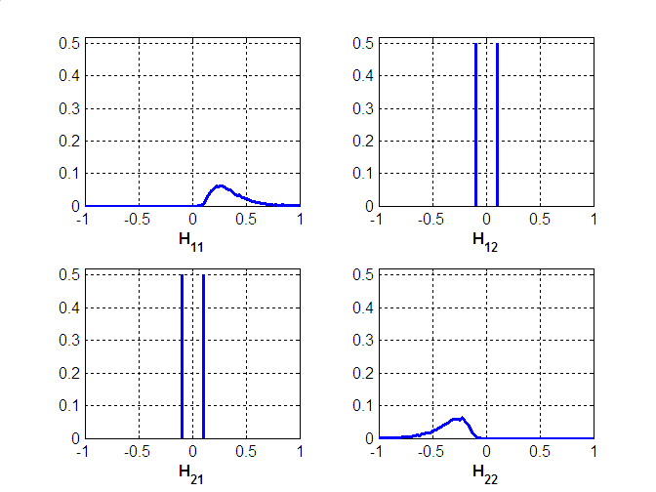
Figure 15. Distributions of the polarization matrix H components for the first order reflections from ceiling
As for the first order reflections from walls, due to the specific geometrical properties of the cluster (zero azimuth angle of departure and arrival) the polarization matrix H is reduced to the reflection matrix R. Correspondingly, the models used to approximate the elements of H are the same as he models used to generate R. The distributions for |H₁₁| and |H₂₂| are log-normal distributions (i.e. have Gaussian distributions in decibel scale) with the mean = -10 dB and standard deviation = 4 dB. H₁₁ always has a positive sign and H₂₂ always has a negative sign. Non-diagonal cross-coupling elements are modeled by two equally probable values ± 0.1 in linear scale (-20 dB in log scale).
The described approximations of the matrix H account for the loss of the signal power due to reflection but do not account for the propagation loss that should be included in the simulation model as it is described in Section 3.3.7.

Polarization Characteristics of Second Order Reflections from Walls and Ceiling
To generate polarization matrices realizations for the second order reflections from walls and ceiling, the methodology described in Section 3.4.1 was used. Calculated (by ray-tracing) empirical distributions are shown in Figure 16.
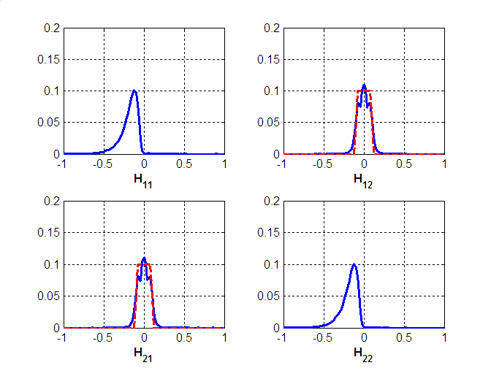
Figure 16. Distributions of the polarization matrix H components for the second order reflections from walls and ceiling. Solid curves show distributions obtained by ray-tracing, dashed curves show proposed approximations. For the components H₁₁, H₂₂, the proposed approximations provide very close matching to the simulated distributions and dashed curves are not plotted
The proposed approximations for the second order reflections from walls and ceiling are as follows. The distributions for |H₁₁| and |H₂₂| are log-normal distributions (i.e. normal distributions in dB scale) with the mean value equal to -16 dB and the standard deviation equal to 5 dB. H₁₁ and H₂₂ have the same sign and are both negative.
Statistical distributions of the cross-coupling components H₁₂ and H₂₁ are approximated by random variables, uniformly distributed in the [-0.1, 0.1] interval.
The described approximations of the matrix H account for the loss of the signal power due to reflection but do not account for the propagation loss that should be included in the simulation model as it is described in Section 3.3.7.

Polarization Characteristics of Second Order Reflections from Walls
Empirical distributions for polarization matrix H components of the second order reflections from walls are shown in Figure 17.

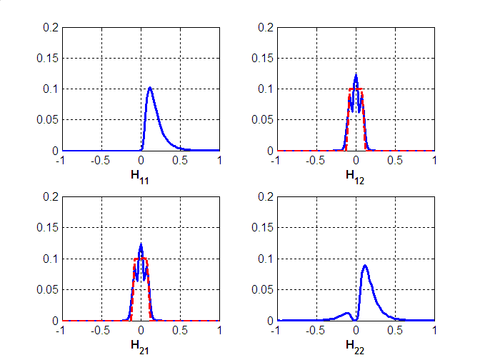
Figure 17. Distributions of the polarization matrix H components for the second order reflections from walls. Solid curves show distributions obtained by ray-tracing, dashed curves show proposed approximations. For the components H₁₁, H₂₂, the proposed approximations provide very close matching to the simulated distributions and dashed curves are not plotted
The proposed approximations for the second order reflections from walls are as follows. The distribution for |H₁₁| is a log-normal distribution with the mean value equal to -16 dB and the standard deviation equal to 5 dB. H₁₁ is always positive.
The distribution for H₂₂ is given by:
$$H_{\text{22}}=p⋅X_{1}−\left(1−p\right)⋅X_{2}$$ | ()
where X₁ and X₂ have the same log-normal distribution with the mean value equal to -16 dB and the standard deviation equal to 5 dB. p is a random variable taking value 1 with probability 0.87 or 0 with the probability 0.13.
Statistical distributions of the cross-coupling components H₁₂ and H₂₁ are approximated by random variables, uniformly distributed in the [-0.1, 0.1] interval.
The described approximations of the matrix H account for the loss of the signal power due to reflection but do not account for the propagation loss that should be included in the simulation model as it is described in Section 3.3.7.

Inter Cluster Parameters for STA-AP Sub-scenario
This section describes statistical models for the inter cluster parameters of the STA-AP sub-scenario.

LOS Ray
The LOS ray modeling is similar to the approach used for the STA-STA sub-scenario (see Section 3.3.1 for details).
There is a difference in the introduction of the coordinate system and calculation of the azimuth angles between the STA-STA and STA-AP sub-scenarios. For the STA-STA sub-scenario, the coordinate system is introduced so that the zero elevation angle plane is the horizontal plane of the room and the zero azimuth angle plane is the vertical plane including the LOS path. In this case, the LOS direction has zero azimuth and elevation angles of arrival and departure. For the STA-AP sub-scenario, the coordinate system is also introduced so that the zero elevation angle plane is the horizontal plane of the room and the zero azimuth angle plane is the vertical plane including the LOS path. However for the STA-AP sub-scenario, this results in the LOS path having zero azimuth angle but non-zero elevation angle. The azimuth and elevation angles for other types of clusters are calculated in the same coordinate system, and the elevation angles of other clusters cannot be considered as calculated relatively to the LOS path.

Time of Arrival (TOA) Distribution for Different NLOS Clusters
There are two types of NLOS clusters for the STA-AP sub-scenario: first order reflected clusters from walls and second order reflected clusters from walls.
The same approach as for the STA-STA sub-scenario was used for modeling TOA of NLOS clusters in the STA-AP sub-scenario. TOA of different clusters is calculated relatively to the LOS path time of arrival. Empirical distributions of the TOA for different cluster group are obtained by ray tracing simulations. Then piecewise linear approximations of the empirical probability density functions (PDFs) are used to develop statistical models for the TOA parameters.
The empirical PDF obtained from ray tracing simulations and their approximations are shown for the first order and second order reflection from walls in Figure 18.
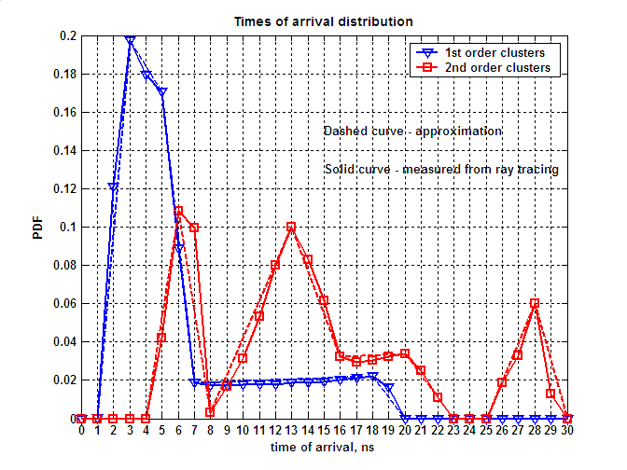
Figure 18. TOA empirical distributions obtained from ray tracing (solid curves) and approximations used in the channel model (dashed curves)
The following equations are used for approximations of TOA PDFs for different clusters groups (time unit is ns):

First order reflections:
$$W_{t}(t)=\left\{\begin{matrix}0 \\ 0\text{.}\text{0977}⋅\text{t-0}\text{.}\text{0983} \\ \text{-0}\text{.}\text{0133}⋅t+0\text{.}\text{2370} \\ \text{-0}\text{.}\text{0760}⋅t+0\text{.}\text{5507} \\ 0\text{.}\text{0003}⋅t+0\text{.}\text{0162} \\ \text{-0}\text{.}\text{0110}⋅t+0\text{.}\text{2237} \\ 0\end{matrix}\right.\begin{matrix} \\ \\ \\ \\ \\ \\ \begin{matrix}t<1 \\ 1≤t<3 \\ 3≤t<5 \\ 5≤t<7 \\ 7≤t<\text{18} \\ \text{18}≤t<\text{20} \\ t≥\text{20}\end{matrix}\end{matrix}$$ | ()

Second order reflections:
$$W_{t}(t)=$$ | ()

Distribution of Azimuth Angles for First Order Reflected Clusters from Walls
The same modeling approach as in the STA-STA sub-scenario (see Section 3.3.3 for details) was used to define statistical models of azimuth angles for the four first order reflected clusters in the STA-AP sub-scenario.
The joint distribution for angle pairs is shown in Figure 19 for pairs with positive and negative angles.

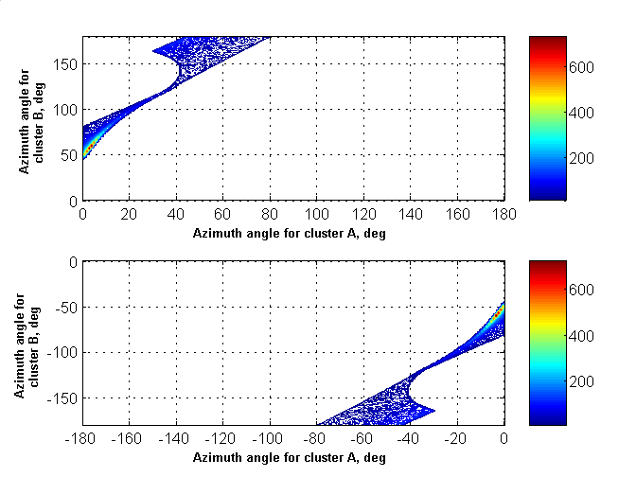
Figure 19. Joint distribution (histogram) of azimuth angles with the same sign for two clusters corresponding to first order reflections
The joint distribution shown in Figure 19 has a complex form, but for the purposes of the channel modeling, it is proposed to approximate it with simple trapezoidal approximations as shown in Figure 20.
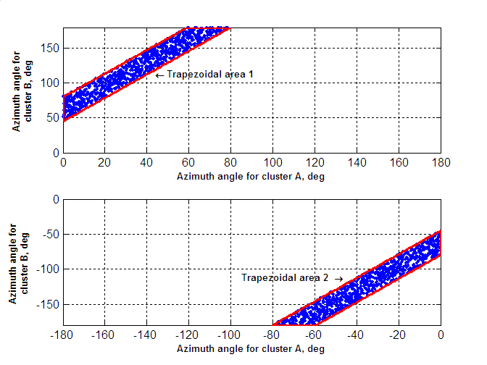
Figure 20. Approximation of the joint distribution of azimuth angles with the same sign for two clusters corresponding to first order reflections
The trapezoidal area 1 is defined by the following equations (all conditions are met simultaneously):
$$\left\{\begin{matrix}ϕ_{B}≥\left(\frac{\text{135}}{\text{80}}\right)⋅ϕ_{A}+{\text{45}}^{0} \\ ϕ_{B}≤\left(\frac{\text{135}}{\text{80}}\right)⋅ϕ_{A}+{\text{80}}^{0} \\ ϕ_{B}≤{\text{180}}^{0} \\ ϕ_{A}≥0^{0}\end{matrix}\right.$$ | ()

The trapezoidal area 2 is defined by the following equations (all conditions are met simultaneously):
$$\left\{\begin{matrix}ϕ_{B}≤\left(\frac{\text{135}}{\text{80}}\right)⋅ϕ_{A}−{\text{45}}^{0} \\ ϕ_{B}≥\left(\frac{\text{135}}{\text{80}}\right)⋅ϕ_{A}−{\text{80}}^{0} \\ ϕ_{B}≥−{\text{180}}^{0} \\ ϕ_{A}≤0^{0}\end{matrix}\right.$$ | ()

Distribution of Azimuth Angles for Second Order Reflected Clusters from Walls
The modeling approach for predicting azimuth angles for the second order reflections from walls is the same as for the STA-STA sub-scenario (see Section 3.3.6 for details).
The joint distribution (histogram) of TX and RX azimuth angles for second order reflections from walls is shown in Figure 11.
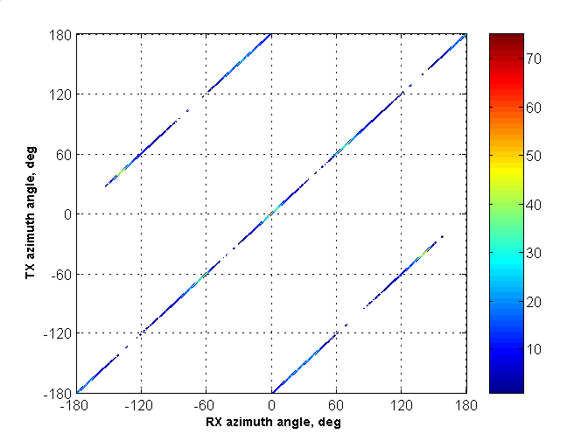
Figure 21. Joint distribution (histogram) for TX and RX azimuth angles for second order wall reflections
As in the case of the STA-STA scenario, there are totally eight clusters and the same model as in the STA-STA scenario is used to generate their azimuth angles (see Section 3.3.6 and Eq. ())

Distribution of Elevation Angles for First and Second Order Reflections
For the STA-AP sub-scenario, statistical models are required to generate elevation angles realizations for all three types of clusters: the LOS ray, the first order reflections from walls, and the second order reflections from walls, because the STA and the AP are placed at different heights. For a single cluster of any type, the elevation angles at the STA and AP have the same absolute values but different signs – positive for the STA and negative for the AP.
Empirical distributions of the elevation angles of different clusters were generated by ray-tracing simulations and then piecewise linear approximations were used to create statistical models. The empirical distributions generated by ray tracing simulations and their approximations are shown for the LOS, first order and second order reflection in Figure 22 (for the AP side – negative elevation angles).

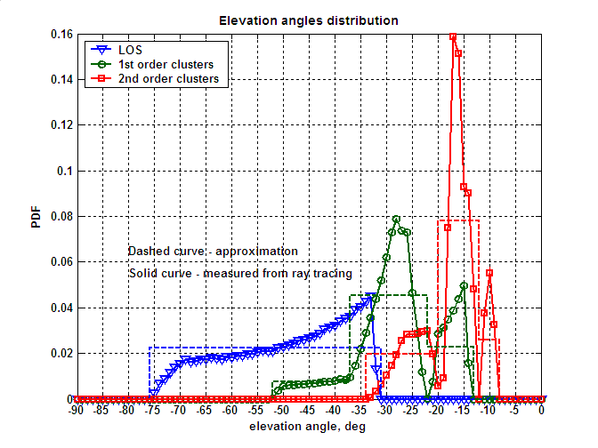
Figure 22. Empirical distributions obtained from ray tracing (solid curves) and approximations used in the channel model (dashed curves) for elevation angles of all three types of clusters
The used piecewise linear approximations are as follows.
LOS path:
$$W_{θ}\left(θ\right)=$$ | ()
First order reflections:
$$W_{θ}\left(θ\right)=$$ | ()
Second order reflections:
$$W_{θ}\left(θ\right)=$$ | ()

Gain of Clusters
The simulation of clusters gain is the same as for the STA-STA sub-scenario (see Section 3.3.7 for details).

Probabilities of Clusters Blockage
As it is discussed in Section 3.3.8, not all the clusters present in the empty conference may be available for establishing a communication link. Some clusters may be blocked by people sitting, standing, or moving around the conference room. This effect is modeled by cluster blockage that happens with some probability. This probability is different for different groups of clusters. The probabilities of clusters blockage for the STA-AP scenario are given in Table 4.
Table 4. Probabilities of clusters blockage for the STA-AP sub-scenario
Cluster type | Probability of cluster blockage
LOS | 0 or 1 (set as a model parameter)
First order reflections from walls | 0.3
Second order reflections from walls | 0.6

The situation for NLOS simulations when all clusters are blocked has a small but non-zero probability. If all generated clusters are blocked then the empty channel realization is discarded and a new cluster blockage realization is generated.

Polarization Impact Modeling for STA-AP Sub-scenario
Polarization impact modeling for the STA-AP sub-scenario adopts the same methodology as for the STA-STA sub-scenario (see Section 2.4 and Section 3.4.1 for a comprehensive description).

Polarization Characteristics of LOS Ray
The polarization modeling for the LOS ray is the same as for the STA-STA sub-scenario (see Section 3.4.2 for details).

Polarization Characteristics of First Order Reflections from Walls
Multiple realizations were generated with the help of ray-tracing for the polarization matrix H for the first order reflected cluster from walls. Calculated empirical distributions and their approximations are shown in Figure 23.
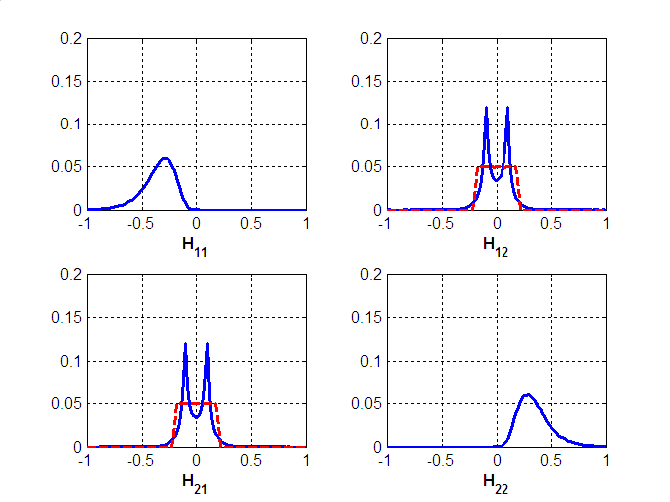
Figure 23. Distributions of the polarization matrix H components for the first order reflections from walls. Solid curves show distributions obtained by ray-tracing, dashed curves show proposed approximations. For the components H₁₁, H₂₂, the proposed approximations provide very close matching to the simulated distributions and dashed curves are not plotted
The proposed approximations for the first order reflections from walls are as follows. The distributions for |H₁₁| and |H₂₂| are log-normal distributions (i.e. normal distributions in dB scale) with the mean value equal to -10 dB and the standard deviation equal to 4 dB. H₁₁ and H₂₂ have different signs – negative for H₁₁ and positive for H₂₂.
Statistical distributions of the cross-coupling components H₁₂ and H₂₁ are approximated by random variables, uniformly distributed in the [-0.2, 0.2] interval.
The described approximations of the matrix H account for the loss of the signal power due to reflection but do not account for the propagation loss that should be included in the simulation model as it is described in Section 3.3.7.

Polarization Characteristics of Second Order Reflections from Walls
Empirical distributions for polarization matrix H components of the second order reflections from walls are shown in Figure 24.
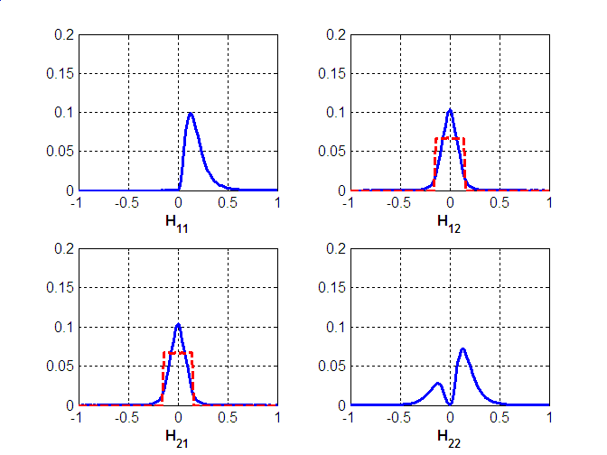
Figure 24. Distributions of the polarization matrix H components for the second order reflections from walls. Solid curves show distributions obtained by ray-tracing, dashed curves show proposed approximations. For the components H₁₁, H₂₂, the proposed approximations provide very close matching to the simulated distributions and dashed curves are not plotted
The proposed approximations for the second order reflections from walls are as follows. The distribution for |H₁₁| is a log-normal distribution with the mean value equal to -16 dB and the standard deviation equal to 5 dB. H₁₁ is always positive.
The distribution for H₂₂ is given by:
$$H_{\text{22}}=p⋅X_{1}−\left(1−p\right)⋅X_{2}$$ | ()
where X₁ and X₂ have the same log-normal distribution with the mean value equal to -16 dB and the standard deviation equal to 5 dB. p is a random variable taking value 1 with probability 0.73 or 0 with the probability 0.27.
Statistical distributions of the cross-coupling components H₁₂ and H₂₁ are approximated by random variables, uniformly distributed in the [-0.15, 0.15] interval.
The described approximations of the matrix H account for the loss of the signal power due to reflection but do not account for the propagation loss that should be included in the simulation model as it is described in Section 3.3.7.

Degradation due to Polarization Impact for Different TX and RX Antennas Polarizations and Different Types of Clusters
<Text>

Intra Cluster Parameters
In accordance with equation () the structure of the i-th cluster of the channel is written as:
$C^{(i)}\left(t,ϕ_{\text{tx}},θ_{\text{tx}},ϕ_{\text{rx}},θ_{\text{rx}}\right)=\sum_{k}{α^{(i,k)}δ\left(t−τ^{(i,k)}\right)δ\left(ϕ_{\text{tx}}−ϕ_{\text{tx}}^{(i,k)}\right)δ\left(θ_{\text{tx}}−θ_{\text{tx}}^{(i,k)}\right)δ\left(ϕ_{\text{rx}}−ϕ_{\text{rx}}^{(i,k)}\right)δ\left(θ_{\text{rx}}−θ_{\text{rx}}^{(i,k)}\right)}$ ()
where a^{(i,k)} is the amplitude of the k-th ray of i-th cluster and ^{(i,k)}, j_{tx}^{(i,k)}, _{tx}^{(i,k)}, j_{rx}^{(i,k)}, _{rx}^{(i,k)} are relative time-angular coordinates of k-th ray of i-th cluster.
The intra cluster parameters of the channel model were estimated from the measurement data. The individual rays were identified in the time domain, and statistical characteristics including average number of rays, ray arrival rate, and ray power decay rates were measured.
Based on the obtained results, the statistical model for the cluster time domain parameters is given. The structure of the model is schematically shown in Figure 25.
Figure 25. Time domain model of the cluster
The cluster consists of a central ray ^{(i,0)} with fixed amplitude and pre-cursor $α^{(i,−N_{f})}…α^{(i,−1)}$ and post-cursor rays $α^{(i,1)}…α^{(i,N_{b})}$. The number of pre-cursor rays N_{f} and post-cursor rays N_{b} was derived from measurements and is fixed in the model as N_{f} = 2 and N_{b} = 4.
Pre-cursor and post-cursor rays are modeled as two Poisson processes with arrival rates λ_{f} = 0.2 ns⁻¹ and λ_{b} = 0.12 ns⁻¹, respectively.
The average amplitudes A_{f} and A_{b} of the pre-cursor and post-cursor rays decay exponentially with power decay times _{f} = 1.3 ns and _{b} = 2.8 ns, respectively:
$$\begin{aligned}A_{f}(τ)=A_{f}(0)e^{{−\left|τ\right|}/{γ_{f}}} \\ A_{b}(τ)=A_{b}(0)e^{{−\left|τ\right|}/{γ_{b}}}\end{aligned}$$ | ()
The individual pre-cursor and post-cursor rays ^{(i,k)} have random uniformly distributed phases and Rayleigh distributed amplitudes with average values A_{f} and A_{b}.
The amplitudes of the pre-cursor and post-cursor rays are coupled with the amplitude of the central ray of the cluster ^{(i,0)} by K-factors that are defined as:
$$\begin{aligned}K_{f}=\text{20}{\text{log}}_{\text{10}}\left|\frac{α^{(i,0)}}{A_{f}(0)}\right| \\ K_{b}=\text{20}{\text{log}}_{\text{10}}\left|\frac{α^{(i,0)}}{A_{b}(0)}\right|\end{aligned}$$ | ()
The K-factors are fixed as K_{f} = 5 dB and K_{b} = 10 dB
The total average (over multiple realizations) power of all cluster rays is normalized to one.
The summary of the estimated intra cluster time domain parameters for the conference room channel model are shown in Table 5.

Table 5. Summary of the intra cluster time domain parameters for the conference room channel model
Parameter | Notation | Value
Pre-cursor rays K-factor | K_{f} | 5 dB
Pre-cursor rays power decay time | _{f} | 1.3 ns
Pre-cursor rate arrival rate | _{f} | 0.20 ns⁻¹
Pre-cursor rays amplitude distribution |  | Rayleigh
Number of pre-cursor rays | N_{f} | 2
Post-cursor rays K-factor | K_{b} | 10 dB
Post-cursor rays power decay time | _{b} | 2.8 ns
Post-cursor rate arrival rate | _{b} | 0.12 ns⁻¹
Post-cursor rays amplitude distribution |  | Rayleigh
Number of post-cursor rays | N_{b} | 4

The power delay profiles calculated from the experimental data and the cluster model are shown in Figure 26. As illustrated, the model is well matched to the measurement data.
Figure 26. Experimental power delay profile (PDP) of the cluster and PDP obtained with the cluster model
In the experimental measurements the identification of the individual rays composing the cluster was done in the time domain only. Identification of rays inside of the cluster in the angular domain requires an increase of the angular resolution by using directional antennas with very high gain or application of the “virtual antenna array” technique where low directional antenna element is used to perform measurements in multiple positions along the virtual antenna array to form an effective antenna aperture.
In the performed experiments the majority of the cluster rays were received within the angle dimension of the antenna pattern that was used (about 17⁰ at 3 dB level). Therefore a simple model may be used to describe the intra cluster angular parameters. Intra cluster azimuth and elevation angles for both transmitter and receiver is modeled as independent normally distributed random variables with zero mean and RMS equal to 5⁰.
Note that it is reasonable to assume that different types of clusters may have distinctive intra cluster structure. For example, properties of the clusters reflected from ceiling may be different from the properties of the clusters reflected from walls because of the different materials and structure of the walls and ceiling. Also one may assume the properties of the first and second order reflected clusters to be different, with the second order reflected clusters having larger spreads in temporal and angular domains. All these effects are understood to be reasonable. However since the number of available experimental results was limited, a common intra cluster model for all types of clusters was developed. Modifications with different intra cluster models for different types of clusters may be a subject of the future channel model enhancements.

Channel Model for Cubicle Environment
TBD

Living Room Channel Model

Modelling Scenario
Home living room is one of the three simulation scenarios defined by the EVM [1].
According to the EVM [1] and the floor plans document [12], dimensions of the home living room are equal to 7 m x 7 m x 3 m (W x L x H). The home living room has a table in the middle, two sofas, and an armchair placed around the table. One outer wall has two windows and a cabinet is placed between them. All furniture dimensions are given in the simulation scenario floor plans document [12].
The EVM defines the home living room simulation scenario where communication is done between a set top box (STB) transmitting uncompressed video, and a TV receiving uncompressed video. The TV is placed in the middle of one of the walls at height of 1.5 m. According to the EVM, the STB is at the same height above the floor as the TV. However, the position of the STB in the horizontal plane can be different. Therefore, a rectangular sector of possible STB positions in the horizontal plane was introduced. The size of the sector was chosen from considerations that all sitting places around the table are covered by the proposed sector and the average distance between the STB and the TV was approximately 4 m. The dimensions of the sector are equal to 4 m x 7 m (W x L) as shown in Figure 27.
Figure 27. Home living room floor plan and the introduced rectangular sector of possible user device space positions
Communication between user the STB and TV may be done using the LOS link and/or first and second order reflections from walls, ceiling, and floor. Reflections from other objects (e.g. plane surfaces of the table or cabinet) and also the propagation due to diffraction are not taken into account in the model.
The rest of the living room channel model description is organized as follows. Section 5.2 explains the model development methodology. Section 5.3 defines temporal and spatial inter cluster parameters. Section 5.4 describes polarization characteristics modelling. Section 5.5 specifies intra cluster parameters.

Model Development Methodology
This section describes the methodology used to develop a channel model for the home living room environment.
To define intra cluster parameters for the home living room scenario, a similar methodology to the one for the conference room channel development (see Section 3.2) was applied. A ray tracing model of the home living room with dimensions 7 x 7 x 3 m (W x L x H) has been used to generate multiple realizations of 1st and 2nd order reflected clusters. Then, similar to the conference room scenario, statistical time and angular characteristics of the first and second order reflections were calculated from ray tracing simulations results and then used to derive the corresponding inter cluster time and angular parameters for the home living room channel model.
For the ray tracing simulations, positions of the transmitting (STB) and receiving (TV) devices were taken as described in the EVM and modeling scenario defined in Section 5.1. STB and TV were taken to be located at the height of 1.5 m above the floor. TV had a fixed position in the middle of one of the walls and the position of STB was randomly placed in a flat layer with the height equal to 1.5 m and the horizontal dimensions equal to 4 x 7 m as described above. Positions of STB were distributed uniformly within this layer.
The first order reflections from walls, first order reflections from ceiling and floor, second order reflections from two walls, second order reflections from ceiling and floor, and second order reflections from the wall and ceiling (floor) were considered. The 3D model of home living room is shown in Figure 28. Note that only a part of the signal clusters (not all of them) are drawn in the figure below.
Figure 28. 3D model of the home living room used for ray tracing and an example of reflected 1st and 2nd order reflections existing between TX and RX for given space positions
For the purposes of channel modeling, all clusters are divided into several groups where clusters in the same group have similar properties. There are 6 groups of clusters for the considered geometry of the home living room environment. The total number of clusters is equal to 19 and the number of clusters in each group is constant for every channel realization and is given in Table 6.
Table 6. Number of clusters in the cluster groups for the home living room environment
Type of Clusters | Number of Clusters
LOS path | 1
First order reflections from walls | 3
First order reflections from ceiling and floor | 2
Second order reflections from two walls | 5
Second order reflections from ceiling and floor | 2
Second order reflections from the wall and ceiling, from the wall and floor | 6

Different groups of clusters have different characteristics (e.g. reflections from walls have zero elevation angles and reflections from ceiling and floor have zero azimuth angles) and this was taking into account in the simulation model. The PDFs of parameters for different clusters have been obtained from ray tracing and their approximations were used for the channel model development.
Not all available clusters predicted by ray-tracing are included in the generated channel realization as some clusters are blocked by furniture and moving people. The probabilities of clusters blockage for different clusters groups of the home living room channel model are introduced.
With perfect mirror reflections each cluster will consist of exactly one ray. But taking into account the roughness and heterogeneity of the surfaces as well as the presence of additional small different reflectors each cluster may include several rays closely spaced with each other in time and angular domains. In the channel model the intra cluster parameters were identified based on the processing of experimental data.

Inter Cluster Parameters
This section gives description of the statistical models for inter-cluster parameters for the home living room environment.

LOS Ray
The LOS ray modelling is similar to the approach introduced for the CR STA-STA sub-scenario. For more details, see Section 3.3.1.

Time of Arrival Distribution for Different NLOS Clusters
TOA of different clusters is calculated relatively to the LOS path time of arrival. Empirical distributions of the TOA for different cluster groups have been obtained by ray tracing simulations. Then piecewise linear approximations of the empirical probability density functions (PDFs) were used to develop statistical models for the TOA parameters.
For the considered geometry of the home living room, TX and RX have a symmetrical position relatively to floor and ceiling because both TX and RX are placed at the height of 1.5 m and the height of the room is 3 m. This allows for some symmetry of different propagation paths (clusters) involving reflections from the ceiling and floor and is taken into account for clusters TOA generation as well as elevation angles generation throughout the model.
The empirical PDFs for the 1st order clusters obtained from ray tracing simulations and their approximations are shown in Figure 29.
The TOA of the first order reflected clusters from the ceiling and floor is always the same.
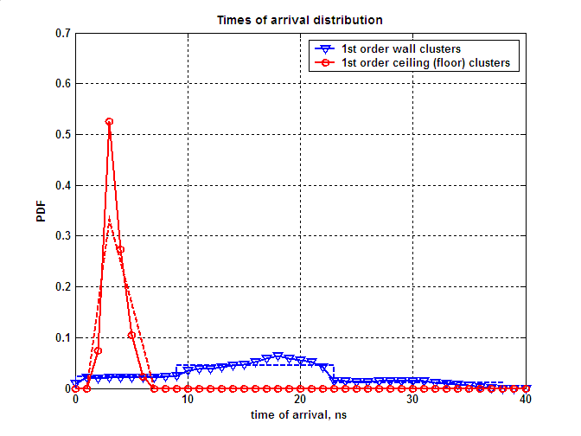
Figure 29. TOA empirical distributions obtained from ray tracing (solid curve) and approximations used in the channel model (dashed curves) for the 1st order clusters

The following equations are used for approximations of TOA PDFs for the 1st order cluster groups (time unit is ns):
First order reflections from walls
$$W_{t}(t)=$$ | ()
First order reflections from ceiling and floor:
$$W_{t}(t)=\left\{\begin{matrix}0 \\ 0\text{.}\text{1667}⋅t\text{-0}\text{.}\text{1667} \\ \text{-0}\text{.}\text{0833}⋅t+0\text{.}\text{5833} \\ 0\end{matrix}\right.\begin{matrix} \\ \\ \\ \begin{matrix}t<1 \\ 1≤t<3 \\ 3≤t<7 \\ t≥7\end{matrix}\end{matrix}$$ | ()
The empirical PDFs for the 2nd order clusters obtained from ray tracing simulations and their approximations are shown in Figure 30.
The TOA of clusters including symmetrical reflections from the ceiling and floor is the same.
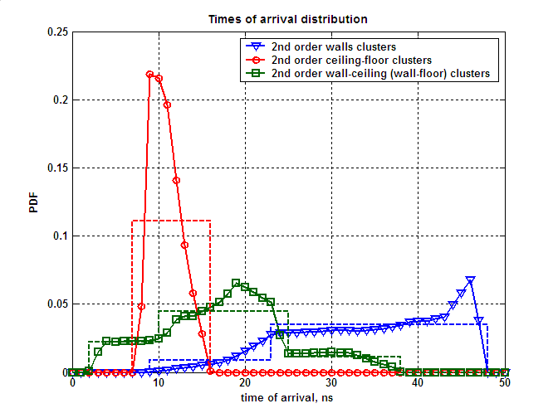
Figure 30. TOA empirical distributions obtained from ray tracing (solid curve) and approximations used in the channel model (dashed curves) for the 2nd order clusters
The equations used for the approximations are as follows.
Second order reflections from walls:
$$W_{t}(t)=$$ | ()
Second order reflections from ceiling and floor:
$$W_{t}(t)=$$ | ()
Second order reflections from the wall and ceiling, from the wall and floor:
$$W_{t}(t)=$$ | ()

Angular Characteristics for First Order Reflection from Walls
There are three clusters corresponding to first order reflections from walls. There is one reflection per wall for all walls except for wall #3 where the TV is mounted (see Figure 27). Reflection from wall #3 does not exist since the RX is placed near this wall. Elevation angles for these clusters are equal to zero and only azimuth angles on TX and RX sides should be generated. An example of three clusters corresponding to the first order reflections is shown in Figure 31 for a random TX position.
Figure 31. Example of three clusters corresponding to the first order reflections from walls

Generating these clusters in the model is similar to that described in Section 3.3.3. In Section 3.3.3, four clusters of first order reflections from walls in the conference room are generated taking into account their specific properties. Azimuth angles of departure and arrival are calculated relatively to the LOS direction. A cluster with a positive angle of departure always has a negative angle of arrival and vice versa. In addition, at the TX side, there are always two clusters with positive angle of departure (“positive pair” of clusters at the TX side) and two clusters with negative angles of departure (“negative pair” of clusters at the TX side). In one pair of clusters, the cluster with a smaller absolute value of angle of departure has a larger absolute value of angle of arrival and vice versa.
Most of the properties of the first order reflections from walls of Section 3.3.3 hold for the home living room scenario. The difference is that one cluster corresponding to the reflection from wall #3 has to be excluded from the consideration. The excluded cluster has a smaller absolute TX azimuth angle and larger RX azimuth angle.
The fourth cluster may be excluded from the “positive pair” or “negative pair” of clusters with equal probabilities of ½. For the given example of the TX position shown in Figure 31, the fourth cluster is excluded from the “positive pair” at the TX side.
The joint distributions for angles pairs are different on the TX and RX sides (this is different from the conference room scenario). The azimuth angles of departure and arrival of the same cluster are generated independently. However, angles of departure (at TX) and arrival (at RX) of the same “pair” (either “positive” or “negative”) are generated jointly. Within one pair, the cluster with a smaller absolute value is referred to as cluster A and the cluster with a larger absolute value is referred to as cluster B (see, for example, Figure 31). No statistical dependence between angles of clusters from different “pairs” is considered.
Figure 32 shows joint distributions (histograms) for “positive” and “negative” on the TX side.
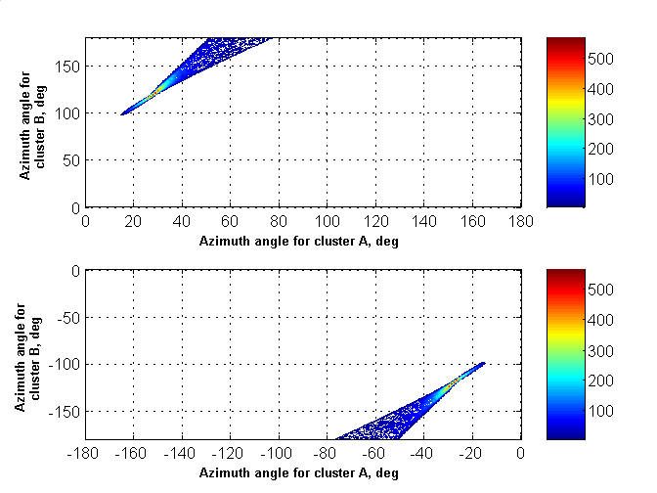
Figure 32. Joint distribution (histogram) of azimuth angles with the same sign for two clusters corresponding to the first order reflections from walls on the TX side

The joint distribution shown in Figure 32 has a complex form and an approximation of this distribution for the channel model is used for simplicity. The distribution shown in Figure 33 (uniform in the marked triangular sectors) was used in the home living room channel model for approximation of the joint distribution for clusters azimuth angles shown in Figure 32.
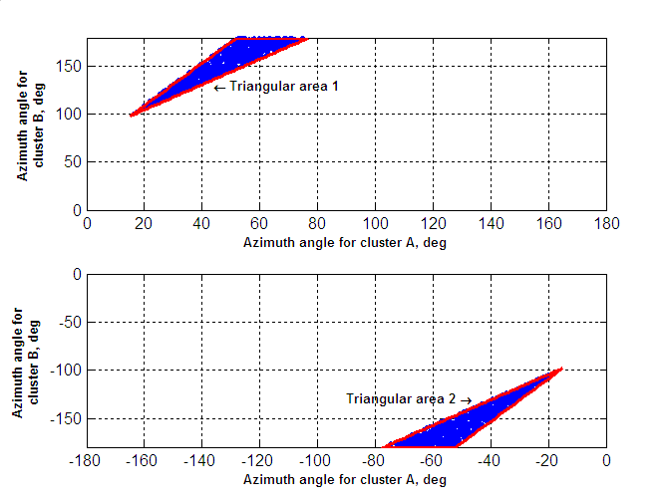
Figure 33. Approximation of the joint distribution of azimuth angles with the same sign for two clusters corresponding to first order reflections from walls on the TX side

Analytically, the proposed approximation for clusters with positive azimuth angles is described as a two dimensional distribution function that is uniform in triangular areas 1 and 2.
Triangular area 1 is defined by the following equations (all conditions are met simultaneously):
$$\left\{\begin{matrix}ϕ_{B}≥\left(\frac{\text{82}}{\text{62}}\right)⋅ϕ_{A}+{\left(\frac{\text{2423}}{\text{31}}\right)}^{0} \\ ϕ_{B}≤\left(\frac{\text{82}}{\text{37}}\right)⋅ϕ_{A}+{\left(\frac{\text{2396}}{\text{37}}\right)}^{0} \\ ϕ_{B}≤{\text{180}}^{0}\end{matrix}\right.$$ | ()
where all angles are measured in degrees.
Triangular area 2 is symmetrical to area 1 and is defined by the following equations (all conditions are met simultaneously):
$$\left\{\begin{matrix}ϕ_{B}≤\left(\frac{\text{82}}{\text{62}}\right)⋅ϕ_{A}−{\left(\frac{\text{2423}}{\text{31}}\right)}^{0} \\ ϕ_{B}≥\left(\frac{\text{82}}{\text{37}}\right)⋅ϕ_{A}−{\left(\frac{\text{2396}}{\text{37}}\right)}^{0} \\ ϕ_{B}≥−{\text{180}}^{0}\end{matrix}\right.$$ | ()

Figure 34 shows joint distributions (histograms) of azimuth angles for “positive” and “negative” pairs at the RX side.
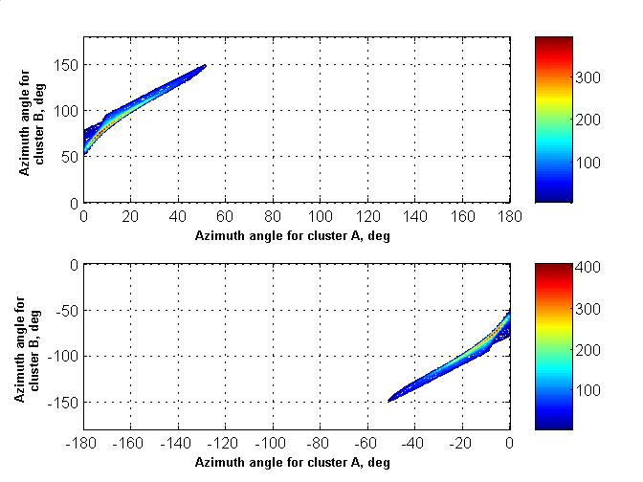
Figure 34. Joint distribution (histogram) of azimuth angles with the same sign for two clusters corresponding to the first order reflections from walls on RX side

The joint distribution shown in Figure 34 has a complex form and an approximation of this distribution for the channel model is used for simplicity. The distribution shown in Figure 35 (uniform in the marked trapezoidal sectors) was used in the home living room channel model for approximation of the joint distribution for clusters azimuth angles on the RX side shown in Figure 34.

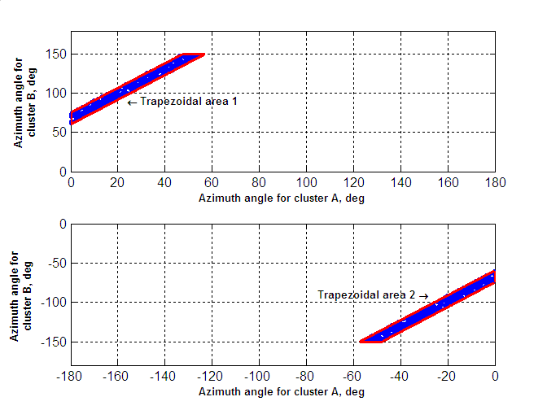
Figure 35. Approximation of the joint distribution of azimuth angles with the same sign for two clusters corresponding to first order reflections from walls on RX side

Analytically, the proposed approximation for clusters with positive azimuth angles is described as a two dimensional distribution function that is uniform in the trapezoidal areas 1 and 2.
Trapezoidal area 1 is defined by the following equations (all conditions are met simultaneously):
$$\left\{\begin{matrix}ϕ_{B}≥\left(\frac{\text{82}}{\text{52}}\right)⋅ϕ_{A}+{\text{60}}^{0} \\ ϕ_{B}≤\left(\frac{\text{82}}{\text{52}}\right)⋅ϕ_{A}+{\text{75}}^{0} \\ ϕ_{B}≤{\text{150}}^{0} \\ ϕ_{A}≥0^{0}\end{matrix}\right.$$ | ()
where all angles are measured in degrees.
Trapezoidal area 2 is symmetrical to area 1 and is defined by the following equations (all conditions are met simultaneously):
$$\left\{\begin{matrix}ϕ_{B}≤\left(\frac{\text{82}}{\text{52}}\right)⋅ϕ_{A}−{\text{60}}^{0} \\ ϕ_{B}≥\left(\frac{\text{82}}{\text{52}}\right)⋅ϕ_{A}−{\text{75}}^{0} \\ ϕ_{B}≥−{\text{150}}^{0} \\ ϕ_{A}≤0^{0}\end{matrix}\right.$$ | ()

Angular Characteristics for First Order Reflections from Ceiling and Floor
There are two clusters corresponding to first order reflections from ceiling and floor. Generation of these clusters takes into account the following properties:
- Azimuth angles for these clusters are equal to zero for TX and RX
- Elevation angles are equal to each other at the TX and RX sides
- Clusters reflected from ceiling and floor have equal absolute values of their elevation angles but opposite signs (the positive sign for the ceiling cluster and the negative sign for the floor cluster).

The empirical PDF of the elevation angle obtained from ray tracing simulations and its approximation are shown in Figure 36.
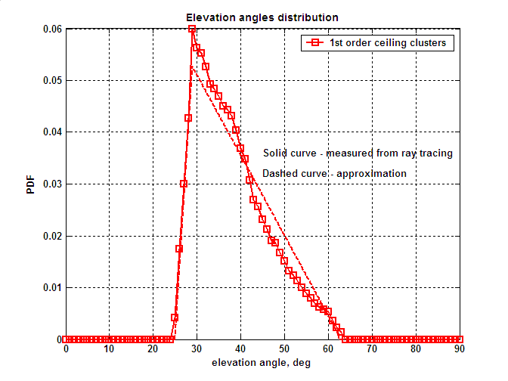
Figure 36. Empirical PDF and approximation for elevation angle of the first order reflections from ceiling

The approximation for the PDF of the elevation angle is given by the following equations:
$$W_{θ}(θ)=$$ | ()
where all angles are measured in degrees.

Angular Characteristics for Second Order Reflections from Walls
This group of clusters has the following main properties:
- There are total 5 clusters corresponding to the second order reflections from walls
- These clusters have elevation angles equal to zero
- The RX azimuth angles for these clusters are equal to either the TX azimuth angle or TX azimuth angle +/- 180⁰.

Figure 37 shows the example of possible 5 clusters for given TX position.
Figure 37. Example of five clusters corresponding to the second order reflections from walls

For the clusters reflected from perpendicular walls, TX and RX azimuth angles are shifted by +/- 180⁰. For the clusters reflected from parallel walls, the azimuth angles at the TX and RX are equal to each other.
The empirical distributions of the azimuth angles on the TX side for the second order clusters reflected from perpendicular walls calculated from ray-tracing simulations and their piecewise approximations are shown in Figure 38.
Figure 38. Empirical distributions obtained from ray tracing (solid curves) and approximations used in the channel model (dashed curves) for the azimuth angles of the second order clusters reflected from perpendicular walls

The used piecewise approximations for the PDFs of the second order reflections from perpendicular walls are as follows:
Reflections from walls 1-4 (4-1):
$$W_{ϕ}\left(ϕ\right)=$$ | ()
Reflections from walls 1-2 (2-1):
$$W_{ϕ}\left(ϕ\right)=$$ | ()
The azimuth angles for the clusters reflected from walls (1-4, 4-1) and (1-2, 2-1) are generated independently with the PDFs provided by equations () and () correspondingly. But it is taken into account that the reflections from walls 4-1 and 2-1 cannot occur simultaneously. Therefore, when this combination of the reflections occurs, the azimuth angles are discarded and the generation is repeated until the allowed combination of the reflections is obtained.
Empirical distributions of azimuth angles at the TX side for the second order clusters reflected from parallel walls obtained from ray-tracing simulations and their piecewise approximations are shown in Figure 39.
Figure 39. Empirical distributions obtained from ray tracing (solid curves) and approximations used in the channel model (dashed curves) for the azimuth angles of the second order clusters reflected from parallel walls

The used piecewise approximations for the PDFs of the second order reflections from parallel walls are as follows:
Reflections from walls 4-2:
$$W_{ϕ}\left(ϕ\right)=$$ | ()
Reflections from walls 2-4:
$$W_{ϕ}\left(ϕ\right)=$$ | ()
Reflections from walls 3-1:
$$W_{ϕ}\left(ϕ\right)=$$ | ()
The azimuth angles for the clusters reflected from parallel walls are generated independently.

Angular Characteristics for Second Order Reflections from Ceiling and Floor
There are two clusters corresponding to second order reflections from ceiling and floor. Generation of these clusters takes into account the following properties:
- Azimuth angles for these clusters are equal to zero for TX and RX
- Elevation angles for ceiling-floor (or floor-ceiling) reflection have equal absolute values and opposite signs at the TX and RX sides
- Elevation angles for ceiling-floor and floor-ceiling reflections have equal absolute values and opposite signs at either TX or RX sides

An empirical PDF of the elevation angle obtained from ray tracing simulations for clusters reflected from ceiling on TX side and an approximation are shown in Figure 40.

Figure 40. Empirical PDF and approximation for elevation angle of second order ceiling-floor reflections on TX side
The approximation for the PDF of the elevation angle is given by the following equations:
$$W_{θ}(θ)=$$ | ()
where all angles are measured in degrees.

Angular Characteristics for Second Order Reflections from Walls and Ceiling (from Walls and Floor)
There are six clusters corresponding to the second order reflections from a wall and then ceiling (floor) or ceiling (floor) and then a wall. Table 7 presents possible types of the reflections in the considered home living room environment and their probabilities. Note that reflections from wall #3 are not considered because the RX is placed near to this wall and the reflections are not possible.

Table 7. Possible 2nd order reflections from walls and ceiling (from walls and floor) in the considered home living room environment and their probabilities
Sub-group # | Reflection | Reflection pair probability inside sub-group
1 | Ceiling – wall #1 | 0
1 | Floor – wall # 1 | 0
1 | Wall #1 – ceiling | 1
1 | Wall #1 – ceiling | 1
2 | Ceiling – wall #2 | ½
2 | Floor – wall # 2 | ½
2 | Wall #2 – ceiling | ½
2 | Wall #2 – floor | ½
3 | Ceiling – wall #4 | ½
3 | Floor – wall # 4 | ½
3 | Wall #4 – ceiling | ½
3 | Wall #4 – floor | ½

The reflections presented in Table 7 are divided into 3 sub-groups: reflections from wall #1, wall #2, and wall #4.
The sub-group #1 includes reflections from wall #1 and then ceiling of floor. Because of the considered geometry of the living room, no clusters first reflecting from ceiling or floor and then from wall # 1 are possible. This is indicated in Table 7 by showing zero probability for “Ceiling – wall # 1” and “Floor – wall # 1” types of clusters and unity probability for “Wall #1 – ceiling” and “Wall #1 – ceiling” clusters.
For sub-groups #2 and #3, the wall may be either the first or second reflecting surface. Due to symmetry of the floor and ceiling relatively to TX and RX positions, the order of reflections holds for both ceiling and floor clusters of the same sub-group. However, it follows from the simulations results that the order of always different between sub-groups #2 and #3 and this dependency is taken into account in the developed statistical channel model. It is reflected in Table 7 that for groups of clusters #2 and #3 both orders of reflections are equiprobable.
Azimuth angles for clusters of the same sub-group are equal to each other. In addition, the azimuth angles for generated three pairs of clusters from the three sub-groups correspond to the azimuth angles of the first order reflections from walls considered in Section 5.3.3. The pair wall-ceiling/wall-floor has a larger absolute value of the azimuth angle at the TX side and the pair ceiling-wall/floor-wall has a smaller absolute value of the azimuth angle at the TX side.
Absolute values of elevation angles for clusters inside each pair are equal to each other and have opposite signs: positive for the ceiling reflection and negative for the floor reflection. Elevation angles for each cluster at the TX and RX sides are equal to each other.
Due to symmetry of the considered home living room geometry, the distributions of the elevation angle for ceiling (floor) – wall #2 and ceiling (floor) – wall #4 clusters are the same. This is also true for clusters wall #2 – ceiling (floor) and wall #4 – ceiling (floor). Hence, only three distributions for elevation angle should be derived to describe all elevation angles dependences. These distributions are presented in Figure 41.

Figure 41. Empirical PDFs and approximations for the elevation angle of the second order reflections from wall and then ceiling and ceiling and then wall

The approximations for the PDFs of the elevation angle are given by the following equations:
Wall #1 – ceiling reflection:
$$W_{θ}(θ)=$$ | ()

Ceiling - wall #2 (4) reflection:
$$W_{θ}(θ)=$$ | ()

Wall #2 (4) – ceiling reflection:
$$W_{θ}(θ)=$$ | ()

Gain of Clusters
TBD

Probabilities of Clusters Blockage
TBD

Clusters Attenuation due to Penetration through Furniture
TBD

Polarization Impact Modelling
TBD

Intra Cluster Parameters
TBD

Antenna Models and Beamforming Algorithms
This section provides a description of reference antenna models and beamforming algorithms that may be used together with the channel model. The reference antenna models and beamforming algorithms were developed to demonstrate the application of the channel model in simulations of 60 GHz communication systems with steerable directional antennas.
Three antenna models are developed together with the given channel model. These are isotropic radiator, basic steerable directional antenna, and phased antenna array. Different types of antenna models with different parameters (e.g. beamwidths) may be used in the simulations. The three developed antenna models capture most of the practical simulation scenarios. However, the channel model is not limited in this sense and any additional antenna models may be created.
The support of polarization characteristics for antennas was introduced in Section 2.4.2. The polarization characteristics are directly supported for the basic steerable antenna model. Polarization characteristics are not supported in the isotropic radiator model because these two concepts are incompatible. Introduction of any polarization characteristics will give rise to spatial radiation selectivity of the isotropic radiator. For the antenna array, the polarization characteristics are also not supported in this version of the document, because the only introduced type of the elementary radiator is the isotropic radiator, which does not support polarization characteristics. Therefore, only basic steerable antenna model may be currently used in the simulations with polarization impact modeling.

Application of Transmit and Receive Antennas to Channel Model
Analytical description for channel impulse response functions without and with polarization characteristics support were introduced in Section 2.2 (equations () and () correspondingly). These equations define a channel impulse response in the space-time domain.
Application of antennas at the TX and RX sides is equivalent to spatial filtering procedure. The channel impulse response after application of TX and RX antennas depends only on the signal time of arrival.
If polarization characteristics for TX and RX antennas are not considered, then application of TX and RX antenna patterns to the channel impulse response described by equation () is given as follows:
$$h_{t}(t)=\int_{0}^{2π}{\int_{0}^{π}{\int_{0}^{2π}{\int_{0}^{π}{g_{\text{RX}}\left(ϕ_{\text{RX}},θ_{\text{RX}}\right)h\left(t,ϕ_{\text{TX}},θ_{\text{TX}},ϕ_{\text{RX}},θ_{\text{RX}}\right)}}g_{\text{RX}}\left(ϕ_{\text{TX}},θ_{\text{TX}}\right)}\text{sin}\left(θ_{\text{RX}}\right){dθ}_{\text{RX}}{dϕ}_{\text{RX}}\text{sin}\left(θ_{\text{TX}}\right){dθ}_{\text{TX}}{dϕ}_{\text{TX}}}$$ | ()
where g_{TX}(φ, θ) and g_{RX}(φ, θ) are antenna gain functions (antenna patterns) for TX and RX antennas respectively. In the case of the isotropic radiator antenna, the gain function is a constant value for all space directions and does not depend on azimuth and elevation angles. Therefore, the channel impulse response includes all rays existing between TX and RX sides. In the common case of steerable directional antenna, g(φ, θ) is a function of azimuth and elevation angles, therefore, some rays are sufficiently attenuated while others are amplified depending on their spatial position.
If polarization properties of TX and RX antennas are taken into account, then application of TX and RX antenna patterns to the channel impulse response described by equation () is given as follows
$$\begin{aligned}h_{t}(t)=\int_{0}^{2π}{\int_{0}^{π}{\int_{0}^{2π}{\int_{0}^{π}{g_{\text{RX}}^{H}\left(ϕ_{\text{RX}},θ_{\text{RX}}\right)h\left(t,ϕ_{\text{TX}},θ_{\text{TX}},ϕ_{\text{RX}},θ_{\text{RX}}\right)}}g_{\text{RX}}\left(ϕ_{\text{TX}},θ_{\text{TX}}\right)}}\text{sin}\left(θ_{\text{RX}}\right){dθ}_{\text{RX}}{dϕ}_{\text{RX}}\text{sin}\left(θ_{\text{TX}}\right){dθ}_{\text{TX}}{dϕ}_{\text{TX}} \\ \end{aligned}$$ | ()
where g_{TX}(φ, θ) and g_{RX}(φ, θ) are antenna gain functions (supporting polarization characteristics) for TX and RX antennas respectively.
Note that the antenna gain function g(φ, θ) is changed when antenna changes its spatial orientation. Therefore, the channel impulse response also depends on the antenna pattern spatial orientation.

Isotropic Radiator
The simplest type of the antenna model is an isotropic radiator [13]. This model has a spherical antenna pattern that equally illuminates all signal rays at the transmitter and equally combines all rays coming from different directions at the receiver.
The isotopic antenna cannot be implemented in practice but is a convenient theoretical model which is used in the channel model for analytical purposes.
This model does not have any spatial selectivity and does not need any beamforming procedure for optimal steering in space.

Basic Steerable Directional Antenna Model

General Description of Basic Steerable Antenna Model
Antenna patterns of the real world antennas have quite complex form and require many details for accurate description. For this reason many known wireless propagation channel models (e.g. [14], [15]) include only a basic antenna model that captures all essential characteristics of real world antennas but is significantly simplified to avoid unnecessary complexity. The most widely used is an antenna model with a main lobe of Gaussian form in linear scale (parabolic form in dB scale) and constant level of side lobes [14], [16]. Such antenna model was also adopted for the channel model.
An input parameter for the antenna model is 3 dB beamwidth of the main lobe _{-3dB}. This parameter fully defines the antenna pattern of the antenna model from which all the other parameters are derived.
A main lobe gain is described using a circularly symmetric Gaussian function which is represented in analytical form as follows:
$$G\left(θ,ϕ\right)=G_{0}\text{exp}\left(−{\text{αθ}}^{2}\right)$$ | ()
where G₀ is a maximum antenna gain,  is elevation angle,  is azimuth angle,  is a coefficient that is determined by the half-power beam width _{-3dB} as:
$α=\frac{4\text{ln}\left(2\right)}{θ_{−3\text{dB}}^{2}}$. | ()
Equation () can be expressed in dB scale as:
$$G_{\text{dB}}=G_{0\text{dB}}−\text{12}⋅{\left(\frac{θ}{θ_{−3\text{dB}}}\right)}^{2}$$ | ()
The maximum gain of the antenna G₀ may be calculated from _{-3dB} using approximation for an ideal circular aperture antenna [16], [17]:
$$G_{0}=(\text{ka})^{2}$$ | ()
$$\text{ka}⋅\text{sin}({θ_{−3\text{dB}}}/2)=1\text{.}\text{6162}$$ | ()

where k is the wavenumber and a is the radius of the aperture respectively
Main-lobe width is determined for -20 dB level relatively to maximum gain value and can be simply obtained from ()
$$θ_{\text{ML}}=2\text{.}6⋅θ_{−3\text{dB}}$$ | ()
The gain for other angles of the basic antenna model (outside the main lobe) is equal to a constant side lobe level. The side lobe level is chosen so that integration of the antenna power gain over total 4 solid angle results in unity (normalization condition).
Figure 42 shows antenna patterns of the proposed antenna model as a function of elevation angle for 3 dB beamwidth equal to 15⁰, 30⁰ and 60⁰.
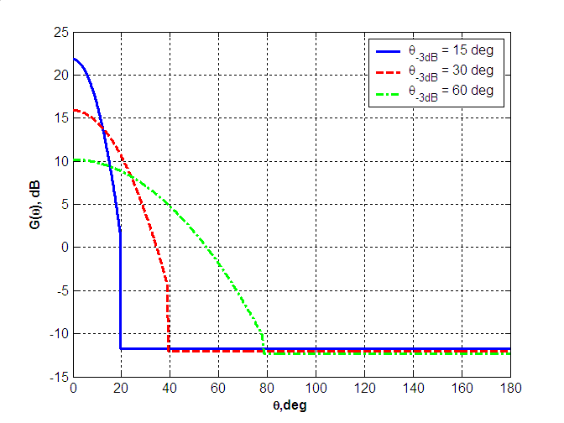
Figure 42. Antenna patterns of the basic antenna model for different values of _{-3dB}
Figure 43 shows a 3D antenna pattern for _{-3dB} = 30⁰. Lines of equal gain correspond to the fixed values of elevation angle.
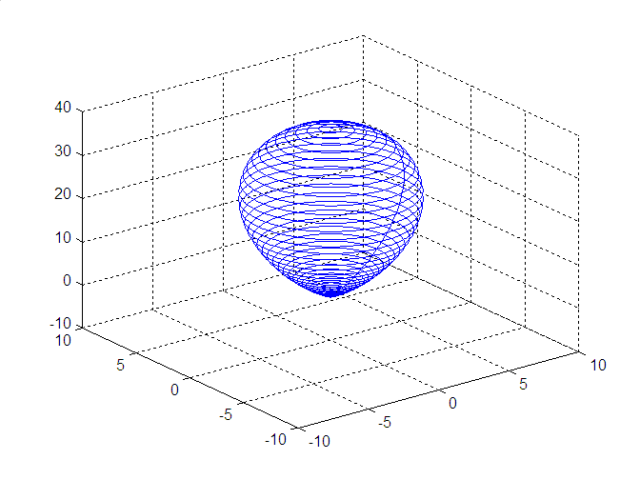
Figure 43. 3D antenna pattern for _{-3dB} = 30⁰

Support of Polarization Characteristics
Polarization characteristics of the basic steerable antenna model are directly supported in the channel model as it is described in Section 2.4. The TX and RX antennas polarization vectors need to be defined to set the antennas polarizations.

Rotation of Basic Steerable Antenna
The proposed antenna model is described in the previous section for the case when it is steered with the maximum gain direction along the positive direction of z axis. However, performing beamforming procedures requires steering the antenna to an arbitrary direction at the TX and RX sides. This section describes how the steering procedure for basic steerable antenna model may be implemented.
The principle of the steering procedure implementation is the following. It is simplest to calculate amplification / attenuation of the propagation channel rays caused by the antenna in the coordinate system when the antenna is steered towards the z axis. In this case the antenna gain for each signal ray only depends on the elevation angle of the rays and does not depend on the azimuth angle. So when the antenna is steered away from the direction of z axis in a primary coordinate system (XYZ) (where all channel rays are defined), a new coordinate system (XYZ)_{r} is introduced so that the antenna is pointed along the axis z_{r} in this new coordinate system. After that, the recalculation of the angular coordinates of all channel rays is performed with the new coordinate system and the gain of antenna is applied.
The primary (XYZ) coordinate system is shown in Figure 44. At the transmitter (or receiver) the angular position of the ray is defined by two angles – azimuth angle  and elevation angle .
Figure 44. Coordinates Associated with Transmitter and Receiver in Beam Search Procedure
The procedure for conversion of angular coordinates from (XYZ) and (XYZ)_{r} coordinate systems is as follows. The unique position of one coordinate system relatively to the other is defined by three rotation transformations known as Euler’s rotations. The first rotation is performed by an angle $ϕ_{r}$ around the Z-axis, the second by the $θ_{r}$ around the X_{r}-axis and the third is by an angle $ψ_{r}$ around the Z_{r}-axis. The Euler’s rotation transformations are illustrated in Figure 45.

Figure 45. Euler’s Rotations
The first rotation determines the target azimuth position relative to the transmitter (or receiver) coordinates. The second rotation sets the elevation angle position. The third rotation can be specified for non-symmetric azimuth distribution of the antenna gain function. But in the case of symmetrical antenna pattern it is omitted without lost of generality. Therefore two rotation angles (azimuth and elevation) need to be specified to determine the required antenna position at the transmitter (or receiver).
To determine the antenna gain coefficient corresponding to a particular ray direction, the conversion of its spatial azimuth and elevation angles in transmitter (receiver) system (XYZ) to rotated coordinates (XYZ)_{r} associated with specific antenna position has to be performed. Such conversion is described by the rotation matrix which is decomposed as a product of elemental Givens rotation matrices.
Azimuth rotation is described by matrix
$R_{1}(ϕ_{r})=\left[\begin{matrix}\text{cos}(ϕ_{r}) & \text{sin}(ϕ_{r}) & 0 \\ −\text{sin}(ϕ_{r}) & \text{cos}(ϕ_{r}) & 0 \\ 0 & 0 & 1\end{matrix}\right]$. | ()
Elevation rotation is described by
$R_{2}(θ_{r})=\left[\begin{matrix}1 & 0 & 0 \\ 0 & \text{cos}(θ_{r}) & \text{sin}(θ_{r}) \\ 0 & −\text{sin}(θ_{r}) & \text{cos}(θ_{r})\end{matrix}\right]$. | ()
Full rotation matrix has a form
$$R=R_{1}(ψ_{r})⋅R_{2}(θ_{r})⋅R_{1}(ϕ_{r})$$ | ()
Note that the order of rotations in Figure 45 is in accordance with order of multiplications in (). The third Euler’s rotation is not applied and therefore the matrix $R\left(ψ_{r}\right)$ is equal to identity matrix and () is simplified to
$R=R_{2}(θ_{r})⋅R_{1}(ϕ_{r})$. | ()
Consider the point determined by spherical coordinates $(r,ϕ,θ)$ in transmitter (receiver) system (XYZ). The corresponding Cartesian coordinates are:
()
The Cartesian coordinates in rotated system are defined by multiplication:
$$\left[\begin{matrix}x_{r} \\ y_{r} \\ z_{r}\end{matrix}\right]=R×\left[\begin{matrix}x \\ y \\ z\end{matrix}\right]$$ | ()
Antenna gain coefficient in rotated coordinates (XYZ)_{r} due to azimuth symmetry is determined by elevation angle only. Elevation angle in rotated coordinates is simply obtained using $z_{r}$ coordinate
$$θ=\text{ar}\text{cos}\left({z_{r}}/r\right)$$ | ()
If the elevation angle of the ray obtained by equation () falls within the main lobe of the antenna pattern, the antenna gain is calculated by substituting the elevation angle value into equation (). If the elevation angle of the ray falls outside of the main lobe of the antenna pattern, the antenna side lobe gain level is applied.

Phased Antenna Array
Phased antenna arrays allow for beam steerable directional antennas in 60 GHz WLAN systems. Therefore, support of this type of antenna in the channel model is important.

Supported Types of Phased Antenna Arrays
Planar type of antenna arrays composed of variable number of identical elements is supported. Elements in the reference array design are isotropic radiators. However, the array model is not limited to only this type of radiators, and can be simply modified for any other type. Elements of planar array are arranged on a rectangular grid. An example of the geometry of an (N_{x}  N_{y}) element array is shown in Figure 46.
Figure 46. Geometry of (N_{x}xN_{y}) elements planar array arranged on rectangular grid
The geometry is obtained by initially placing N_{x} elements with equal spacing of d_{x} along the x-axis and then placing a linear N_{x} array next to each other with equal spacing in the y-direction (normal to x). Therefore only arrays with equal spacing along different dimensions are considered, but steps along x and y directions in the general case are not equal.
Also it is important to note that the channel model allows to arbitrarily position the antenna relative to the main coordinate system of the channel model associated with the LOS direction. The position of the antenna array is defined by setting three corresponding Euler’s rotation angles. The recalculation of the coordinates of the rays from the main coordinate system to the coordinate system associated with the antenna array is done by Euler’s rotations as described in Section 6.3.2 above.

Antenna Gain Calculation for Planar Phased Arrays
This section provides an antenna gain calculation for planar arrays described in section above. A computation of gain may account for antenna efficiency as well as its directional capabilities. However, effects related to antenna radiation efficiency (i.e. the difference between power absorbed by antenna and radiated power) are not considered in this model. Therefore gain function and directivity are assumed to be the equivalent measures.
Directivity is defined as ratio of the radiation intensity in a given direction from antenna to the radiation intensity averaged over all directions [13]. For planar arrays composed from identical elements intensity, the field at a point in far-zone is a product of single element radiation pattern (element factor) and array factor [17]. In the case when isotropic radiators are utilized as array elements, the element factor is constant for all spatial directions and equal to 1. Each array has its own factor and, in general, it is a function of the number of elements in array, their geometrical arrangement, spacing between elements, and their relative phases and amplitudes.
The following will calculate a precise mathematical equation for directivity distribution for a planar rectangular array described above. First we introduce a spherical system of coordinates associated with a planar array as shown in Figure 47.
Figure 47. System of coordinates associated with planar array
The center of coordinates coincides with the geometrical center of array and xy-plane lies in the plane of the array. Axis x (the same is true for y) is parallel to one side of the array and normal to the other side. Axis z is normal to the plane of the array. Elevation angle  in this system is the angle between the positive z-axis and the line between the origin and the target point. Azimuth angle  is the angle between the positive x-axis and the line from the origin to the target point projected onto the xy-plane.
The directivity in accordance with this definition [13] is equal to the following ratio:
$D\left(θ,ϕ\right)=\frac{U\left(θ,ϕ\right)}{\frac{1}{4π}\int_{0}^{2π}{\int_{0}^{π/2}{U\left(θ,ϕ\right)⋅\text{sin}\left(θ\right)dθdϕ}}}$, | ()
where $U\left(θ,ϕ\right)$ is the intensity of the field in the far-zone along the $\left(θ,ϕ\right)$ direction. The average radiation intensity in denominator is equal to total power radiated by antenna divided by the total solid angle$4π$. So, the directivity of a non-isotropic source is equal to the ratio of radiation intensity in a given direction to intensity of isotropic source in the same direction with the condition that it radiates the same total power. It is assumed that radiation occurs only into the half-space above the array and directivity for elevation angles greater than $π/2$ is equal to zero.
The total intensity radiated along the (, ) direction by the (N_{x}  N_{y}) element array, assuming no coupling between the elements, is equal to the square module of the following double sum:
$U\left(θ,ϕ\right)={\left|\sum_{n_{x}=0}^{N_{x}−1}{\sum_{n_{y}=0}^{N_{y}−1}{f\left(θ,ϕ\right)⋅W_{\text{nx},\text{ny}}⋅\text{exp}\left({jΔϕ}_{\text{nx},\text{ny}}\right)}}\right|}^{2}$, | ()
where f(, ) is a radiation pattern of the single element, W_{nx,ny} are complex weights determining phase excitation for each element of array, and ${Δϕ}_{\text{nx},\text{ny}}$ is a phase shift for an element with coordinates (n_{x},n_{y}) relative to (0,0) element based upon the geometry of the array (see Figure 46). The magnitude of radiators excitation is identical and equal to 1.
The phase shift for this array geometry for element (n_{x},n_{y}) and (, ) spatial direction is obtained as follows:
${Δϕ}_{\text{nx},\text{ny}}=k_{x}⋅d_{x}⋅n_{x}+k_{y}⋅d_{y}⋅n_{y}$,  $\begin{aligned}k_{x}=k⋅\text{sin}\left(θ\right)⋅\text{cos}\left(ϕ\right) \\ k_{y}=k⋅\text{sin}\left(θ\right)⋅\text{sin}\left(ϕ\right)\end{aligned}$, | ()
where d_{x} and d_{y} are the distances between elements along different array dimensions, k_{x} and k_{y} are projections of wave vector into the x and y axis correspondingly.
The essential assumption introduced above is that planar array is composed from identical elements. Under this assumption equation () can be represented as a product of two factors:
$U\left(θ,ϕ\right)={\left|\underset{\text{Element} \text{factor}}{\underbrace{f\left(θ,ϕ\right)}}\right|}^{2}⋅{\left|\underset{\text{Array} \text{factor}}{\underbrace{\sum_{n_{x}=0}^{N_{x}−1}{\sum_{n_{y}=0}^{N_{y}−1}{W_{\text{nx},\text{ny}}⋅\text{exp}\left({jΔϕ}_{\text{nx},\text{ny}}\right)}}}}\right|}^{2}$. | ()
The second multiplier in () is called the array factor. The array factor only includes array parameters and does not depend on the directional characteristics of the radiating elements themselves. In the case of isotropic radiators, intensity of the field depends only on the array factor, and () is reduced to
$U\left(θ,ϕ\right)={\left|\sum_{n_{x}=0}^{N_{x}−1}{\sum_{n_{y}=0}^{N_{y}−1}{W_{\text{nx},\text{ny}}⋅\text{exp}\left({jΔϕ}_{\text{nx},\text{ny}}\right)}}\right|}^{2}$. | ()
For the given geometry of a planar array, equation () represents the dependence of intensity distribution function on weight matrix coefficients.
Directivity properties of a phased array depend on phase excitation of each element in the array. In the general case, arbitrary complex weights can be applied to derive a target directivity distribution. It is essential to note that the normalization condition for weight matrix of following type
$$\sum_{\text{nx}=0}^{\text{Nx}−1}{{\sum_{\text{ny}=0}^{\text{Ny}−1}{\left|W_{\text{nx},\text{ny}}\right|}}^{2}}=1$$ | ()
is insufficient for saving average radiating power as a constant value. So the normalization of the transmitted power has to be done through integration of the intensity over the total 4 solid angle to get the total power.
In the general case the integral for the total power can not be resolved in analytical form and numerical approach should be applied to obtain directivity distribution.
For 60 GHz WLAN systems the most important practical case is when the antenna pattern has one main beam which is steered to a particular direction (₀, ₀). In this case, the phase excitation for different elements should be set as:
$$W_{\text{nx},\text{ny}}=\text{exp}\left(−{jΔψ}_{\text{nx},\text{ny}}\right)$$ | ()
where phase shift ${Δψ}_{\text{nx},\text{ny}}$ has the same definition as ${Δϕ}_{\text{nx},\text{ny}}$ in (). The only difference is that instead of $\left(θ,ϕ\right)$, angles $\left(θ_{0},ϕ_{0}\right)$ are applied. Such a weight matrix definition allows for the reduction of the integral for the average total power to summations. This eliminates the need to integrate the intensity distribution for each new spatial position. In papers [18], [19] analytical equations for average total power intensity are provided for different types of element factor. In the case of isotropic radiator the equation has the form presented below:
$\int_{0}^{2π}{\int_{0}^{π/2}{U\left(θ,ϕ\right)⋅\text{sin}\left(θ\right)dθdϕ=4{πN}_{x}N_{y}T}}$,  $$\begin{aligned}T=\frac{1}{2}+\sum_{n_{x}=1}^{N_{x}−1}{\text{cos}\left(n_{x}{\text{kd}}_{x}\text{sin}\left(θ_{0}\right)\text{cos}\left(ϕ_{0}\right)\right)⋅\left(1−\frac{n_{x}}{N_{x}}\right)\frac{\text{sin}\left(n_{x}{\text{kd}}_{x}\right)}{n_{x}{\text{kd}}_{x}}}+ \\ +\sum_{n_{y}=1}^{N_{y}−1}{\text{cos}\left(n_{y}{\text{kd}}_{y}\text{sin}\left(θ_{0}\right)\text{sin}\left(ϕ_{0}\right)\right)⋅\left(1−\frac{n_{y}}{N_{y}}\right)\frac{\text{sin}\left(n_{y}{\text{kd}}_{y}\right)}{n_{y}{\text{kd}}_{y}}}+ \\ +2\sum_{n_{x}=1}^{N_{x}−1}{\sum_{n_{y}=1}^{N_{y}−1}{\text{cos}\left(n_{x}{\text{kd}}_{x}\text{sin}\left(θ_{0}\right)\text{cos}\left(ϕ_{0}\right)+n_{y}{\text{kd}}_{y}\text{sin}\left(θ_{0}\right)\text{sin}\left(ϕ_{0}\right)\right)⋅}}\left(1−\frac{n_{x}}{N_{x}}\right)\left(1−\frac{n_{y}}{N_{y}}\right)\frac{\text{sin}\left(\sqrt{{\left(n_{x}{\text{kd}}_{x}\right)}^{2}+{\left(n_{y}{\text{kd}}_{y}\right)}^{2}}\right)}{\sqrt{{\left(n_{x}{\text{kd}}_{x}\right)}^{2}+{\left(n_{y}{\text{kd}}_{y}\right)}^{2}}}\end{aligned}$$ | ()
Equation () allows rapid machine calculation of directivity distribution () for an arbitrary spatial position corresponding to the main beam setting by elevation and azimuth angles $\left(θ_{0},ϕ_{0}\right)$.
The following example illustrates the directional capabilities of a planar phased array with a geometry of (N_{x} = 6,N_{y} = 6), dx = dy = 0.5λ. Figure 48 shows the degradation of directivity corresponding to maximum radiation intensity as a function of elevation scan angle $θ_{0}$ along two azimuth directions $ϕ_{0}=0^{∘}, {\text{45}}^{∘}$.
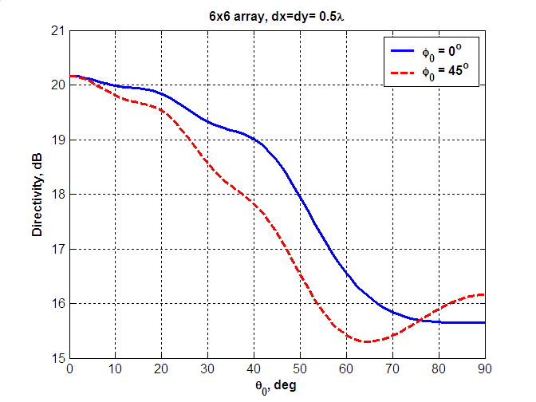
Figure 48. Example of directivity degradation for (6x6) planar phased array as a function of elevation angle along two azimuth directions
As it can be seen from Figure 48 directivity capabilities of a planar phased array closely depends on spatial beam position. Directivity decreases as elevation angle $θ_{0}$increases. In addition, the roll off factors for degradation curves are different for different azimuth directions.
Figure 49 shows 3D directivity patterns for a 6x6 planar phased array corresponding to different elevation scan angles $θ_{0}=0^{∘}$ (broadside radiation) and $θ_{0}={\text{30}}^{∘}$.
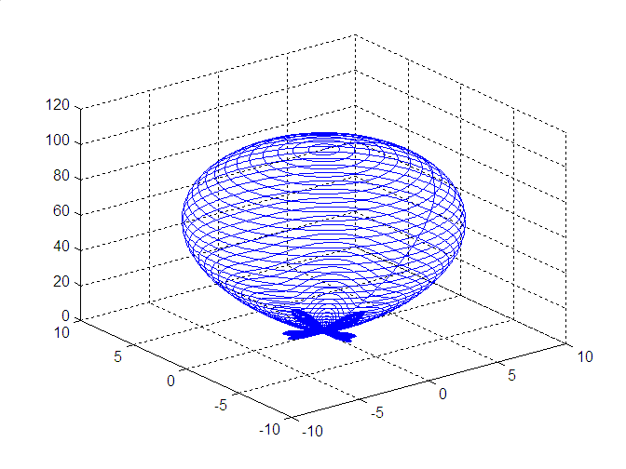 | 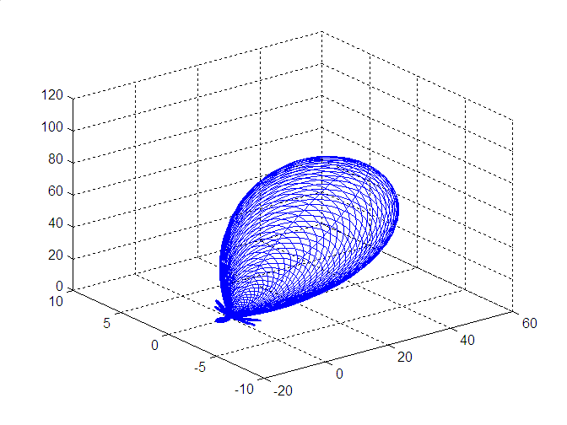
(a) $θ_{0}=0^{∘}$ (broadside radiation) | (b) $θ_{0}={\text{30}}^{∘}$
Figure 49. 3D directivity radiation patterns for 6x6 planar phased array for two values of elevation scan angles

Path Loss

Path Loss Modeling
Sections 2 – 5 provide description of the general structure of the 60 GHz WLAN channel models and procedures proposed for the generation of the channel model parameters that are specific for different evaluation scenarios.
The developed channel models provide complex amplitudes of different rays taking into account the attenuation of the signal between the transmitter and receiver along the rays in a real scale (). Hence, each ray has a part of information about the propagation loss of the channel and a part of information about the impulse response.
Note that this approach is different from a traditional channel modeling approach in the WLAN bands of 2.4 and 5 GHz where separate models are generated for path loss and channel impulse response. In 2.4 GHz and 5 GHz bands most of the channel rays contribute to the total received signal power even if multiple antennas are used and spatial signal processing algorithms are applied. Thus, the separation between path loss and impulse response models is possible and the path loss function describes average energy (power) behavior of electromagnetic field for different distances and the channel impulse response function independently describes channel realization behavior.
In the 60 GHz WLAN band, the necessity of application of high directional steerable antennas and beamforming algorithms will lead to filtering out (in a spatial domain) of a single cluster of the propagation channel. So in many cases both the frequency selectivity and propagation loss of the channel will be only defined by characteristics of a single cluster. Thus, for the same TX and RX locations, the path loss and channel impulse response may be significantly different depending on the characteristics of the cluster used for communications and also directivity properties of antennas and a used beamforming algorithm. These facts, in general, do not allow developing independent models for path loss and channel impulse response characteristics.
The 60 GHz channel models developed in Sections 2 – 5 do not need independent path loss model and are directly applicable for simulations of beamforming algorithms and simulations of communication links. However, an independent path loss model is helpful for network (or MAC) simulations where direct application of the developed channel models and complete modeling of the beamforming algorithms may unnecessary complicate the network simulations, which have a different focus. To solve this problem, it is possible to derive an independent path loss model if some assumptions about the 60 GHz WLAN system such as antenna type and beamforming algorithm are fixed.
In next sections, the path loss models are developed for different evaluation scenarios with fixing antenna configurations and beamforming algorithms.
The current version of the path loss models does not support impact of polarization characteristics. Proposed path loss models are valid for the communication system using antennas with linear horizontal polarization.

Path Loss Model for Conference Room
This section presents path loss models for the conference room environment with LOS and NLOS scenarios. The path loss models are developed for the STA-STA sub-scenario. The path loss models for the STA-AP sub-scenario are TBD.
The path loss models are developed using the basic steerable directional antenna model from Section 6 with beamwidths from 10⁰ to 60⁰ and a beamforming algorithm adjusting TX and RX antennas along the ray (cluster) with a maximum power.
For each scenario, a path loss formula predicting average path loss values for different TX-RX separation distances was found and, additionally, a shadow fading (SF) model, characterizing deviations of instantaneous path loss values from the average value for this distance, was developed.

LOS Scenario
To develop a path loss model for the LOS scenario, the basic steerable antenna model and the maximum ray beamforming algorithms were used. The instantaneous path loss values were generated using statistical channel model for different TX and RX locations. Averaging over 10000 channel realizations was performed to calculate average path loss values for each TX-RX separation distance.
Figure 50 shows the average path loss as a function of the distance for the conference room environment with the LOS scenario.
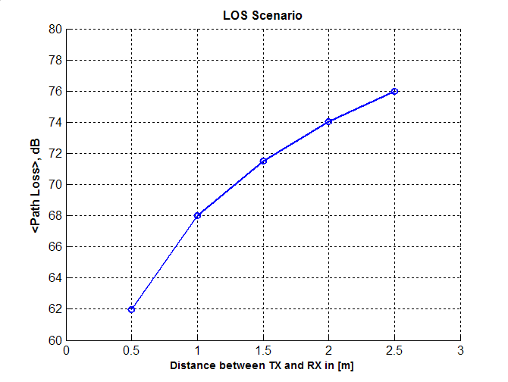
Figure 50. Average path loss vs. distance for the LOS scenario
It was estimated from Figure 50 that curve may be well approximated by the r² law, where r is the TX-RX separation distance. Additionally, it was verified that similar curves for other antenna beamwidths in the range from 10⁰ to 60⁰ match each other very closely (within 0.1 dB) and may be approximated by the same polynomial law.
To calculate the deviation of instantaneous path loss from the average value, the histogram of instantaneous path loss realizations for the conference room LOS scenario, the TX-RX separation equal to 2 m, and 30⁰ antenna beamwidth is plotted in Figure 51.

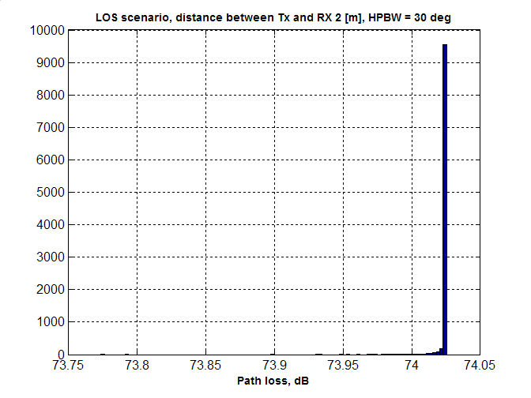
Figure 51. Histogram of path loss realizations for LOS scenario
It may be seen from Figure 51 that for LOS scenario deviations of actual path loss values are very low (because the most part of the channel power is the LOS ray). Hence, no shadow fading may be assumed for the path loss model of the LOS scenario since all LOS realizations of the channel with the same distance will have the same path loss.
Based on the obtained simulation results a simple path loss model may be proposed for LOS scenario based on the Friis transmission equation:
$${\text{PL}}_{\text{LOS}}[\text{dB}]=A_{\text{LOS}}+\text{20}{\text{log}}_{\text{10}}\left(f\right)+\text{10}n_{\text{LOS}}{\text{log}}_{\text{10}}\left(R\right)$$ | ()
where A_{LOS} = 32.5 dB, n_{LOS} = 2.0, f is the carrier frequency in GHz, R is the distance between TX and RX in m. As it is described above, no shadow fading model is required for the LOS scenario, since instantaneous path loss realizations are always very close to the average value given by ().
The value of A_{LOS} is specific for the selected type of antenna and beamforming algorithm. A_{LOS} depends on the antenna beamwidth, but for the considered beamwidth range from 10⁰ to 60⁰, the variation was found to be negligible (< 0.1 dB).
To verify (), Figure 52 shows simulated path loss values using statistical channel model, path loss formula () and experimental path loss values measured in the conference room environment with 17⁰ beamwidth directional antennas steered along the LOS path. (The conference room experiments description may be found in [4]).
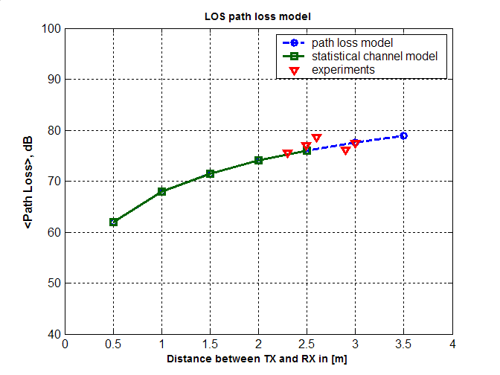
Figure 52. Comparison of simulated path loss using statistical channel model, path loss formula () and experimental path loss values for the LOS scenario
It may be seen that the proposed path loss model () is well matched to both the statistical conference room channel model and experimental data.

NLOS Scenario
A procedure, similar to that used in the LOS scenario, was applied to develop a path loss model for the NLOS scenario in the conference room environment. As for the LOS scenario, the basic steerable directional antenna model with beamwidths from 10⁰ to 60⁰ and the beamforming algorithm adjusting TX and RX antennas along the ray with maximum power were used.
Figure 53 shows the average path loss as a function of the distance for the conference room environment with the NLOS scenario. The average path loss values in Figure 53 were calculated by averaging over 10000 path loss values obtained with the conference room statistical channel model for each TX-RX separation distance. The average path loss curves are plotted for different antenna beamwidths from 10⁰ to 60⁰ in 10⁰ steps.

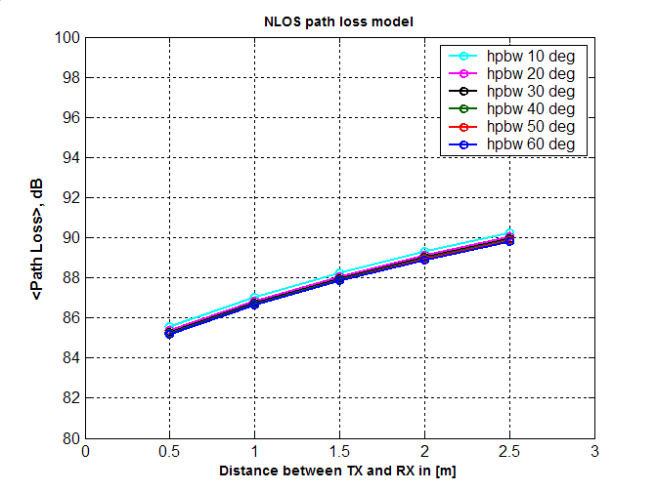
Figure 53. Average path loss vs. distance for the NLOS scenario
Figure 53 shows that the path loss curves for different antenna beamwidths follow close to each other (within 1 dB) for all TX-RX distances. Thus, the dependence of the path values on the antenna beamwidth may be neglected and it was verified, that all curves may be well approximated by r^{0.6} law, where r is the TX-RX separation distance.
To calculate the deviation of instantaneous path loss from the average value, the histogram of instantaneous path loss realizations for the conference room NLOS scenario, the TX-RX separation equal to 2 m, and 30⁰ antenna beamwidth is plotted in Figure 51.

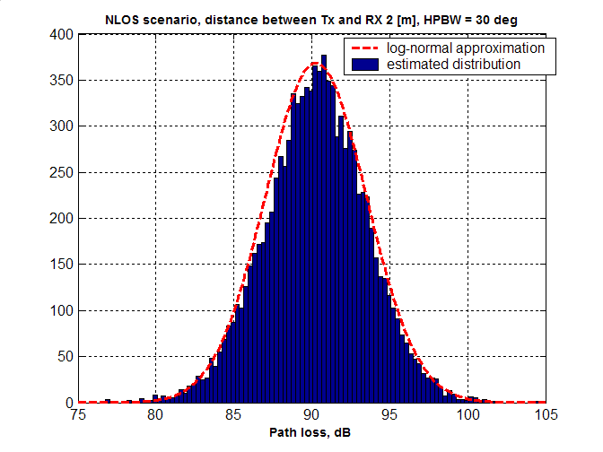
Figure 54. Histogram of path loss realizations for NLOS scenario and the log-normal approximation
It may be seen from Figure 54 that for the NLOS scenario the variance of path loss is significant and shadow fading model should be introduced. Figure 54 shows normal (Gaussian) in dB (log-normal in absolute scale) analytical distribution with mean and variance parameters estimated from the histogram. That provides good matching to the simulated results and may be used as a shadow fading model for the conference room NLOS scenario.
Figure 55 shows the shadow fading standard deviation in dB as a function of the TX-RX separation distance plotted for different antenna beamwidths.

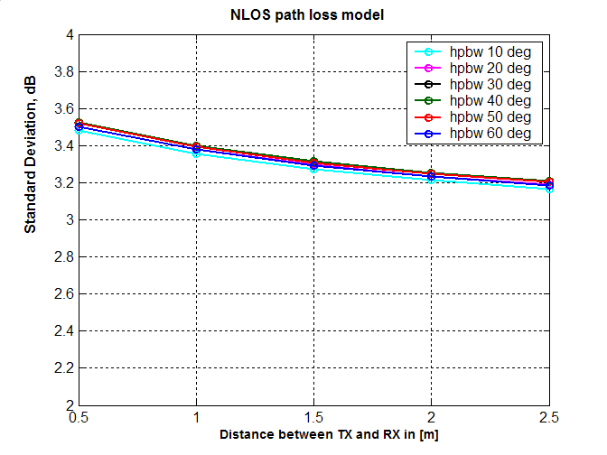
Figure 55. Standard deviation of shadow fading for the NLOS scenario as a function of distance
The results in Figure 55 show that the standard deviation  of the path loss slightly depends on the TX – RX separation distance but approximately may be taken equal to 3.3dB for all distances.
Additionally, Figure 55 shows that dependence of  on antenna beamwidth is small because, for the considered range of antenna beamwidths (10⁰ to 60⁰), antenna selects only one spatial channel cluster for most of the cases.
Based on the obtained results, the average path loss model may be proposed for the NLOS scenario as:
$${\text{PL}}_{\text{NLOS}}[\text{dB}]=A_{\text{NLOS}}+\text{20}{\text{log}}_{\text{10}}\left(f\right)+\text{10}n_{\text{NLOS}}{\text{log}}_{\text{10}}\left(R\right)$$ | ()
where A_{NLOS} = 51.5 dB, n_{LOS} = 0.6, f is the carrier frequency in GHz, R is the distance between TX and RX in m.
The values of A_{NLOS} and n_{NLOS} may be specified for the selected type of antenna and beamforming algorithm. A_{NLOS} depends on the antenna beamwidth, but for the considered beamwidth range from 10⁰ to 60⁰ the variation is small (< 1 dB) and can be neglected.
To generate instantaneous path loss realizations, the shadow fading (SF) model should be applied. The SF values distribution is normal in dB (log-normal in absolute values) with standard deviation  = 3.3 dB.
To verify (), Figure 56 shows simulated path loss values using statistical channel model, path loss formula () and experimental path loss values measured in the conference room environment with 17⁰ beamwidth directional antennas steered along the most powerful NLOS signal cluster. (The conference room experiments description may be found in [4]).

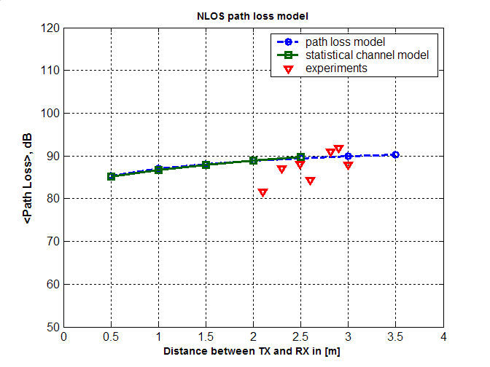
Figure 56. Comparison of simulated path loss using statistical channel model, path loss formula () and experimental path loss values for the NLOS scenario
It may be seen that the proposed path loss model () is well matched to both the statistical conference room channel model and experimental data.

Path Loss Model for Cubicle Environment
TBD

Path Loss Model for Living Room
TBD

Path Loss Model Summary
The characteristics of the 60 GHz WLAN propagation channel complicate the development of the independent path loss model. However, if antenna system parameters and beamforming algorithms are fixed then it is possible to derive an average path loss model using the standard form:
$\text{PL}[\text{dB}]=A+\text{20}{\text{log}}_{\text{10}}\left(f\right)+\text{10}n{\text{log}}_{\text{10}}\left(R\right)$. | ()
Here A and n are parameters specific for the scenario and antenna system, f is the carrier frequency in GHz, R is the distance between TX and RX in m.
To generate path loss realizations, the normal in dB shadow fading (SF) model should be used together with the average path loss model (). SF standard deviation  is specific for the scenario and antenna system parameters.
The path loss model parameters for the conference room scenario, basic steerable antenna model and maximum ray power beamforming algorithm are shown in Table 8. Path loss model parameters for living room and cubicle environments are TBD.
Table 8. Path loss model parameters
Scenario | A, dB | n | SF std. dev., dB
Conference room LOS | 32.5 | 2.0 | 0
Conference room NLOS | 51.5 | 0.6 | 3.3
Living room LOS | TBD | TBD | TBD
Living room NLOS | TBD | TBD | TBD
Cubicle environment LOS | TBD | TBD | TBD
Cubicle environment NLOS | TBD | TBD | TBD

Interference Environment Modeling
TBD

References

- IEEE doc. 802.11-09/0096r8. TGad evaluation methodology, E. Perahia, Jan. 19, 2009.
- IEEE doc. 802.11-08/0811r1. Channel Modeling for 60 GHz WLAN systems, A. Maltsev et al, July 14, 2008.
- IEEE doc. 802.11-09/0323r0. TGad channel model requirements, V. Erceg et al, March 10, 2009.
- IEEE doc. 802.11-08/1044r0. 60 GHz WLAN experimental investigations, A. Maltsev et al, Sept. 8, 2008.
- IEEE doc. 802.11-09/0721r1. Propagation measurements and considerations in conference room, living room, and cubicle environments. Part 1, H. Sawada et al, July 2, 2008.
- H. Xu, V. Kukshya, and T. S. Rappaport, “Spatial and temporal characteristics of 60 GHz indoor channels,” IEEE J. Sel. Areas Commun., vol. 20, no. 3, pp. 620–630, Apr. 2002
- B. Neekzad, K. Sayrafian-Pour, J. Perez, and J. S. Baras, “Comparison of ray tracing simulations and millimeter wave channel sounding measurements”, in Proc. of 18th Annual IEEE Int. Symp. on Personal, Indoor and Mobile Radio Commun. (PIMRC'07).
- IEEE doc. 802.11-09/0552r0. Experimental investigation of polarization impact on 60 GHz WLAN systems, A. Maltsev et al, May 11, 2009.
- IEEE doc. 802.11-09/0431r0. Polarization model for 60 GHz, A. Maltsev et al, April 2, 2009.
- K. Sato et al, “Measurements of Reflection and Transmission
Characteristics of Interior Structures of Office Building in the 60 GHz Band”,
IEEE Trans. Antennas Propag., vol. 45, no. 12., pp.1783-1792, Dec. 1997.
- IEEE doc. 802.11-03/940r4, TGn channel models, V. Erceg et al, May. 5, 2004.
- IEEE doc. 802.11-09/0499r1. Simulation scenario floor plans, E. Perahia, R. Maslennikov, May 9, 2009.
- IEEE Std 145-1993. IEEE Standard Definitions of Terms for Antennas, March 18, 1993
- Spatial channel model text description, SCM text v.7.0, Spatial channel model AHG (combined ad-hoc from 3GPP&3GPPs), Aug. 19, 2003.
- IEEE doc. 15-07-0584-01-003c, TG3c channel modeling sub-committee final report, Su-Khiong Yong et al, Mar. 13, 2007.
- IEEE doc. 802.15-06/474r0, Reference antenna model with side lobe for TG3c evaluation, I. Toyoda et al, Nov. 2006.
- C.A. Balanis, Antenna Theory. New Jersey: Wiley, 2005.
- B. J. Forman, “A novel directivity expression for planar antenna arrays,” Radio Science, vol. 5, no. 7, July 1970, pp. 1077-1083.
- M. J. Lee, I. Song, S. Yoon, and S. R. Par, “Evaluation of directivity for planar antenna arrays,” IEEE Antennas Propagat. Mag., vol. 42, no. 3, June 2000

