IEEE P802.11
Wireless LANs
Channel Models for 60 GHz WLAN Systems
Date: 2009-05-11
Author(s):
Name | Affiliation | Address | Phone | email
Alexander Maltsev | Intel | Turgeneva str., 30,  Nizhny Novgorod, 603024, Russia | +7-831-4162461 | alexander.maltsev@  intel.com
Vinko Erceg | Broadcom |  |  | verceg@broadcom.com
Eldad Perahia | Intel |  |  | eldad.perahia@intel.com
Chris Hansen | Broadcom |  |  | chansen@broadcom.com
Roman Maslennikov | Intel |  |  | roman.maslennikov@  intel.com
Artyom Lomayev | Intel |  |  | artyom.lomayev@  intel.com
Alexey Sevastyanov | Intel |  |  | alexey.sevastyanov@  intel.com
Alexey Khoryaev | Intel |  |  | alexey.khoryaev  @intel.com
Abstract
Description of channel models for 60 GHz Wireless Local Area Networks (WLANs) systems based on the results of experimental measurements.

Introduction
This document describes the channel models for 60 GHz Wireless Local Area Networks (WLANs) systems based on the results of experimental measurements. The goal of the channel modeling is to assist 60 GHz WLAN standardization process.
The document proposes a general structure of a new channel model which takes into account important properties of 60 GHz electromagnetic waves propagation. The current revision of this document presents a detailed description and parameters of the channel model for a conference room scenario. The channel model allows for generating a channel realization that includes space, time, amplitude and phase characteristics of all rays comprising this channel realization. The space characteristics of rays include azimuth and elevation angles for both transmit and receive sides.
Reference antenna models that may be applied to the generated space-time channel realizations are implemented in the channel model and are described. Three types of antenna models are proposed to be used together with the channel model. These are isotropic antenna, basic steerable directional antenna and phased antenna array models.

Scenarios for Channel Modeling
Three basic channel modeling scenarios are proposed in accordance with the proposal for the TGad Evaluation Methodology document [1]. These are conference room, cubicle and living room scenarios.

General Characteristics of Channel Model

Requirements for Channel Model
The following are requirements of channel models for 60 GHz WLAN systems [2] taking into account properties of 60 GHz channels and applications of 60 GHz WLAN technology:
- Provide accurate space-time characteristics of the propagation channel (basic requirement) for main usage models of interest;
- Support beamforming with steerable directional antennas on both TX and RX sides with no limitation on the antenna technology (i.e. non-steerable antennas, sector-switching antennas, antenna arrays);
- Account for polarization characteristics of antennas and signals;
- Support non-stationarity characteristics of the propagation channel arising from people motion around the area causing time-dependent channel variations.

General Structure of Channel Model
The current version of the document proposes a channel structure model that provides accurate space-time characteristics and supports application of any type of directional antenna technology. The polarization impacts and non-stationarity are currently not included.
The channel impulse response function for the channel model may be written using a general structure as:
$$\begin{aligned}h\left(t,ϕ_{\text{tx}},θ_{\text{tx}},ϕ_{\text{rx}},θ_{\text{rx}}\right)=\sum_{i}{A^{(i)}C^{(i)}\left(t−T^{(i)},ϕ_{\text{tx}}−Φ_{\text{tx}}^{(i)},θ_{\text{tx}}−Θ_{\text{tx}}^{(i)},ϕ_{\text{rx}}−Φ_{\text{rx}}^{(i)},θ_{\text{rx}}−Θ_{\text{rx}}^{(i)}\right)} \\ C^{(i)}\left(t,ϕ_{\text{tx}},θ_{\text{tx}},ϕ_{\text{rx}},θ_{\text{rx}}\right)=\sum_{k}{α^{(i,k)}δ\left(t−τ^{(i,k)}\right)δ\left(ϕ_{\text{tx}}−ϕ_{\text{tx}}^{(i,k)}\right)δ\left(θ_{\text{tx}}−θ_{\text{tx}}^{(i,k)}\right)δ\left(ϕ_{\text{rx}}−ϕ_{\text{rx}}^{(i,k)}\right)δ\left(θ_{\text{rx}}−θ_{\text{rx}}^{(i,k)}\right)}\end{aligned}$$ | ()
where:
- h is a generated channel impulse response.
- t, ϕ_{tx}, θ_{tx}, ϕ_{rx}, θ_{rx} are time and azimuth and elevation angles at the transmitter and receiver, respectively.
- A^{(i)} and C^{(i)} are the gain and the channel impulse response for i-th cluster respectively.
- δ( )- is the Dirac delta function.
- T^{(i)}, Φ_{tx}^{(i)}, Θ_{tx}^{(i)}, Φ_{rx}^{(i)}, Θ_{rx}^{(i)} are time-angular coordinates of i-th cluster.
- α^{(i,k)} is the amplitude of the k-th ray of i-th cluster
- τ^{(i,k)}, ϕ_{tx}^{(i,k)}, θ_{tx}^{(i,k)}, ϕ_{rx}^{(i,k)}, θ_{rx}^{(i,k)} are relative time-angular coordinates of k-th ray of i-th cluster.
The proposed channel model adopts the clustering approach with each cluster consisting of several rays closely spaced in time and angular domains. In a real environment, time and angular parameters of different clusters and rays are time varying functions due to a non-stationary environment. However, the rate of these variations is relatively slow. In this document all time and angular parameters of the model were treated as virtually time-invariant random variables. The support of time varying channel model will be provided later.
The same general structure of the channel model () was used for all three considered modeling scenarios. However, statistical characteristics of different time and angular parameters of the channel model are specific for each scenario. To further improve the accuracy of the propagation channel prediction, two additional channel modeling mechanisms are introduced. First, the clusters within each scenario are classified into different types (e.g. first and second order reflections from walls are different types of clusters) with specific statistical characteristics of inter cluster parameters. Second, some of parameters of individual clusters within the same cluster type are described by taking into account their statistical dependence. These approaches improve the accuracy of the propagation channel modeling. This was verified by directly comparing the channel model with experimental data and ray-tracing simulations.

Usage of Channel Model in Simulations
This subsection gives a brief description of the channel realization generation process that is implemented in the channel model. The whole process of the channel realization generation is schematically shown in Figure 1.
Figure 1. Process of channel realization generation
The generation of the channel impulse response begins with selecting model input parameters.
The next step is generation of all possible channel clusters between the transmitter and receiver. Amplitude, time, and angular characteristics for all clusters are generated.
In a real environment not all the clusters are available for communication, some of the clusters are blocked by people, furniture, and other objects. To take this into account, a part of the clusters is blocked in the channel model. The blocked part of the clusters is selected randomly. Each cluster has an individual probability of being blocked. This probability is independent from the blockage probabilities of other clusters.
After a subset of non-blocked clusters is defined the intra cluster parameters for each non-blocked cluster are generated. Each cluster consists of multiple rays and the output of this step includes amplitude, phase, time, and angular parameters for all rays of the given channel realization. After this step the generation of channel realization is completed. But in order to be used a simulation, antenna models must be applied to the generated realization and it must be converted from continuous to discrete time.
Reference antenna models and beamforming algorithms are included, which may be applied in the next step of the channel realization generation process. The beamforming algorithms may have input from the baseband, for example, setting the weight vector of antenna array.
In the last step the channel impulse is converted from continuous time to discrete time with the specified sample. After this step the generation of the discrete time channel impulse response is completed and useable in simulations.

Conference Room Channel Model

Measurements and Modeling Scenarios
The channel model for the conference room environment is based on the experimental results that were partially presented in [3].
Several sets of measurements have been carried out in three similar office conference rooms with dimensions equal approximately to 3 m x 4.5 m x 3 m (W x L x H). All the conference rooms have a big table in the middle and chairs around the table. The capacity of the rooms is about 8 to 10 people. More details on the measurements scenario and exploited setup may be found in [3].
The measurement scenario corresponds to the channel model scenario where several devices placed on the table in a conference room communicate with each other using LOS communications and first and second order reflections from walls and ceiling.
Reflections from the table were not considered. The reflections from the table may lead to very deep flat fading due to interference of two strong rays (LOS and reflected rays) with a small separation in the time domain and angular domains. The impact of the table reflections may be taken into account in the conference room (CR) model by introducing the fading effect into the LOS path. But a table channel model would need to be a subject of a separate experimental investigation.

Model Development Methodology
This subsection describes the methodology used to develop the channel model for the conference room environment.
The experimental results demonstrated that the propagation channel is clustered and that time and angular positions of clusters correspond (with low deviations) to the first and second order reflections predicted by the geometrical optics (ray tracing). The clustering phenomenon of the propagation channel has been taken into account in the channel model structure as shown in Section 3.
The inter cluster parameters include amplitude of the cluster, time of arrival, azimuth and elevation angles for TX and RX. As it was described above, good matching of time and angular characteristics between measurements and ray tracing has been obtained experimentally.
Since the experimental set of parameters values was limited, time and angular inter cluster parameters were obtained from ray tracing simulations. A ray tracing model of the conference room with dimensions 4.5 x 3 x 3 m has been used to generate multiple realizations of 1st and 2nd order reflected clusters. Communicating devices were assumed to be located at the table in a center of the room. TX and RX pairs were randomly placed in a flat layer with the height equal to 1m and the horizontal dimensions equal to 2.5 x 1 m. The TX and RX positions were distributed uniformly within this layer.
The first and second order reflections from walls and ceiling were considered. The reflections from the floor were not taken into account as they were assumed to be blocked by the table. The 3D model of the room is schematically shown in Figure 2.
Figure 2. 3D model of conference room used for ray tracing
Statistical time and angular characteristics of the first and second order reflections were calculated from ray tracing simulations results and then used to derive the corresponding inter cluster time and angular parameters for the CR channel model.
The probability density functions (PDFs) for amplitudes of the clusters were estimated using an approximation of the experimental statistical distribution.
For the purposes of channel modeling all clusters are divided into five groups:
- LOS path
- Four first order (reflected) clusters from four walls;
- One first order cluster from ceiling;
- Four second order clusters from the walls and ceiling. The chosen geometrical positions of TX and RX guarantee that there are four such clusters in total – one cluster for every wall with either reflection from the wall and then ceiling or the ceiling and then the wall.
- Eight second order clusters corresponding to reflections from two walls.
Different groups of clusters have different characteristics (e.g. reflections from walls only have zero elevation angle) and this was taking into account in the simulation model. The PDFs of parameters for different clusters have been obtained from ray tracing and their approximations were used for the channel model development.
As mentioned in Section 3.3 not all available clusters are included in the generated channel realization as some clusters are blocked. The probabilities of clusters blockage for different clusters groups of the conference room channel model are described in Section 4.3.8.
With perfect mirror reflections each cluster will consist of exactly one ray. But taking into account the roughness and heterogeneity of the surfaces as well as the presence of additional small different reflectors each cluster may include several rays closely spaced with each other in time and angular domains. In the channel model the intra cluster parameters were identified based on the processing of experimental data. The description of the intra cluster parameters modeling is provided below in Section 4.4.

Inter Cluster Parameters
This subsection gives description of the statistical models for inter cluster parameters.

LOS Ray
The first type of cluster is the LOS path, which is modeled as a single ray with the gain equal to:
A⁽⁰⁾ = λ/(4πd) | ()
where λ is a wavelength, and d is a separation between TX and RX. Parameters λ and d are input parameters of the channel model.
Relationship () is derived from the Friis transmission equation, which sets the signal receive power P_{rx} as:
$$P_{\text{rx}}=G_{\text{tx}}G_{\text{rx}}{\left(\frac{λ}{4πd}\right)}^{2}P_{\text{tx}}$$ | ()
where G_{tx} and G_{rx} are TX and RX antennas gains respectively and P_{tx} is the transmitted power. The antenna gain coefficients are taken into account when an antenna model is applied and so the LOS amplitude gain is given by ().
The LOS component has zero TX and RX azimuth and elevation angles and also zero time of arrival (TOA). The TX and RX elevation and azimuth angles, as well as times for arrival for other clusters, are defined relatively to the LOS path.

Time of Arrival Distribution for Different NLOS Clusters
TOA of different clusters is calculated relatively to the LOS path time of arrival. Empirical distributions of the TOA for different cluster group have been obtained by ray tracing simulations. Then piecewise linear approximations of the empirical probability density functions (PDFs) were used to develop statistical models for the TOA parameters.
The empirical PDF obtained from ray tracing simulations and their approximations are shown for different groups of clusters in Figure 3.
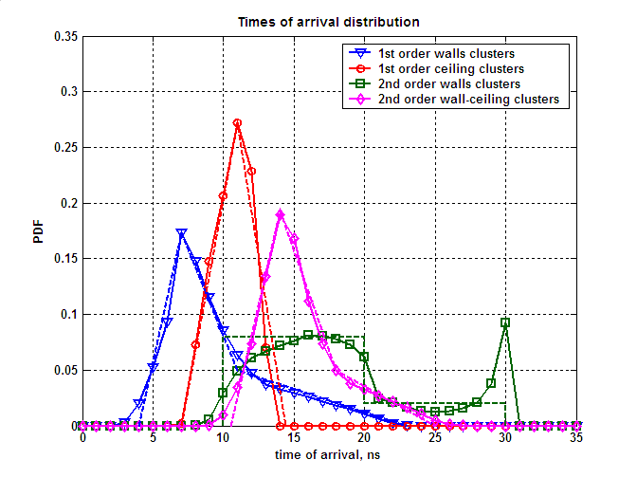
Figure 3. TOA empirical distributions obtained from ray tracing (solid curves) and approximations used in the channel model (dashed curves)
The following equations are used for approximations of TOA PDFs for different clusters groups (time unit is ns):
First order reflections from walls
$$W_{t}(t)=\left\{\begin{matrix}0 \\ 0\text{.}\text{0577}⋅\text{t-0}\text{.}\text{2307} \\ \text{-0}\text{.}\text{0307}⋅t+0\text{.}\text{3882} \\ \text{-0}\text{.}\text{0042}⋅t+0\text{.}\text{0958} \\ 0\end{matrix}\right.\begin{matrix} \\ \\ \\ \\ \begin{matrix}t<4 \\ 4≤t<7 \\ 7≤t<\text{11} \\ \text{11}≤t<\text{23} \\ t≥\text{23}\end{matrix}\end{matrix}$$ | ()
First order reflections from ceiling
$$W_{t}(t)=\left\{\begin{matrix}0 \\ 0\text{.}\text{0677}⋅t\text{-0}\text{.}\text{4741} \\ \text{-0}\text{.}\text{0797}⋅t+1\text{.}\text{1473} \\ 0\end{matrix}\right.\begin{matrix} \\ \\ \\ \begin{matrix}t<7 \\ 7≤t<\text{11} \\ \text{11}≤t<\text{14}\text{.}4 \\ t≥\text{14}\text{.}4\end{matrix}\end{matrix}$$ | ()
Second order reflections from walls and ceiling
$$W_{t}(t)=$$ | ()
Second order reflections from walls
$$W_{t}(t)=$$ | ()

Angular Characteristics for First Order Reflection from Walls
There are four clusters corresponding to four first order reflections from walls (one reflection per wall).
An example of four clusters corresponding to the first order reflections from walls is shown in Figure 4.
Figure 4. Example of four clusters corresponding to the first order reflections from walls
The example illustrated in Figure 4 demonstrates that angular parameters of the four clusters are dependent upon each other. If angular parameters of the four clusters were generated independently, there may be a case of overlapping of multiple clusters. Such overlapping is not encountered in practice and will impact simulation results.
The model for generating the clusters corresponding to the first order wall reflections take into account the following properties:
- Elevation angle is equal to zero for all clusters at both TX and RX;
- There are always two positive and two negative angles when considering TX azimuth angles of all four clusters. For example, in Figure 4 ϕ_{1TX} and ϕ_{4TX} are positive, but ϕ_{2TX} and ϕ_{3TX} are negative.
- At the RX side there are also two positive and two negative azimuth angles. In Figure 4 ϕ_{2TX} and ϕ_{3TX} are positive, but ϕ_{1TX} and ϕ_{4TX} are negative.
- Every cluster has either positive TX and negative RX azimuth angles, or, vise versa, negative TX and positive RX azimuth angles. For example, cluster 1 and 4 in Figure 4 have positive TX azimuth angles but negative RX azimuth angles. Clusters 2 and 3 in Figure 4 have negative TX azimuth angles but positive RX azimuth angles.
- Considering a pair of clusters with positive TX and negative RX azimuth angles (e.g. clusters 1 and 4 in Figure 4), a cluster with the larger absolute value of TX azimuth angle (e.g. cluster 1 in Figure 4) will have a smaller (than other cluster) absolute value of the RX azimuth angle (cluster 1). Correspondingly the cluster with smaller absolute TX azimuth angle (cluster 4) will have a larger absolute RX azimuth angle. The same is true for the other pair of clusters with negative TX and positive RX azimuth angles (e.g. clusters 2 and 3 in Figure 4).
Taking into account the described properties, the azimuth angles were generated simultaneously for pairs of clusters with the same signs of azimuth angles (e.g. clusters 1 and 4 from Figure 4). The TX and RX angles for a given pair were generated independently but with taking account property V described above.
The joint distribution (histogram) for angle pairs is shown in Figure 5 for pairs with positive and negative angles. The pair of angles for cluster A (ϕ_{A}) and angles for cluster B (ϕ_{B}) in Figure 5 may be two positive TX angles and two negative for clusters 1 and 4 from Figure 4. Also the distribution from Figure 5 is valid for two positive RX angles and two negative TX angles for clusters 2 and 3 from Figure 5.
Figure 5. Joint distribution (histogram) of azimuth angles with the same sign for two clusters corresponding to first order reflections
As it was mentioned above the main reason for using the joint distribution of a pair of clusters azimuth angles is to maintain necessary relationships between angular characteristics of different clusters. It can be seen from Figure 5 that there are no first order clusters which are closely spaced in angular domain.
The joint distribution shown in Figure 5 has a complex form and an approximation of this distribution for the channel model is used for simplicity. The distribution shown in Figure 6 (uniform in the marked trapezoidal sectors) was used in the conference room channel model for approximation of the joint distribution for clusters azimuth angles shown in Figure 5.
Figure 6. Approximation of the joint distribution of azimuth angles with the same sign for two clusters corresponding to first order reflections
Analytically the proposed approximation for clusters with positive azimuth angles is described as a two dimensional distribution function that is uniform in the trapezoidal areas 1 and 2.
The trapezoidal area 1 is defined by the following equations (all conditions are met simultaneously):
$$\left\{\begin{matrix}ϕ_{B}≥\left(\frac{\text{140}}{\text{90}}\right)⋅ϕ_{A}+{\text{62}}^{0} \\ ϕ_{B}≤\left(\frac{\text{140}}{\text{90}}\right)⋅ϕ_{A}+{\text{82}}^{0} \\ ϕ_{B}≤{\text{180}}^{0} \\ ϕ_{A}≥0^{0}\end{matrix}\right.$$ | ()
where all angles are measured in degrees.
The trapezoidal 2 area is symmetrical to area 1 and is defined by the following equations (all conditions are met simultaneously):

$$\left\{\begin{matrix}ϕ_{B}≤\left(\frac{\text{140}}{\text{90}}\right)⋅ϕ_{A}−{\text{62}}^{0} \\ ϕ_{B}≥\left(\frac{\text{140}}{\text{90}}\right)⋅ϕ_{A}−{\text{82}}^{0} \\ ϕ_{B}≥−{\text{180}}^{0} \\ ϕ_{A}≤0^{0}\end{matrix}\right.$$ | ()

Angular Characteristics for First Order Reflections from Ceiling
A single cluster corresponding to the 1st order reflection from the ceiling takes into account the following properties:
- all azimuth angles are equal to zero;
- elevation angles for TX and RX are equal to each other.
The empirical PDF of the elevation angle obtained from ray tracing simulations and an approximation are shown below in Figure 7.
The approximation for the PDF of the elevation angle is given by the following equations:
$$W_{θ}(θ)=$$ | ()
where all angles are measured in degrees.

Angular Characteristics for Second Order Reflections from Walls and Ceiling
The model for the second order reflections from walls and ceiling take into account the following properties:
- There are in total four second order clusters corresponding to reflection from wall and then ceiling or from ceiling and then wall for the chosen distributions of TX and RX positions.
- There is always exactly one reflection for each wall (either wall and then ceiling or ceiling and then wall).
- The azimuth angles for these clusters are equal to the azimuth angles of the clusters from first order reflections from walls.
- The elevation angles of the same cluster are equal for TX and RX.
The empirical PDFs and approximations for elevation of second order walls and ceiling reflections are plotted in Figure 7.
The elevation angles are generated using the following equation:
$$W_{θ}(θ)=$$ | ()
where all angles are measured in degrees.
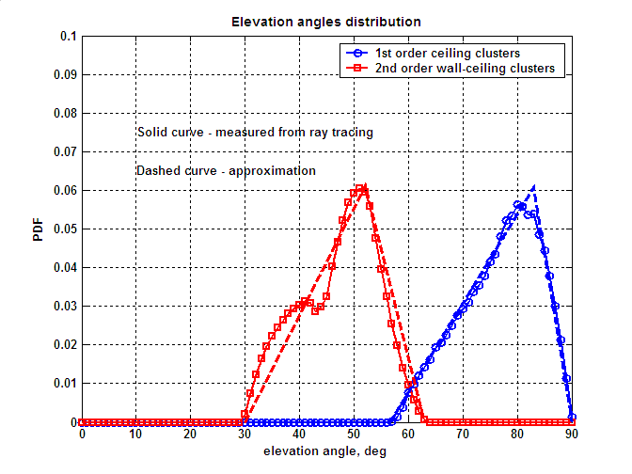
Figure 7. Empirical PDF and approximations for elevation angles of first order reflections from ceiling and second order reflections from walls and ceiling

Angular Characteristics for Second Order Reflections from Walls
This group of clusters has the following main properties:
- There are in total eight clusters corresponding to the second order reflections from walls.
- These clusters have elevation angles equal to zero.
- The TX azimuth angles for these clusters are equal to either the RX azimuth angle or RX azimuth angle +/– 180⁰.
- There are four regions in the joint distribution of TX and RX azimuth angles and there are always two clusters in each region.
The joint distribution (histogram) of TX and RX azimuth angles for second order reflections from walls is shown in Figure 8. It can be seen that there are in total four different regions, as mentioned above, and two clusters were generated for each region. The uniform distribution in the range of [-180⁰,0⁰] or [0⁰,180⁰] was used for an approximation of the azimuth angle distribution function.

Figure 8. Joint distribution (histogram) for TX and RX Azimuth angles for second order wall reflections
TX and RX azimuth angles ϕ_{tx1,} ϕ_{rx1, …,} ϕ_{tx8}, ϕ_{rx8} for the eight second order reflections from walls are calculated as:

$$\begin{aligned}\left\{ϕ_{\text{tx}1}={\text{180}}^{∘}⋅u_{1} | \right.\end{aligned}$$ | $$\begin{aligned}\left\{ϕ_{\text{tx}2}={\text{180}}^{∘}⋅u_{2} | \right.\end{aligned}$$ | ()
$$\begin{aligned}\left\{ϕ_{\text{tx}3}={\text{180}}^{∘}⋅\left(u_{3}−1\right) | \right.\end{aligned}$$ | $$\begin{aligned}\left\{ϕ_{\text{tx}4}={\text{180}}^{∘}⋅\left(u_{4}−1\right) | \right.\end{aligned}$$ | ()
$$\begin{aligned}\left\{ϕ_{\text{tx}5}={\text{180}}^{∘}⋅\left(u_{5}−1\right) | \right.\end{aligned}$$ | $$\begin{aligned}\left\{ϕ_{\text{tx}6}={\text{180}}^{∘}⋅\left(u_{6}−1\right) | \right.\end{aligned}$$ | ()
$$\begin{aligned}\left\{ϕ_{{\text{tx}}_{7}}={\text{180}}^{∘}⋅u_{7} | \right.\end{aligned}$$ | $$\begin{aligned}\left\{ϕ_{\text{tx}8}={\text{180}}^{∘}⋅u_{8} | \right.\end{aligned}$$ | ()

where u₁, …, u₈ – are independent random variables uniformly distributed in the interval [0,1].

Gain of Clusters
As it was mentioned above the gain for LOS is predicted by the Friis transmission equation (or free space propagation law). For NLOS first and second order reflected clusters the gain is calculated as:
A^{(i)} = g^{(i)} λ / (4π (d + R)); R = c ⋅ t | ()
where g^{(i)} is a reflection loss, λ is a wavelength (5 mm), d is a distance between TX and RX (along LOS path), R is a total distance along the cluster path decreased by d, R is calculated as a product of TOA relatively LOS and the speed of light.
Figure 9 shows histograms of measured reflection losses the first (a) and second (b) order reflection clusters and their approximations by Gaussian distributions. The model for g^{(i)} obtained from experimental distributions of the first and second order reflections is given by a log-normal distribution (normal in dB). The parameters of distribution for the first order reflection clusters is given in Figure 9a and the parameters of distribution for the second order reflection clusters is given in Figure 9b.
Figure 9. Histograms of measured reflection losses for the first (a) and second (b) order reflection clusters and approximations by Gaussian distributions

Probabilities of Clusters Blockage
In a real environment not all clusters that occur in an empty conference room may be used for communication. Part of the clusters may be blocked by people sitting or moving in the conference room and also by other objects. This effect is taken into account in the channel model by the introduction of the cluster blockage probability associated with each type of cluster. In reality, different objects and people blocking signal propagation paths may have more complicated effect on the channel structure. For example, additional reflected clusters may appear. But, in order to keep the channel model complexity low, this effect was modeled by simple cluster blockage.
Table 1. Probabilities of clusters blockage
Cluster type | Probability of cluster blockage
LOS | 0 or 1 (set as a model parameter)
First order reflections from walls | 0.4
First order reflections from ceiling | 0.1
Second order reflections from wall and ceiling | 0.3
Second order reflections from walls | 0.8

The values of probabilities for cluster blockage are selected based on the consideration that in a conference room reflections from walls have a higher probability of being blocked by humans in a conference room than reflections from the ceiling. Reflections from the ceiling should be available most of the time.
The situation for NLOS simulations when all clusters are blocked has a small but non-zero probability. If all generated clusters are blocked then the empty channel realization is discarded and a new cluster blockage realization is generated.

Intra Cluster Parameters
In accordance with equation () the structure of the i-th cluster of the channel is written as:
$C^{(i)}\left(t,ϕ_{\text{tx}},θ_{\text{tx}},ϕ_{\text{rx}},θ_{\text{rx}}\right)=\sum_{k}{α^{(i,k)}δ\left(t−τ^{(i,k)}\right)δ\left(ϕ_{\text{tx}}−ϕ_{\text{tx}}^{(i,k)}\right)δ\left(θ_{\text{tx}}−θ_{\text{tx}}^{(i,k)}\right)δ\left(ϕ_{\text{rx}}−ϕ_{\text{rx}}^{(i,k)}\right)δ\left(θ_{\text{rx}}−θ_{\text{rx}}^{(i,k)}\right)}$ ()
where α^{(i,k)} is the amplitude of the k-th ray of i-th cluster and τ^{(i,k)}, ϕ_{tx}^{(i,k)}, θ_{tx}^{(i,k)}, ϕ_{rx}^{(i,k)}, θ_{rx}^{(i,k)} are relative time-angular coordinates of k-th ray of i-th cluster.
The intra cluster parameters of the channel model were estimated from the measurement data. The individual rays were identified in the time domain, and statistical characteristics including average number of rays, ray arrival rate, and ray power decay rates were measured.
Based on the obtained results, the statistical model for the cluster time domain parameters is given. The structure of the model is schematically shown in Figure 10.
Figure 10. Time domain model of the cluster
The cluster consists of a central ray α^{(i,0)} with fixed amplitude and pre-cursor $α^{(i,−N_{f})}…α^{(i,−1)}$ and post-cursor rays $α^{(i,1)}…α^{(i,N_{b})}$. The number of pre-cursor rays N_{f} and post-cursor rays N_{b} was derived from measurements and is fixed in the model as N_{f} = 2 and N_{b} = 4.
Pre-cursor and post-cursor rays are modeled as two Poisson processes with arrival rates λ_{f} = 0.2 ns⁻¹ and λ_{b} = 0.12 ns⁻¹, respectively.
The average amplitudes A_{f} and A_{b} of the pre-cursor and post-cursor rays decay exponentially with power decay times γ_{f} = 1.3 ns and γ_{b} = 2.8 ns, respectively:
$$\begin{aligned}A_{f}(τ)=A_{f}(0)e^{{−\left|τ\right|}/{γ_{f}}} \\ A_{b}(τ)=A_{b}(0)e^{{−\left|τ\right|}/{γ_{b}}}\end{aligned}$$ | ()
The individual pre-cursor and post-cursor rays α^{(i,k)} have random uniformly distributed phases and Rayleigh distributed amplitudes with average values A_{f} and A_{b}.
The amplitudes of the pre-cursor and post-cursor rays are coupled with the amplitude of the central ray of the cluster α^{(i,0)} by K-factors that are defined as:
$$\begin{aligned}K_{f}=\text{20}{\text{log}}_{\text{10}}\left|\frac{α^{(i,0)}}{A_{f}(0)}\right| \\ K_{b}=\text{20}{\text{log}}_{\text{10}}\left|\frac{α^{(i,0)}}{A_{b}(0)}\right|\end{aligned}$$ | (4)
The K-factors are fixed as K_{f} = 5 dB and K_{b} = 10 dB
The total average (over multiple realizations) power of all cluster rays is normalized to one.
The summary of the estimated intra cluster time domain parameters for the conference room channel model are shown in Table 2.

Table 2. Summary of the intra cluster time domain parameters for the conference room channel model
Parameter | Notation | Value
Pre-cursor rays K-factor | K_{f} | 5 dB
Pre-cursor rays power decay time | γ_{f} | 1.3 ns
Pre-cursor rate arrival rate | λ_{f} | 0.20 ns⁻¹
Pre-cursor rays amplitude distribution |  | Rayleigh
Number of pre-cursor rays | N_{f} | 2
Post-cursor rays K-factor | K_{b} | 10 dB
Post-cursor rays power decay time | γ_{b} | 2.8 ns
Post-cursor rate arrival rate | λ_{b} | 0.12 ns⁻¹
Post-cursor rays amplitude distribution |  | Rayleigh
Number of post-cursor rays | N_{b} | 4

The power delay profiles calculated from the experimental data and the cluster model are shown in Figure 11. As illustrated, the model is well matched to the measurement data.
Figure 11. Experimental power delay profile (PDP) of the cluster and PDP obtained with the cluster model
In the experimental measurements the identification of the individual rays composing the cluster was done in the time domain only. Identification of rays inside of the cluster in the angular domain requires an increase of the angular resolution by using directional antennas with very high gain or application of the “virtual antenna array” technique where low directional antenna element is used to perform measurements in multiple positions along the virtual antenna array to form an effective antenna aperture.
In the performed experiments the majority of the cluster rays were received within the angle dimension of the antenna pattern that was used (about 17⁰ at 3 dB level). Therefore a simple model may be used to describe the intra cluster angular parameters. Intra cluster azimuth and elevation angles for both transmitter and receiver is modeled as independent normally distributed random variables with zero mean and RMS equal to 5⁰.

Channel Model for Cubicle Environment
TBD

Living Room Channel Model
TBD

Antenna Models and Beamforming Algorithms
This section provides a description of reference antenna models and beamforming algorithms that may be used together with the channel model. The reference antenna models and beamforming algorithms were developed to demonstrate the application of the channel model in simulations of 60 GHz communication systems with steerable directional antennas.
Three antenna models are developed together with the given channel model. These are isotropic radiator, basic steerable directional antenna, and phased antenna array. Different types of antenna models with different parameters (e.g. beamwidths) may be used in the simulations. The three developed antenna models capture most of the practical simulation scenarios. However, the channel model is not limited in this sense and any additional antenna models may be created.

Isotropic Radiator
The simplest type of the antenna model is an isotropic radiator [5]. This model has a spherical antenna pattern that equally illuminates all signal rays at the transmitter and equally combines all rays coming from different directions at the receiver.
The isotopic antenna can not be implemented in practice but is a convenient theoretical model which is used in the channel model for analytical purposes.
This model does not have any spatial selectivity and does not need any beamforming procedure for optimal steering in space.

Basic Steerable Directional Antenna Model

General Description of Basic Steerable Antenna Model
Antenna patterns of the real world antennas have quite complex form and require many details for accurate description. For this reason many known wireless propagation channel models (e.g. [6], [7]) include only a basic antenna model that captures all essential characteristics of real world antennas but is significantly simplified to avoid unnecessary complexity. The most widely used is an antenna model with a main lobe of Gaussian form in linear scale (parabolic form in dB scale) and constant level of side lobes [6], [8]. Such antenna model was also adopted for the channel model.
An input parameter for the antenna model is 3 dB beamwidth of the main lobe θ_{-3dB}. This parameter fully defines the antenna pattern of the antenna model from which all the other parameters are derived.
A main lobe gain is described using a circularly symmetric Gaussian distribution which is represented in analytical form as follows:
$$G\left(θ,ϕ\right)=G_{0}\text{exp}\left(−{\text{αθ}}^{2}\right)$$ | ()
where G₀ is a maximum antenna gain, θ is elevation angle, ϕ is azimuth angle, α is a coefficient that is determined by the half-power beam width θ_{-3dB} as:
$α=\frac{4\text{ln}\left(2\right)}{θ_{−3\text{dB}}^{2}}$. | ()
Equation () can be expressed in dB scale as:
$$G_{\text{dB}}=G_{0\text{dB}}−\text{12}⋅{\left(\frac{θ}{θ_{−3\text{dB}}}\right)}^{2}$$ | ()
The maximum gain of the antenna G₀ may be calculated from θ_{-3dB} using approximation for an ideal circular aperture antenna [8], [9]:
$$G_{0}=(\text{ka})^{2}$$ | ()
$$\text{ka}⋅\text{sin}({θ_{−3\text{dB}}}/2)=1\text{.}\text{6162}$$ | ()

where k is the wavenumber and a is the radius of the aperture respectively
Main-lobe width is determined for -20 dB level relatively to maximum gain value and can be simply obtained from ()
$$θ_{\text{ML}}=2\text{.}6⋅θ_{−3\text{dB}}$$ | ()
The gain for other angles of the basic antenna model (outside the main lobe) is equal to a constant side lobe level. The side lobe level is chosen so that integration of the antenna power gain over total 4π solid angle results in unity (normalization condition).
Figure 12 shows antenna patterns of the proposed antenna model as a function of elevation angle for 3 dB beamwidth equal to 15⁰, 30⁰ and 60⁰.
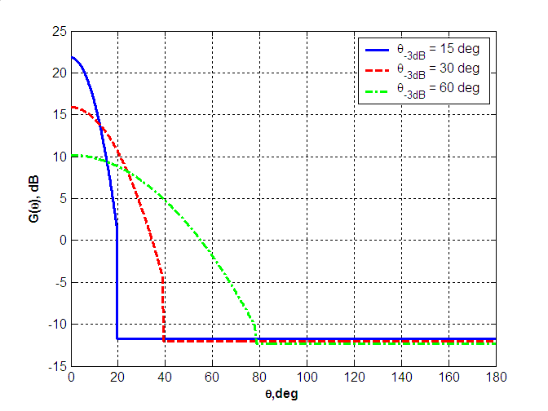
Figure 12. Antenna patterns of the basic antenna model for different values of θ_{-3dB}
Figure 13 shows a 3D antenna pattern for θ_{-3dB} = 30⁰. Lines of equal gain correspond to the fixed values of elevation angle.
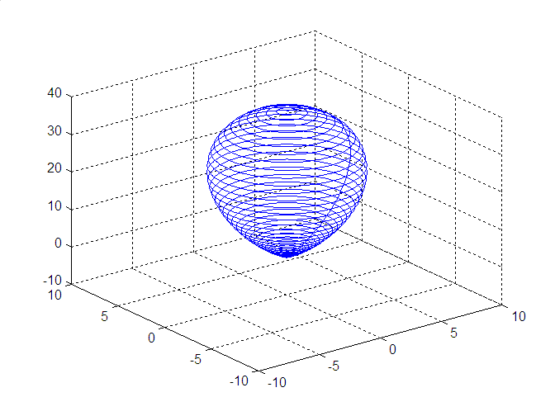
Figure 13. 3D antenna pattern for θ_{-3dB} = 30⁰

Rotation of Basic Steerable Antenna
The proposed antenna model is described in the previous section for the case when it is steered with the maximum gain direction along the positive direction of z axis. However, performing beamforming procedures requires steering the antenna to an arbitrary direction at the TX and RX sides. This section describes how the steering procedure for basic steerable antenna model may be implemented.
The principle of the steering procedure implementation is the following. It is simplest to calculate amplification / attenuation of the propagation channel rays caused by the antenna in the coordinate system when the antenna is steered towards the z axis. In this case the antenna gain for each signal ray only depends on the elevation angle of the rays and does not depend on the azimuth angle. So when the antenna is steered away from the direction of z axis in a primary coordinate system (XYZ) (where all channel rays are defined), a new coordinate system (XYZ)_{r} is introduced so that the antenna is pointed along the axis z_{r} in this new coordinate system. After that, the recalculation of the angular coordinates of all channel rays is performed with the new coordinate system and the gain of antenna is applied.
The primary (XYZ) coordinate system is shown in Figure 14. At the transmitter (or receiver) the angular position of the ray is defined by two angles – azimuth angle ϕ and elevation angle θ.
Figure 14. Coordinates Associated with Transmitter and Receiver in Beam Search Procedure
The procedure for conversion of angular coordinates from (XYZ) and (XYZ)_{r} coordinate systems is as follows. The unique position of one coordinate system relatively to the other is defined by three rotation transformations known as Euler’s rotations. The first rotation is performed by an angle $ϕ_{r}$ around the Z-axis, the second by the $θ_{r}$ around the X_{r}-axis and the third is by an angle $ψ_{r}$ around the Z_{r}-axis. The Euler’s rotation transformations are illustrated in Figure 15.

Figure 15. Euler’s Rotations
The first rotation determines the target azimuth position relative to the transmitter (or receiver) coordinates. The second rotation sets the elevation angle position. The third rotation can be specified for non-symmetric azimuth distribution of the antenna gain function. But in the case of symmetrical antenna pattern it is omitted without lost of generality. Therefore two rotation angles (azimuth and elevation) need to be specified to determine the required antenna position at the transmitter (or receiver).
To determine the antenna gain coefficient corresponding to a particular ray direction, the conversion of its spatial azimuth and elevation angles in transmitter (receiver) system (XYZ) to rotated coordinates (XYZ)_{r} associated with specific antenna position has to be performed. Such conversion is described by the rotation matrix which is decomposed as a product of elemental Givens rotation matrices.
Azimuth rotation is described by matrix
$R_{1}(ϕ_{r})=\left[\begin{matrix}\text{cos}(ϕ_{r}) & \text{sin}(ϕ_{r}) & 0 \\ −\text{sin}(ϕ_{r}) & \text{cos}(ϕ_{r}) & 0 \\ 0 & 0 & 1\end{matrix}\right]$. | ()
Elevation rotation is described by
$R_{2}(θ_{r})=\left[\begin{matrix}1 & 0 & 0 \\ 0 & \text{cos}(θ_{r}) & \text{sin}(θ_{r}) \\ 0 & −\text{sin}(θ_{r}) & \text{cos}(θ_{r})\end{matrix}\right]$. | ()
Full rotation matrix has a form
$$R=R_{1}(ψ_{r})⋅R_{2}(θ_{r})⋅R_{1}(ϕ_{r})$$ | ()
Note that the order of rotations in Figure 15 is in accordance with order of multiplications in (). The third Euler’s rotation is not applied and therefore the matrix $R\left(ψ_{r}\right)$ is equal to identity matrix and () is simplified to
$R=R_{2}(θ_{r})⋅R_{1}(ϕ_{r})$. | ()
Consider the point determined by spherical coordinates $(r,ϕ,θ)$ in transmitter (receiver) system (XYZ). The corresponding Cartesian coordinates are:
()
The Cartesian coordinates in rotated system are defined by multiplication:
$$\left[\begin{matrix}x_{r} \\ y_{r} \\ z_{r}\end{matrix}\right]=R×\left[\begin{matrix}x \\ y \\ z\end{matrix}\right]$$ | ()
Antenna gain coefficient in rotated coordinates (XYZ)_{r} due to azimuth symmetry is determined by elevation angle only. Elevation angle in rotated coordinates is simply obtained using $z_{r}$ coordinate
$$θ=\text{ar}\text{cos}\left({z_{r}}/r\right)$$ | ()
If the elevation angle of the ray obtained by equation () falls within the main lobe of the antenna pattern, the antenna gain is calculated by substituting the elevation angle value into equation (). If the elevation angle of the ray falls outside of the main lobe of the antenna pattern, the antenna side lobe gain level is applied.

Phased Antenna Array
Phased antenna arrays allow for beam steerable directional antennas in 60 GHz WLAN systems. Therefore, support of this type of antenna in the channel model is important.

Supported Types of Phased Antenna Arrays
Planar type of antenna arrays composed of variable number of identical elements is supported. Elements in the reference array design are isotropic radiators. However, the array model is not limited to only this type of radiators, and can be simply modified for any other type. Elements of planar array are arranged on a rectangular grid. An example of the geometry of an (N_{x} × N_{y}) element array is shown in Figure 16.
Figure 16. Geometry of (N_{x}xN_{y}) elements planar array arranged on rectangular grid
The geometry is obtained by initially placing N_{x} elements with equal spacing of d_{x} along the x-axis and then placing a linear N_{x} array next to each other with equal spacing in the y-direction (normal to x). Therefore only arrays with equal spacing along different dimensions are considered, but steps along x and y directions in the general case are not equal.
Also it is important to note that the channel model allows to arbitrarily position the antenna relative to the main coordinate system of the channel model associated with the LOS direction. The position of the antenna array is defined by setting three corresponding Euler’s rotation angles. The recalculation of the coordinates of the rays from the main coordinate system to the coordinate system associated with the antenna array is done by Euler’s rotations as described in Section 7.2.2 above.

Antenna Gain Calculation for Planar Phased Arrays
This section provides an antenna gain calculation for planar arrays described in section above. A computation of gain may account for antenna efficiency as well as its directional capabilities. However, effects related to antenna radiation efficiency (i.e. the difference between power absorbed by antenna and radiated power) are not considered in this model. Therefore gain function and directivity are assumed to be the equivalent measures.
Directivity is defined as ratio of the radiation intensity in a given direction from antenna to the radiation intensity averaged over all directions [5]. For planar arrays composed from identical elements intensity, the field at a point in far-zone is a product of single element radiation pattern (element factor) and array factor [9]. In the case when isotropic radiators are utilized as array elements, the element factor is constant for all spatial directions and equal to 1. Each array has its own factor and, in general, it is a function of the number of elements in array, their geometrical arrangement, spacing between elements, and their relative phases and amplitudes.
The following will calculate a precise mathematical equation for directivity distribution for a planar rectangular array described above. First we introduce a spherical system of coordinates associated with a planar array as shown in Figure 17.
Figure 17. System of coordinates associated with planar array
The center of coordinates coincides with the geometrical center of array and xy-plane lies in the plane of the array. Axis x (the same is true for y) is parallel to one side of the array and normal to the other side. Axis z is normal to the plane of the array. Elevation angle θ in this system is the angle between the positive z-axis and the line between the origin and the target point. Azimuth angle ϕ is the angle between the positive x-axis and the line from the origin to the target point projected onto the xy-plane.
The directivity in accordance with this definition [5] is equal to the following ratio:
$D\left(θ,ϕ\right)=\frac{U\left(θ,ϕ\right)}{\frac{1}{4π}\int_{0}^{2π}{\int_{0}^{π/2}{U\left(θ,ϕ\right)⋅\text{sin}\left(θ\right)dθdϕ}}}$, | ()
where $U\left(θ,ϕ\right)$ is the intensity of the field in the far-zone along the $\left(θ,ϕ\right)$ direction. The average radiation intensity in denominator is equal to total power radiated by antenna divided by the total solid angle$4π$. So, the directivity of a non-isotropic source is equal to the ratio of radiation intensity in a given direction to intensity of isotropic source in the same direction with the condition that it radiates the same total power. It is assumed that radiation occurs only into the half-space above the array and directivity for elevation angles greater than $π/2$ is equal to zero.
The total intensity radiated along the (θ, ϕ) direction by the (N_{x} × N_{y}) element array, assuming no coupling between the elements, is equal to the square module of the following double sum:
$U\left(θ,ϕ\right)={\left|\sum_{n_{x}=0}^{N_{x}−1}{\sum_{n_{y}=0}^{N_{y}−1}{f\left(θ,ϕ\right)⋅W_{\text{nx},\text{ny}}⋅\text{exp}\left({jΔϕ}_{\text{nx},\text{ny}}\right)}}\right|}^{2}$, | ()
where f(θ, ϕ) is a radiation pattern of the single element, W_{nx,ny} are complex weights determining phase excitation for each element of array, and ${Δϕ}_{\text{nx},\text{ny}}$ is a phase shift for an element with coordinates (n_{x},n_{y}) relative to (0,0) element based upon the geometry of the array (see Figure 16). The magnitude of radiators excitation is identical and equal to 1.
The phase shift for this array geometry for element (n_{x},n_{y}) and (θ, ϕ) spatial direction is obtained as follows:
${Δϕ}_{\text{nx},\text{ny}}=k_{x}⋅d_{x}⋅n_{x}+k_{y}⋅d_{y}⋅n_{y}$,  $\begin{aligned}k_{x}=k⋅\text{sin}\left(θ\right)⋅\text{cos}\left(ϕ\right) \\ k_{y}=k⋅\text{sin}\left(θ\right)⋅\text{sin}\left(ϕ\right)\end{aligned}$, | ()
where d_{x} and d_{y} are the distances between elements along different array dimensions, k_{x} and k_{y} are projections of wave vector into the x and y axis correspondingly.
The essential assumption introduced above is that planar array is composed from identical elements. Under this assumption equation () can be represented as a product of two factors:
$U\left(θ,ϕ\right)={\left|\underset{\text{Element} \text{factor}}{\underbrace{f\left(θ,ϕ\right)}}\right|}^{2}⋅{\left|\underset{\text{Array} \text{factor}}{\underbrace{\sum_{n_{x}=0}^{N_{x}−1}{\sum_{n_{y}=0}^{N_{y}−1}{W_{\text{nx},\text{ny}}⋅\text{exp}\left({jΔϕ}_{\text{nx},\text{ny}}\right)}}}}\right|}^{2}$. | ()
The second multiplier in () is called the array factor. The array factor only includes array parameters and does not depend on the directional characteristics of the radiating elements themselves. In the case of isotropic radiators, intensity of the field depends only on the array factor, and () is reduced to
$U\left(θ,ϕ\right)={\left|\sum_{n_{x}=0}^{N_{x}−1}{\sum_{n_{y}=0}^{N_{y}−1}{W_{\text{nx},\text{ny}}⋅\text{exp}\left({jΔϕ}_{\text{nx},\text{ny}}\right)}}\right|}^{2}$. | ()
For the given geometry of a planar array, equation () represents the dependence of intensity distribution function on weight matrix coefficients.
Directivity properties of a phased array depend on phase excitation of each element in the array. In the general case, arbitrary complex weights can be applied to derive a target directivity distribution. It is essential to note that the normalization condition for weight matrix of following type
$$\sum_{\text{nx}=0}^{\text{Nx}−1}{{\sum_{\text{ny}=0}^{\text{Ny}−1}{\left|W_{\text{nx},\text{ny}}\right|}}^{2}}=1$$ | ()
is insufficient for saving average radiating power as a constant value. So the normalization of the transmitted power has to be done through integration of the intensity over the total 4π solid angle to get the total power.
In the general case the integral for the total power can not be resolved in analytical form and numerical approach should be applied to obtain directivity distribution.
For 60 GHz WLAN systems the most important practical case is when the antenna pattern has one main beam which is steered to a particular direction (θ₀, ϕ₀). In this case, the phase excitation for different elements should be set as:
$$W_{\text{nx},\text{ny}}=\text{exp}\left(−{jΔψ}_{\text{nx},\text{ny}}\right)$$ | ()
where phase shift ${Δψ}_{\text{nx},\text{ny}}$ has the same definition as ${Δϕ}_{\text{nx},\text{ny}}$ in (). The only difference is that instead of $\left(θ,ϕ\right)$, angles $\left(θ_{0},ϕ_{0}\right)$ are applied. Such a weight matrix definition allows for the reduction of the integral for the average total power to summations. This eliminates the need to integrate the intensity distribution for each new spatial position. In papers [10], [11] analytical equations for average total power intensity are provided for different types of element factor. In the case of isotropic radiator the equation has the form presented below:
$\int_{0}^{2π}{\int_{0}^{π/2}{U\left(θ,ϕ\right)⋅\text{sin}\left(θ\right)dθdϕ=4{πN}_{x}N_{y}T}}$,  $$\begin{aligned}T=\frac{1}{2}+\sum_{n_{x}=1}^{N_{x}−1}{\text{cos}\left(n_{x}{\text{kd}}_{x}\text{sin}\left(θ_{0}\right)\text{cos}\left(ϕ_{0}\right)\right)⋅\left(1−\frac{n_{x}}{N_{x}}\right)\frac{\text{sin}\left(n_{x}{\text{kd}}_{x}\right)}{n_{x}{\text{kd}}_{x}}}+ \\ +\sum_{n_{y}=1}^{N_{y}−1}{\text{cos}\left(n_{y}{\text{kd}}_{y}\text{sin}\left(θ_{0}\right)\text{sin}\left(ϕ_{0}\right)\right)⋅\left(1−\frac{n_{y}}{N_{y}}\right)\frac{\text{sin}\left(n_{y}{\text{kd}}_{y}\right)}{n_{y}{\text{kd}}_{y}}}+ \\ +2\sum_{n_{x}=1}^{N_{x}−1}{\sum_{n_{y}=1}^{N_{y}−1}{\text{cos}\left(n_{x}{\text{kd}}_{x}\text{sin}\left(θ_{0}\right)\text{cos}\left(ϕ_{0}\right)+n_{y}{\text{kd}}_{y}\text{sin}\left(θ_{0}\right)\text{sin}\left(ϕ_{0}\right)\right)⋅}}\left(1−\frac{n_{x}}{N_{x}}\right)\left(1−\frac{n_{y}}{N_{y}}\right)\frac{\text{sin}\left(\sqrt{{\left(n_{x}{\text{kd}}_{x}\right)}^{2}+{\left(n_{y}{\text{kd}}_{y}\right)}^{2}}\right)}{\sqrt{{\left(n_{x}{\text{kd}}_{x}\right)}^{2}+{\left(n_{y}{\text{kd}}_{y}\right)}^{2}}}\end{aligned}$$ | ()
Equation () allows rapid machine calculation of directivity distribution () for an arbitrary spatial position corresponding to the main beam setting by elevation and azimuth angles $\left(θ_{0},ϕ_{0}\right)$.
The following example illustrates the directional capabilities of a planar phased array with a geometry of (N_{x} = 6,N_{y} = 6), dx = dy = 0.5λ. Figure 18 shows the degradation of directivity corresponding to maximum radiation intensity as a function of elevation scan angle $θ_{0}$ along two azimuth directions $ϕ_{0}=0^{∘}, {\text{45}}^{∘}$.
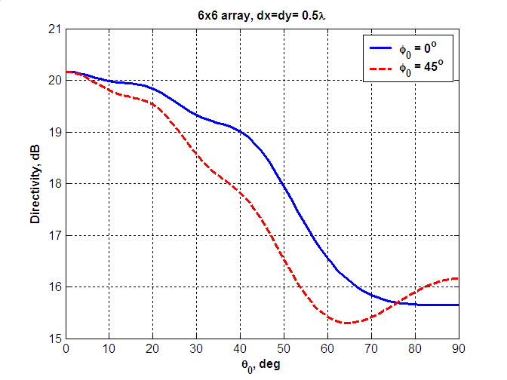
Figure 18. Example of directivity degradation for (6x6) planar phased array as a function of elevation angle along two azimuth directions
As it can be seen from Figure 18 directivity capabilities of a planar phased array closely depends on spatial beam position. Directivity decreases as elevation angle $θ_{0}$increases. In addition, the roll off factors for degradation curves are different for different azimuth directions.
Figure 19 shows 3D directivity patterns for a 6x6 planar phased array corresponding to different elevation scan angles $θ_{0}=0^{∘}$ (broadside radiation) and $θ_{0}={\text{30}}^{∘}$.
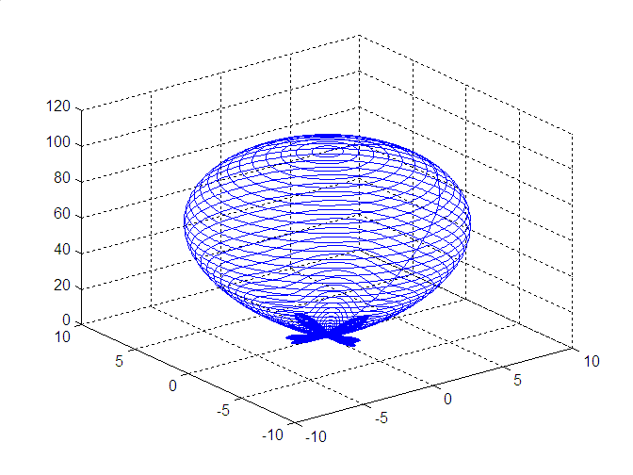 | 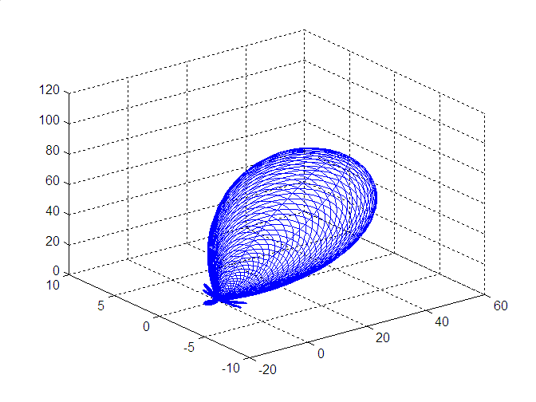
(a) $θ_{0}=0^{∘}$ (broadside radiation) | (b) $θ_{0}={\text{30}}^{∘}$
Figure 19. 3D directivity radiation patterns for 6x6 planar phased array for two values of elevation scan angles

Path Loss

Path Loss Modeling
Sections 3 – 6 provide description of the general structure of the 60 GHz WLAN channel models and procedures proposed for the generation of the channel model parameters that are specific for different evaluation scenarios.
The developed channel models provide complex amplitudes of different rays taking into account the attenuation of the signal between the transmitter and receiver along the rays in a real scale (). Hence, each ray has a part of information about the propagation loss of the channel and a part of information about the impulse response.
Note that this approach is different from a traditional channel modeling approach in the WLAN bands of 2.4 and 5 GHz where separate models are generated for path loss and channel impulse response. In 2.4 GHz and 5 GHz bands most of the channel rays contribute to the total received signal power even if multiple antennas are used and spatial signal processing algorithms are applied. Thus, the separation between path loss and impulse response models is possible and the path loss function describes average energy (power) behavior of electromagnetic field for different distances and the channel impulse response function independently describes channel realization behavior.
In the 60 GHz WLAN band, the necessity of application of high directional steerable antennas and beamforming algorithms will lead to filtering out (in a spatial domain) of a single cluster of the propagation channel. So in many cases both the frequency selectivity and propagation loss of the channel will be only defined by characteristics of a single cluster. Thus, for the same TX and RX locations, the path loss and channel impulse response may be significantly different depending on the characteristics of the cluster used for communications and also directivity properties of antennas and a used beamforming algorithm. These facts, in general, do not allow developing independent models for path loss and channel impulse response characteristics.
The 60 GHz channel models developed in Sections 3 – 6 do not need independent path loss model and are directly applicable for simulations of beamforming algorithms and simulations of communication links. However, an independent path loss model is helpful for network (or MAC) simulations where direct application of the developed channel models and complete modeling of the beamforming algorithms may unnecessary complicate the network simulations, which have a different focus. To solve this problem, it is possible to derive an independent path loss model if some assumptions about the 60 GHz WLAN system such as antenna type and beamforming algorithm are fixed.
In next sections, the path loss models are developed for different evaluation scenarios with fixing antenna configurations and beamforming algorithms.

Path Loss Model for Conference Room
This section presents path loss models for the conference room environment with LOS and NLOS scenarios.
The path loss models are developed using the basic steerable directional antenna model from Section 7 with beamwidths from 10⁰ to 60⁰ and a beamforming algorithm adjusting TX and RX antennas along the ray (cluster) with a maximum power.
For each scenario, a path loss formula predicting average path loss values for different TX-RX separation distances was found and, additionally, a shadow fading (SF) model, characterizing deviations of instantaneous path loss values from the average value for this distance, was developed.

LOS Scenario
To develop a path loss model for the LOS scenario, the basic steerable antenna model and the maximum ray beamforming algorithms were used. The instantaneous path loss values were generated using statistical channel model for different TX and RX locations. Averaging over 10000 channel realizations was performed to calculate average path loss values for each TX-RX separation distance.
Figure 20 shows an average path loss as a function of distance for the conference room environment with the LOS scenario.
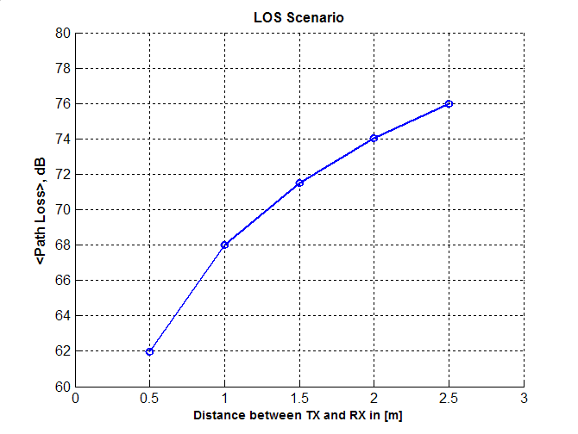
Figure 20. Average path loss vs. distance for the LOS scenario
It was estimated from Figure 20 that curve may be well approximated by the r² law, where r is the TX-RX separation distance. Additionally, it was verified that similar curves for other antenna beamwidths in the range from 10⁰ to 60⁰ match each other very closely (within 0.1 dB) and may be approximated by the same polynomial law.
To calculate the deviation of instantaneous path loss from the average value, the histogram of instantaneous path loss realizations for the conference room LOS scenario, the TX-RX separation equal to 2 m, and 30⁰ antenna beamwidth is plotted in Figure 21.

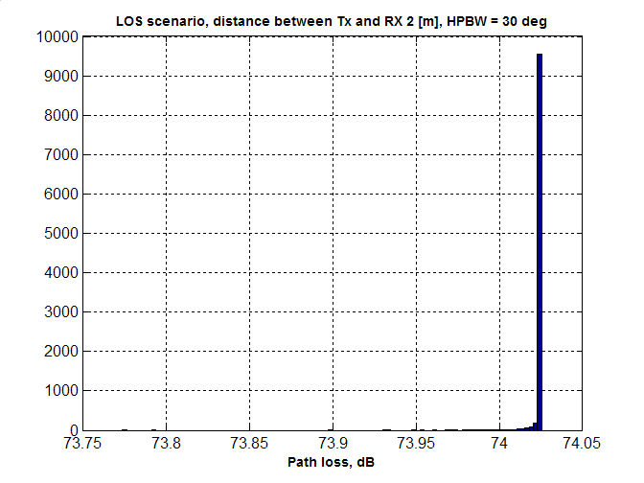
Figure 21. Histogram of path loss realizations for LOS scenario
It may be seen from Figure 21 that for LOS scenario deviations of actual path loss values are very low (because the most part of the channel power is the LOS ray). Hence, no shadow fading may be assumed for the path loss model of the LOS scenario since all LOS realizations of the channel with the same distance will have the same path loss.
Based on the obtained simulation results a simple path loss model may be proposed for LOS scenario based on the Friis transmission equation:
$${\text{PL}}_{\text{LOS}}[\text{dB}]=A_{\text{LOS}}+\text{20}{\text{log}}_{\text{10}}\left(f\right)+\text{10}n_{\text{LOS}}{\text{log}}_{\text{10}}\left(R\right)$$ | ()
where A_{LOS} = 32.5 dB, n_{LOS} = 2.0, f is the carrier frequency in GHz, R is the distance between TX and RX in m. As it is described above, no shadow fading model is required for the LOS scenario, since instantaneous path loss realizations are always very close to the average value given by ().
The value of A_{LOS} is specific for the selected type of antenna and beamforming algorithm. A_{LOS} depends on the antenna beamwidth, but for the considered beamwidth range from 10⁰ to 60⁰, the variation was found to be negligible (< 0.1 dB).
To verify (), Figure 22 shows simulated path loss values using statistical channel model, path loss formula () and experimental path loss values measured in the conference room environment with 17⁰ beamwidth directional antennas steered along the LOS path. (The conference room experiments description may be found in [3]).
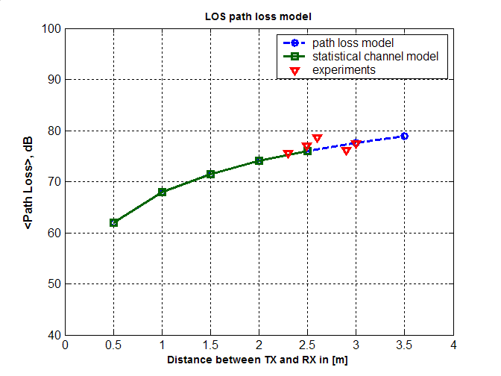
Figure 22. Comparison of simulated path loss using statistical channel model, path loss formula () and experimental path loss values for the LOS scenario
It may be seen that the proposed path loss model () is well matched to both the statistical conference room channel model and experimental data.

NLOS Scenario
A procedure, similar to that used in the LOS scenario, was applied to develop a path loss model for the NLOS scenario in the conference room environment. As for the LOS scenario, the basic steerable directional antenna model with beamwidths from 10⁰ to 60⁰ and the beamforming algorithm adjusting TX and RX antennas along the ray with maximum power were used.
Figure 23 shows an average path loss as a function of distance for the conference room environment with the NLOS scenario. The average path loss values in Figure 23 were calculated by averaging over 10000 path loss values obtained with the conference room statistical channel model for each TX-RX separation distance. The average path loss curves are plotted for different antenna beamwidths from 10⁰ to 60⁰ in 10⁰ steps.

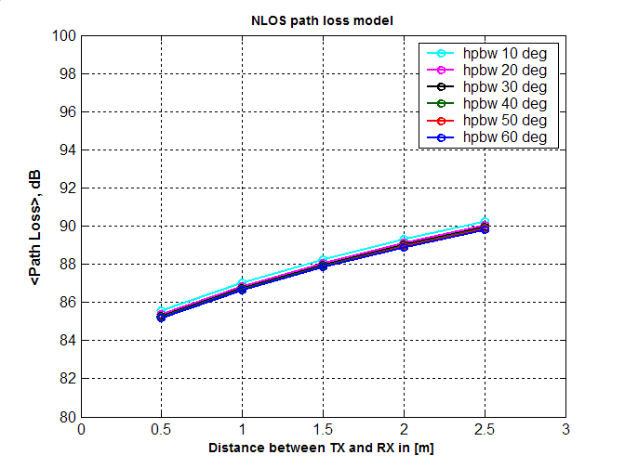
Figure 23. Average path loss vs. distance for the NLOS scenario
Figure 23 shows that the path loss curves for different antenna beamwidths follow close to each other (within 1 dB) for all TX-RX distances. Thus, the dependence of the path values on the antenna beamwidth may be neglected and it was verified, that all curves may be well approximated by r^{0.6} law, where r is the TX-RX separation distance.
To calculate the deviation of instantaneous path loss from the average value, the histogram of instantaneous path loss realizations for the conference room NLOS scenario, the TX-RX separation equal to 2 m, and 30⁰ antenna beamwidth is plotted in Figure 21.

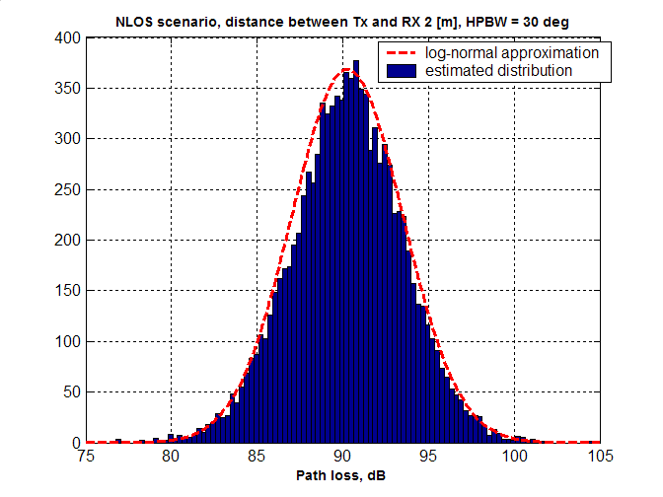
Figure 24. Histogram of path loss realizations for NLOS scenario and the log-normal approximation
It may be seen from Figure 24 that for the NLOS scenario the variance of path loss is significant and shadow fading model should be introduced. Figure 24 shows normal (Gaussian) in dB (log-normal in absolute scale) analytical distribution with mean and variance parameters estimated from the histogram. That provides good matching to the simulated results and may be used as a shadow fading model for the conference room NLOS scenario.
Figure 25 shows the shadow fading standard deviation in dB as a function of the TX-RX separation distance plotted for different antenna beamwidths.

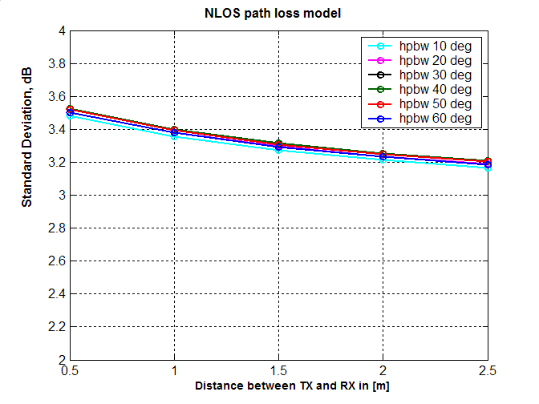
Figure 25. Standard deviation of shadow fading for the NLOS scenario as a function of distance
The results in Figure 25 show that the standard deviation σ of the path loss slightly depends on the TX – RX separation distance but approximately may be taken equal to 3.3dB for all distances.
Additionally, Figure 25 shows that dependence of σ on antenna beamwidth is small because, for the considered range of antenna beamwidths (10⁰ to 60⁰), antenna selects only one spatial channel cluster for most of the cases.
Based on the obtained results, the average path loss model may be proposed for the NLOS scenario as:
$${\text{PL}}_{\text{NLOS}}[\text{dB}]=A_{\text{NLOS}}+\text{20}{\text{log}}_{\text{10}}\left(f\right)+\text{10}n_{\text{NLOS}}{\text{log}}_{\text{10}}\left(R\right)$$ | ()
where A_{NLOS} = 51.5 dB, n_{LOS} = 0.6, f is the carrier frequency in GHz, R is the distance between TX and RX in m.
The values of A_{NLOS} and n_{NLOS} may be specified for the selected type of antenna and beamforming algorithm. A_{NLOS} depends on the antenna beamwidth, but for the considered beamwidth range from 10⁰ to 60⁰ the variation is small (< 1 dB) and can be neglected.
To generate instantaneous path loss realizations, the shadow fading (SF) model should be applied. The SF values distribution is normal in dB (log-normal in absolute values) with standard deviation σ = 3.3 dB.
To verify (), Figure 26 shows simulated path loss values using statistical channel model, path loss formula () and experimental path loss values measured in the conference room environment with 17⁰ beamwidth directional antennas steered along the most powerful NLOS signal cluster. (The conference room experiments description may be found in [3]).

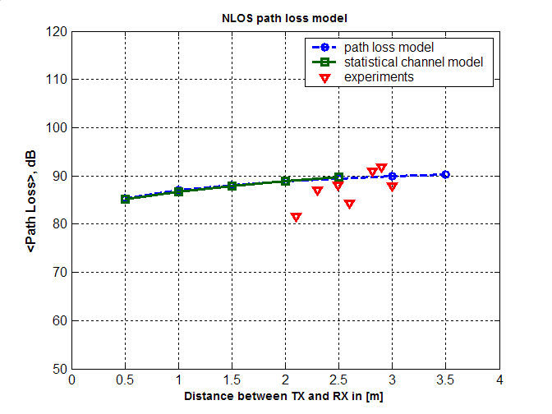
Figure 26. Comparison of simulated path loss using statistical channel model, path loss formula () and experimental path loss values for the NLOS scenario
It may be seen that the proposed path loss model () is well matched to both the statistical conference room channel model and experimental data.

Path Loss Model for Cubicle Environment
TBD

Path Loss Model for Living Room
TBD

Path Loss Model Summary
The characteristics of the 60 GHz WLAN propagation channel complicate the development of the independent path loss model. However, if antenna system parameters and beamforming algorithms are fixed then it is possible to derive an average path loss model using the standard form:
$\text{PL}[\text{dB}]=A+\text{20}{\text{log}}_{\text{10}}\left(f\right)+\text{10}n{\text{log}}_{\text{10}}\left(R\right)$. | ()
Here A and n are parameters specific for the scenario and antenna system, f is the carrier frequency in GHz, R is the distance between TX and RX in m.
To generate path loss realizations, the normal in dB shadow fading (SF) model should be used together with the average path loss model (). SF standard deviation σ is specific for the scenario and antenna system parameters.
The path loss model parameters for the conference room scenario, basic steerable antenna model and maximum ray power beamforming algorithm are shown in Table 3.
Table 3. Path loss model parameters
Scenario | A, dB | n | SF std. dev., dB
Conference room LOS | 32.5 | 2.0 | 0
Conference room NLOS | 51.5 | 0.6 | 3.3

References:

- IEEE doc. 802.11-09/0096r0. TGad evaluation methodology, E. Perahia, Jan. 19, 2009.
- IEEE doc. 802.11-08/0811r1. Channel Modeling for 60 GHz WLAN Systems, A. Maltsev et al, July 14, 2008.
- IEEE doc. 802.11-08/1044r0. 60 GHz WLAN Experimental Investigations, A. Maltsev et al, Sept. 8, 2008.
- IEEE doc. 802.11-03/940r4, TGn channel models, V. Erceg et al, May. 5, 2004.
- IEEE Std 145-1993. IEEE Standard Definitions of Terms for Antennas, March 18, 1993
- Spatial channel model text description, SCM text v.7.0, Spatial channel model AHG (combined ad-hoc from 3GPP&3GPPs), Aug. 19, 2003.
- IEEE doc. 15-07-0584-01-003c, TG3c channel modeling sub-committee final report, Su-Khiong Yong et al, Mar. 13, 2007.
- IEEE doc. 802.15-06/474r0, Reference antenna model with side lobe for TG3c evaluation, I. Toyoda et al, Nov. 2006.
- C.A. Balanis, Antenna Theory. New Jersey: Wiley, 2005.
- B. J. Forman, “A novel directivity expression for planar antenna arrays,” Radio Science, vol. 5, no. 7, July 1970, pp. 1077-1083.
- M. J. Lee, I. Song, S. Yoon, and S. R. Par, “Evaluation of directivity for planar antenna arrays,” IEEE Antennas Propagat. Mag., vol. 42, no. 3, June 2000

