IEEE P802.11
Wireless LANs

TGac Channel Model Addendum

March, 2009

Authors:
Greg Breit, gbreit@qualcomm.com
Hemanth Sampath, hsampath@qualcomm.com
Sameer Vermani, vermani@qualcomm.com
Richard Van Nee, rvannee@qualcomm.com
Minho Cheong, minho@etri.re.kr
Naoki Honma, honma.naoki@lab.ntt.co.jp
Takatori Yasushi, takatori.yasushi@lab.ntt.co.jp
Yongho Seok, yhseok@lge.com
Seyeong Choi, seyeong.choi@lge.com
Phillipe Chambelin, philippe.chambelin@thomson.net
John Benko, john.benk@orange.com
Laurent Cariou, laurent.cariou@orange-ftgroup.com
VK Jones, vkjones@qualcomm.com
Allert Van Zelst, allert@qualcomm.com

Note:
The author list will grow to reflect those providing
explicit contributions and review comments.

Abstract

This document provides the addendum to TGn channel model document to be used for the Very High Throughput Task Group (TGac).

Revision History

Date | Version | Description of changes
03/09/09 | 1.0 | First Draft of TGac Channel Modem Addendum Document
 |  | .

Introduction

The TGn task group has developed a comprehensive MIMO broadband channel models, with support for 40 MHz channelization and 4 antennas. The TGac task group is targeting > 1 Gbps MAC SAP throughput using one or more of the following technologies:
- Higher order MIMO (> 4x4)
- Multi-User MIMO with > 4 AP antennas
- Higher Bandwidth (> 40 MHz)
- OFDMA.
In this document we propose some simple modifications to TGn channel models to enable their use for TGac.

Modifications to handle larger system Bandwidth

The TGn channel models assumed minimum tap spacing of 10 nsec and were employed for system Bandwidth of up to 40 MHz. TGac systems can have much larger bandwidth. For TGac systems with larger overall system bandwidth (W), we propose to decrease channel tap spacing by a factor of. The calculation of W and tap spacing is illustrated in the below examples:
- Example 1: A TGac modem can have 2 channels of 40 MHz each that are spaced by 60 MHz for sufficient isolation. In this case, W = 40*2+60 = 140 MHz and the channel tap spacing will be reduced by a factor, leading to an effective channel tap spacing of 2.5 nsec.
- Example 2: TGac modem can have 4 contiguous channels of 20 MHz each. In this case, W = 80 MHz and the channel tap spacing will be reduced by a factor , leading to an effective channel tap spacing of 5 nsec
The reduced channel tap-spacing is modeled by linearly interpolating the Cluster channel tap power values, on a cluster by cluster basis. We now provide an illustration of channel tap interpolator for TGn Channel Model B assuming Example 2.

TGn – Channel Model B [2]

 | Tap index | 1 | 2 | 3 | 4 | 5 | 6 | 7 | 8 | 9
 | Excess delay [ns] | 0 | 10 | 20 | 30 | 40 | 50 | 60 | 70 | 80
Cluster 1 | Power  [dB] | 0 | -5.4 | -10.8 | -16.2 | -21.7
AoA | AoA  [°] | 4.3 | 4.3 | 4.3 | 4.3 | 4.3
AS  (receiver) | AS  [°] | 14.4 | 14.4 | 14.4 | 14.4 | 14.4
AoD | AoD  [°] | 225.1 | 225.1 | 225.1 | 225.1 | 225.1
AS  (transmitter) | AS  [°] | 14.4 | 14.4 | 14.4 | 14.4 | 14.4
Cluster 2 | Power  [dB] |  |  | -3.2 | -6.3 | -9.4 | -12.5 | -15.6 | -18.7 | -21.8
AoA | AoA  [°] |  |  | 118.4 | 118.4 | 118.4 | 118.4 | 118.4 | 118.4 | 118.4
AS | AS  [°] |  |  | 25.2 | 25.2 | 25.2 | 25.2 | 25.2 | 25.2 | 25.2
AoD | AoD  [°] |  |  | 106.5 | 106.5 | 106.5 | 106.5 | 106.5 | 106.5 | 106.5
AS | AS  [°] |  |  | 25.4 | 25.4 | 25.4 | 25.4 | 25.4 | 25.4 | 25.4

TGac – Channel Model B (W=80 MHz):

 | TGn Tap Index | 1 |  | 2 |  | 3 |  | 4 |  | 5 |  | 6 |  | 7 |  | 8 |  | 9
 | TGac  Tap  Index | 1 | 2 | 3 | 4 | 5 | 6 | 7 | 8 | 9 | 10 | 11 | 12 | 13 | 14 | 15 | 16 | 17
 | Excess delay [ns] | 0 | 5 | 10 | 15 | 20 | 25 | 30 | 35 | 40 | 45 | 50 | 55 | 60 | 65 | 70 | 75 | 80
Cluster 1 | Power  [dB] | 0 | -2.7 | -5.4 | -8.1 | -10.8 | -13.5 | -16.2 | -18.9 | -21.7
AoA | AoA  [°] | 4.3 | 4.3 | 4.3 | 4.3 | 4.3 | 4.3 | 4.3 | 4.3 | 4.3
AS  (receiver) | AS  [°] | 14.4 | 14.4 | 14.4 | 14.4 | 14.4 | 14.4 | 14.4 | 14.4 | 14.4
AoD | AoD  [°] | 225.1 | 225.1 | 225.1 | 225.1 | 225.1 | 225.1 | 225.1 | 225.1 | 225.1
AS  (transmitter) | AS  [°] | 14.4 | 14.4 | 14.4 | 14.4 | 14.4 | 14.4 | 14.4 | 14.4 | 14.4
Cluster 2 | Power  [dB] |  |  |  |  | -3.2 | -4.75 | -6.3 | -7.85 | -9.4 | -10.95 | -12.5 | -14.05 | -15.6 | -17.15 | -18.7 | -20.25 | -21.8
AoA | AoA  [°] |  |  |  |  | 118.4 | 118.4 | 118.4 | 118.4 | 118.4 | 118.4 | 118.4 | 118.4 | 118.4 | 118.4 | 118.4 | 118.4 | 118.4
AS | AS  [°] |  |  |  |  | 25.2 | 25.2 | 25.2 | 25.2 | 25.2 | 25.2 | 25.2 | 25.2 | 25.2 | 25.2 | 25.2 | 25.2 | 25.2
AoD | AoD  [°] |  |  |  |  | 106.5 | 106.5 | 106.5 | 106.5 | 106.5 | 106.5 | 106.5 | 106.5 | 106.5 | 106.5 | 106.5 | 106.5 | 106.5
AS | AS  [°] |  |  |  |  | 25.4 | 25.4 | 25.4 | 25.4 | 25.4 | 25.4 | 25.4 | 25.4 | 25.4 | 25.4 | 25.4 | 25.4 | 25.4

Higher Order (8x8) MIMO

The TGn channel models were originally conceived for systems with 4x4 MIMO, and are based on the Kronecker channel correlation model assumption [4]. We investigated whether the Kronecker models are also sufficient to reasonably predict performance in realistic environments. Note that from a standards development perspective, it is sufficient for channel models to tightly bound and sweep the range of performance in real environments. Furthermore, it is desirable that the channel model is simple enough and builds on TGn channel models to allow a fair and efficient comparison of different standards proposals.
Figure 1 show CDFs of PHY capacity for several simulated and measured 8x8 MIMO channels assuming 20dB average SNR. In this figure, capacity is calculated as$C={\text{log}}_{2}\text{det}(I_{N_{r}}+\frac{\text{SNR}}{N_{t}}{\text{HH}}^{})$, where SNR is the average receive Signal to Noise ratio, N_{r} and N_{t} are the number of receive and transmit antennas respectively, and ‘*’ denotes the Hermitian transpose.

The top most plot in Figure 1 shows performance curves depicting capacity of 24 8x8 channels measured in an indoor office environment at 5 GHz using λ/2-spaced linear dipole arrays at the transmitter and receiver [1]. Corresponding capacity of an i.i.d. channel is provided for comparison.

The thick performance curves in the center and bottom plots in Figure 1 respectively show results for TGn Model B and Model D, extended to eight antennas. The center and bottom plots also show channel capacity CDFs of the extended 8x8 TGn model results obtained by randomly rotating the TGn defined cluster AoA and AoDs to emulate the case-by-case variation expected in real-world environments. Random AoA offsets were distributed uniformly between ±180° while random AoD offsets were distributed uniformly between ±30°. For each case, the same offset was applied to all clusters.

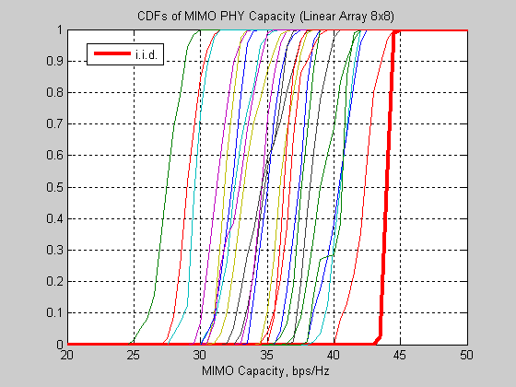
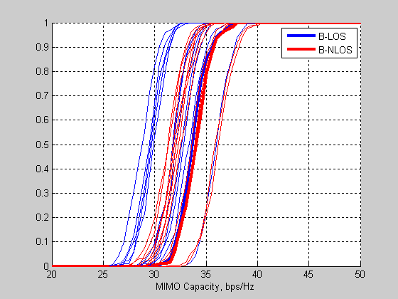
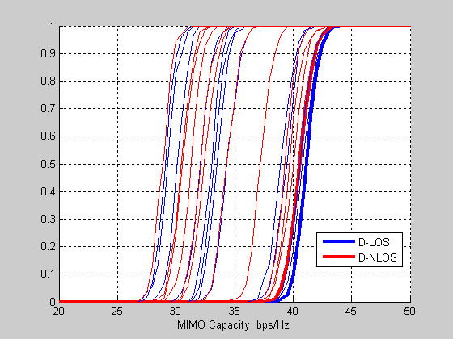
Figure 1: CDFs of MIMO channel capacity. Top: Results of 24 indoor channel measurements. Center: TGn Model B (thick lines) plus multiple model instances using randomly offset cluster AoAs and AoDs (thin lines). Bottom: TGn Model D (thick lines) plus multiple model instances using randomly offset cluster AoAs and AoDs (thin lines).

Figure 2 shows capacity results for the same channels as Figure 1, but in this case, capacity is calculated from post-processing SINR after MMSE precoding. In this case, an MMSE precoding matrix is calculated as:
$B=H^{}(I_{N_{r}}\frac{N_{r}}{\text{SNR}}+{\text{HH}}^{})^{−1}$
and applied to each 8x8 channel instance. The post processing SINRs were calculated for each stream and subcarrier and the PHY capacity for each stream/subcarrier calculated as log₂(1+SINR). For each instance, sum-average channel capacity was calculated by averaging across subcarriers and summing across spatial streams.
Most of the measured results fall between the curves generated from the extended TGn models. The measured data which are comparable to the worst-case Model B results were all collected in strongly directional channels, with the receive array oriented in the “end-fire” orientation with respect to the dominant cluster (AoA=90° for the dominant cluster), which is pessimistic compared to the TGn-defined cluster AoAs and AoDs.
Based on the generally good agreement between the TGn channel models for 8x8 MIMO and channel measurements in indoor enterprise environments, we propose to re-use the Kronecker channel model for 8x8 MIMO.

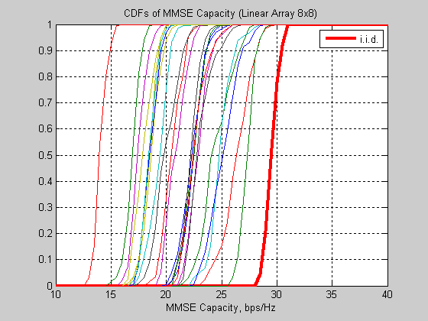
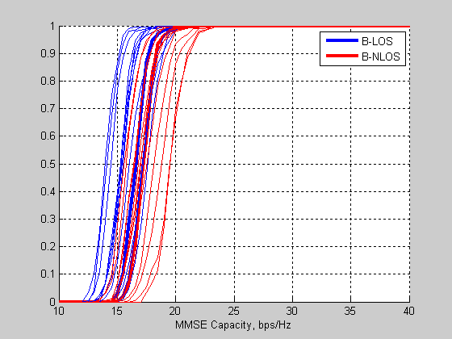
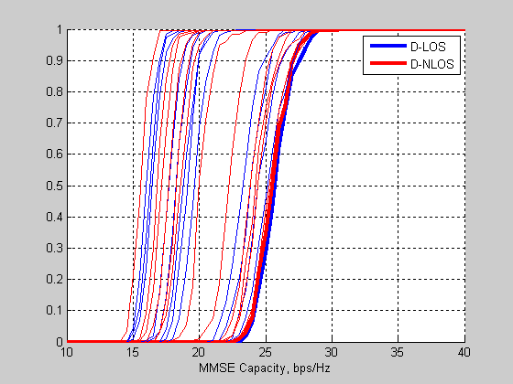
Figure 2: CDFs of MIMO-MMSE Precoded channel capacity. Top: Results of 24 indoor channel measurements. Center: TGn Model B (thick lines) plus multiple model instances using randomly offset cluster AoAs and AoDs (thin lines). Bottom: TGn Model D (thick lines) plus multiple model instances using randomly offset cluster AoAs and AoDs (thin lines).

Modifications to AoA and AoD for Multi-User MIMO with up to 16 AP antennas

Motivation

TGac requires specification of channels to multiple users as simultaneous communication will take place to multiple STAs in technologies like multi-user MIMO. The TGn channel model document specifies the cluster AoAs and AoDs for point to point single user transmissions. Extensions of these AoDs and AoAs to the multi-user case are needed.

Physical Reasoning

In [5], it is shown that for the same receiver location, different transmitter locations lead to a different AoA at the receiver. Specifically, the measurements report that clusters AoA vary by 0-20 degrees in NLOS scenario (class room) and 0-60 degrees in LOS scenario (great hall), depending on location. This is equivalent to a multi-user MIMO scenario where we fix the transmitter location and have the receivers at different locations. Based on the results shown in [5], we conjecture that for the same transmitter location, different receiver locations lead to a different AoD at the transmitter.

However, from a physical point of view, it is clear that if all the scatterers in the channel are very close to the AP, then the AoD will be similar regardless of STA location or orientation. See 3 below.

AP may have a similar AoDs for clusters regardless of transmission to STA-1 or STA-2
Scenario: NLOS channel with scatterers close to AP
Figure 3: NLOS channel with scatterers very close to the AP

However, not all scenarios fall in this category. In LOS channels, as shown in Figure 4, AoDs for the main LOS component (and the resulting steering vectors) will be different for different clients. Enforcing identical AoDs in this case is not physically realistic. More importantly such a restriction will “break” multi-user transmission in pure LOS scenarios if the steering vectors are deemed identical.

From Physics, AP has a different AoD to STA-1 and STA-2. This implies that, the LOS steering vectors to STA-1 and STA-2 are different
Scenario: Pure LOS channel
Figure 4: A typical depiction of a pure LOS scenario

Furthermore, there will be scenarios where not all clusters are close to the AP, or where different clusters will be relevant to different clients as can be seen in Figure 5 below. This is supported by the findings in [5] where the authors show that some clusters are relevant for one location, whereas absent in other locations. Enforcing identical AoD in this case will lower SDMA capacity.
Different scatterers may be relevant to different STAs. This would imply that AP may have a different AoDs for clusters corresponding to STA-1 and STA-2
Scenario: NLOS channel with scatterers far away from AP
Figure 5: A typical NLOS situation where scatterers are far away from the AP

TGac Modifications
We assume TGn-defined cluster AoDs and AoAs as baseline and make the following modifications to the AoA and AoD for each client:
- A single pseudo-random offset is added to all cluster AoDs and AoAs.
  - Assuming a “pseudo-random” offset selection allows a quick and fair comparison across proposals, by ensuring all proposals use identical AoA/AoDs across clients. Note also that using a single AoA/AoD offset retains TGn angular spacing between clusters.
- The NLOS Cluster AoD offsets are uniformly distributed between ±30°.
  - This is based on the experimental results obtained in [5], and also strives to achieve a compromise on the physical scenarios outlined earlier in the section.
- The NLOS Cluster AoA offsets are uniformly distributed between ±180°.
  - This is because each client can see independent AoA depending on its orientation and location.
- The LOS tap AoA and AoD offsets are uniformly distributed between ±180°.
  - This is because the direct LOS path to each client can have independent AoA/AoD depending on its location.

There are several advantages of the above TGac modifications. First, the model is physically realistic and can be realized via a simple modification to the TGn channel model. Secondly, MU-MIMO to each distinct set of clients results in a different capacity performance due to the statistical variation of AoA/AoD across clients. The simulation complexity increase in the TGac channel model is also reasonable since the Transmit and Receive antenna correlation matrices need only be computed once per client, for the entire simulation run.

Justification for different AoDs through performance simulations

Physical arguments alone are not sufficient to justify adding complexity to the existing TGn channel model. The additional complexity is justified only if there is a significant impact on system performance by assuming unequal AoDs. To investigate these further, simulations were performed to evaluate sensitivity of SDMA channel capacity to unequal AoD among users. Below we list the assumptions and the scenarios under which we perform the simulations.
- Assumptions:
  - 16 TX antennas, 8 STAs, 2 RX antennas per STA
  - TGn channel models B, D (LOS and NLOS scenarios) used as baseline
    - AoD and AoA as specified in the TGn channel model document
  - Composite multi-user channel matrix constructed from vertical concatenation of 8 2x16 channel matrices
    - Clients are effectively uncorrelated from each other
- Scenarios:
  - TGn-defined cluster AoDs and AoAs used for all clients
  - For each client, a random offset is added to cluster AoDs and AoAs (all cluster angles for a single client are rotated by the same amount)
    - NLOS cluster AoD offsets are uniformly distributed between ±30°
    - NLOS cluster AoA offsets are uniformly distributed between ±180°
    - LOS tap AoA/AoD offsets are uniformly distributed between ±180°

Channel Capacity Analysis
For each random scenario, we generate 200 composite channel realizations. Sum-average channel capacity is determined for each realization from MMSE post-processing SINRs as described in Section 3. Finally, CDFs are generated across all 200 channel instances.
Figure 6 below shows capacity CDFs for the two scenarios based on TGn Channel Model B. In each case, the thick black curve represents Scenario 1, where all clients use the same AoA and AoD, while the thin curves represent ten independent instances of Scenario 2, where each client uses an AoA and AoD offset from the TGn definitions by a fixed random amount as described above. In LOS conditions, capacity improves by 20% when different per-client AoDs and AoAs are assumed, depending on the chosen angular offsets. The principal mechanism for this capacity improvement is because (a) the AoD variation in LOS channel component leads to variation of steering vectors across clients and (b) Cluster AoD diversity across clients leads to decrease in Tx antenna correlation, especially for model with small AS (few clusters). The improvement is less pronounced under NLOS conditions due to the absence of LOS path.
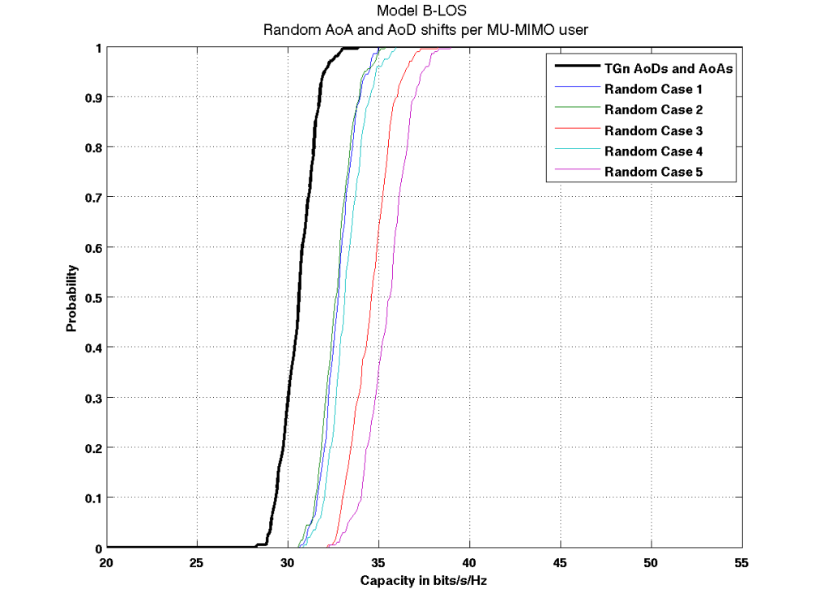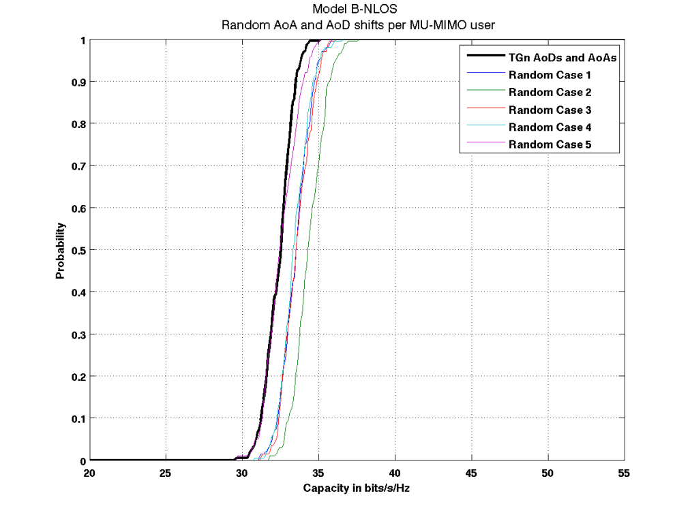
Figure 6: CDFs of modelled SDMA channel capacity, based on TGn Channel Model B (Top: LOS; Bottom: NLOS). The thick black curve represents the case where TGn-defined AoAs and AoDs are used for all clients. The thin curves show 5 different cases where random offsets from the TGn AoDs and AoAs are applied for each client.
Figure 7 shows the capacity CDFs for the two scenarios based on TGn Channel Model D. Here, the combined impact of AoA and AoD diversity seems to lead to a -10% decrease in capacity.
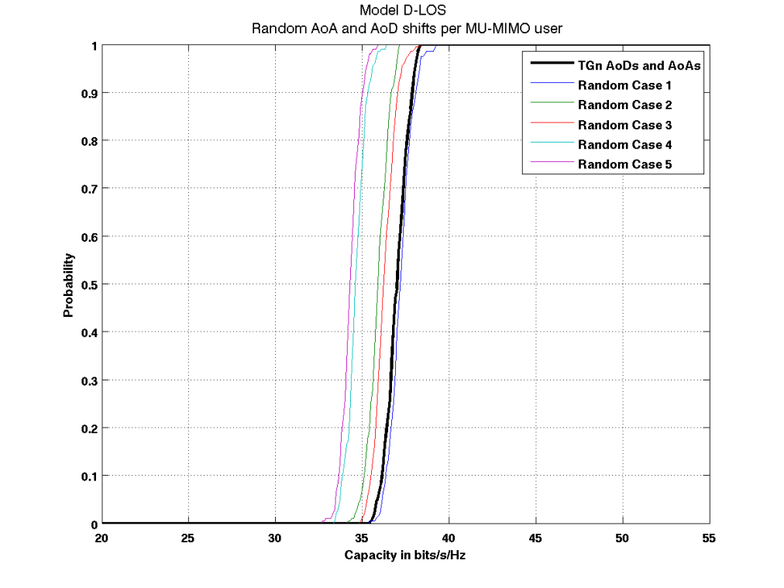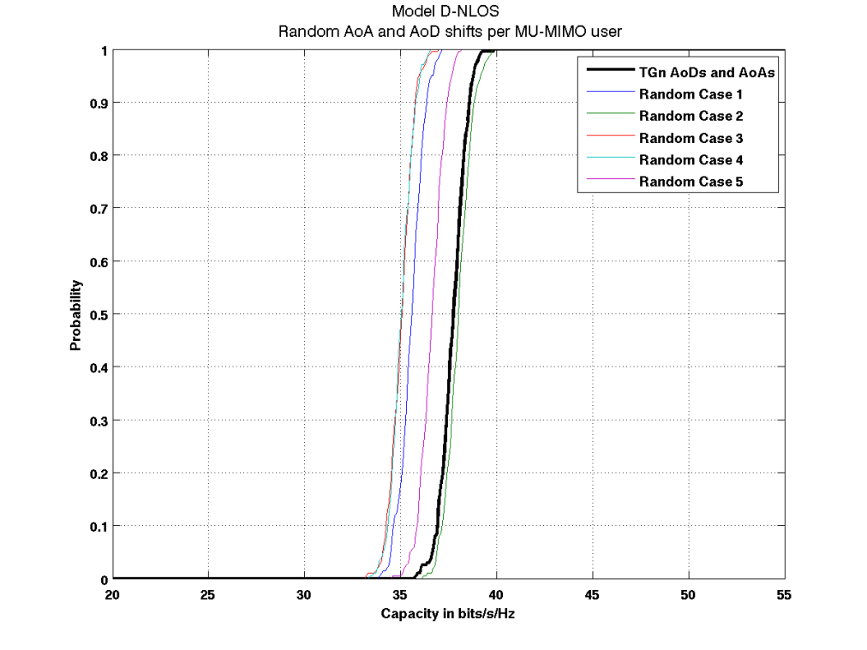
Figure 7: CDFs of modelled multi-user channel capacity, based on TGn Channel Model D (Top: LOS; Bottom: NLOS). The thick black curve represents the case where TGn-defined AoA and AoD are used for all clients. The thin curves show 5 different cases where random offsets from the TGn AoDs and AoAs are applied for each client.

This contradiction with the results of Model B is because the TGn-defined AoAs for the three Model D clusters are near-optimal in terms of RX correlation for a linear antenna array. Any common rotation of these three cluster AoAs tends to produce a less favorable RX correlation matrix for a single client. Consequently, randomly rotating these AoAs for each user in a composite multi-user MIMO channel will tend to diminish capacity compared to using the TGn values for all users. We did not observe this phenomenon for Model B, which suggests that rotating the cluster AoAs for that model has a less biased effect on RX correlation than in Model D.
Figure 8 shows the capacity CDFs for the two scenarios based on TGn Channel Model F. Here, the combined impact of AoA and AoD diversity seems to negligible change in capacity.
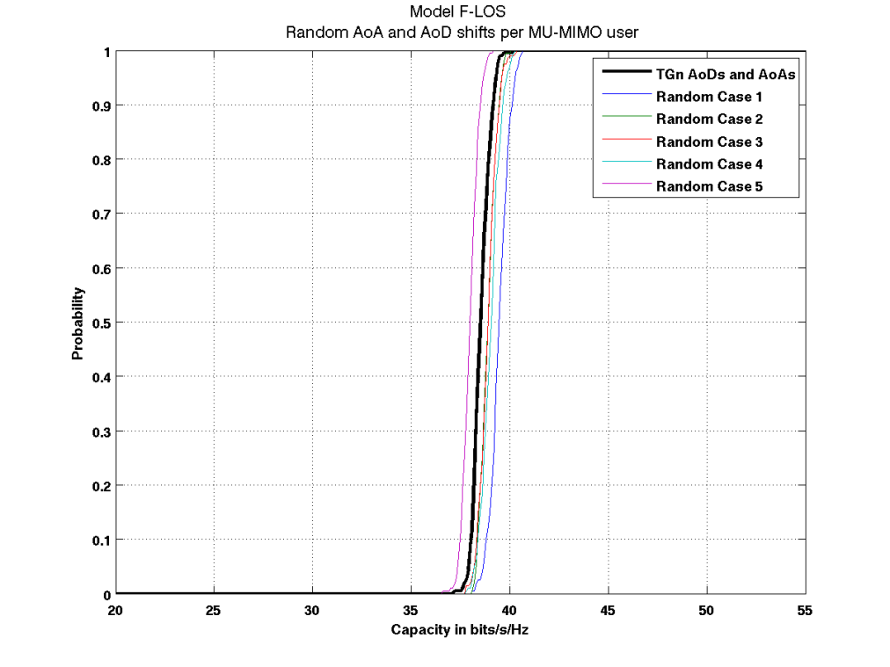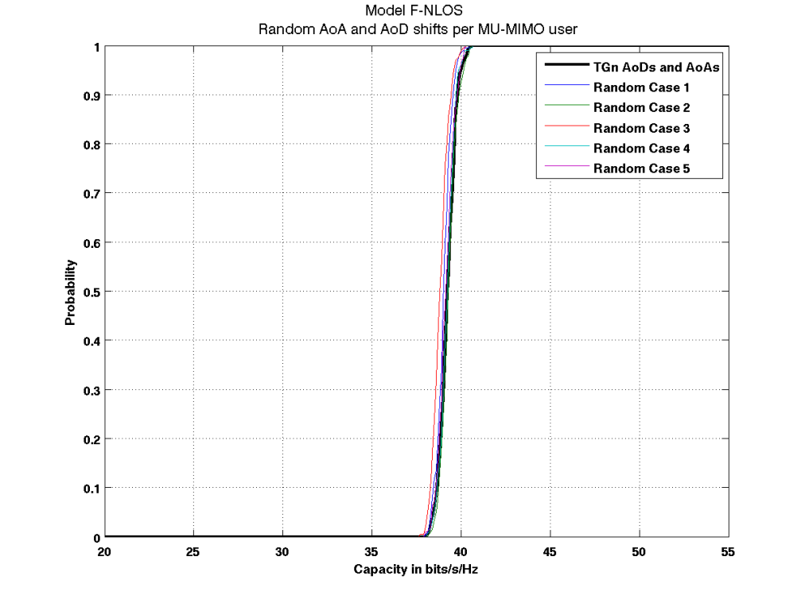
Figure 8: CDFs of modelled multi-user channel capacity, based on TGn Channel Model F (Top: LOS; Bottom: NLOS). The thick black curve represents the case where TGn-defined AoA and AoD are used for all clients. The thin curves show 5 different cases where random offsets from the TGn AoDs and AoAs are applied for each client.

This is because channel model F has 6 clusters, each with a large AS of 30-60 degrees. The net AS across all the clusters is significantly large enough to make the capacity CDF less sensitive to AoA/AoD variations.

To conclude, these results show that AoD diversity across STAs impacts multi-user MIMO performance in LOS channel models, with smaller number of clusters and smaller AS per clusters such as Channel Model B. As seen in Figure 8, AoD diversity between clients has less of an effect in channels where there is already significant angular spread, such as Model F.

Incorporating Dual-Polarized Antennas

By exploiting polarization diversity in the channel, dual-polarized antennas allow for a significant improvement in MIMO channel capacity, especially in LOS scenarios. Furthermore, co-located dual-polarized antennas can also minimize real estate in devices with large number of antennas. We believe dual-pol antennas are likely to be employed in TGac devices.
Using the same transmitter and receiver locations as the channel measurements depicted in Section 3, we collected 8x8 channel data using an array of 4 co-located cross-polarized slot antenna pairs at both the transmitter and receiver. MIMO channel capacities were calculated as described previously.
For comparison to the measurements, we implemented the polarization diversity extensions to the TGn channel model suggested in Erceg et al., and extended the model to an 8x8 channel as described in Section 3. We assumed an XPD value of 10 dB for the steering matrix H_{F}, and a 3 dB XPD value for the variable matrix H_{v}. We furthermore assumed 0.2 correlations for co-located cross-polarized antenna elements.
Figure 9 shows the results of the measurements and analysis. In contrast to the linear dipole array measurements shown in Section 3, which generally fell between the Model B and Model D predictions (with a few measurements falling below Model B), these measurements are more tightly clustered, and are generally centered on the Model D predictions. Specifically, the performance of MIMO in LOS scenarios significantly improves by using dual-polarized antennas.
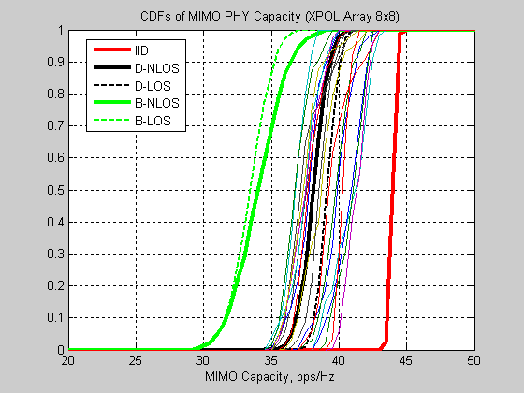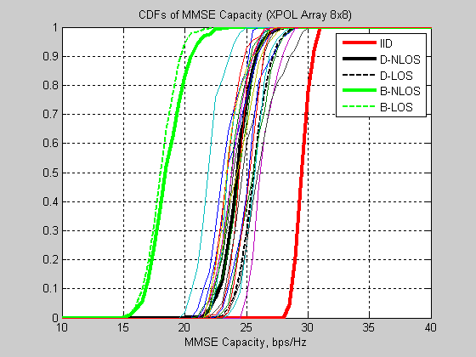
Figure 9: MIMO-LogDet (left) and MIMO-MMSE Precoded (right) channel capacity for measurements and model predictions incorporating polarization diversity.
Based on the outcome of these results, we believe the polarization diversity extensions to the TGn channel model suggested in Erceg et al. are realistic and should be implemented in the TGac channel model.

- References
- Breit, G. et al. “802.11ac Channel Modeling.” Doc. IEEE802.11-09/0088r1.
- Erceg, V. et al. “TGn Channel Models.” Doc. IEEE802.11-03/940r4.
- Kenny, T., Perahia, E. “Reuse of TGn Channel Model for SDMA in TGac.” Doc.IEEE802.11-09/0179r0.
- Schumacher, L.; Pedersen, K.I.; Mogensen, P.E., "From antenna spacings to theoretical capacities - guidelines for simulating MIMO systems," Personal, Indoor and Mobile Radio Communications, 2002. The 13th IEEE International Symposium on, vol.2, no., pp. 587-592 vol.2, 15-18 Sept. 2002.
- Jian-Guo Wang; Mohan, A.S.; Aubrey, T.A., "Angles-of-arrival of multipath signals in indoor environments," Vehicular Technology Conference, 1996. 'Mobile Technology for the Human Race'., IEEE 46th , vol.1, no., pp.155-159 vol.1, 28 Apr-1 May 1996

