IEEE P802.11
Wireless LANs
MAC State Generic Convergence Function state machine update
Date: 2009-01-22
Author(s):
Name | Affiliation | Address | Phone | email
Necati Canpolat | Intel Corporation | 2111 NE. 25th Ave,  Hillsboro, OR 97124 | +1 503 264 8014 | necati.canpolat@intel.com

Abstract
This proposal addresses the LB 137 CIDs: 4384, 4385, 4265, 4266, 4267, and 4268. It updates the Figure 11B-1.

This document is based on 802.11u-d4.02.
11B.2 Convergence function state machine
11B.2.1 Overview of state machine
Replace the Figure 11B-1 with the one below:

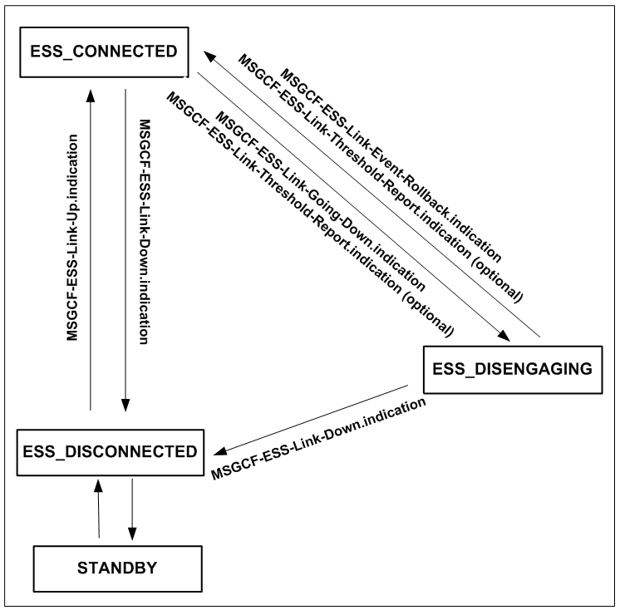

Figure 11B-1—MAC State Generic Convergence Function state machine

