IEEE P802.11
Wireless LANs
LB-137 CID 4066: Removal of Figure 5-11
Date: 2009-01-19
Author(s):
Name | Affiliation | Address | Phone | email
Stephen McCann | Research in Motion (RIM) UK Ltd | 200 Bath Road, Slough, Berkshire, SL1 3XE, UK | +44 1753 667099 | smccann@rim.com

Abstract
This proposal addresses CID 4066 to remove the similarity between Figures 5-10 and 5-11.

This document is based on 802.11u-D4.01.

5.7 Reference model

Insert the following subclause heading 5.7.1 after 5.7 and move the text in 5.7 to 5.7.1:

5.7.1 General

Change the first paragraph of 5.7.1 as follows:
This standard presents the architectural view, emphasizing the separation of the system into two major parts: the MAC of the data link layer (DLL) and the PHY. These layers are intended to correspond closely to the lowest layers of the ISO/IEC basic reference model of Open Systems Interconnection (OSI) (ISO/IEC 7498-1: 1994). The MAC State Generic Convergence Function provides services to higher layer protocols based on MAC state machines and interactions between the layers. The layers and sublayers described in this standard are shown in Figure 5-10.
Replace the Figure 5-10 with the one below:

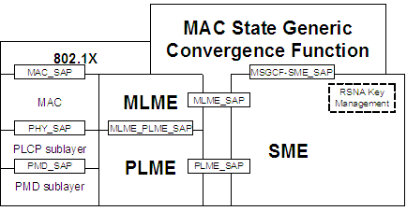

Figure 5-10 Portion of the ISO/IEC basic reference model covered in this standard

Insert the following text after Figure 5-10:
There is a requirement from higher layer entities, such as Interworking Gateways and Mobility Managers, to access detailed information, through the exposure of the MAC and PHY layers. This information is available through the interfaces of the MAC and PHY sublayer management entities. Figure 5-10 shows an entity, the MAC State Generic Convergence Function (MSGCF), defined in clause 11B, that has access to all management information and can provide information to higher level entities.
Insert the following subclause 5.7.2 after 5.7.1:

5.7.2 Interworking reference model

Interworking functions may require correlating information from multiple management entities. It is the function of the MAC State Generic Convergence Function (MSGCF) to correlate information for higher-layer entities. The MSGCF does not interact directly with the MLME SAP and PLME SAP, but is made aware of interactions between the MLME and SME, and between the PLME and SME. After correlation of lower-layer MLME and PLME events, the MSGCF may synthesize indications to higher-layer protocols.

An example of how the MSGCF interfaces to these higher layer entities, is provided by the Media Independent Handover (MIH) interface, as defined within reference IEEE 802.21 D14.0.

The MSGCF is designed to provide the status of the connection of a non-AP STA to a set of APs composing a single ESS. Figure 5-11 illustrates the concept of an ESS Link. This higher-layer concept is intended to reflect the state of a connection to an ESS independent of any particular access point. In Figure 5-11, STA3 is associated with either AP1 or AP2. The state of the ESS Link is up when STA3 is associated with any of the APs comprising an ESS.

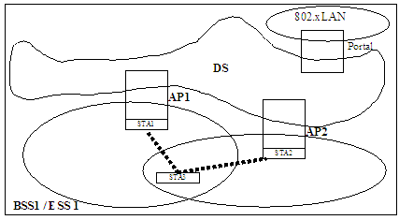

Figure 5-11 ESS Link illustration

