IEEE P802.11
Wireless LANs
LB132 MAC convergence function diagrams
Date: YYYY-MM-DD
Author(s):
Name | Affiliation | Address | Phone | email
Matthew Gast | Trapeze Networks | 5753 W. Las Positas Blvd  Pleasanton, CA 94588 USA | +1 925 474 2273 | msg@trapezenetworks.com
Abstract

This submission resolves LB#132 comments # 370, 438, 578, 621, 622, and 643 relating to diagrammatic depictions of the MAC convergence function.

This submission is based on Draft P802.11u-D3.01.

Summary

CID 370
- Fix name of convergence function as displayed in the diagram
- Change to sans serif font to match clause 5
CID 621
- No action is necessary, as the comment requests changes to the SAP names in the baseline.
CID 438
- Remove arrows from diagram 5-10 and replace with overlapping SAP blocks
CID 622
- Adds LLC sublayer as requested for MIH function. MIH function requires both data services to send data frames directly, as well as input from MSGCF.
- Separates Figure 5-10 into two figures. The base Figure 5-10 shows the architectural elements, and Figure 5-10u is added in a new clause that shows interaction with higher layer elements.
CID 578
- Adds text to clarify that MSGCF does not interact directly with management entities.
CID 643
- The MSGCF applies at both an AP and station, but a separate figure was added to illustrate operation with higher layer entities.

Editing Instructions

In clause 5.7, replace 5-10 with the following figure:

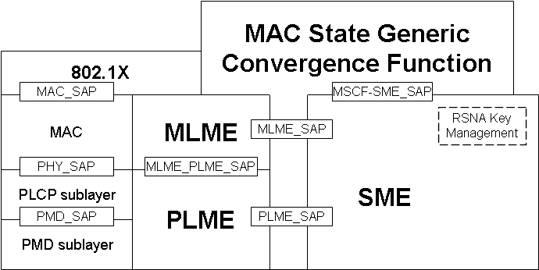

Add the following clause as 5.7.1, following clause 5.7, renumbering the Figure as appropriate for insertion:

5.7.1. Interworking reference model

Interworking functions may require correlating information from multiple management entities. Figure 5-10u illustrates the use of the MAC State Generic Convergence Function (MSGCF) to correlate information for higher-layer entities. The MSGCF does not interact directly with the MLME SAP and PLME SAP, but is made aware of interactions between the MLME and SME, and between the PLME and SME. After correlation of lower-layer MLME and PLME events, the MSGCF may synthesize indications to higher-layer protocols.

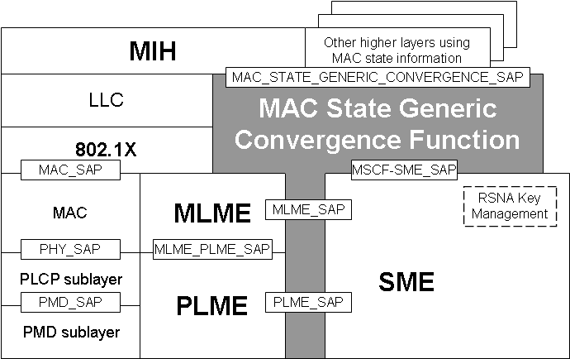
Figure 5-10u: Interworking Reference Model

References:
Draft P802.11u-D3.01

