IEEE P802.11
Wireless LANs
TGs Lihue Ad-hoc Minutes
Date: 2008-09-06
Author(s):
Name | Affiliation | Address | Phone | email
Donald Eastlake 3rd | Motorola | 155 Beaver Street, Milford, MA 01757 USA | +1-508-634-2066 | d3e3e3@gmail.com
Abstract
Minutes and participants list for a ad hoc meeting of the IEEE 802.11 TGs held September 3-5, 2008, at the Kaua‘i Hilton Beach Resort, Lihue, Kaua‘i, Hawaii.

Contents

Minutes 3
Wednesday, 3 September 2008 3
Thursday 4 September 2008 4
Friday 5 September 2008 5
Picture 6
Participants 7

Minutes
Donald Eastlake 3rd took minutes.
An annotated agenda is available in submission 11-08/953r5.

Wednesday, 3 September 2008

The Chair convened the call at 09:10 HST

The Chair’s announcement included the following informational pointers:

IEEE Patent Policy
http://standards.ieee.org/board/pat/pat-slideset.ppt
Patent FAQ
http://standards.ieee.org/board/pat/faq.pdf
LoA Form
http://standards.ieee.org/board/pat/loa.pdf
Affiliation FAQ
http://standards.ieee.org/faqs/affiliationFAQ.html
Anti-Trust FAQ
http://standards.ieee.org/resources/antitrust-guidelines.pdf
Ethics
http://www.ieee.org/portal/cms_docs/about/CoE_poster.pdf
IEEE 802.11 Working Group Policies and Procedures
https://mentor.ieee.org/802.11/public-file/07/11-07-0360-04-0000-802-11-policies-and-procedures.doc

Since our permanent secretary was unable to attend the ad hoc meeting, the Chair acted as Secretary.

The Chair presented the latest PatCom slide set. There were no questions.

The Chair reminded everyone that, since this is an ad hoc, manual attendance recording is required.

The Chair inquired if anyone in the meeting was personally aware of any patent claims that are potentially essential to implementation of the proposed standard under consideration by the group and that are not already the subject of an Accepted Letter of Assurance. No one indicated such awareness.

The Chair reviewed the proposed Agenda in 11-08/953r3.
There were no objections or suggested additions to the Agenda.

Since our permanent Editor was unable to attend this ad hoc, the Chair briefly reviewed the status of the Draft and comment resolutions spreadsheet. The latest Draft is D2.01, which is updated through the May meeting in Jacksonville. A D2.02 updated through the July meeting in Denver should be available by the Waikoloa meeting next week. The current comment resolutions spreadsheet in 11-08/493r18, which should include resolutions adopted through the end of the Denver meeting and other resolutions produced at the Denver meeting but too late to be voted on.

The Chair asked if there were any submissions to present. Guido Hiertz mentioned that he had produced an edit, with changes tracked, of the Word conversion of D2.01 with “Mesh Point” generally changed to “Mesh Station”. The Chair pointed out that at least one expected attendee wouldn’t be showing up until the next day, Thursday, and suggested that the presentation be postponed until then. This was agreed to. It was also pointed out that, while this Word document cannot be made into a public submission, since it is the entire Draft, it could be uploaded during the Waikoloa meeting into an area accessible to meeting attendees.

The Chair suggested that this meeting should work primarily on Open comments in the General category. There was no objection.

The remainder of the morning, work was done to resolve Open General comments in 11-08/493r18.

The group recessed at 12:00 for lunch.

At 13:15, after lunch, it reconvened.

The Chair again reminded the group about manual attendance recording and IPR.

The group worked for the remainder of the day on resolving Open General comments in 11-08/493r18.

The comment resolution work done this day is summarized in 11-08/1033r0.

At 16:45 the ad hoc meeting recessed until 09:00 Thursday. (Earlier than originally scheduled due to the social Wednesday evening.)

Thursday 4 September 2008

The meeting was called to order at 09.05.

The Chair reminded everyone that we were still operating under the IPR rules and inquired if anyone in the meeting was personally aware of any patent claims that are potentially essential to implementation of the proposed standard under consideration by the group and that are not already the subject of an Accepted Letter of Assurance. No one indicated such awareness.

A copy of the updated spreadsheet with yesterdays work in it was distributed to the attendees by memory stick.

Guido Hiertz, Presented a complete Word conversion of the D2.01 draft marked up to change “Mesh Point” (MP) to “Mesh Station” (Mesh STA), etc.
Q: Should we also stop using Mesh Portal and just say Portal?
A: Probably but it would be best not to make too many changes in one motion.
Q: We need to also indicate that Mesh Points / Stations do not inherit everything that the base standard says about QoS Stations.
A: Right but that seems like a different issue for what I am trying to address in this Word document.
Q: What about MBSS (Mesh BSS) versus MSS (Mesh Service Set)?
A: I wanted to make use of as much as possible of what the base standard says about BSS…
Q/A: Should things be expressed in terms of the JOIN and START primitives?

Guido’s work met with generally approval from the meeting.

The meeting then continued with work on Open General comments.

At 12:00 the group recessed for lunch.

The meeting was called back to order after lunch.

The group continued to work on Open General comments.

The work done on comment resolution in the first two days of the meeting is summarized in 11-08/1033r1.

At 18:00 the Chair adjourned the ad-hoc meeting until 09:00 Friday 5 September 2008.

Friday 5 September 2008
The Chair called the meeting to order at 09:15.

The Chair reminded everyone that we were still operating under the IPR rules and inquired if anyone in the meeting was personally aware of any patent claims that are potentially essential to implementation of the proposed standard under consideration by the group and that are not already the subject of an Accepted Letter of Assurance. No one indicated such awareness.

The chair announced that 11-08/1033r0 and r1 had been uploaded.

The group continued to work on the resolution of General Open comments.

It was noted that the subsection numbers in Annex V in D2.01 are off by +4. For example, there is no V.1, it appearing as V.5.

After all Open General comments had a non-blank resolution code (column V), there was a discussion of the conflict between 11-08/783 and 11-08/526 adopted in Denver. The informal opinion of the ad hoc was that 11-08/783 is a more fundamental crypto change and should be applied first. 11-08/526, while important, is really just a change to use some common parameters across multiple radios / virtual MPs and does not affect the fundamental crypto. So, for example, where 783 changes MA to MKD and
526 changes MA to MA-ID (and generally adds a "-ID" suffix), the result after both should be MKD-ID.

Having at least filled in the resolution code for all Open General Comments, the group proceeded to go back over those comments with a resolution code of Defer to see if it could be changed to Accept, Counter, or Reject.

At 12:05 we recessed for lunch.

The group was called back to order and continued to work on the Deferred Open General comments.

The task group recessed briefly and all went out into the sun to be photographed with permission of the working group chair.

The group was called back to order and continued to work on the Deferred Open General comments.

The comment resolution work of all three days of the ad hoc meeting is summarized in 11-08/1033r2.

At 15:45, the group adjourned.

Picture

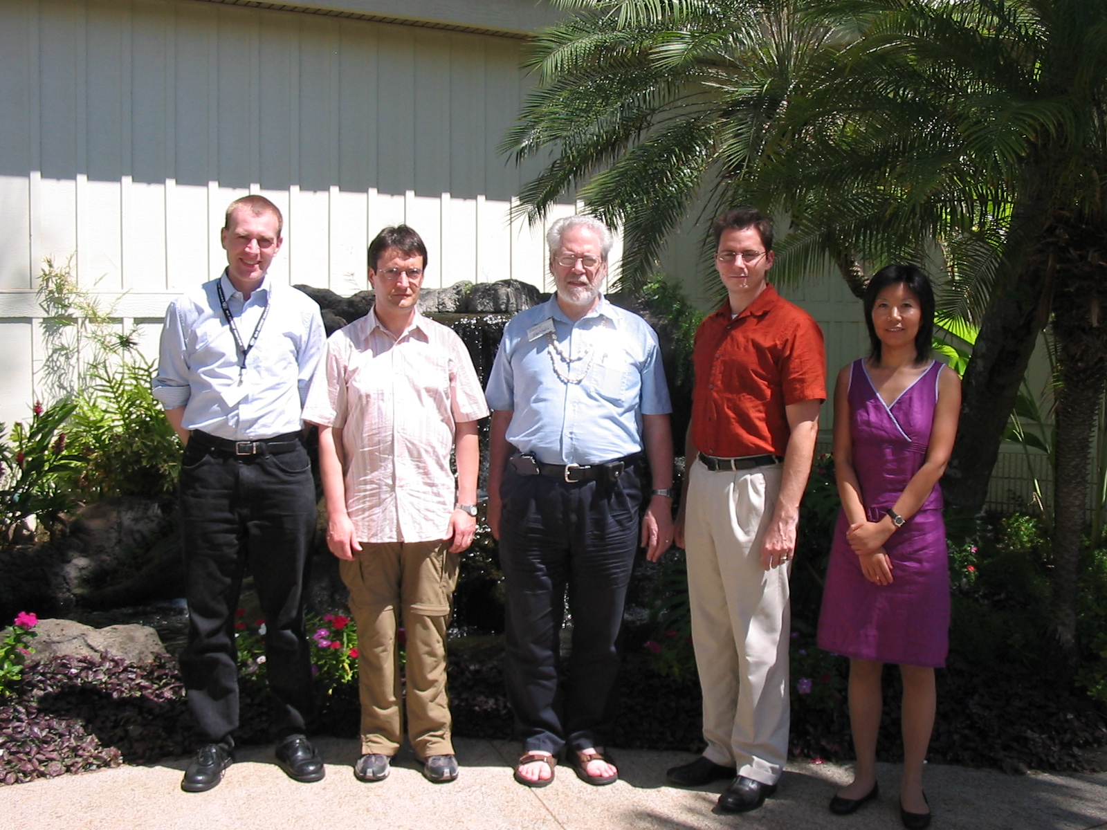

Participants

- Donald E. Eastlake 3rd – Motorola
- Qi Wang – Broadcom
- Guenael Strutt – Motorola
- Guido Hiertz – Philips
- Michael Bahr – Siemens
- Dorothy Stanley – Aruba Networks

