IEEE P802.11
Wireless LANs
TGs Santa Clara Ad-hoc Minutes
Date: 2008-05-10
Author(s):
Name | Affiliation | Address | Phone | email
Jan Kruys | Cisco |  |  | jkruys@cisco.com
Abstract
Minutes and participants list for a teleconference of the IEEE 802.11 TGs ad-hoc meeting held May 8-9, 2008, hosted by Intel in Room 209 of their SC12 facility at 3600 Juliette Lane, Santa Clara, California.

Contents

Minutes 3
Participants 5

Minutes
Minutes were taken by Jan Kruys and edited by Donald Eastlake 3rd.
An annotated agenda is available in submission 11-08/461r3.

Thursday, 8 May 2008

The Chair convened the call at 09:12 PST

The Chair’s announcement included the following informational pointers:

IEEE Patent Policy
http://standards.ieee.org/board/pat/pat-slideset.ppt
Patent FAQ
http://standards.ieee.org/board/pat/faq.pdf
LoA Form
http://standards.ieee.org/board/pat/loa.pdf
Affiliation FAQ
http://standards.ieee.org/faqs/affiliationFAQ.html
Anti-Trust FAQ
http://standards.ieee.org/resources/antitrust-guidelines.pdf
Ethics
http://www.ieee.org/portal/cms_docs/about/CoE_poster.pdf
IEEE 802.11 Working Group Policies and Procedures
https://mentor.ieee.org/802.11/public-file/07/11-07-0360-04-0000-802-11-policies-and-procedures.doc

The Chair presented the latest PatCom slide set. There were no questions.

The Chair inquired f anyone in the meeting was personally aware of the holder of any patent claims that are potentially essential to implementation of the proposed standard under consideration by the group and that are not already the subject of an Accepted Letter of Assurance. No one indicated such awareness.

The Chair reviewed the proposed Agenda:
1. Attendance
2. IPR and other relevant IEEE policies (see pointers above).
3. Agenda for this meeting – see document 11-08/461r1
4. Miscellaneous announcements
5. Letter Ballot Comment Resolution
6. Preparation for the Jacksonville meeting
7. Adjourn
There were no objections or suggested additions to the Agenda.

4. The Chair expects that a permanent Editor for TGs will be selected at the Jacksonville meeting.

5. The chair presented document 11-08-0493-02-000s-lb-126-comment-resolutions.

In all, 1,958 comments were received, 611 marked editorial and 1347 technical.
The chair proposed to split up in two groups, each to categorize half on the comments received. This was done. The Categories chosen were General, MAC, RFI and Security. For each further issue identifiers were added by the groups with issue identifiers starting with the same letter as the category they were in.

A new column was added to 11-08/493 between G & H for Topic Category.

The meeting divided into two Subgroups
SubGroup 1: CIDs 1+: Michelle Gong coordinator – categorizing comments
SubGroup 2: CIDs 1053+: Guenael Strutt coordinator – categorizing and entering tentative resolutions

The ad hoc continue to work through Lunch which was provided by Intel, the hosts.

SubGroup 1 completed categorization and the ad hoc proceeded as follows:
SubGroup 1: Entering tentative resolutions for non-security comments with CIDs 1-1052.
SubGroup 2: CIDs 1053+: Guenael Strutt coordinator – categorizing and entering tentative resolutions
Security SubGroup: Dan Harkins coordinator – entering tentative resolutions for security comments with CIDs 1-1052.

The ad hoc recombined and Recessed at 17:15 until 09:00 tomorrow, Friday.

Friday 9 May 2008

The meeting was resumed at 09.15 on May 9.

The Chair reminded everyone that we were still operating under the IPR rules and inquired f anyone in the meeting was personally aware of the holder of any patent claims that are potentially essential to implementation of the proposed standard under consideration by the group and that are not already the subject of an Accepted Letter of Assurance. No one indicated such awareness.

The chair summarized the progress made the day before and noted some of the details of converging the spreadsheets with categorizing. The result is captured in version 3 of the spreadsheet.

Work continued in subgroups; all comments were categorized. The result is version 06 with a version 07 to be posted over the weekend. There was a general consensus that the group did not need to meet on Saturday.

Unanimous consent was obtained from the task group members present to have a picture of the group taken for non-commercial purposes. (Permission had previously been obtained from the 802.11 Working Group Chair.)

6. Preparation for Jacksonville. See document 11-08/462r3.

The chair discussed the Jacksonville agenda – the group has 11 time slots. Monday there will be a presentation on a “presence” protocol.

7. The Chair asked if there were any further topics for discussion. There were none.

The Chair adjourned the ad-hoc meeting 17.10 on Friday the 9th of May 2008.
.
Pictures
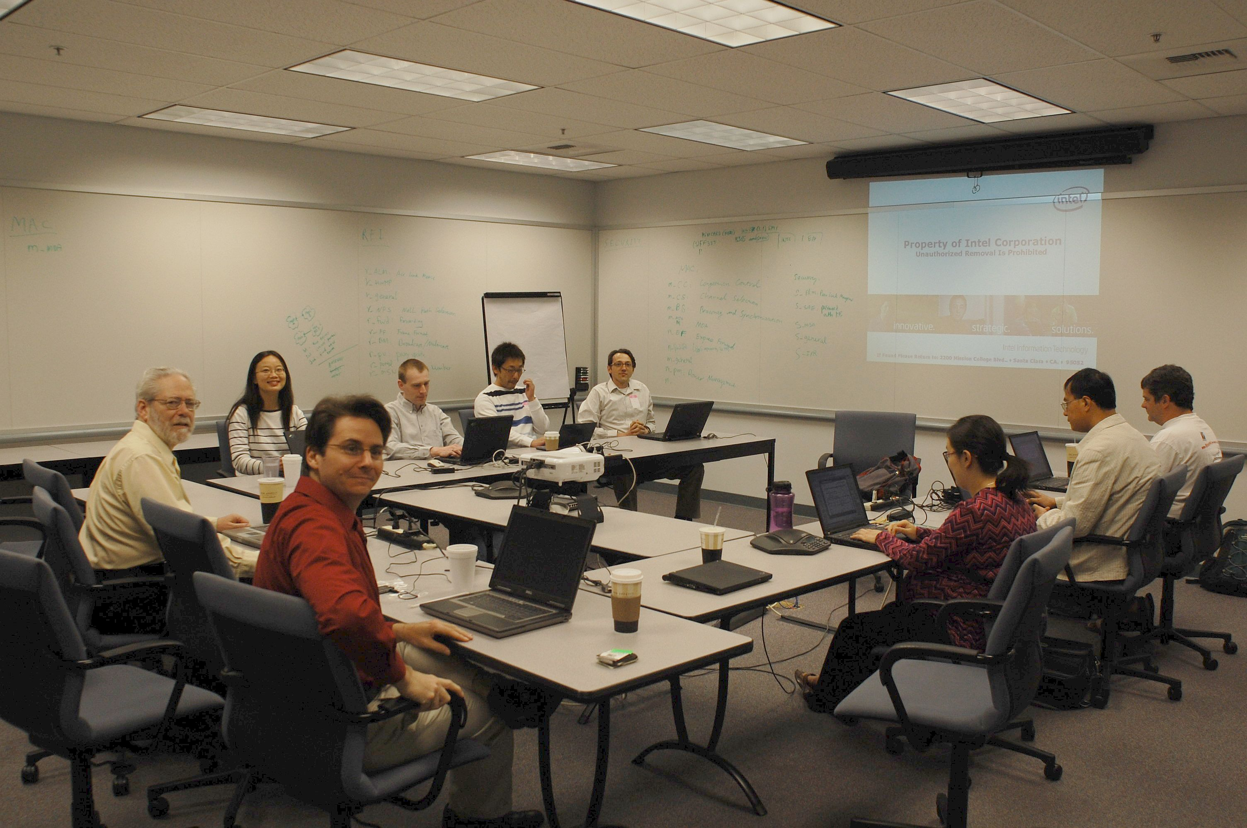
Picture Above Taken by Jan Kruys

Venue
Participants

- Donald E. Eastlake 3rd – Motorola
- Michelle Gong, Intel
- Dan Harkins, Aruba
- Meiyuan Zhao, Intel
- Liwen Chu, ST
- Qi Wang, Broadcom
- Xavier Cordona, OLPC
- Guenael Strutt, Motorola
- Jan Kruys, Cisco Systems, Inc.
- Guido Hiertz, Philips
- Kazuyuki Sakoda, Sony

