IEEE P802.11
Wireless LANs
802.11 TGn LB115 Submission CID 5888
Date: 2008-01-30
Author(s):
Name | Company | Address | Phone | email
Adrian Stephens | Intel Corporation |  |  | Adrian.p.stephens@intel.com
Abstract
This document contains proposed changes to the IEEE P802.11n Draft to address the following LB115 comments assigned to the author: 5188

The changes marked in this document are based on TGn Draft version D3.02.
They relate to:
- TGn Ad-hoc: MAC
- Comment group: MAC General

Acknowledgement: Brian Hart (Cisco) provided the basis for much of this analysis.

Comment
CID | Page | Clause | Resn Status | Comment | Proposed Change
5188 | 379.11 | D |  | I haven't seen any analysis on meeting 802 Overview and Architecture requirements 7.3 c [The probability that an MSDU delivered at an MSAP contains an undetected error, due to operation of the MAC service provider, shall be less than 5 × 10-14 per octet of MSDU length. ] across all combinations of MCS, beamforming and number of streams, to justify changing maximum frame body length. | Do not change dot11FragmentationThreshold without analysis showing 802 O&A requirements are met for all combinations of PHY options and MAC (e.g. Block Ack) procedures.

Discussion

The question is raised as to whether the change in fragment size (which is specific to the use of A-MSDU by a HT STA) affects the compliance of the 802.11 standard to the error rate requirements in STD 802-2001.

The relevant section is item c) of subclause is 7.3: (highlighted below)
7.3 Error rates
Error performance of IEEE 802 LANs and MANs is required to be such as follows:
a) For wired or optical fiber physical media: Within a single access domain, the probability that a
transmitted MAC frame (excluding any preamble) is not reported correctly at the Physical Service
interface of an intended receiving peer MAC entity, due only to operation of the Physical layer, shall
be less than 8 ⋅ 10-8 per octet of MAC frame length.
b) For wireless physical media: Within a single access domain, the probability that a MAC Service
Data Unit (MSDU) is not delivered correctly at an MSAP of an intended receiving MAC service
user, due to the operation of the Physical layer and the MAC protocol, shall be less than 8 ⋅ 10-8 per
octet of MSDU length.
NOTE—The performance measure stated in (a) defines a highly desirable characteristic of LAN performance, as it has a
bearing on other aspects of the delivered service, such as frame loss and transmission delays caused by the need to
retransmit. However, this measure is not realistic for all physical media; for example, wireless media may be unable to
meet this level of physical layer performance due to the inherent transmission characteristics of the medium. In such
cases, the operation of the MAC protocol must employ additional mechanisms, for example, error detection and
correction mechanisms, in order to enable the MAC service provider to meet the performance levels implied by this
condition in the service offered at the MAC service boundary.
c) The probability that an MSDU delivered at an MSAP contains an undetected error, due to operation
of the MAC service provider, shall be less than 5 ⋅ 10-14 per octet of MSDU length.
NOTE—For example, (a) the worst-case probability of losing a maximum-length IEEE 802.3 frame (1518 octets) through
physical-layer damage is to be less than 1.21 ⋅ 10-4, or approximately 1 in 8250; (c) the worst-case probability that a
similar frame, which contains an MSDU of 1500 octets, is delivered with an undetected error is to be less than
7.5 ⋅ 10-11, or approximately 1 in 13 300 000 000.

Terms used in this discussion

Term | Definition
nErrorOctets | The number of octets within MSDUs passed up through the MAC SAP which contain an error.
nGoodOctets | The number of octets within MSDUs passed up through the MAC SAP which do not contain an error.
OER | Octet error rate – i.e., the probability that an octet indicated through the MAC SAP contains an error.
RWER | Raw word error rate – i.e., the probability that a 32-bit word includes one or more errors pre CRC checking.
nCRC | Size of the CRC (32 bits)
nDetect | Number of errors the CRC can detec
nHeaderCheck | The number of bits in the MAC header that must be correct for an MPDU to be accepted = 47 bits of addressing + 2 bits of version + 2 bits of type, or 51 bits.
PFC | The probability of a false CRC match
nMPDU | Size of an MPDU – typically ~1500B
nWords | Size of an MPDU in words = nMPDU/4
pRandomMPDU | The probability that a random MSDU is passed up as a good one
pMiddle | Probability that a packet has a “middle collision”
BER | Bit error rate
pNoHeaderError | The probability that the header contains no errors
pEnoughErrors | The probability that the packet contains more errors than the ability of the CRC to deterministically detect the error

Error Mechanisms

Metric

The metric of interest is the probability that an octet of MSDU delivered at the MAC Data SAP contains an error.

The OER is given by:

Scrambled Packets

Consider when something (e.g., constant interference) causes packets to be randomly scrambled. The naïve expectation is that in equation 1.1, we will have nGoodOctets = 0, and nErrorOctets may be non-zero. So the OER is unity – i.e. any MSDUs that are indicated are certainly bogus.

But this expectation is misleading. Assume each MSDU has a random content. The probability that a random MSDU passes the header checks, plus a false positive CRC is:

Or about 5E-26. Consider a STA receiving 1500B MPDUs at 54 Mpbs. The interarrival rate is about 300us. To observe a single random MPDU event passed up, we need to wait for 300us / pRandomMPDU, which is ~5E21s or about 5E14 years.

So the naïve expectation is a little misleading. By the time this mechanism causes any observable errors, the observer will be long dead, the equipment long out of warrantee, and STD 802.11-2007 will have been replaced by STD 802.11-400,000,000,000,000.

Collision at the start of a packet
This is a relatively frequent event. The slotted CSMA/CA protocol results in collisions due to contention for channel access.

The collision results in a BER that is effectively constant throughout the packet. It can be considered in one of two regions of interest:
- Complete scrambling. This is equivalent to the “Scrambled Packets” discussion above. We expect to see no false positive octets arriving in this case.
- Elevated BER. This is equivalent to the thermal noise case, which is considered below.

Collision in the middle of a packet

The rate of occurance of this event is dependent entirely on the operating setup. An isolated network might never experience these events. Overlapping networks will undoubtedly experience these events due to hidden node conditions.

It is hard to quantify the probability of a middle collision (pMiddle), but we can guess a value of 1% for the sake of argument.

When this event occurs, all octets after the collision are considered to be random. On average this is going to be half the MPDU size. We assume that the MAC header bits are not corrupted. This is the main difference between this event and the “scrambled packet” – we lose the ability of the MAC header to provide many bits of additional checking.

In this case

Which evaluates to ~10E-12.

In order to hit a 5x10E-14 OER, we would need pMiddle to be ~10E-4. While this may be true in an isolated case, the MAC is deliberately tolerant of PER ~10%. There has been no attempt to optimize the MAC to avoid middle collisions, and it is entirely unreasonable to expect this low a rate of middle collisions in an arbitrary OBSS environment.

Another point to note is that this rate is independent of packet size (nMPDU).

Has 802.11n made the OER any worse or better? There are two effects to consider:
- A-MPDU aggregation. MPDUs in an aggregate after the point of collision are header-checked and convert to the performance of the “scrambled packet” analysis. This might be enough to reduce the OER by a factor of ten.
- Secondary channel OBSS. If there is an OBSS in the secondary channel, intuition indicates that pMiddle will increase.

Which of these two effects is the stronger is hard to say and difficult to quantify. My intuition is that the A-MPDU effect is stronger than the OBSS effect, but I’m willing to play it safe by saying that the two balance out.

So we can conclude that:
- 802.11 fails to meet the architectural requirement for OER due to middle collisions
- 802.11n has probably not made the OER significantly worse or significantly better than IEEE STD 802.11-2007

Thermal noise

In the thermal noise case, we initially characterise the errors by a BER. Errors are independent and randomly scattered through the MPDU.

We characterise the performance of the CRC as being able to detect nDetect=1 error of up to 32 bits, which we call a word for the purpose of this section.

The interaction between the CRC and the decoder is complex. The Viterbi decoder tends to emit runs of errors equal to the length of its traceback. So the model of independent bit errors scattered through the MPDU doesn’t really obtain.

Given this, we will characterise the errors by a raw word error rate: RWER. RWER can be determined from a target PER as follows:
Given a 10% PER for 250W MPDUs, RWER is 4.2135e-004.

We will calculate nError for a single MPDU as follows by summing over the possible number of word errors. Conservatively we assume that if a word is in error, all the octets in that word are in error.

The last term relates to the ability of the CRC to detect an error once the number of errors exceeds nDetect.

The number of good octets is the probability that zero errors occur, times the size of the MPDU.

Calculating the result for nWords=250W, RWER=4.2E-4 we get OER=1.0859e-014

As a function of nMPDU, the result is shown below:
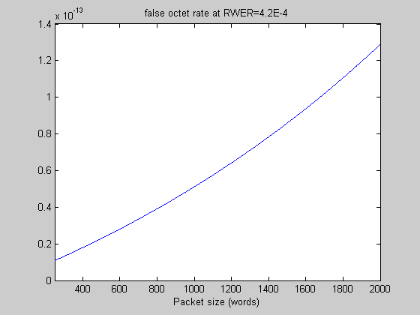

Observe that this exceeds the architectural limit at a packet size ~1000 words.

This was calculated with a constant RWER. This is an unrealistic assumption, as 80% of MPDUs of 2000W will contain errors. Any realistic link adaptation algorithm will target a PER ~10%, regardless of MPDU length. It is also based on the conservative assumption that if a word contains an error, all four octets contain an error.

The OER resulting from a constant PER of 10% is as follows:
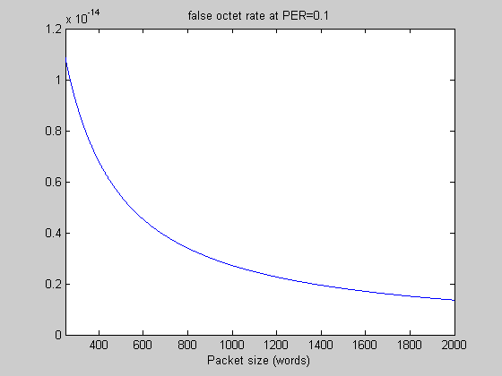

Which is within the architectural limits.

The conclusion is that, given realistic link adaptation, the OER due to thermal noise will be within architectural limits.

Proposed Resolution

Reject. See 11-08/0221r1.

This submission shows that 802.11n meets the architectural requirements, except in the “middle collision” case.

However, in this case, the performance of 802.11n is no different from the baseline standard, and is independent of MPDU length. So the commenter’s implied assertion that TGn’s increased fragment size has caused it to exceed an architectural limit is not supported by this analysis.

One of two 48 bit addresses, one for unicast and one for broadcast
I think that when packets become very small, the assumption that the header is not affected by a middle collision becomes suspect. In this case, I think the error rate decreases. I’ve not done the work to quantify this – i.e., it’s an exercise for the reader.

