IEEE P802.11
Wireless LANs
Text Updates for Binding of Peer Link and Security Association
Date: 2008-01-14
Author(s):
Name | Affiliation | Address | Phone | Email
Meiyuan Zhao | Intel Corporation | RNB-6-61 2200 Mission College Blvd, Santa Clara, CA 95052 USA | +1-408-653-5517 | meiyuan.zhao@intel.com
Jesse Walker | Intel Corporation | JF3-206, 2111 NE 25th Ave, Hillsboro, OR 97124 | +1-503-712-1849 | jesse.walker@intel.com
Abstract
In both the Peer Link Management and Abbreviated Handshake protocols, the peer link and its security association are still not fully bound together.

This document proposes changes to the draft to enable full binding of peer link and its security association, so that their establishment and tear down are synchronized. The major changes are following:
- The key derivations in MSA 4-Way Handshake (for PTK) and in Abbreviated Handshake (for TK) add (localLinkID, peerLinkID) to enable full binding of the identifier of peer link instance and its security association
- MLME-SignalPeerLinkStatus.indication() primitive adds new status code “PEER-LINK-SA-ESTABLISHED” to indicate successful establishment of peer link instance and its security association upon successful MSA 4-Way Handshake and Abbreviated Handshake.
- If there’s a reason to terminate a security association (other than tearing down its peer link instance), additional operation is needed to make sure its peer link instance is deleted first, then the security association is destroyed. The text reflecting this change TBD

Addition to these changes, this document provides some minor updates to reflect correct state machine behaviour and peer link/physical link relationship.

Baseline: D1.07, 11-07/2839r3 (key usage update), 11-07/2569r2 (peer link, physical link relationship), 11-07/2855r0 (more efficient KDF), and 11-07/2816r0 (AbbrHS minor updates)

7.3.1.8 Reason Code field
Modify table 22 as shown:
- Reason codes
Reason code | Meaning
 | “PEER-LINK-CANCELLED”. IEEE 802.11 SME cancels the link instance with the reason other than reaching the maximum number of neighbors
 | “MESH-MAX-NEIGHBORS”. The Mesh Point has reached the supported maximum number of neighbors
 | “MESH-CAPABILITY-POLICY-VIOLATION”. The received information violates the Mesh Configuration policy configured in the Mesh Point profile
 | “MESH-CLOSE-RCVD”. The Mesh Point has received a Peer Link Close message requesting to close the peer link.
 | “MESH-MAX-RETRIES”. The Mesh Point has re-sent dot11MeshMaxRetries Peer Link Open messages, without receiving a Peer Link Confirm message.
 | “MESH-CONFIRM-TIMEOUT”. The confirmTimer for the mesh peer link instance times out.
 | “MESH-SECURITY-ROLE-NEGOTIATION-DIFFERS”. The Mesh Point uses a different method for Role Negotiation, preventing MSA authentication from completing.
 | “MESH-SECURITY-AUTHENTICATION-IMPOSSIBLE”. No common PMK-MA exists, and Initial MSA Authentication is also impossible, since no connection to the MKD exists.
 | “MESH-SECURITY-FAILED-VERIFICATION”. The security-related information received in the peer link management message does not match the expected values.
 | “MESH-INVALID-GTK”. The Mesh Point fails to unwrap the GTK or the values in the wrapped contents do not match
 | “MESH-MISMATCH-GTK”. The MP that sends the GTK fails to verify that the same value is received by the peer
 | “MESH-INCONSISTENT-PARAMETERS”. The Mesh Point receives inconsistent information about the mesh paramters between Peer Link Management frames
4655-65 535 | Reserved

7.3.1.9 Status Code field
Modify table 23 as shown, re-numbering as needed:
Table 23—Status codes
Reason code | Meaning
 | “PEER-LINK-MAX-RETRIES”. The MSA Abbreviated Handshake fails because no response after maximal number of retries.
 | “PEER-LINK-NO-PMK”. The Abbreviated Handshake fails because no shared PMK
 | “PEER-LINK-ALT-PMK”. The Abbreviated Handshake fails because no matching chosen PMK, but there exits an alternative choice.
 | “PEER-LINK-NO-AKM”. The Abbreviated Handshake fails because no commonly supported AKM suite for Abbreviated Handshake exists.
 | “PEER-LINK-ALT-AKM”. The Abbreviated Handshake fails because no matching chosen AKM, but there exists an alternative choice.
 | “PEER-LINK-NO-KDF”. The Abbreviated Handshake fails because no supported KDF. The peer MP supports a different KDF.
 | “MESH-LINK-MAX-RETRIES”. The MSA Abbreviated Handshake fails because no response after maximal number of retries.
 | “MESH-LINK-NO-PMK”. The Abbreviated Handshake fails because no shared PMK
 | “MESH-LINK-ALT-PMK”. The Abbreviated Handshake fails because no matching chosen PMK, but there exits an alternative choice.
 | “MESH-LINK-NO-AKM”. The Abbreviated Handshake fails because no commonly supported AKM suite for Abbreviated Handshake exists.
 | “MESH-LINK-ALT-AKM”. The Abbreviated Handshake fails because no matching chosen AKM, but there exists an alternative choice.
 | “MESH-LINK-NO-KDF”. The Abbreviated Handshake fails because no supported KDF. The peer MP supports a different KDF.
5559-65 535 | Reserved
<ANA 24> | “PEER-LINK-SA-ESTABLISHED”. The peer link, its security association, and their binding have been successfully established.
5960-65 535 | Reserved

Modify clause 8.8.6 as shown below:
- PTK
The third level key of the mesh key hierarchy link security branch is the PTK. This key is mutually derived by the Supplicant MP and the MA with the key length being a function of the negotiated cipher suites as defined by Table 8-2 in 8.5.2.
The PTK derivation is as follows:
PTK = KDF-PTKLen(PMK-MA, “Mesh PTK Key derivation”, MPTKSNonce, MPTKANonce, min(localLinkID, peerLinkID), max(localLinkID, peerLinkID), MA-ID, SPA, PMK-MAName)
where
- KDF-PTKLen is the KDF function as defined in Error: Reference source not found used to generate a PTK of length PTKLen.
- PMK-MA is the key that is shared between the Supplicant MP and the MA
- “Mesh PTK Key derivation” is 0x4D6573682050544B204B65792064657269766174696F6E.
- MPTKSNonce is a 256 bit pseudo-random bit string contributed by the Supplicant MP
- MPTKANonce is a 256 bit pseudo-random string contributed by the MKD or MA
- localLinkID is link identifier, contributed by the MP, of the link instance, with which the security association is bound
- peerLinkID is link identifier, contributed by the peer MP, of the link instance, with which the security association is bound
- SPA is the Supplicant MP’s MAC address
- MA-ID is the MAC address of the MA.
- PMK-MAName is defined in Error: Reference source not found
- PTKlen is the total number of bits to derive, e.g., number of bits of the PTK. The length is dependent on the negotiated cipher suites as defined by Table 8-2 in 8.5.2.
Each PTK has three component keys, KCK, KEK, and TK, derived as follows:
The KCK shall be computed as the first 128 bits (bits 0-127) of the PTK:
KCK = L(PTK, 0, 128)
where L(-) is defined in 8.5.1.
The KCK is used to provide data origin authenticity between a supplicant MP and the MA when used in EAPOL-Key frames defined in Error: Reference source not found.
The KEK shall be computed as bits 128-255 of the PTK:
KEK = L(PTK, 128, 128)
The KEK is used to provide data confidentiality between a supplicant MP and the MA when used in EAPOL-Key frames defined in Error: Reference source not found.
Temporal keys (TK) shall be computed as bits 256-383 (for CCMP) or bits 256-511 (for TKIP) of the PTK:
TK = L(PTK, 256, 128), or
TK = L(PTK, 256, 256)
The temporal key is configured into the Supplicant MP through the use of the MLME-SETKEYS.request primitive. The MP uses the temporal key with the pairwise cipher suite; interpretation of this value is cipher-suite specific.
The PTK is referenced and named as follows:
PTKName = NDF(SHA-256(“Mesh PTK Name” || PMK-MAName || MPTKSNonce || MPTKANonce || MA-ID || SPA))
where
- “Mesh PTK Name” is 0x4D6573682050544B204E616D65.

Modify clause 10.3.41 as shown below:
- SignalPeerLinkStatus
The following primitives report the link status to the mesh entity as the result of peer link management.
- MLME-SignalPeerLinkStatus.indication
- Function
This primitive indicates that the mesh entity has finished the link establishment procedure with a specified peer mesh entity and reports the status of the link.
- Semantics of the service primitive
The primitive parameters are as follows:

MLME-SignalPeerLinkStatus.indication(
local Link ID,
Status
Code,
KeyInfo,
AKMInfo,
KDFInfo
)
Name | Type | Valid range | Description
local Link ID | Integer | 1—2¹⁶-1 | Specifies the integer generated by the local mesh entity to identify this link instance
StatusCode | Enumeration | PEER-LINK-ESTABLISHED,  PEER-LINK-SA-ESTABLISHED,  PEER-LINK-CLOSED, PEER-LINK-MAX-RETRIES, PEER-LINK-NO-PMK, PEER-LINK-ALT-PMK, PEER-LINK-NO-AKM, PEER-LINK-ALT-AKM, PEER-LINK-NO-KDF | Indicates the status of the peer link establishment procedure
KeyInfo | Integer | 0—2¹²⁸-1 | Specifies the PMKID of the alternative PMK-MA chosen by the candidate peer MP, if the StatusCode value is “PEER-LINK-ALT-PMK”. Otherwise, set to 0.
AKMInfo | Integer | 0—2³²-1 | Sepcifies the AKM suite selector of the alternative AKM suite as the result of AKM suite selection, if the StatusCode value is “PEER-LINK-ALT-AKM”. Otherwise, set to 0.
KDFInfo | Integer | 0—2³²-1 | Sepcifies the KDF selector of the KDF that the candidate peer MP supports, if the StatusCode value is “PEER-LINK-NO-KDF”. Otherwise, set to 0.

- When generated
This primitive is generated when the mesh entity finishes the link management procedure, either when the peer link is established, or when it is closed.
- Effect of receipt
This primitive enables the mesh entity to handle the link instance status.

Modify clause 11A.2.3.2 as indicated below:
- Events and Actions
The finite state machine uses three types of events: events created by IEEE 802.11 SME, external events generated by frame processing, and events associated internal timers.
IEEE 802.11 SME uses the following primitives to pass events to the finite state machine.
- CNCL -- MLME-CancelPeerLink.request(localLinkID, ReasonCode) event is used to instruct the link instance to cancel the link with the peer MP. The link instance uses MLME-CancelPeerLink.confirm(localLinkID, ResultCode) primitive to return the result to IEEE 802.11 SME.
- PASOPN -- MLME-PassivePeerLinkOpen.request event is used to instruct the link instance to passively listen to a peer link establishment frame from a candidate peer MP. The link instance uses MLME-PassivePeerLinkOpen.confirm(localLinkID) to return the result to IEEE 802.11 SME.
- ACTOPN -- MLME-ActivePeerLinkOpen.request(peerMAC) event is used to instruct the link instance to actively initiate the peer link establishment with the candidate peer MP whose MAC address is peerMAC. The link instance uses MLME-ActivePeerLinkOpen.confirm(peerMAC, localLinkID) primitive to return the result to IEEE 802.11 SME.
- BNDSA – MLME-BindSecurityAssociation.request(localLinkID, MPTKANonce, MPTKSNonce) event is used to instruct the link instance to bind the security association established via MSA 4-Way Handshake with the current link instance. The link instance uses MLME-BindSecurityAssociation.request(localLinkID, ResultCode) primitive to return the result to IEEE 802.11 SME.
The events generated by frame processing are
- CLS_ACPT -- PeerLinkClose_Accept(peerMAC, localLinkID, peerLinkID, reasonCode) event indicates that a Peer Link Close frame meeting the correctness criteria of 11A.2.2.2 has been received from peerMAC for the link instance identified by localLinkID and peerLinkID. The reasonCode specifies the reason that causes the generation of the Peer Link Close frame.
- CLS_IGNR -- PeerLinkClose_Ignore(peerMAC, localLinkID, peerLinkID) event indicates that a Peer Link Close frame with mis-matched link identifiers, as specified in 11A.2.2.2, has been received from peerMAC for the link instance identified by localLinkID and peerLinkID.
- OPN_ACPT -- PeerLinkOpen_Accept(peerMAC, peerLinkID, Configuration) event indicates that a Peer Link Open frame meeting the correctness criteria of 11A.2.2.3 has been received from peerMAC for the link instance identified by localLinkID and peerLinkID. The Configuration is the set of information received in the Mesh Configuration information element.
- OPN_IGNR -- PeerLinkOpen_Ignore(peerMAC, peerLinkID) event indicates that a Peer Link Open frame with mismatched link identifiers, as specified in 11A.2.2.3, has been received from peerMAC for the link instance identified by locakLinkID and peerLinkID.
- OPN_RJCT -- PeerLinkOpen_Reject(peerMAC, peerLinkID, Configuration, ReasonCode) event indicates that a Peer Link Open frame with an invalid Configuration field, as specified in 11A.2.2.3, has been received from peerMAC for the link instance identified by localLinkID and peerLinkID. The Configuration is the set of information as received from Mesh Configuration element. The ReasonCode is set to MESH-CONFIGURATION-POLICY-VIOLATION.
- CNF_ACPT -- PeerLinkConfirm_Accept(peerMAC, localLinkID, peerLinkID, Configuration) event indicates that a Peer Link Confirm frame meeting the correctness criteria of 11A.2.2.4 has been received from peerMAC for the link instance identified by localLinkID and peerLinkID. The Configuration is the set of information as received from Mesh Configuration element.
- CNF_IGNR -- PeerLinkConfirm_Ignore(peerMAC, localLinkID, peerLinkID) event indicates that a Peer Link Confirm frame with mis-matched link identifiers, as specified in 11A.2.2.4, has been received from peerMAC for the link instance identified by localLinkID and peerLinkID.
- CNF_RJCT -- PeerLinkConfirm_Reject(peerMAC, localLinkID, peerLinkID, Configuration, ReasonCode) event indicates that a Peer Link Confirm frame with an invalid Configuration fields, as specified in 11A.2.2.4, has been received from peerMAC for the link instance identified by localLinkID and peerLinkID. The Configuration is the set of information as received from Mesh Configuration element. The ReasonCode is set to MESH-CONFIGURATION-POLICY-VIOLATION. This event is denoted as.
The internal events are as follows. The term Timeout(localLinkID, item) represents a timeout identified locally by item, for the link instance identified by localLinkID.
Three types of timers are used by the finite state machine.
The retryTimer triggers a re-send of the Peer Link Open frame when a Peer Link Confirm frame was not received as a response.
- TOR1 – This event refers to Timeout(localLinkID, retryTimer) and the dot11MeshMaxRetries has not been reached. The state machine shall resend the Peer Link Open frame.
- TOR2 – This event refers to Timeout(localLinkID, retryTimer) and the dot11MESHMaxRetries has been reached. The link instance shall be closed when TOR2 occurs.
- TOC – The Timeout(localLinkID, confirmTimer) event. The confirmTimer aborts a link establishment attempt if a Peer Link Open frame never arrives after receiving the Peer Link Confirm frame. TOC event occurs, the link instance shall be closed.
- TOH event – The Timeout(localLinkID, holdingTimer) event. The holdingTimer allows a grace period for closing the link instance; it is necessary to avoid deadlocks and livelocks that arise due to interactions between link establishment and termination. When TOH occurs, the link instance shall be closed completely and the finite state machine shall transition to IDLE state.
The finite state machine may take an action triggered by an event. It uses two types of actions: sending a peer link management frame and handling a timer.
Actions related to sending a peer link management frame:
- sndOPN -- The sendOpen(peerMAC, localLinkID, Configuration) is the action that the link instance takes to send a Peer Link Open frame to the candidate peer MP, whose MAC address is peerMAC. The frame shall carry localLinkID and the supported Mesh Configuration, as specified as Configuration.
- sndCNF -- The sendConfirm(peerMAC, localLinkID, peerLinkID, Configuration) is the action that the link instance takes to send a Peer Link Confirm frame to the candidate peer MP, whose MAC address is peerMAC. The frame shall carry localLinkID, peerLinkID, and the supported Mesh Configuration, as specified as Configuration.
- sndCLS -- The sendClose(peerMAC, localLinkID, peerLinkID, reasonCode) is the action that the link instance takes to send a Peer Link Close frame to the peer MP or candidate peer MP, whose MAC address is peerMAC. The frame shall carry localLinkID and peerLinkID. If the peerLinkID is unknown, it shall be set to zero. The reasonCode shall specify the reason that the Peer Link Close is sent, whose value shall be set to a value between 46 to 51 as specified in Table 7-22. If the link instance is bound with the security association, security parameters shall be sent in MSAIE with the following fields set with corresponding values:
  - Handshake Control field shall be set to 0.
  - Selected AKM Suite field shall be set to the AKM suite selector for the link instance
  - Selected Pairwise Cipher Suite field shall be set to the selected pairwise cipher suite for the link instance
  - Chosen PMK field shall be set to a key identifier that indicates the selected PMK-MA for the link instance
  - Local Nonce field shall be set to the nonce that the MP generated during MSA 4-Wah Handshake. It is equal to MPTKANonce if the MP was determined as Authenticator during MSA 4-Way Handshake. Otherwise the value shall be set to the value of MPTKSNonce.
  - Peer Nonce field shall be set to the nonce that the peer MP generated during MSA 4-Wah Handshake. It is equal to MPTKANonce if the peer MP was determined as Authenticator during MSA 4-Way Handshake. Otherwise the value shall be set to the value of MPTKSNonce.
The MIC field in Peer Link Close shall contain a 16-octet MIC calculated using the KCK portion of the PTK of the session using the AES-128-CMAC algorithm on the concatenation in the following ofer, of:
- The MP MAC address
- The peer MP MAC address
- Contents of the Peer Link Close frame except the MIC field
The actions on handling timers are setTimer(localLinkID, item, value) and clearTimer(localLinkID, item).
- The setTimer(localLinkID, item, timeout) action sets the timeout value specified by timeout to the timer specified by item. This action only sets the timer for one time for the link instance identified by localLinkID. When the timeout time has passed, the timer expires and the event Timeout(localLinkID, item) is triggered, after which the timer is no longer in effect.
The corresponding actions are denoted as setR, setC, setH, for timer retryTimer, confirmTimer, holdingTimer respectively.
Before setting the retryTimer, the finite state machine shall apply the default link open request backoff algorithm to compute the updated timeout value as the following:
timeout = return timeout + (getRandom mod timeout),
where getRandom routine generates a random value. The initial value of timeout shall be set to dot11MeshRetryTimeout. This function statistically increases the length of time for each Peer Link Open retry by 50%. The backoff was inserted into the design to recover from a “gold rush”, which could happen if several already-linked MPs simultaneously detected a new MP trying to enter the mesh network.
- The clearTimer(localLinkID, item) action clears the timer item for the link instance identified by localLinkID. The corresponding actions are denoted as clR, clC, clH, for timer retryTimer, confirmTimer, holdingTimer respectively.
NOTE -- The value of dot11MeshMaxRetries is under study. If zero is the appropriate value, the backoff algorithm is not need and will be removed.

Modify clause 11A.2.3.3 as shown below:

- State transitions
Peer Link Management Finite State Machine and Finite State Machine of Peer Link Management Protocol summarize the state transitions for the peer link management protocol.
In Peer Link Management Finite State Machine, each row represents state transitions from the state to all other states. The blank entry means impossible transition.
- Peer Link Management Finite State Machine
 |  | To State
 |  | IDLE | LISTEN | OPN_SNT | CNF_RCVD | OPN_RCVD | ESTAB | HOLDING
From State | IDLE |  | PASOPN/ -- | ACTOPN/ (sndOPN, setR)
From State | LISTEN | CNCL / -- |  | ACTOPN/ (sndOPN, setR) |  | OPN_ACPT/ (sndOPN, sndCNF, setR)
From State | OPN_SNT |  |  | TOR1/ (sndOPN, setR) | CNF_ACPT/ (clR, setC) | OPN_ACPT/ (sndCNF) |  | CLS_ACPT, OPN_RJCT, CNF_RJCT, TOR2, CNCL/ (sndCLS, clR, setH)
From State | CNF_RCVD |  |  |  | CNF_ACPT / -- |  | OPN_ACPT / (clC, sndCNF) | CLS_ACPT, OPN_RJCT, CNF_RJCT, CNCL/ (sndCLS, clC, setH)  TOC / (sndCLS, setH)
From State | OPN_RCVD |  |  |  |  | TOR1 / (sndOPN, setR) | CNF_ACPT / clR | CLS_ACPT, OPN_RJCT, CNF_RJCT,TOR2, CNCL/ (sndCLS, clR, setH)
From State | ESTAB |  |  |  |  |  | OPN_ACPT / sndCNF,  BNDSA/-- | CLS_ACPT, OPN_RJCT, CNF_RJCT,CNCL/ (sndCLS, setH)
From State | HOLDING | TOH/--, CLS_ACPT / clH |  |  |  |  |  | OPN_ACPT, CNF_ACPT, OPN_RJCT, CNF_RJCT/ sndCLS

In Finite State Machine of Peer Link Management Protocol, each arrow represents a state transition. All other events not shown in Finite State Machine of Peer Link Management Protocol indicates that no action causes the state transition 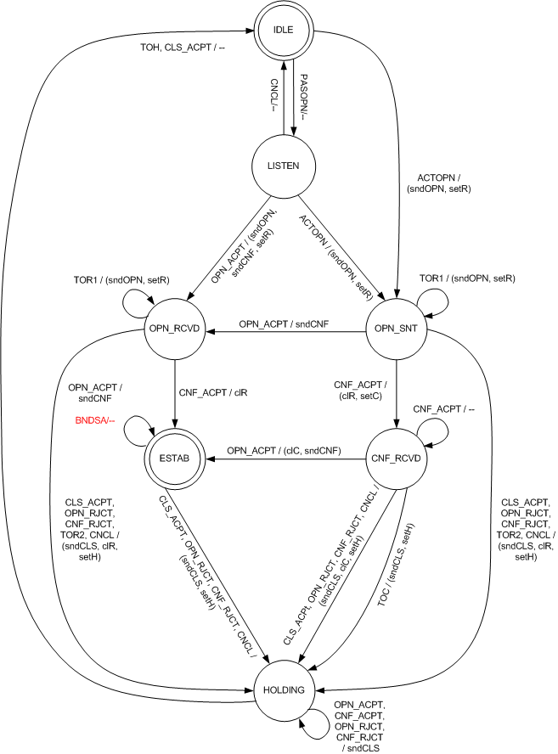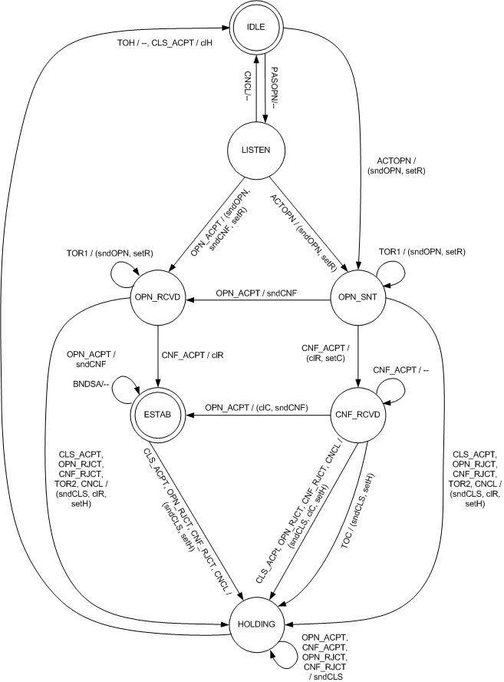
- Finite State Machine of Peer Link Management Protocol
The event/action representation is defined as the following. “E/A” string represents that the action A is taken given that the event E occurs. “E1, E2/A” string represents that the action A is taken given that the event E1 or event E2 occurs. “E/(A1, A2)” string represents that the action A1 and A2 are taken at a time when event E occurs.
Note that Peer Link Management Finite State Machine and Finite State Machine of Peer Link Management Protocol are used for illustration purpose. The protocol behavior is in the following subclauses.
- IDLE state
In the IDLE state the state machine shall not respond to incoming frames from a candidate peer MP.
When PASOPN event occurs, the link instance shall record information in Configuration, generate a new link identifier localLinkID, initiate the retryCounter to zero, and begin listening for a Link Open frame. The link instance shall issue MLME-PassivePeerLinkOpen.confirm(localLinkID) to return the result to IEEE 802.11 SME. The finite state machine transitions to LISTEN state.
When ACTOPN event occurs, The link instance shall encode the link information in the Mesh Configuration element, generate a new link identifier localLinkID, initiate the retryCounter to zero, and send a Peer Link Open frame to the candidate peer MP whose address is peerMAC. The retryTimer is set according to retryTimeout. The MP uses MLME-ActivePeerLinkOpen.confirm(peerMAC, localLinkID) to return the result to IEEE 802.11 SME. The finite state machine transitions to OPEN_SENT state.
All other events shall be ignored in this state.
- LISTEN state
In the LISTEN state, the link instance waits for unsolicited Link Open frames.
When a CNCL event occurs, the state machine transitions to IDLE state. The link instance shall use the MLME-SignalPeerLinkStatus.indication(localLinkID, PEER-LINK-CLOSED) primitive to report the result to the IEEE 802.11 SME.
When an ACTOPN event occurs, the link instance shall send a Peer Link Open frame to the candidate peer MP identified by peerMAC. The Peer Link Open frame shall contain the localLinkID and Mesh Configuration information. The retryTimer is set according to dot11MeshRetryTimeout. The finite state machine transitions to OPEN_SENT state.
When a CLS_ACPT event occurs, the finite state machine transitions to IDLE state. The link instance shall use the MLME-SignalPeerLinkStatus.indication(localLinkID, PEER-LINK-CLOSED) primitive to report the result to the IEEE 802.11 SME.
When an OPN_ACPT event occurs, the link instance shall send the corresponding Peer Link Confirm frame to respond to the Peer Link Open frame. And it shall send a Peer Link Open frame to request a Peer Link Confirm frame from the candidate peer MP. The retryTimer is set according to dot11MeshRetryTimeout value. The finite state machine transitions to OPEN_RCVD state.
All other events shall be ignored in this state.
- OPEN_SENT state
In the OPEN_SENT state, the link instance waits for a Peer Link Confirm frame. In this state, the retryTimer is set.
When a CNCL event occurs, the MP shall clear the retryTimer, send a Peer Link Close frame with reason code PEER-LINK-CANCELLED, and set the holdingTimer according to the value of dot11MeshHoldingTimeout. The finite state machine transitions to HOLDING state.
When a CLS_ACPT event occurs, the MP shall clear the retryTimer, send a Peer Link Close frame with reason code MESH-CLOSE-RCVD, and set the holdingTimer according to the value of dot11MeshHoldingTimeout. The finite state machine transitions to HOLDING state.
When an OPN_ACPT event occurs, the MP shall send the corresponding Peer Link Confirm frame to respond to the incoming Peer Link Open frame. The finite state machine transitions to OPN_RCVD state. Note that the retryTimer is still in effect after the state transition.
When an OPN_RJCT event occurs, the MP shall clear the retryTimer, send a Peer Link Close frame with reason code specified by the OPN_RJCT event, and set the holdingTimer according to the value of dot11MeshHoldingTimeout. The finite state machine transitions to HOLDING state.
When a CNF_ACPT event occurs, the MP shall clear the retryTimer and shall set the confirmTimer according to the value of dot11MeshConfirmTimeout and the finite state machine transitions to CNF_RCVD state.
When a CNF_RJCT event occurs, the MP shall clear the retryTimer, send a Peer Link Close frame with reason code specified by the CNF_RJCT event, and set the holdingTimer according to the value of dot11MeshHoldingTimeout. The finite state machine transitions to HOLDING state.
When a TOR1 event occurs, the Peer Link Open frame shall be resent and the retryCounter shall be incremented. The retryTimer shall be set according to the updated retryTimeout computed by the backoff algorithm. No state transition occurs.
When a TOR2 event occurs, the MP shall send a Peer Link Close frame with reason code MESH-MAX-RETRIES. The holdingTimer shall be set according to the value of dot11MeshHoldingTimeout, and the finite state machine transitions to HOLDING state.
All other events shall be ignored in this state.
- CNF_RCVD state
In the CNF_RCVD state, the link instance has received a Peer Link Confirm frame and is waiting for a Peer Link Open frame.
When a CNCL event occurs, the MP shall clear the confirmTimer, send a Peer Link Close frame with the reason code PEER-LINK-CANCELLED, and set the holdingTimer according to the value of dot11MeshHoldingTimeout. The finite state machine transitions to HOLDING state.
When a CLS_ACPT event occurs, the MP shall clear the confirmTimer, send a Peer Link Close frame with reason code MESH-CLOSE-RCVD, and set the holdingTimer according to the value of dot11MeshHoldingTimeout. The finite state machine transitions to HOLDING state.
When an OPN_ACPT event occurs, the MP shall clear the confirmTimer and shall send the corresponding Peer Link Confirm frame to respond to the incoming Peer Link Open frame. The finite state machine transitions to ESTAB state. The link instance shall use the MLME-SignalPeerLinkStatus.indication(localLinkID, PEER-LINK-ESTABLISHED) primitive to report the result to the IEEE 802.11 SME.
When an OPN_RJCT event occurs, the MP shall clear the confirmTimer, send a Peer Link Close frame with reason code as specified by the OPN_RJCT event, and set the holdingTimer according to the value of dot11MeshHoldingTimeout. The finite state machine transitions to HOLDING state.
When a CNF_RJCT event occurs, the MP shall clear the confirmTimer, send a Peer Link Close frame with reason code as specified by the CNF_RJCT event, and set the holdingTimer according to the value of dot11MeshHoldingTimeout. The finite state machine transitions to HOLDING state.
When TOC event occurs, the MP shall send a Peer Link Close frame with reason code MESH-CONFIRM-TIMEOUT and set the holdingTimer according to the value of dot11MeshHoldingTimeout. The finite state machine transitions to HOLDING state.
All other events shall be ignored in this state.
- OPEN_RCVD state
In the OPEN_RCVD state, the link instance has received a Peer Link Open frame and sent a Peer Link Open frame and the corresponding Peer Link Confirm frame. An incoming Peer Link Confirm is expected.
When a CNCL event occurs, the MP shall clear the retryTimer, send a Peer Link Close frame with reason code PEER-LINK-CANCELLED, and set the holdingTimer according to the value of dot11MeshHoldingTimeout. The finite state machine transitions to HOLDING state.
When a CLS_ACPT event occurs, the MP shall clear the retryTimer, send a Peer Link Close frame, and set the holdingTimer according to the value of dot11MeshHoldingTimeout. The finite state machine transitions to HOLDING state.
When an OPN_ACPT event occurs, the MP shall resend the corresponding Peer Link Confirm frame. No state transition occurs.
When an OPN_RJCT event occurs, the MP shall clear the retryTimer, send a Peer Link Close frame with reason code as specified by the OPN_RJCT event, and set the holdingTimer according to the value of dot11MeshHoldingTimeout. The finite state machine transitions to HOLDING state.
When a CNF_ACPT event occurs, the retryTimer shall be cleared. The finite state machine transitions to ESTAB state. The MP invokes the MLME-SignalPeerLinkStatus.indication(localLinkID, PEER-LINK-ESTABLISHED) to report the result to the IEEE 802.11 SME.
When a CNF_RJCT event occurs, the MP shall clear the retryTimer, send a Peer Link Close frame with reason code as specified by the CNF_RJCT event, and set the holdingTimer according to the value of dot11MeshHoldingTimeout. The finite state machine transitions to HOLDING state.
When a TOR1 event occurs, the Peer Link Open frame shall be resent and the retryCounter shall be incremented. The retryTimer shall be set according to the updated retryTimeout computed by the backoff algorithm. No state transition occurs.
When a TOR2 event occurs, the MP shall send a Peer Link Close frame with reason code MESH-MAX-RETRIES. The holdingTimer shall be set according to the value of dot11MeshHoldingTimeout, and the finite state machine transitions to HOLDING state.
All other events shall be ignored in this state.
- ESTAB state
In the ESTAB state, the link instance has been successfully established with the peer MP.
When a CNCL event occurs, the MP shall send a Peer Link Close frame with reason code PEER-LINK-CANCELLED, and set the holdingTimer according to the value of dot11MeshHoldingTimeout. The finite state machine transitions to HOLDING state.
When a CLS_ACPT event occurs, the MP shall send a Peer Link Close frame with reason code MESH-CLOSE-RCVD, and set the holdingTimer according to the value of dot11MeshHoldingTimeout. The finite state machine transitions to HOLDING state.
When an OPN_ACPT event occurs, the MP shall respond again by resending the corresponding Peer Link Confirm frame. No state transition occurs.
When a BNDSA event occurs, the MP shall bind security association identified by MPTKANonce and MPTKSNonce with the link instance (see 11A.2.3.2). Corresponding localNonce and peerNonce are recorded in the current link instance FSM. The MP shall invoke the MLME-SignalPeerLinkStatus.indication(localLinkID, PEER-LINK-SA-ESTABLISHED) to report the result to the IEEE 802.11 SME. No state transition occurs.
All other events shall be ignored in this state.
- HOLDING state
In HOLDING state, the MP is closing the link. The holdingTimer is in effect.
When a CLS_ACPT event occurs, the holdingTimer shall be cleared.
Any security association bound with the link instance (if any) shall be destroyed. And the primitive MLME-SignalPeerLinkStatus.indication(localLinkID, PEER-LINK-CLOSED) shall be used to report the result to the IEEE 802.11 SME. The finite state machine transitions to IDLE state.
When any of the following four events occurs, the MP shall respond by sending the corresponding Peer Link Close frame. No state transition occurs: OPN_ACPT, CNF_ACPT, OPN_RJCT, CNF_RJCT.
When a TOH event occurs, The security association bound with the link instance (if any) shall be destroyed. The primitive MLME-SignalPeerLinkStatus.indication(localLinkID, PEER-LINK-CLOSED) shall be used to report the result to the IEEE 802.11 SME. The finite state machine transitions to IDLE state.
All other events are ignored in this state.
Modify Clause 11A.4.3.4 as shown below:

11A.4.3.6 Keys and Key Derivation Algorithm
To execute the Abbreviated Handshake, the MP shall derive the keys, including a key encryption key (AKEK), a key confirmation key (AKCK), and a temporal key (TK) using the chosen PMK-MA.
The AKEK and AKCK are derived statically from the chosen PMK-MA. The TK is derived based on dynamic information provided by localNonce and peerNonce. Figure s75 illustrates the key derivation algorithm for Abbreviated Handshake protocol.
PMK-MA
AKCK || AKEK ← KDF-256(PMK-MA, “AKCK AKEK Derivation”,

Selected AKM Suite,
min(localMAC, peerMAC), max(localMAC, peerMAC))

localLinkID, peerLinkID
AKCK and AKEK
Temporal key (TK)
localNonce, peerNonce
TK ← KDF-X(PMK-MA,
“Temporal Key Derivation”,
min(localNonce, peerNonce), max(localNonce, peerNonce),
min(localLinkID, peerLinkID),
max(localLinkID, peerLinkID),
Selected AKM Suite,
min(localMAC, peerMAC), max(localMAC, peerMAC))
Figure s75 Key Derivation for Abbreviated MSA Authentication

AKCK and AKEK are mutually derived by the local MP and the peer MP once a new PMK-MA has been selected. The AKCK is used to provide data origin authenticity in the Abbreviated Handshake and the Group Key Handshake messages. The AKEK is used to provide data confidentiality in the Abbreviated Handshake and the Group Key Handshake messages.
The AKEK and AKCK shall be derived from the PMK-MA by
AKEK || AKCK ← KDF-256(PMK-MA, “AKCK AKEK Derivation”, Selected AKM Suite, min(localMAC, peerMAC), max(localMAC, peerMAC))
The min and max operations for IEEE 802 addresses are with the address converted to a positive integer, treating the first transmitted octet as the most significant octet of the integer as specified in 8.5.1.2.
The AKCK shall be computes as the first 128 bits (bits 0—127) of the resulting string:
AKCK ← L(AKEK||AKCK, 0, 128)
The AKEK shall be computed as the second 128 bits (bits 128-255) of the resulting string:
AKEK ← L(AKEK||AKCK, 128, 128)
The termporal key (TK) shall be derived from the PMK-MA by
TK ← KDF-X(PMK-MA, “Temporal Key Derivation”, min(localNonce, peerNonce), max(localNonce, peerNonce), min(localLinkID, peerLinkID), max(localLinkID, peerLinkID, Selected AKM Suite, min(localMAC, peerMAC), max(localMAC, peeerMAC))

CCMP uses X = 128. The Min and Max operations for IEEE 802 addresses are with the address converted to a positive integer treating the first transmitted octet as the most significant octet of the integer as specified in 8.5.1.2. The Min and Max operations for nonces are with the nonces treated as positive integers converted as specified in 7.1.1.
The TK is used to protect commnications between two peer MPs. The local MP and peer MP normally derive a TK only once per link instance. The local MP or peer MP may use the Abbreviated MSA Handshake to derive a new TK.
The TK is referenced and named as follows:
TKName = NDF(PMK-MAName || “TK Name” || min(localNonce, peerNonce) || max(localNonce, peerNonce) || min(localLinkID, peerLinkID) || max(localLinkID, peerLinkID) || Selected AKM Suite || min(localMAC, peerMAC) || max(localMAC, peerMAC)
PMK-MAName is the identifier of the chosen PMK-MA.

Modify Clause 11A.4.3.10 as shown below:

11A.4.3.10 Finite State Machine

11A.4.3.10.1 Overview
The finite state machine for Abbreviated Handshake supports all the states, events, and actions defined for the finite state machine for the Peer Link Management protocol. New events, actions, and state transitions are added to specify the security functions for Abbreviated Handshake.
When a finite state machine is generated and actived for an Abbreviated Handshake instance, the localNonce shall be generated and used together with a new localLinkID to identify the instance.

11A.4.3.10.2 New Events and Actions
All events for rejecting or ignoring received action frames shall report the corresponding reason code related to Abbreviated Handshake functions as described in clause 11A4.3.6.
In addition, there are four new events.
NOKEY_RJCT – This event refers to the failure of PMK selection. The trigger of this event is accompanied with a status code. Either the two MPs do not share a valid PMK-MA for Abbreviated Handshake (“PEER-LINK-NO-KEY”), or the chosen PMK-MA by the MP is not a shared PMK-MA by the two MPs. The received Peer Link Management frame shall be discarded. Thus the link instance shall be closed. However, the MP shall not send a Peer Link Close frame as the result of this event.
NOAKM_RJCT—This event refers to the failure of AKM Suite Selection. The trigger of this event is accompanied with a status code. Either the two MPs do not share a valid AKM suite for Abbreviated Handshake (“PEER-LINK-NO-AKM”), or the chosen AKM suite by the MP is not a shared AKM by the two MPs (“PEER-LINK-ALT-AKM”). The received Peer Link Management frame shall be discarded. Thus the link instance shall be closed. However, the MP shall not send a Peer Link Close frame as the result of this event.
NOKDF_RJCT—This event refers to the failure of supporting the KDF that the candidate peer MP supports. The trigger of this event is accompanied with a status code, “PEER-LINK-NO-KDF”. The received Peer Link Management frame shall be discarded. Thus the link instance shall be closed. However, the MP shall not send a Peer Link Close frame as the result of this event.
TOR3 – This event refers to Timeout(localLinkID, retryTimer), the dot11MESHMAXRetries has been reached, with the Abbreviated Handshake enabled. The link instance shall be closed when TOR3 occurs. Since the PMK selection never occurs, the MP shall not send Peer Link Close frame.
The actions of sending peer link management frames are updated as the following.
sndOPN – Generate a Peer Link Open frame for the current Abbreviated Handshake protocol instance (as specified in 11A.4.3.9.4) and send it to the candidate peer MP.
sndCNF – Generate a Peer Link Confirm frame for the current Abbreviated Handshake protocol instance (as specified in 11A.4.3.9.6) and send it to the candidate peer MP.
sndClose – Generate a Peer Link Close frame for the current Abbreviated Handshake protocol instance (as specified in 11A.4.3.9.2) and send it to the candidate peer MP.

11A.4.3.10.3 State transitions
All state transitions specified in Peer Link Management finite state machine shall be used for Abbreviated Handshake finite state machine.
In LISTEN state, the following are the additional state transitions and performed actions
The NOKEY_RJCT event shall be ignored
When NOAKM_RJCT event occurs, the finite state machine transitions to IDLE state
When OPN_IGNR event occurs with the status code PEER-LINK-ALT-PMK, the status code and the candidate peer MP’s choice of the PMK-MA for the instance shall be reported to IEEE 802 SME via MLME-SignalLinkStatus.indication primitive.
When NOKDF_RJCT event occurs, the status code PEER-LINK-NO-KDF and candidate peer MP’s announcement of the KDF for the link instance shall be reported to IEEE 802 SME via MLME-SignalLinkStatus.indication primitive.
In OPN_SNT state, the following are additional state transitions and actions
When NOKEY_RJCT event occurs, the MLME-SignalLinkStatus.indication primitive shall be used to inform the IEEE 802 SME the failure of establishing the authenticated peer link with the status code PEER-LINK-NO-PMK. The received Peer Link Open frame shall be discarded. The retryTimer is cleared and the finite state machine transitions to IDLE state.
When NOAKM_RJCT event occurs, the MLME-SignalLinkStatus.indication primitive shall be used to inform to IEEE 802 SME the failure of establishing the authenticated peer lin with the status code PEER-LINK-NO-PMK. The received Peer Link Open frame shall be discarded. The retryTimer is cleared and the finiate state machine transitions to HOLDING state.
When OPN_IGNR event occurs with the status code PEER-LINK-ALT-PMK, the status code and the candidate peer MP’s choice of the PMK-MA for the instance shall be reported to IEEE 802 SME via MLME-SignalLinkStatus.indication primitive.
When NOKDF_RJCT event occurs, the MLME-SignalLinkStatus.indication primitive shall be used to inform the IEEE 802 SME the failure of establishing the authenticated peer link with the status code PEER-LINK-NO-KDF. The received Peer Link Open frame shall be discarded. The retryTimer is cleared and the finite state machine transitions to HOLDING state.
When TOR3 event occurs, the MLME-SignalLinkStatus.indication primitive shall be used to inform the IEEE 802 SME the failure of establishing the peer link with the status code “PEER-LINK-MAX-RETIES”. The finite state machine transitions to HOLDING state.
In OPN_RCVD state, the following are the additional actions
When CNF_ACPT event occurs, in addition to the actions for Peer Link Management protocol, the MLME-installKey.request primitive shall be called to install the established temporal key and received GTK from the peer MP. The MP shall invoke the MLME-SignalPeerLinkStatus.indication with status code “PEER-LINK-SA-ESTABLISHED” to report successful establishment of peer link and its security association to the IEEE 802.11 SME.
In CNF_RCVD state, the following are the additional actions
When CNF_ACPT event occurs, in addition to the actions for Peer Link Management protocol, the MLME-installKey.request primitive shall be called to install the established temporal key and received GTK from the peer MP. The MP shall invoke the MLME-SignalPeerLinkStatus.indication with status code “PEER-LINK-SA-ESTABLISHED” to report successful establishment of peer link and its security association to the IEEE 802.11 SME.
In ESTAB state, when BNDSA event occurs, the MP shall ignore it, since the established peer link and its security association are already bound to each other.
Table s43 and Figure s75 specify the state transitions of the finite state machine for Abbreviated Handshake. The text in red highlights the additional new state transitions for Abbreviated Handshake, compared with Peer Link Mangaement finite state machine for basic peer links.

- Abbreviated Handshake Finite State Machine
 |  | To State
 |  | IDLE | LISTEN | OPN_SNT | CNF_RCVD | OPN_RCVD | ESTAB | HOLDING
From State | IDLE |  | PASOPN/ -- | ACTOPN/ (sndOPN, setR)
From State | LISTEN | CNCL, NOKEY_RJCT,  NOAKM_RJCT, NOKDF_RJCT / -- |  | ACTOPN/ (sndOPN, setR) |  | OPN_ACPT/ (sndOPN, sndCNF, setR)
From State | OPN_SNT |  |  | TOR1/ (sndOPN, setR) | CNF_ACPT/ (clR, setC) | OPN_ACPT/ (sndCNF) |  | CLS_ACPT, OPN_RJCT, CNF_RJCT, TOR2, CNCL/ (sndCLS, clR, setH)  TOR3, NOKEY_RJCT, NOAKM_RJCT, NOKDF_RJCT / (clR, setH)
From State | CNF_RCVD |  |  |  | CNF_ACPT / -- |  | OPN_ACPT / (clC, sndCNF) | CLS_ACPT, OPN_RJCT, CNF_RJCT, CNCL/ (sndCLS, clC, setH)  TOC / (sndCLS, setH)
From State | OPN_RCVD |  |  |  |  | TOR1 / (sndOPN, setR) | CNF_ACPT / clR | CLS_ACPT, OPN_RJCT, CNF_RJCT,TOR2, CNCL/ (sndCLS, clR, setH)
From State | ESTAB |  |  |  |  |  | OPN_ACPT / sndCNF | CLS_ACPT, OPN_RJCT, CNF_RJCT,CNCL/ (sndCLS, setH)
From State | HOLDING | TOH / --, CLS_ACPT / clH |  |  |  |  |  | OPN_ACPT, CNF_ACPT, OPN_RJCT, CNF_RJCT / sndCLS

- 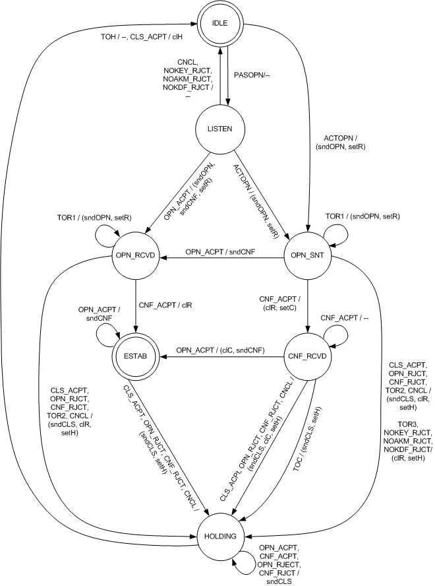
- Figure s76 Finite State Machine of Abbreviated Handshake Protocol

