IEEE P802.11
Wireless LANs
TGp LB 110 Comment Resolution for Provider/User distinction
Date: 2007-01-03
Author(s):
Name | Affiliation | Address | Phone | email
Francois Simon | US DOT | ARINC, Inc.  2551 Riva Road  Annapolis, MD 21401 | 410-266-4531 | fsimon@arinc.com

Abstract
This paper addresses the comments addressing “Provider/user Distinction” classification. It includes responses to CR#: 7, 52, 53, 55, 56, and 58
(See also doc # 2835 for related comment resolutions.)

LB110 Comment Resolution

- COMMENT: [From Spreadsheet] INSERT Original Comment Here:

ID | Commenter | Clause | Pg | Ln | Type | Comment | Suggested Remedy | Recommended Resolution
7 | Fischer, Matthew | General | 1 | 1 | TR | It is not clear to me how a STA is determined to be either a WAVE provider or a WAVE user. There should be something somewhere in the document that formalizes these terms, linking them to MIB values and subsequently, to behaviors. | Clairfy which STA become WAVE providers and which become WAVE users versus neither of these and what causes these distinctions. | Accepted – (accepted in principal). Refer to Clause 2 – CID# 7 of this document for clarification.
52 | Chaplin, Clint | 3.168a | 2 | 20 | TR | "consisting of a single WAVE service provider and none or more WAVE service users." None or more? | "consisting of a single WAVE service provider and one or more WAVE service users." or "consisting of a single WAVE service provider and optionally one or more WAVE service users." | Accepted – (accepted in principal). A new definition of WAVE basic service set is proposed. See Clause 2 – CID# 52 of this document.
53 | Cypher, David | 3.168a | 2 | 20 | T | "A set may consist of … none or more WAVE service users." If there are no users, is this a WBSS? That is there is a provider but no one is there to communicate with it. (Similar to "If a tree falls in the woods and no one is there it hear it, does it make a sound?"). Draft 2.0 contained "1 or more" | Change 1) none to zero to remove the ambiguity that a typo exists (i.e., and extra n in front of one.) OR 2) none to one, if it was a typo. | Accepted – (accepted in principal). A new definition of WAVE basic service set is proposed. See Clause 2 – CID# 52 of this document.
55 | Noens, Richard | 3.168a | 2 | 20 | TR | "A set of cooperation stations operating in WAVE mode consisting of a single WAVE service provider and none or more WAVE service users." If it is none then then there is not a set and there is no cooperation. Perhaps none was ment to be one. | Change none to one if that was what was intended. If not please explain how there can be cooperation between a WAVE service provider and no other entity. | Accepted – (accepted in principal). Refer to Clause 2 – CID# 55 of this document for clarification.
56 | Buttar, Alistair | 3.168a | 2 | 20 | TR | "A set of cooperation stations operating in WAVE mode consisting of a single WAVE service provider and none or more WAVE service users." The word 'none' doesn't make sense. | Either change 'none' to 'one' if this is appropriate, or explain how there can be cooperation between a WAVE service provider and no other entity. | Accepted – (accepted in principal). Refer to Clause 2 – CID# 55 of this document for clarification.
58 | Jiang, Daniel | 3 | 2 | 20 | TR | Why does a WBSS have one and only one provider? It seems to be a case of mixing up the need to define one and only one initiator in a WBSS with the number of STAs allowed to advitise for it. The current definition might be sufficient for a roadside infrastruture oriented service provision point of view but will restrict the uses for peer to peer vehicular groups in terms of group forming, maintenance and split operations. For example, if the STA that starts such a WBSS decides to leave (e.g. to join another WBSS for some more important services), should the current WBSS simply close? | Remove the phrase "a single WAVE service provider" from the sentence and reconsider the definition. | Accepted – (accepted in principal). A new definition of WAVE basic service set is proposed. See Clause 2 – CID# 52 of this document.

- Background, Explanation, Discussion, etc.:

These Comments are associated with comments related to “Provider/user Distinction” classification

Relating to CID # 7

It is proposed to remove entirely the notion of “user” and “provider”from the amendment. For the 802.11p amendement is concerned, a STA in WAVE mode can be a WAVE BSS initiator (e.g. sending the WAVE beacon announcing a WAVE BSS) or a STA joining the WAVE BSS, if desired; meaning that the service(s) announced by the WAVE BSS initiator is compatible with the WAVE mode STA receiving the WAVE announcement. It is best expressed in the proposed updated Figure 11.19, subclause 11.14.2 (see clause 4 of this document)

Relating to CID # 52

A new definition of WAVE basic service set (WAVE BSS) is proposed and reads as follow “A set of cooperating stations operating in WAVE mode consisting of a single WAVE STA that transmits a WAVE beacon and zero or more WAVE STAs that have join this BSS.”

Relating to CID # 55

There are several possibilities that when a WAVE mode STA initiates a WAVE BSS: a) There is no WAVE STA in radio range of the WAVE BSS initiator. The WBSS initiator may keep sending WAVE beacons as required; b) While not likely in the immediate future (frequency spectrum incompatability), there may be non-WAVE STA(s) within radio range. Such STAs may use some information (e.g.; timing) from the WAVE beacon without having the capability to join the WAVE BSS; c) There is/are WAVE STAs in radio range but they are not ‘interested’ to join this WAVE BSS (e.g.; lack of application compatability); d) There is/are WAVE STAs with the “desire’ to join this WAVE BSS and proceed with the joining procedure (see subclause 11.14.2 of the amendment). A new definition of “WAVE basic service set” is proposed; see CID# 52 above.

- Recommended Resolution of the Comments:

See the right column above for the resolutions of the individual comments.

- Recommended Changes to P802.11p D3.0:

3. Definitions

3.168a WAVE basic service set: A set of cooperating stations operating in WAVE mode consisting of a single WAVE STA that transmits a WAVE beacon and zero or more WAVE STAs that have join this BSS.

    - Joining a WAVE BSS

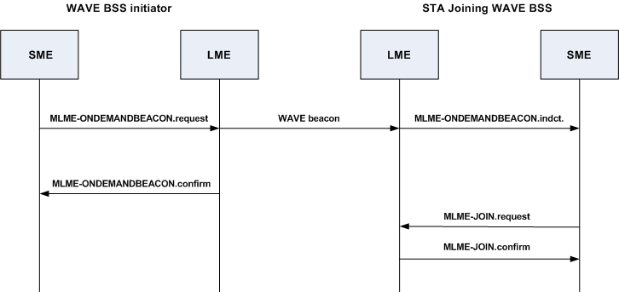

Figure 11-19 – WAVE announcement process

- Motion (if technical and/or significant):

Move to accept the Recommended Resolutions to these comments and the Recommended changes to P802.11p D3.0 noted above and instruct the editor to make these changes to P802.11p D3.0.

Motion by: ___Francois Simon________________Date:
Second: ______________________

Approve: | Disapprove: | Abstain:

References:

IEEE P802.11p/D3.0

