IEEE P802.11
Wireless LANs
Compromise OTA Draft Text
Date: 2007-11-15
Author(s):
Name | Affiliation | Address | Phone | email
Dalton Victor | Broadcom Corporation | 190 Mathilda Place  Sunnyvale, CA 94086 | 408-922-5824 | dvictor@broadcom.com
Mark Kobayashi | Broadcom Corporation | 190 Mathilda Place  Sunnyvale, CA 94086 | 408-543-3318 | mmk@broadcom.com
Abstract
- This draft text is to replace sections 5.5, 5.6 and 5.7 for resolving several CIDS in the Over The Air environment and metrics in the 1.0 TGT Draft text.
- The number of CIDs resolved by this methodology is >> 40
- The CIDs addressed are:
  - 773,774,775,782,783,784,785,786,789,790,793,794,795,796,797,798,799,800,801,803,804,805,806,807,808,809,810,812,813,814,815,816,817,820,819,821,822,824,825,826, …

5.5 Over-the-air environment

5.5.1 External Antenna Model

5.5.1.1 Introduction and purpose

The over-the-air outdoor LOS test environment may be used, where applicable to devices with external antennas, for measurements of metrics and sub-metrics that are described in this recommended practice It provides a test environment using complete systems.
The general setup for tests using this methodology comprises a DUT or SUT and a WLCP. The following subclauses describe the typical test setup and major building blocks for tests carried out using this environment.

5.5.1.2 Configuration and setup

5.5.1.2.1 Resource requirements
The following equipment is necessary to carry out tests using this environment:
a) A WLCP, which may be a reference AP or reference endstation, depending on the test objectives.
b) A test stand.
c) A test station cart
d) A wired test controller / traffic generator.
e) A spectrum analyzer.
f) Interconnecting cables for the WLCP and the test controller / traffic generator.
The DUT may be any wireless 802.11 device (AP or endstation) that includes the relevant SW running on the specific platform.
The test area should meet the following requirements:
a) No extraneous signal in the test environment. A spectrum analyzer may be used to ensure that no active interference is present.
e) The DUT or WLCP should not have any receptivity-enhancing material surrounding them.

5.5.1.2.2 Test setup
The general setup comprises the DUT and the WLCP. Figure 11 setup. In the case where either the WLCP or the DUT is an AP, the AP is placed on a test stand (fixed) and the DUT
on a turntable on top of a test station cart. In the case where both the WLCP and the
DUT are endstations, the DUT is placed on the turntable. A traffic generator is used to generate data traffic from the WLCP to the DUT above the Layer 2 (MAC) protocol layer.
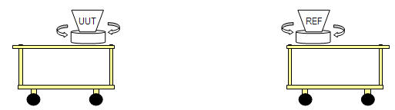
Figure 11 - Typical OTA Setup

5.5.1.3 Procedure

5.5.1.3.1 Preparation of the test setup
The test setup should be configured as shown in Figure 11. Orientation of the SUT and WLCP should be at 0 degrees at beginning of test.

5.5.1.3.2 Running Tests
a) Make sure that SUT and WLCP are associated and able to ping consistantly
b) Run throughput test for 20 seconds.
c) Note max throughput achieved during 20 second run.
d) Re-orient SUT and/or WLCP
e) Run test for each of 16 orientation pairs as shown in Figure 12.
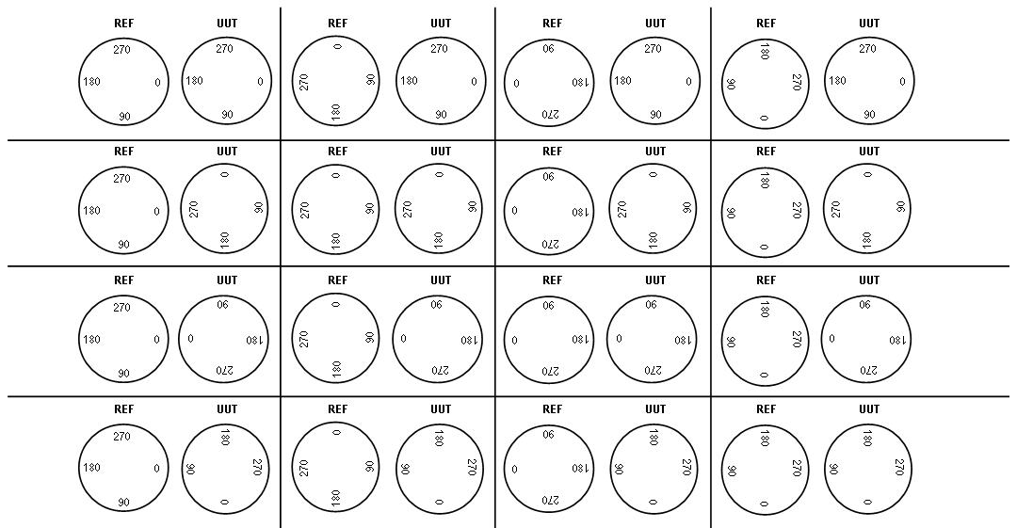
Figure 12 - Orientation modes for SUT and WLCP

5.5.1.4 Modifiers and variations
Any modifiers used should be reported with the test results.

5.5.1.5 Special reporting requirements
Max throughput at each position and orientation of SUT and WLCP should be noted. Position of carts relative to walls and other reflector/absorbers should be shown in a building or area layout diagram (blueprint).

