IEEE P802.11
Wireless LANs
Key Usage Update on Peer Link Management
Date: 2007-11-14
Author(s):
Name | Affiliation | Address | Phone | Email
Meiyuan Zhao | Intel Corporation | RNB-6-61 2200 Mission College Blvd, Santa Clara, CA 95052 USA | +1-408-653-5517 | meiyuan.zhao@intel.com
Jesse Walker | Intel Corporation | JF3-206, 2111 NE 25th Ave, Hillsboro, OR 97124 USA | +1-503-712-1849 | jesse.walker@intel.com
Abstract
This document proposes changes to bind security association with the link instance and update the key usage for PLM protocol.

Baseline: D1.07

Add the following text after clause 10.3.45
    - BindSecurityAssociation
This mechanism supports the process of binding the established security associations with the link instance.
10.3.46.1 MLME-BindSecurityAssociation.request
        - Function
This primitive requests the binding of established security associations with the link instance.
        - Semantics of the service primitive
The primitive parameters are as follows:

MLME-BindSecurityAssociation.request(
local Link ID,
MPTKANonce,
MPTKSNonce
)
Name | Type | Valid range | Description
local Link ID | Integer | 1—2¹⁶-1 | Specifies the integer generated by the local mesh entity to identify the link instance
MPTKANonce | Integer | 1—2²⁵⁶-1 | Nonce generated by the authenticator during MSA 4-Way Handshake.
peer Nonce | Integer | 1—2²⁵⁶-1 | Nonce generated by the supplicant during MSA 4-Way Handshake.

10.3.46.1.3 When generated
This primitive is generated by the SME to bind the established security associations with the link instance.
10.3.46.1.4 Effect of receipt
This primitive sets the mesh entity to set all security parameters relevant to the security associations to the link instance as the result of completing MSA 4-Way Handshake successfully. If the MP was the Authenticator during the MSA 4-Way Handshake, the MPTKANonce value is used to set as localNonce and the MPTKSNonce value is used to set as peerNonce, perspectively, to identify the security association. Otherwise, the localNonce is set as MPTKSNonce value and the peerNonce is set as MPTKANonce value.
      - MLME-BindSecurityAssociation.confirm
        - Function
This primitive reports the result of bind security association request.
10.3.46.2.2 Semantics of the service primitive
The primitive parameters are as follows:

MLME-BindSecurityAssociation.confirm(
local Link ID,
ResultCode
)
Name | Type | Valid range | Description
local Link ID | Integer | 1—2¹⁶-1 | Specifies the integer generated by the local mesh entity to identify the link instance
ResultCode | Enumeration | SUCCESS  ,  FAILURE-NOT-FOUND | Indicates the result of the bind security association request. The result is either success or failure when the link instance is not found.

10.3.46.2.3 When generated
This primitive is generated by the MLME as the result of an MLME-BindSecurityAssociation.request.
        - Effect of receipt
The SME is notified of the results of the bind security association procedure.

Modify clause 11A.2.2.2 as indicated below
- Process Peer Link Close frames
If the MP has security association binding with the link instance, the MP shall check that MSAIE and MIC field present in the received Peer Link Close frame. If not, the received frame shall be silently discarded. Otherwise, the MP shall follow the procedure specified in 11A.3.9.3 to process MSAIE and MIC field, and return corresponding status code. If this procedure succeeds, the MP shall proceed with the following basic Peer Link Close frame processing procedure.
The CLS_IGNR event shall be triggered if the Peer Link Close frame contains a mismatched instance identifier or an incomplete instance identifier.
A received instance identifier is a mismatch if:
- the locally recorded peerLinkID exists and it does not match the value in the Local Link ID field in the frame, or
- the frame carries a non-zero value in the Peer Link ID field of the frame, but the value does not match the local record of localLinkID.
The received instance identifier is incomplete if the value of the Peer Link ID field is zero.
In other cases, the CLS_ACPT event shall be triggered.
Modify clause 11A.2.3.2 as indicated below:
- Events and Actions
The finite state machine uses three types of events: events created by IEEE 802.11 SME, external events generated by frame processing, and events associated internal timers.
IEEE 802.11 SME uses the following primitives to pass events to the finite state machine.
- CNCL -- MLME-CancelPeerLink.request(localLinkID, ReasonCode) event is used to instruct the link instance to cancel the link with the peer MP. The link instance uses MLME-CancelPeerLink.confirm(localLinkID, ResultCode) primitive to return the result to IEEE 802.11 SME.
- PASOPN -- MLME-PassivePeerLinkOpen.request event is used to instruct the link instance to passively listen to a peer link establishment frame from a candidate peer MP. The link instance uses MLME-PassivePeerLinkOpen.confirm(localLinkID) to return the result to IEEE 802.11 SME.
- ACTOPN -- MLME-ActivePeerLinkOpen.request(peerMAC) event is used to instruct the link instance to actively initiate the peer link establishment with the candidate peer MP whose MAC address is peerMAC. The link instance uses MLME-ActivePeerLinkOpen.confirm(peerMAC, localLinkID) primitive to return the result to IEEE 802.11 SME.
- BNDSA – MLME-BindSecurityAssociation.request(localLinkID, MPTKANonce, MPTKSNonce) event is used to instruct the link instance to bind the security association established via MSA 4-Way Handshake with the current link instance. The link instance uses MLME-BindSecurityAssociation.request(localLinkID, ResultCode) primitive to return the result to IEEE 802.11 SME.
The events generated by frame processing are
- CLS_ACPT -- PeerLinkClose_Accept(peerMAC, localLinkID, peerLinkID, reasonCode) event indicates that a Peer Link Close frame meeting the correctness criteria of 11A.2.2.2 has been received from peerMAC for the link instance identified by localLinkID and peerLinkID. The reasonCode specifies the reason that causes the generation of the Peer Link Close frame.
- CLS_IGNR -- PeerLinkClose_Ignore(peerMAC, localLinkID, peerLinkID) event indicates that a Peer Link Close frame with mis-matched link identifiers, as specified in 11A.2.2.2, has been received from peerMAC for the link instance identified by localLinkID and peerLinkID.
- OPN_ACPT -- PeerLinkOpen_Accept(peerMAC, peerLinkID, Configuration) event indicates that a Peer Link Open frame meeting the correctness criteria of 11A.2.2.3 has been received from peerMAC for the link instance identified by localLinkID and peerLinkID. The Configuration is the set of information received in the Mesh Configuration information element.
- OPN_IGNR -- PeerLinkOpen_Ignore(peerMAC, peerLinkID) event indicates that a Peer Link Open frame with mismatched link identifiers, as specified in 11A.2.2.3, has been received from peerMAC for the link instance identified by locakLinkID and peerLinkID.
- OPN_RJCT -- PeerLinkOpen_Reject(peerMAC, peerLinkID, Configuration, ReasonCode) event indicates that a Peer Link Open frame with an invalid Configuration field, as specified in 11A.2.2.3, has been received from peerMAC for the link instance identified by localLinkID and peerLinkID. The Configuration is the set of information as received from Mesh Configuration element. The ReasonCode is set to MESH-CONFIGURATION-POLICY-VIOLATION.
- CNF_ACPT -- PeerLinkConfirm_Accept(peerMAC, localLinkID, peerLinkID, Configuration) event indicates that a Peer Link Confirm frame meeting the correctness criteria of 11A.2.2.4 has been received from peerMAC for the link instance identified by localLinkID and peerLinkID. The Configuration is the set of information as received from Mesh Configuration element.
- CNF_IGNR -- PeerLinkConfirm_Ignore(peerMAC, localLinkID, peerLinkID) event indicates that a Peer Link Confirm frame with mis-matched link identifiers, as specified in 11A.2.2.4, has been received from peerMAC for the link instance identified by localLinkID and peerLinkID.
- CNF_RJCT -- PeerLinkConfirm_Reject(peerMAC, localLinkID, peerLinkID, Configuration, ReasonCode) event indicates that a Peer Link Confirm frame with an invalid Configuration fields, as specified in 11A.2.2.4, has been received from peerMAC for the link instance identified by localLinkID and peerLinkID. The Configuration is the set of information as received from Mesh Configuration element. The ReasonCode is set to MESH-CONFIGURATION-POLICY-VIOLATION. This event is denoted as.
The internal events are as follows. The term Timeout(localLinkID, item) represents a timeout identified locally by item, for the link instance identified by localLinkID.
Three types of timers are used by the finite state machine.
The retryTimer triggers a re-send of the Peer Link Open frame when a Peer Link Confirm frame was not received as a response.
- TOR1 – This event refers to Timeout(localLinkID, retryTimer) and the dot11MeshMaxRetries has not been reached. The state machine shall resend the Peer Link Open frame.
- TOR2 – This event refers to Timeout(localLinkID, retryTimer) and the dot11MESHMaxRetries has been reached. The link instance shall be closed when TOR2 occurs.
- TOC – The Timeout(localLinkID, confirmTimer) event. The confirmTimer aborts a link establishment attempt if a Peer Link Open frame never arrives after receiving the Peer Link Confirm frame. TOC event occurs, the link instance shall be closed.
- TOH event – The Timeout(localLinkID, holdingTimer) event. The holdingTimer allows a grace period for closing the link instance; it is necessary to avoid deadlocks and livelocks that arise due to interactions between link establishment and termination. When TOH occurs, the link instance shall be closed completely and the finite state machine shall transition to IDLE state.
The finite state machine may take an action triggered by an event. It uses two types of actions: sending a peer link management frame and handling a timer.
Actions related to sending a peer link management frame:
- sndOPN -- The sendOpen(peerMAC, localLinkID, Configuration) is the action that the link instance takes to send a Peer Link Open frame to the candidate peer MP, whose MAC address is peerMAC. The frame shall carry localLinkID and the supported Mesh Configuration, as specified as Configuration.
- sndCNF -- The sendConfirm(peerMAC, localLinkID, peerLinkID, Configuration) is the action that the link instance takes to send a Peer Link Confirm frame to the candidate peer MP, whose MAC address is peerMAC. The frame shall carry localLinkID, peerLinkID, and the supported Mesh Configuration, as specified as Configuration.
- sndCLS -- The sendClose(peerMAC, localLinkID, peerLinkID, reasonCode) is the action that the link instance takes to send a Peer Link Close frame to the peer MP or candidate peer MP, whose MAC address is peerMAC. The frame shall carry localLinkID and peerLinkID. If the peerLinkID is unknown, it shall be set to zero. The reasonCode shall specify the reason that the Peer Link Close is sent, whose value shall be set to a value between 46 to 51 as specified in Table 7-22. If the link instance is bound with the security association, security parameters shall be sent in MSAIE with the following fields set with corresponding values:
  - Handshake Control field shall be set to 0.
  - Selected AKM Suite field shall be set to the AKM suite selector for the link instance
  - Selected Pairwise Cipher Suite field shall be set to the selected pairwise cipher suite for the link instance
  - Chosen PMK field shall be set to a key identifier that indicates the selected PMK-MA for the link instance
  - Local Nonce field shall be set to the nonce that the MP generated during MSA 4-Wah Handshake. It is equal to MPTKANonce if the MP was determined as Authenticator during MSA 4-Way Handshake. Otherwise the value shall be set to the value of MPTKSNonce.
  - Peer Nonce field shall be set to the nonce that the peer MP generated during MSA 4-Wah Handshake. It is equal to MPTKANonce if the peer MP was determined as Authenticator during MSA 4-Way Handshake. Otherwise the value shall be set to the value of MPTKSNonce.
The MIC field in Peer Link Close shall contain a 16-octet MIC calculated using the KCK portion of the PTK of the session using the AES-128-CMAC algorithm on the concatenation in the following ofer, of:
- The MP MAC address
- The peer MP MAC address
- Contents of the Peer Link Close frame except the MIC field
The actions on handling timers are setTimer(localLinkID, item, value) and clearTimer(localLinkID, item).
- The setTimer(localLinkID, item, timeout) action sets the timeout value specified by timeout to the timer specified by item. This action only sets the timer for one time for the link instance identified by localLinkID. When the timeout time has passed, the timer expires and the event Timeout(localLinkID, item) is triggered, after which the timer is no longer in effect.
The corresponding actions are denoted as setR, setC, setH, for timer retryTimer, confirmTimer, holdingTimer respectively.
Before setting the retryTimer, the finite state machine shall apply the default link open request backoff algorithm to compute the updated timeout value as the following:
timeout = return timeout + (getRandom mod timeout),
where getRandom routine generates a random value. The initial value of timeout shall be set to dot11MeshRetryTimeout. This function statistically increases the length of time for each Peer Link Open retry by 50%. The backoff was inserted into the design to recover from a “gold rush”, which could happen if several already-linked MPs simultaneously detected a new MP trying to enter the mesh network.
- The clearTimer(localLinkID, item) action clears the timer item for the link instance identified by localLinkID. The corresponding actions are denoted as clR, clC, clH, for timer retryTimer, confirmTimer, holdingTimer respectively.
NOTE -- The value of dot11MeshMaxRetries is under study. If zero is the appropriate value, the backoff algorithm is not need and will be removed.

Modify table s45 as shown below:

- Peer Link Management Finite State Machine
 |  | To State
 |  | IDLE | LISTEN | OPN_SNT | CNF_RCVD | OPN_RCVD | ESTAB | HOLDING
From State | IDLE |  | PASOPN/ -- | ACTOPN/ (sndOPN, setR)
From State | LISTEN | CNCL / -- |  | ACTOPN/ (sndOPN, setR) |  | OPN_ACPT/ (sndOPN, sndCNF, setR)
From State | OPN_SNT |  |  | TOR1/ (sndOPN, setR) | CNF_ACPT/ (clR, setC) | OPN_ACPT/ (sndCNF) |  | CLS_ACPT, OPN_RJCT, CNF_RJCT, TOR2, CNCL/ (sndCLS, clR, setH)
From State | CNF_RCVD |  |  |  | CNF_ACPT / -- |  | OPN_ACPT / (clC, sndCNF) | CLS_ACPT, OPN_RJCT, CNF_RJCT, CNCL/ (sndCLS, clC, setH)  TOC / (sndCLS, setH)
From State | OPN_RCVD |  |  |  |  | TOR1 / (sndOPN, setR) | CNF_ACPT / clR | CLS_ACPT, OPN_RJCT, CNF_RJCT,TOR2, CNCL/ (sndCLS, clR, setH)
From State | ESTAB |  |  |  |  |  | OPN_ACPT / sndCNF  BNDSA/-- | CLS_ACPT, OPN_RJCT, CNF_RJCT,CNCL/ (sndCLS, setH)
From State | HOLDING | TOH, CLS_ACPT / -- |  |  |  |  |  | OPN_ACPT, CNF_ACPT, OPN_RJCT, CNF_RJCT/ sndCLS

Modify Figure55 as shown below:

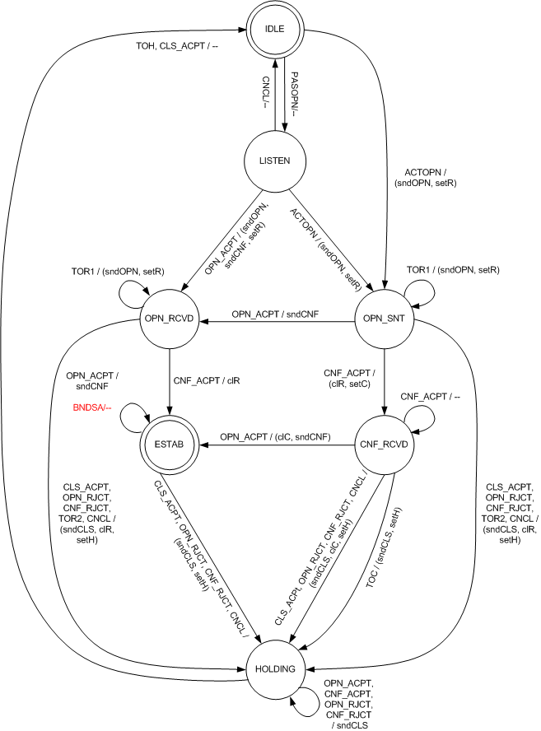

- Finite State Machine of Peer Link Management Protocol
The event/action representation is defined as the following. “E/A” string represents that the action A is taken given that the event E occurs. “E1, E2/A” string represents that the action A is taken given that the event E1 or event E2 occurs. “E/(A1, A2)” string represents that the action A1 and A2 are taken at a time when event E occurs.

- ESTAB state
In the ESTAB state, the link instance has been successfully established with the peer MP.
When a CNCL event occurs, the MP shall send a Peer Link Close frame with reason code MESH-LINK-CANCELLED, and set the holdingTimer according to the value of dot11MeshHoldingTimeout. The finite state machine transitions to HOLDING state.
When a CLS_ACPT event occurs, the MP shall send a Peer Link Close frame with reason code MESH-CLOSE-RCVD, and set the holdingTimer according to the value of dot11MeshHoldingTimeout. The finite state machine transitions to HOLDING state.
When an OPN_ACPT event occurs, the MP shall respond again by resending the corresponding Peer Link Confirm frame. No state transition occurs.
When a BNDSA event occurs, the MP shall bind security association with the link instance (see 11A.2.3.2). Corresponding localNonce and peerNonce are recorded in the current link instance FSM. No state transition occurs.
All other events shall be ignored in this state.

Insert the following text at the end of 11A.4.2:
After a successful MSA 4-Way Handshake, the MLME.BindSecurityAssociation.request primitive shall be used to bind the link instance with the security association established upon the link instance.

