IEEE P802.11
Wireless LANs
Proposal for resolution of comments for P802.11.2-D1.0 section 5.4
Date: 2006-11-3
Author(s):
Name | Company | Address | Phone | email
Alexander Tolpin | Intel | PO Box 1659, Matam Industrial Park, Haifa 31015 Israel | +972-4-865-5430 | alexander.tolpin@intel.com

Abstract
This document contains the proposal for resolution of the comments to draft P802.11.2-1.0. The comments are referenced in the document IEEE 802.11-07-0659r15 CID 1053, 1111, 1119, 174, 359, 1198, 432, 175, 1807, 8, 1200, 9, 239, 1120, and 1201.

Notice: This document has been prepared to assist IEEE 802.11. It is offered as a basis for discussion and is not binding on the contributing individual(s) or organization(s). The material in this document is subject to change in form and content after further study. The contributor(s) reserve(s) the right to add, amend or withdraw material contained herein.

Release: The contributor grants a free, irrevocable license to the IEEE to incorporate material contained in this contribution, and any modifications thereof, in the creation of an IEEE Standards publication; to copyright in the IEEE’s name any IEEE Standards publication even though it may include portions of this contribution; and at the IEEE’s sole discretion to permit others to reproduce in whole or in part the resulting IEEE Standards publication. The contributor also acknowledges and accepts that this contribution may be made public by IEEE 802.11.

Patent Policy and Procedures: The contributor is familiar with the IEEE 802 Patent Policy and Procedures <http:// ieee802.org/guides/bylaws/sb-bylaws.pdf>, including the statement "IEEE standards may include the known use of patent(s), including patent applications, provided the IEEE receives assurance from the patent holder or applicant with respect to patents essential for compliance with both mandatory and optional portions of the standard." Early disclosure to the Working Group of patent information that might be relevant to the standard is essential to reduce the possibility for delays in the development process and increase the likelihood that the draft publication will be approved for publication. Please notify the Chair <stuart@ok-brit.com> as early as possible, in written or electronic form, if patented technology (or technology under patent application) might be incorporated into a draft standard being developed within the IEEE 802.11 Working Group. If you have questions, contact the IEEE Patent Committee Administrator at <patcom@ieee.org>.

Comments CID 1053, 1111, 1119, 174, 359, 1198, 432, 175, 1807, 1200, 9, 239, 1120, and 1201
Here is the text of the comments to be addressed

ID | Clause | Page.Line | T or E | Part of Not Ready? | Comment | Suggested Remedy | Resolution | Resolution Text
1053 | Y | 5.4 | 23.2 | T | This environment is missing addressing 11n devices testing | Add relevant changes that will make this environment applicable to 11n devices including MIMO and FAT channel testing
1111 | N | 5.4 | 23.20 | T | The conducted environment lacks a well-defined modifier for testing under simulated multipath conditions. | Specify modifiers to include channel emulation using standard models (11a and 11n models). The 11n models should come from 11-03/940r4.
1119 | Y | 5.4 | 23.2 | T | The conducted environment lacks a well-defined modifier for testing under simulated multipath conditions. | Specify modifiers to include channel emulation using standard models, specifically, 11n models (from 11-03/940r4).
174 | Y | 5.4.1 | 23.32 | T | "Modeling of real-life experience…" statement does not quite capture the concept. Most conducted tests don't "model" real world tests. | Change statement to something like "Allows testing of higher level metrics under ideal channel conditions or as a function of select RF channel characteristics such as path loss, fading, interference, etc."
359 | Y | 5.4.2.1 | 23.45 | T | Couplers/combiners should be used in conunction with cables. | Make indicated change
1198 | Y | 5.4.2.1 | 24.09 | T | "relevant software" too unspecific (relevant for what?) | Be more specific by, e.g., adding: "... relevant software required to conduct the test such as software generating traffic etc."
432 | Y | 5.4.2.2 | 24.5 | T | Superset diagram should include hardware required for ACI measurements | Add equipment required for ACI measurements.
175 | Y | 5.4.2.2 | 24.52 | T | Line 49, "Both the DUT and the WLCP are isolated by a shielded enclosure…". Need more detail and specificity in this statement that the DUT and WLCP must be isolated from each other as well as the outside environment. | Change text of this and similar occurances to "Both the DUT and the WLCP must be isolated from each other as well as from any extraneous signals by using sheilded enclosures as needed."
1807 | Y | 5.4.2.2 | 25.01 | T | How is power at the DUT derived? | Explain in draft text what insertion losses need to be taken into account. Modify diagram with labels to explain how to do this.
1200 | Y | 5.4.3.2 | 25.27 | T | "all test software should be verified" --- too unspecific. What does "verifying" mean? That you check that the software can be started, that you check that is does not have a memory leak :-). How the user assure that a software regording, e.g., throughput doeas actually record the correct value (and at what accuracy)? | Include examples of the envisioned test software in 5.4.2.1, p24, line 9; and give here some examples what kind of verification is meant.
9 | N | 5.4.4 | 25.42 | T | Simulation of multipath does not explicit allow channel simulator. | Include a channel simulator as part of the modifications that simulate multipath effects.
239 | N | 5.4.4 | 25.42 | T | While the test configuration is valid for a cabled scenario just using controllable attenuation does not truly represent the effects of an RF environment. A more realistic test scenario would include an RF Channel Emulator, or at least include it as an allowable modifier or variation. | The Conducted Test Enviornment configuration should be modified to support an RF channel emulator. If not part of the core configuration it should at least be listed as an allowable modifier or variation with the appropriate recommended diagrams (including taking the required isolation necessary to account for 30 dB fades into account).  The incorporation of an RF Channel Emualtor could still allow individuals to test based on controllable RF Attenuation Levels only (i.e. without the addittion of fading) if the emulator supported a Static Channel Mode or Configuration.
1120 | Y | 5.4.4 | 25.42 | T | It is true that one can use "different RF cables with different lengths to simulate phase differences…" etc, to simulate multipath effects. However, there is no recommended baseline model. Without an accepted baseline, different vendors will test using different models for their particular advantage, to the detriment of anyone who would like to compare results on an equal basis. | Delete Item (c) from this list
1201 | Y | 5.4.5 | 25.47 | T | The test set-up should be recorded, esp. if the "modifiers" are employed | Replace the sentence by: "The actual test set-up including the involved components' settings (e.g. caused attenuation or phase differences) should be reported."

Resolution for Comment [2] ID# 1053, 1111, 1119, 239, 9
Replace text in 5.4.4
“c) Different RF cables with different lengths to simulate phase differences, and attenuators to simulate amplitude variations, may be used to simulate multipath effects:”
to the following text:
“c) channel simulator.”

Resolution for Comment [2] ID# 174
Replace text in 5.4.1
“Modeling of real-life experience;”
to the following text:
“Allows testing of higher level metrics under ideal channel conditions or as a function of select RF channel characteristics such as path loss, fading, interference, etc.;”

Resolution for Comment [2] ID# 359
Replace text in 5.4.2
“e) Interconnecting cables.”
to the following text:
“e) Interconnecting cables and couplers/combiners.”

Resolution for Comment [2] ID# 1198
Replace text in 5.4.2
“relevant SW running on the specific platform.”
to the following text:
“relevant software required to conduct the test such as software generating traffic etc.”

Resolution for Comment [2] ID# 175
Replace text in 5.4.2.2 line 24.52
“Both the DUT and the WLCP are isolated by a shielded enclosure.”
to the following text:
“Both the DUT and the WLCP must be isolated from each other as well as from any extraneous signals by using shielded enclosures as needed”

Resolution for Comment [2] ID#, 432, 1807
Add names “Unidirectional couplers to Figures 9 and 10.
Add names “combiners” to the Figure 10.
Add calibration points A₁, A₂, B₁, B₂, PM₁ and PM₂ to Figures 9 and 10.
Add “Isolator” symbol and name to the Figure 10.

Add in 5.4.2.2 after line 25.11
“One conductive setup may be combined with other conductive setup or external equipment through additional isolators and attenuators”

Add in 5.4.3.2 after line 25.32
“The calibration procedure is as follows:
a) Measure the path loss from indicated calibration point B₁, B₂ to point A₁, A₂
b) Measure the path loss from point A₁, A₂, to the power meter marked PM₁
c) Measure the path loss from point B₁, B₂ to the power meter marked PM₂
d) The power meters should be configured to measure power using the directional coupler closest to the path of interest.”

Replace the figure 9 to the following:

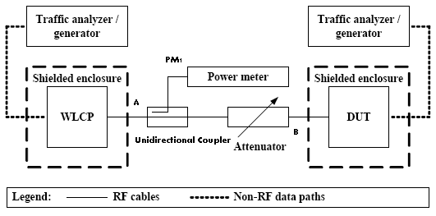
Replace the figure 10 to the following:

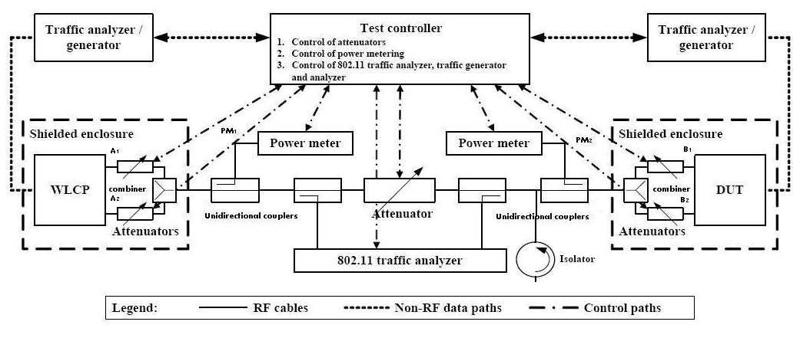

Resolution for Comment [2] ID# 1200
Remove in 5.4.32 the sentence “All test software should be verified.”
This also addresses CID 53

Resolution for Comment [2] ID# 1201
Replace in 5.4.5 line 25.47 the text “No special reporting requirements are associated with this environment” to the text “The actual test set-up including the involved components' settings (e.g. caused attenuation or phase differences) should be reported.”

References
- P802.11.2-D1.0. Draft Recommended Practice for the Evaluation of 802.11 Wireless Performance.
- IEEE 802.11-07-659r15. lb101-comment-resolution.

