IEEE P802.11
Wireless LANs
802.11 WG Chairs' received email letter response from CSIRO regarding LoA requests for IEEE P802.11n
Date: 2007-09-27
Author(s):
Name | Affiliation | Address | Phone | email
Stuart J. Kerry | NXP Semiconductors | 1109 McKay Drive,  M/S 48A SJ,  San Jose, CA 95037, USA | +1 (408) 474-7356 | stuart@ok-brit.com
Abstract
Email letter response from Denis Redfern, CSIRO to IEEE 802.11 WG Chair regarding the requests for LoA for IEEE P802.11n.

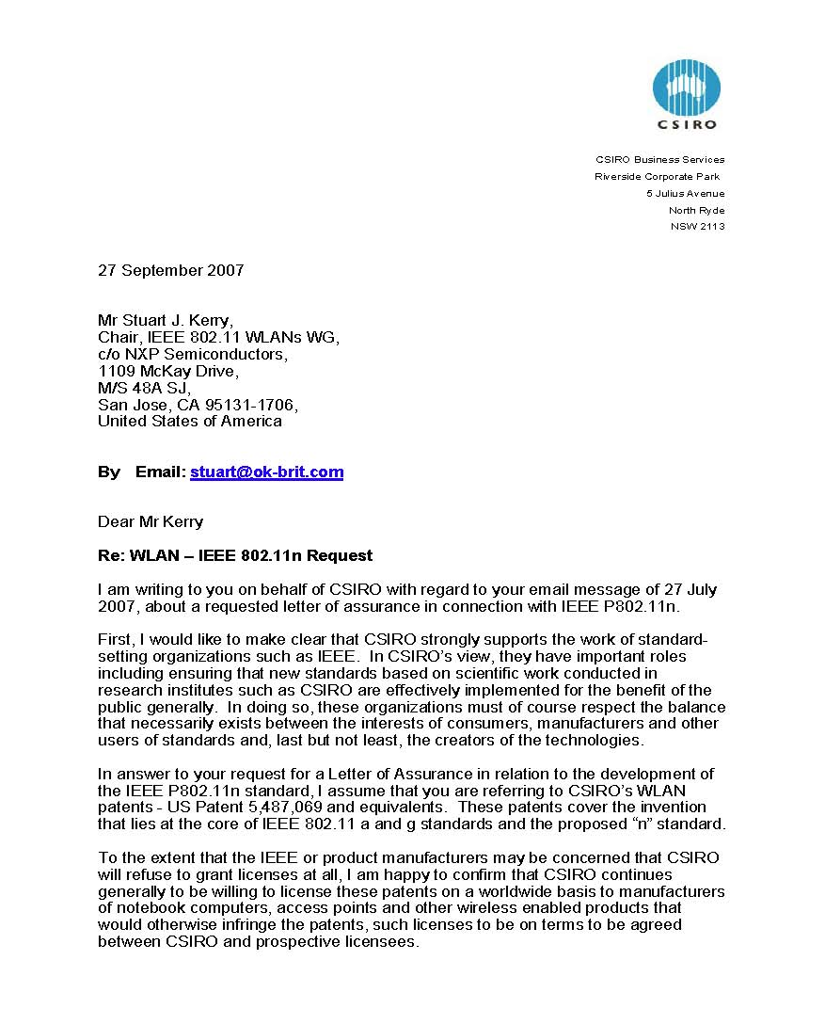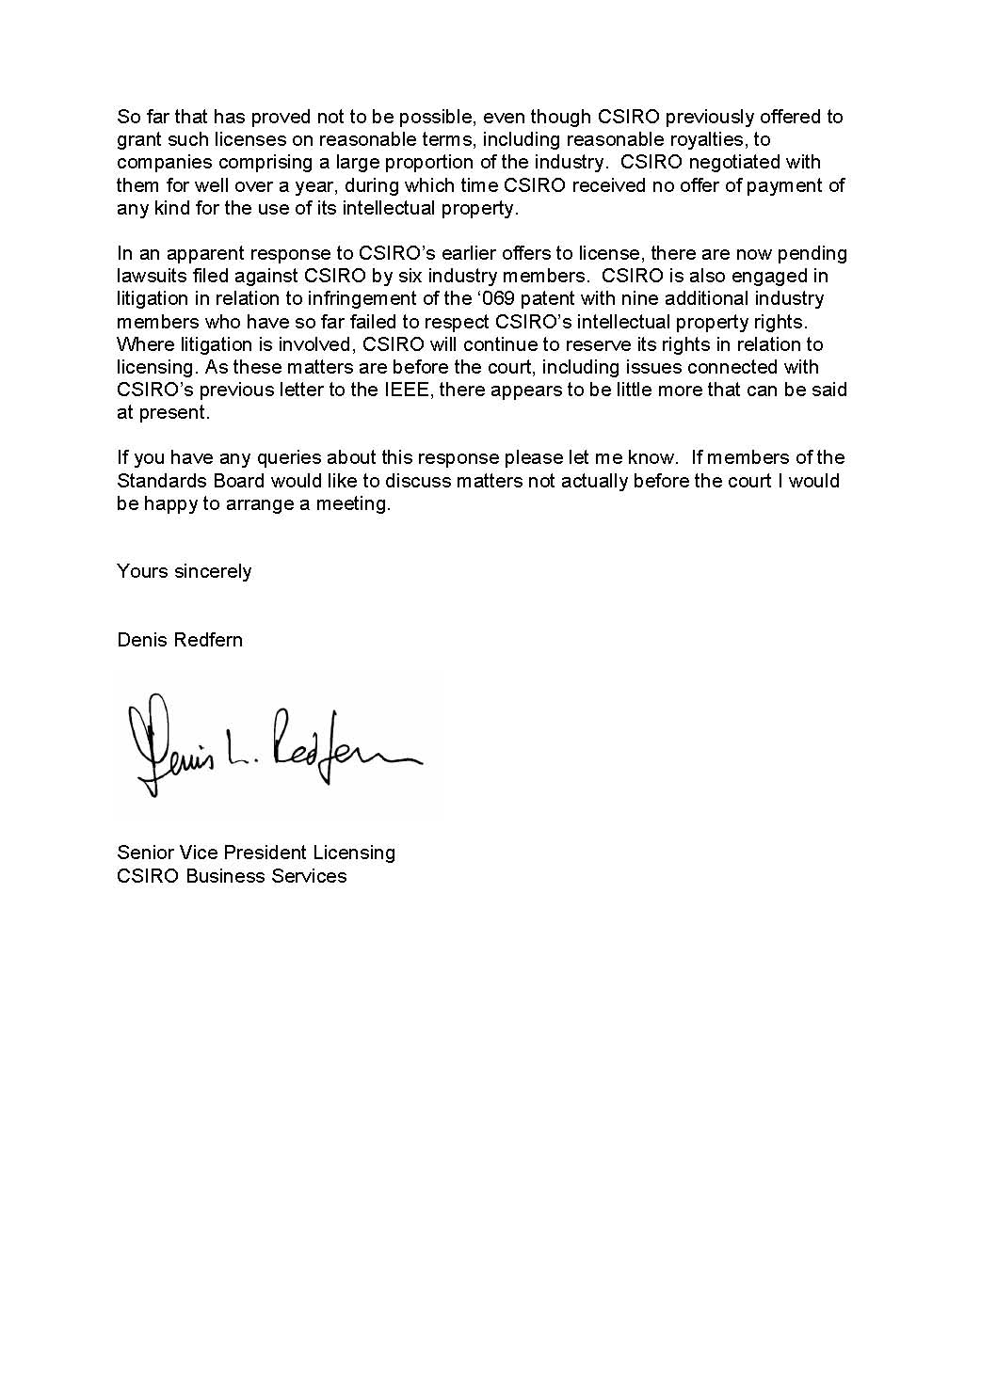
References:

