IEEE P802.11
Wireless LANs
COAT Section Resolutions
Date: 2007-11-12
Author(s):
Name | Company | Address | Phone | email
Anthony Maida | 3eTI | 9715 Key West Ave, 5th Flr  Rockville, MD 20850 | 301-944-1253 | amaida@3eti.com

Abstract
This document contains the proposal for resolution of some comments to draft P802.11.2-D1.0. The comments referenced to are listed in the document IEEE 802.11-07-0659r9 and the comments addressed are: 146, 148, 156, 157, 158, 161, 4, 951, 1039, 5, 166,

CID 146

- “The network analyzer is only required for evaluating and calibrating the environment; not for tests performed using the environment.”
The only section in which the Network Analyzer is not required is 5.3.3.3

  - Further analysis of section 5.3.3.3 indicates it is a secondary metric of the actual test being described.
    - The test here is titled Calibrated Over the Air Test (COAT) Environment
    - The procedures address the setting up and measuring of the COAT Environment
    - The measurements and setup of the Environment are intended to lead into performance testing.
      - This section does not concern itself with performance testing, rather 5.3.3.3 is inserted to indicate to the tester the information required from this section to proceed with performance testing.
  - This comment should be rejected as it is made on a misinterpretation of the intention of the section based solely upon 5.3.3.3 being placed as a guideline rather than a recommended procedure or test practice.

Instruct the editor to make no changes to the current section.

5.3.3.3 Measuring performance
The performance measurement should be carried out according to the following constraints:
a) The actual test should be performed as outlined in the specific primary or secondary metric measurement
methodology, using the calibrated path loss measured during the calibration procedure in
5.3.3.2.

b) Care should be taken to allow enough time for the DUT to recover and return to a normal state
between trials.

c) The environment should be calibrated for all required frequency bands (channel) and orientations
prior to performing the test.

CID 148

- “A screen room is different from a shielded room and typically does not have 95 dB of shielding effectiveness.”
- Screen rooms are specified to have a shielding effectiveness of greater than 75 dB while shielded rooms are specified to have a shielding effectiveness of 100 dB.
- The value called out in the draft may be a typo and the author may have meant 75 dB rather than 95 dB.
- Cost will be a concern for corporations seeking to follow these recommended test practices and a screen room is a substantially lower cost than a shielded room.
- My recommendation is to defer this to the original author to clarify whether he or she meant 75 dB as opposed to 95 dB.

Instruct the editor to make the following changes highlighted in red within the respective sections shown below:

5.3.2.1 Resource requirements

The following equipment is necessary to carry out tests while using this environment:

a) An RF shielded screen room, partially lined chamber or anechoic chamber. Isolation in the frequency
band being tested between the inside and outside of the screen room or anechoic chamber
should exceed 75dB.

5.3.3.1 Preparation of the environment
The preparation of the environment should include the following steps:
a) Confirm that the test environment is free of extraneous noise. A spectrum analyzer with an attached
antenna should be used to verify that there is no extraneous noise present throughout the test environment.
There should be at least 75dB of isolation between the clean environment and other possible
external RF noise sources.

CID 156

- “It doesn't matter if the reference antenna is used for transmit or receive unless uni-directional active components (such as an amplifier) are being characterized as part of the path loss.”
- The names assigned to the antennas in this section are misnomers.
- The name of the antennas called out in this section should be named Measurement and Reference rather than Calibrated and Directional which open the door to mass confusion.
  - The Reference Antenna would be the one directly connected to the Network Analyzer, hence this is the one performing the measurement seen on the display screen of the Network Analyzer.
  - The SUT Antenna would be the one within the anechoic chamber currently labeled Calibrated Antenna. The reference antenna is used at all times.
    - You would want a low uncertainty calibrated antenna used as the reference antenna in this test so your results are viable for any subsequent test performed in this environment.
  - The Calibration antenna is used during the calibration of the test setup and is replaced by the SUT antenna during testing.

- My recommendation would be to change the nomenclature of the antennas to SUT, Reference, and Calibration rather than using any other argumentative nomenclature.

Instruct the editor to make the following changes highlighted in red within the respective sections shown below:

5.3.1 Introduction and purpose
This environment supports consistent and reliable path loss measurements for a COAT. The environment is
designed to be easily repeatable in time and location while yielding accurate results. This environment
should be used for COAT measurements of primary and secondary metrics described in this recommended
practice.

The general setup for tests using this environment comprises of a reference antenna, a SUT antenna, a Calibration antenna, an RF shielded room (or anechoic chamber) with the desired channel characteristics, a characterized receive antenna, and a variable attenuator and a network analyzer.

5.3.2.1 Resource requirements

The following equipment is necessary to carry out tests while using this environment:

a) An RF shielded screen room, partially lined chamber or anechoic chamber. Isolation in the frequency band being tested between the inside and outside of the screen room or anechoic chamber should exceed 75dB.
b) A traffic generator (reference node) capable of associating with the wireless interface(s) of the DUT and generating traffic at the desired rate.

c) Characterized reference and calibration antennas for WLCP and calibration. The patterns and gains of these antennas should be known to a high degree of accuracy from vendor specification sheets or antenna characterization measurements. These antennas are used for determining the path loss from the quiet zone through the measurement antenna, cables, etc. to the calibrated input or output of the test instrumentation.

d) SUT antennas, cabling, and instrumentation for determining the quality of the quiet zone and the impact of the chamber, positioning system, etc. on the measurement.

….

Optional equipment, depending on test needs, include the following:
a) Standardized phantom head, hands, table/lap-tops, etc. for near field impact measurements.
b) A support structure with known RF properties for mounting the DUT in a known, repeatable position.
Possibilities for such a support structure include:
1) Expanded polystyrene block.
2) Dielectric table.
3) Turntable capable of rotating the DUT/SUT 360°.
4) Spherical positioning system with minimal RF impact capable of moving the DUT/SUT and/or
reference antenna to cover the entire spherical radiation pattern of the DUT.

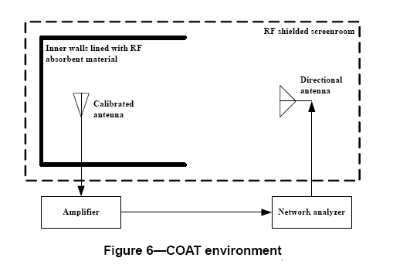
SUT
Reference

5.3.3.1 Preparation of the environment

The preparation of the environment should include the following steps:

a) Confirm that the test environment is free of extraneous noise. A spectrum analyzer with an attached reference antenna should be used to verify that there is no extraneous noise present throughout the test environment. There should be at least 75dB of isolation between the clean environment and other possible external RF noise sources.

b) Place the transmit reference antenna such that it is in the radiating far field of the SUT.

c) Confirm that the entire SUT can be encapsulated within the measured RF quiet zone.

5.3.3.2 Calibration and monitoring

The following procedure provides detailed information for precise calibration of an OTA test range using a vector network analyzer, with special attention paid to possible sources of error to ensure that low uncertainty measurements can be made. The range calibration is performed in a two-step process, where first the frequency response of the test equipment and cabling used to perform the calibration is measured and then those components are used along with a calibration antenna to measure the frequency response of the range, reference antenna, SUT antenna, and cabling used in the OTA tests. The difference between these two measurements (in dB) combined with the gain of the reference antenna provides the desired path loss calibration values.

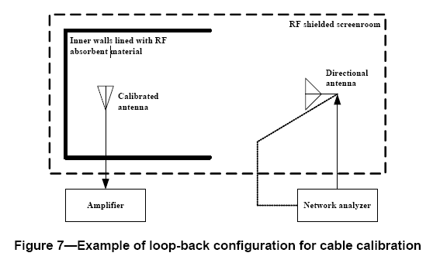
SUT
Reference

Page 21 – Lines 46 – 54

NOTE—It is suggested that an array of laser pointing and alignment devices be used to precisely note the location and orientation of the SUT and reference antennas.

h) Remove the SUT from the test environment.
i) Place a characterized antenna (calibration antenna) in exactly the same location and orientation as the SUT antenna using precise locators (such as laser pointing and alignment devices). See Figure 8.
j) Measure the path loss and channel characteristics using a network analyzer connected to the reference antenna and/or calibration antennas.

Page 22 – Lines 1 – 8

NOTE—The path-loss for any combination of SUT and reference antenna gains is calculated as follows:

Path Loss = Measured overall loss (dB) – measured cable losses (dB) – SUT antenna gain (dBi) – reference antenna gain (dBi)

k) Confirm that the channel characteristics between the transmit reference antenna and the SUT are within ±1dB of the desired values. A network analyzer should be used to measure channel characteristics. The data and plots from the network analyzer should be retained for inclusion in the results.

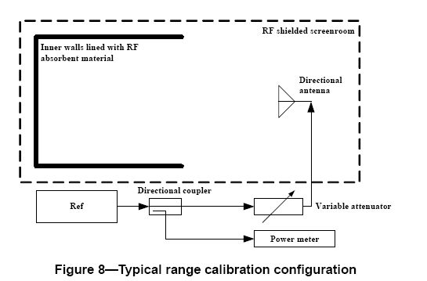
Reference
Page 23 Lines 1 – 11

Only one variation should be tested at a time.

As an alternative, the SUT antenna may be used in lieu of a reference receiver antenna to characterize the environment, provided that the characteristics of the SUT antenna is known to a high degree of accuracy. If the SUT antenna is utilized for characterization in this manner, system effects due to the packaging of the SUT will very likely be calibrated out. Therefore, if the SUT antenna is utilized for characterizing the environment, this should be noted in the test report.

CID 157

“This text describes the measurement antenna (the one that will be used during measurements of the DUT/SUT), not the reference antenna (the one used to calibrate the path loss).”

- If my recommendation for CID 156 is deemed acceptable, then the same recommendation would apply to CID 157.

CID 158

“The measurement antenna should be pointing to the DUT, especially since it's required to be directional by other parts of this section.”

Antenna requirements have many variations such as: gain, frequency, distance propagated, etc. Specifying an antenna would open the door to misinterpretation.
Only test clauses E.3.1, E.4.1, and E.5.1 specify a directional antenna as the preferred antenna but do not require it.
Here we should follow suit to stay consistent.

SUT, Reference, and Cablibration Antennas: Can be either directional or omni-directional.

My recommendation would be to remove any reference as to type of antenna used in the diagrams, add the above language to the description of the antennas defined as recommendation for CID 156.

Instruct the editor to add the following Note to the end of the following section:

5.3.2.1 Resource requirements

NOTE—SUT, reference, and calibration antennas may either be directional or omni-directional.

CID 161

“This procedure lists use of a VNA, but the introduction only required use of a network analyzer (which could be vector or scalar).”

Should we care to break out the different subtypes of a Network Analyzer, then more language should be added as part of the requirements and procedures.

Instruct the editor to make the following changes highlighted in red within the respective sections shown below:

5.3.2.1 Resource requirements

f) Network analyzer, spectrum analyzer with tracking generator, or stable signal generator and measurement receiver (spectrum analyzer, power meter, etc.) having a wide dynamic range and high linearity, all with current calibration(s).

5.3.3.2.1 Calibration step 1: cable calibration

d) Perform a frequency scan or sweep to cover the required test frequencies and record the result. Depending on the equipment used, refer to the following procedure:
  - For a vector network analyzer, first record the swept frequency response curve with no calibration applied. This will be used for verifying that the analyzer is in the appropriate linear region (not overloaded) and has enough dynamic range. Perform a calibration of the analyzer to normalize out the response of the cable loop. This calibration will serve as the source reference test. While a full two-port calibration is desirable to provide the lowest measurement uncertainty and account for standing wave issues, etc., flexing of cables, movement of rotary joints, and other variations may make the calibration less accurate in practice. A thorough response normalization, while having a higher level of uncertainty specified by the manufacturer, may actually be more accurate in practice due to the cable variations involved.
  - For scalar swept frequency devices (scalar network analyzers, spectrum analyzers with tracking generators, etc.) record the swept frequency response curve of the cable loop. If the analyzer contains a scalar calibration or trace math function, it may be used to subtract this reference curve from subsequent measurements.
  - For discrete signal generator and receiver combinations, The power level of the signal source must remain fixed for all measurements. Ensure that the received signal is below the compression point of the receiver (linear region) and sufficiently far above the noise floor of the receiver to account for the expected range path loss. Adjust all receivers to be set to a frequency span of 20 MHz, and ensure the reading shown on the receiver is at least 10 dB above the noise floor. Tune the receiver and signal generator to each frequency and record the reading of the receiver.
Note: The recommended device is the VNA for this type of measurement, the other measuring schemes will return results with lower accuracy.

j) Measure the path loss and channel characteristics using either a scalar/vector network analyzer, or a discrete signal generator/receiver combination …

k) Confirm that the channel characteristics between the transmit reference antenna and the SUT are within ±1dB of the desired values. A vector network analyzer should be used to measure channel characteristics. The data and plots from the vector network analyzer should be retained for inclusion in the results.

CID 4

“These lines refer to a reference antenna, but the reference Figure (7) only depicts a directional and a calibrated antenna”

My recommendation is based on the acceptance of the resolution proposed for CID 156 which will clear the misperception caused by the figures. Also change the antenna on the right side of the figure to be universal.

General Antenna Schematic Symbols:



CID 951

“The sentence starting with "It is recommended" seems overly vague.”

The recommended remedy of the author of this CID does not yield a reason for the 20 dB above the noise floor.
Multiple site searches indicates the acceptable IEEE standard is 10-15 dB above the noise floor for these types of measurements.
Referring to recommended text to be added in CID 161, this language is incorporated to be concrete and taking out “It is recommended”.

My recommendation is upon acceptance of recommendation of proposed remedy of CID 161, the same language be applied throughout the section where appropriate.

CID 1039

“Which receiver? How do you ensure this requirement?”

My recommendation is upon acceptance of recommendation of proposed remedy of CID 161, the clarification requested for CID 1039 would be satisfied.

CID 5

“Step i refers to a characterized (calibration) antenna and Figure 8, but the only antenna shown in Figure 8 is a directional transmitting antenna.”

See CID 4 recommendation.

CID 166

“It's apparent that this procedure was the merger of two different submissions. Step i) is back to calling the reference antenna something else, and step j) does the same for the measurement antenna.”

Accepting resolution for CID 156 would clear up the language causing inconsistencies referred to in CID 166.

