IEEE P802.11
Wireless LANs
September 12-14, 2007, TGs ad hoc Minutes
Date: 2007-09-12
Author(s):
Name | Company | Address | Phone | email
Malik Audeh | Tropos | 555 Del Rey Avenue,  Sunnyvale, CA 94085 USAS | +1-408-331-6834 | Audeh@tropos.com
Dee Denteneer | Philips | HTC 37  5656 AE Eindhoven  The Netherlands | + 33 40 27 46937 | Dee.denteneer@philips.com
Donald Eastlake | Motorola | 111 Locke Drive, Marlboro, MA 01757 USA | +1-503-786-7554 | donald.eastlake@motorola.com
Abstract
Minutes and participants list for the ad hoc meeting of IEEE 802.11 TGs held September 12-13, 2007 in Līhu‘e, Kaua‘i, Hawai‘i, hosted by Donald and Jill Eastlake. Minutes taken by Malik Auden (12 September) and Dee Denteneer (13-14 September). Minutes edited by Donald Eastlake.

Contents

Minutes 3
Wednesday, September 12 3
Thursday, September 13 4
Friday, September 14 4
Photograph 5
Participants 6

Minutes

Ad hoc Meeting, 12-14 September, Hilton Kaua‘i Beach Resort, Līhu‘e, Kaua‘i, Hawai‘i, USA
The annotated agenda for this meeting is 11-07/2331r3

Wednesday, September 12

Minutes for September 12, 2007 ad-hoc

Meeting called to order at 9:53am by TGs Chair Donald Eastlake (Motorola) who apologized due to the delay caused by some problems configuring the router for the TGr ad hoc..

The Chair reminded everyone to record attendance manually as this is an ad-hoc.
The Chair presented agenda document 11-07/2331r2.

The Chair read and presented the materials on the IEEE patent policy, all 5 slides were shown. The Chair read slides 1 and 5 and the WG chair instruction slide. No one offered any notices of essential patent claims.

Photographs have been allowed at this ad-hoc meeting by permission of WG chair as long as they are not for commercial purposes and the TG approves.

The group agreed unanimously to photographs as long as the pictures are not on the beach.

The Chair showed the agenda. The current draft is D1.06. The comment spreadsheet for the draft is 11-07/23r46. The Chair will be maintaining the comment spreadsheet for this meeting. Lunch is agreed to be at 12:00. Today’s meeting will recess at 4:30pm until Thursday at 9:00am.

The Chair asked if anyone had any materials to present. Two participants indicated they might have presentations later in the ad-hoc.

The Chair gave a brief update on the TGs Draft 1.06. The Chair has been updating the spreadsheet since the July plenary session, and the spreadsheet is now 11-07/23r46. If there is mark in Column X, then proposed resolutions have been changed since the Plenary. These would need to be voted in a full TGs session to actually be Closed.

The Chair presented document 11-07/2408r0 describing the 802.11s process and history, including a table of the progress on resolving comments. The current schedule as indicated on the 802.11 website was shown.

Q: How many contentious issues remain?
A: Most of the remaining comments are the more difficult ones.

There are 4 high-level categories of comments. RFI, MAC, General, Security. About 50 comments remain in RFI, General, Security, over 200 in MAC. Guenael Strutt (Motorola) wants to have an RFI session to work on management-related comments.

Q: Does the PAR expansion approval affect anything in the Draft?
A: No, we believe the draft falls within the current approved scope.

Straw Poll of areas of interest:
General – 1
MAC – 7
Security – 3
RFI -- 3

MAC group will take one half of the room, Security will take the other half. The meeting is divided into subgroups.

The meeting recessed for lunch at about 12:10 PM.

The meetings resumed in the afternoon in subgroups, one on MAC, one on Security.

The Chair recessed the session at 4:27pm.

Thursday, September 13

We convened at 9am, with the agenda as in 2331r3.

People were reminded of the IEEE IPR policy. The chairman inquired after essential patents and none were brought forward. There was a reminder to manually record attendance.

Michelle gave an update on the progress yesterday in the MAC subgroup.
MAC Ad Hoc Group
1. Discussed the Mesh DTIM Interval, i.e. CID 82 and 4153. Some suggested defining the Mesh DTIM Interval in section 7.3.1. Others suggested removing the mesh DTIM interval, which requires more changes to the draft. Defer until the synchronization schemes have been finalized.
2. Discussed the Designated Beacon Broadcast (DBB). Suggested removing the feature. Need to double check which sections should be removed.
3. Discussion on fixing the discrepancies between the frame format section and the MAC section regarding mesh beacon and BSS beacon, i.e. document 11-7-2306/r2. The group achieved consensus on transmitting two beacons separately.
4. Resolved 13 comments in the Power Save section

Meiyuan gave an update on the progress yesterday in the Security subgroup. These are summarized in 11-07/2411r1.

Two topics seemed to need group input and were specifically addressed. Concerning CID 590: GTK for mesh broadcast; is there separate security needed for mesh broadcast. The proposal is to have one extra key for this. Another concerned the removal of the PSK modes? Possible resolution, remove except between the MKD and the authenticator. Contributions are sought. It was countered that for simple applications, PSK might still be useful. Different PSKs between MPs are not in the draft. A Mesh wide PSK is not safe. Guido: Especially for CE applications, very simple solutions are a must. Should we support a method that we know that is bad. Kevin, it is a necessary evil. There must be a solution that does not require anything outside of the MPs.

Straw poll: Who is in favour of the total elimination of PSKs. For: 1; Against: many, not counted.

Alternate Straw poll: Who is in favour of defining PSK technology for MP to MP communications: yes: 8 – no: 1.

Straw poll: In favour of there being two separate GTKs for mesh and AP broadcasts.
For 6; Against 0; Undecided 7.

Guenael reported 11-07/2409: miscellaneous RFI comments. Malik was in favour to have recommended values for all MIB constants.

We split into subgroups for MAC and RFI.

We recessed for lunch.

We reconvened at 1pm.

Guenael proposed to discuss the issue of non-forwarding devices. This can be achieved by implementing a small subset of HWMP. Is there a difference with a device that implements all and turns it off?

The group split into MAC and General subgroups.

Donald gave an update of the progress of the general group, see 2331r3 slide 13.

We recessed until Friday at 9am

Friday, September 14

We reconvened at 9am.

People were reminded of the IEEE IPR policy. The chairman inquired after essential patents and none were brought forward. There was a reminder to manually record attendance.

Michelle gave an overview of the progress in the MAC subgroup.
Total 60 comments resolved during the conference calls before this ad hoc and at this ad hoc: 23 accept, 15 counter, and 22 rejected
More specifically, in yesterday’s session:
1. Resolved 11 comments in the Power Save section
2. Discussed one synchronization scheme that proposes to have a Profile TSF offset in the beacon and to have synchronization profile exchange after the peer link is set up. An MP’s own TSF time plus the Profile TSF offset equals a common mesh TSF time. Discussed whether it is necessary to have a common mesh TSF time. A synchronization profile IE and a synchronization profile parameter set field are defined. Suggested removing “DTIM length” and “ATIM window” from the synchronization profile parameter set field because the ATIM window is already included in the beacon and the mesh DTIM Interval may either be removed or be included in the beacon.

The RFI subgroup did MIB stuff.

Tony presented 11-07/2432/r0.

Donald and Dee went through a set of editorial comments, see 11-07/2301/r2.
It was discussed that if only MSA is for multihop action frames, then it may be clearer to explicitly state this in Clause 74b1. This was considered to go beyond editorial.

Dee presented 11-07/2375r1.

The meeting split into ad hoc groups for MAC and contemplation.
We reconvened at 12.30 pm

Donald went over the agenda for the interim as in 11-07/2290r2. A number of presentations for this agenda were announced, and included in 11-07/2290.

We adjourned at 1pm.

Photograph

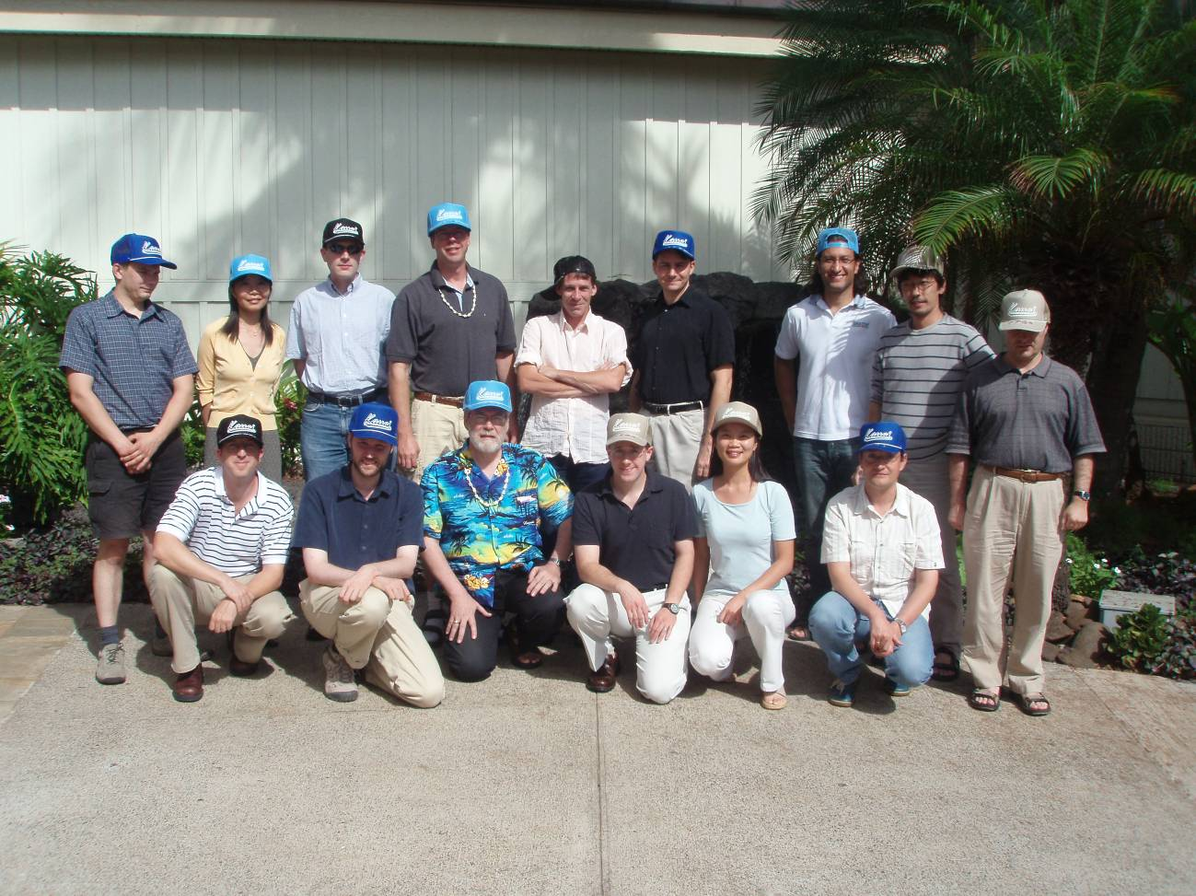

Participants

Donald Eastlake 3rd (Motorola)
Kevin Hayes (Atheros)
Thomas Kuehuel (Microsoft)
Tony Braskitch (Motorola)
Guenael Strutt (Motorola)
Qi Wang (Broadcom)
Juan Carlos Zuniga (InterDigital)
Kazayuki Sakoda (Sony)
Michael Bahr (Siemens)
Mathew Gast (Trapese Networks)
Guido R. Hiertz (Philips)
Malik Audeh (Tropos)
Meiyuan Zhao (Intel)
Michelle Gong (Intel)
Jarkko Kneckt (Nokia)
Dee Denteneer (Philips)

