IEEE P802.11
Wireless LANs
Minutes for the Task Group u / 3GPP SA2 teleconference
Date: 2007-05-30
Author(s):
Name | Company | Address | Phone | email
Michael Williams | Nokia
Abstract
This document contains the meeting minutes from the joint Task Group u / 3GPP SA2 teleconference held on 30th May 2007

Notice: This document has been prepared to assist IEEE 802.11. It is offered as a basis for discussion and is not binding on the contributing individual(s) or organization(s). The material in this document is subject to change in form and content after further study. The contributor(s) reserve(s) the right to add, amend or withdraw material contained herein.
Chair started teleconference at 10:05 ET

Roll Call

Stephen McCann NSN (.11) Chair
Jari Konera Teliasonera (SA2)
Eleanor Hepworth NSN (.11)
Gottfried Punz NSN (SA2)
Michael Williams Nokia (802.11) Secretary
György Wolfner NSN (SA2)
Peng Zhang Huawei (SA2)
Necati Canpolat Intel
Srini Sreemanthula Nokia
Hong Cheng Panasonic (.11)
Dave Stevenson Cisco
Subir Das Telcordia (.11)
Frank Ciatti NSN (SA2)
Colin Blanchard BT
Vijay Patel Andrew Corporation (.11)
Simon Barber Deviscape .11
Campile Shahin (SA2)
Magnus Olsson Ericsson (SA2)
Juan Carlos Zuniga Interdigital (.11)
Lars Falk TeliaSonera (.11)
Sarla Qualcomm (SA2)
Feng ZTE (SA2)
George Bumiller RIM (.11)
David Williams (Qualcomm SA2)
Ulises Olvera-Hernandez Interdigital (.11)
Ajay Rajkumar Lucent (.11)
Yoshi Ohba Toshiba (.11)
Joerg NSN (SA2)
Wolfgang Granzow Qualcomm (SA2)
Faroukh Bari AT&T (SA2)

IEEE 802.11 P & P

Please note the following items:
IEEE Patent Policy - http://standards.ieee.org/board/pat/pat-slideset.ppt
Affiliation FAQ - http://standards.ieee.org/faqs/affiliationFAQ.html
Anti-Trust FAQ - http://standards.ieee.org/resources/antitrust-guidelines.pdf
Ethics - http://www.ieee.org/portal/cms_docs/about/CoE_poster.pdf

The chair asked if every IEEE 802.11 attendee understood and was familiar with the patent policy. No one questioned this point.

Members from 3GPP SA2 pointed out that this teleconference has no official representative from the 3GPP side.

List of issues to discuss

• Liaison exchanges for nearly 3 years without much progress
• IEEE 802.11 Initial letter ballot now (IEEE 802.11 internal peer review)
• 3GPP working on handover, interworking with non-3GPP
• Can we come up with optimized interworking interface for release 8 or release 9

Status and main interest of IEEE 802.11 work related to 3GPP SA2

- 802.11 has modified interfaces to create a more generic interworking interface for all external networks
- Initial requirements were taken from 3G definitions

Status and main interest of 3GPP SA2 related to IEEE 802.11

Gottfried Punz talked about his slides (11-07-1963-00-000u-sa2-status-and-interest-in-ieee-802-11u.ppt) which presented the current status of the 3GPP SA I-WLAN architecture. Slide #3 was very interesting and is re-produced here for clarity.

Trusted
Non-3GPP IP Access
TS 23.402**): Non-Roaming Reference Architecture for non-3GPP Accesses
Trusted/Untrusted*
Non-3GPP IP Access
or 3GPP Access
SGi
PCRF
S7
S6a
HSS
ePDG
S2b
Serving SAE Gateway
Wn*
3GPP AAA
Server

Operator’s IP Services
(e.g. IMS, PSS etc.)

Wm*

Wx*

Untrusted
Non-3GPP IP Access
Wa*

Ta*

HPLMN
Non-3GPP Networks
S1-U
S1-MME
EUTRAN
2G/3G SGSN
S4
S3
S5
S6c
Rx+
S2a
PDN SAE Gateway
MME
S11
S10
UE
S2c
* Untrusted non-3GPP access requires ePDG in the data path
Handovers (Discovery and Selection of non-3GPP Access is needed before)
**) Colouring of non-3GPP accesses and red arrows (incl. text in red) added for this presentation

Main Issues:
- Minimize processing of mobility events
- Authentication within WLAN is going to be slow
- Need as much support as possible from .11u functionality
- See TS23.402

Question (Q): slide #3 discriminates between trusted & untrusted non-3GPP access. Is the WLAN point of view also trusted and untrusted
Answer (A): This trusted vs. untrusted is operator definition
So the segregation can go both ways (i.e. mutual authentication/trust of both networks)

Q: Slide #3: Is this enumeration of all types of networks?
A: Maybe not wise to include left node bubble, only for client mobility procedures

Q : Slide #3, Is IEEE 802.11 effectively defining the Wn* and Wa* interfaces on RHS of diagram
Assuming a single mode device like PDA or laptop, wanting connectivity to 3G network. IEEE 802.21 scope is essentially the red line at bottom of diagram, handover different types of media

Q: Slide #3, What about S2a and Ta* interfaces?
A: IEEE 802.11u doesn’t distinguish between trusted and untrusted, so yes they are in scope
Q : Concern about if this is correct, S2a and Wn* are different ?
A: Include control mechanisms for mobility in S2a, but not Wn* which has IPSec tunnel as in I-WLAN definition today.
- Comment that IPSec terminates at ePDG.
- Comment that S2a and S2c are mirrors of S2b. The ePDG is in between. So Wn is data Wm is control plane. So TGu provide control plan interface which is same for S2a, b and c.
- Concensus that the IP tunneling is not within IEEE 802.11u scope, but control signaling might be within their scope
- Comment that Wm is control plane only for AAA

IEEE 802.11u perspective on architecture

Stephen McCann then gave a corresponding walk through of 11-07-1964-00-000u-teleconference-agenda.ppt (Architecture diagram from IEEE 802.11u). Again this is reproduced here for clarity:

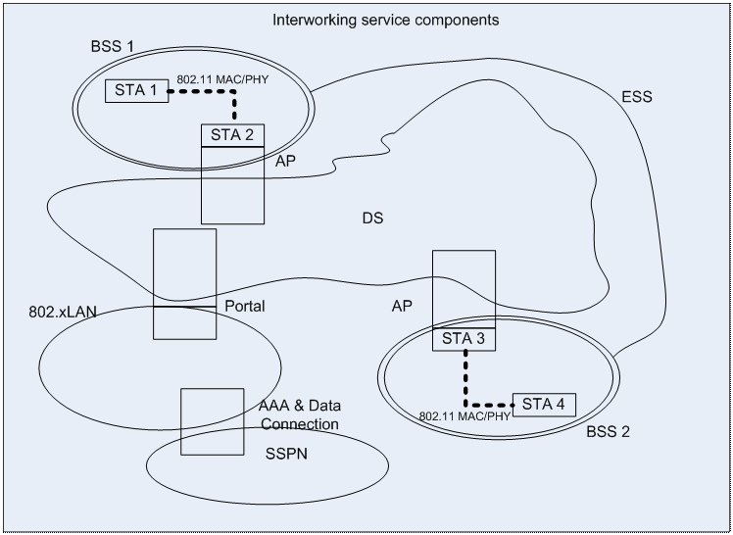

Main Issues:
- AAA and data connection at botton
- SSPN is subscription service provider network (operator)
- IEEE 802.x LAN
- Defining the “portal” interface, the outside edge connecting to an outside network
- IEEE 802.11u does not consider mobility or handover which should be discussed with .21’s
- IEEE 802.11u does deal with network discovery

Terms:
AN = Access Network
BSS =-Basic Service Setistribution
AP = access point

IEEE 802.11u Network selection and discovery

IEEE 802.11u trying to disassociate the use of SSID from network discovery
So using an SSID to indicate the operator cannot provide enough information
Now have a much more advanced technique, which de-couples the SSID from the network identity.
Providing a great deal of info on the network

Q : from SA2: This info seems very useful. Can it be used passive scanning or active only?
A: This will be an active IEEE 802.11 mechanism, request/response technique. There is not enough room in the IEEE 802.11 beacon to transmit all the info. IEEE 802.11u adds a HESSID 6 octet MAC address, which is globally unique. It can be used as an identifier for the access network

IEEE 802.11 AAA issues

IEEE 802.11u providing a more extended interface to provide more info about WLAN
New control features also, within relation to the QoS mapping
IEEE 802.11u allows a mapping of the air interface (e.g. IEEE 802.11e and WMM) to 3GPP QoS interfaces

OPEN ISSUE: Which group in 3GPP is defining the mapping of QoS classes to non-3GPP access technologies?

IEEE 802.11 Support for Emergency Services

When the user is accessing their services via WLAN

IEEE 802.11u will provide emergency services (ES)
- Service Capability Advertisement
- IEEE 802.11 Beacon has several bits indicating .the network can provide ES calls and the Emergency Alert System (EAS).
- Admission control
- Unauthenticated network access using public user credentials.

IEEE 802 Emergency Services SSID

There should be a common set of credentials and identities for all IEEE 802 technologies.

OPEN ISSUE: Who to talk to in 3GPP about emergency services ?

Q: Is the IEEE 802.11 indicator sufficient to say that the ES will be handled by the IMS system? Both WiMAX and WLAN have same problem to indicate the ES system behind
A: Could there be a generic ES system for both IEEE 802 and 3GPP. There is assumption that on 3GPP side the ES will be IMS based. This point requires further thought.

Operation of IEEE 802.21

IEEE 802.11u and IEEE 802.21 have a relationship between them for the information service
Comment that IEEE 802.21 services can be accessed over different layers
Comment that we need dedicated telecom to clarify what is provided by each
The mechanism that IEEE 802.11u is using for network discovery may be the one that IEEE 802.21 provides.

Future Teleconferences/Work

Set up network selection specific teleconference between IEEE 802.11u and 3GPP SA2
- Once the telecom scope is definined, we can generate materials for the meeting
- SA2 asks what information can be shared from IEEE side, needs to see the capabilities
- SA2 cannot reference materials that are not publicly available
- Unfortunately, IEEE 802.11 cannot share the IEEE 802.11u draft easily, but this issue is being looked into. There have been discussions of possibly publishing IEEE 802.11u early, to allow other standardisation entities to reference it.

Setup a separate IEEE 802.21 related teleconference

Teleconference Adjourned at 11:08 ET

Left over bits from the agenda

- Architecture and signalling protocols beyond the WLAN access point (PDG/IMS/VCC in the case of 3GPP and optional use of the IEEE 802.21 Media Independent Handover Information Server (IS) in the case of IEEE 802)
- Other service availability and integrity issues eg protection against Distributed Denial of Service attacks.
- 3GPP's potential use of the new information provided by an IEEE 802.11u capable network to the AAA server in the mobile network for I-WLAN.
- 3GPP's potential use of the new control features provided by the IEEE 802.11u capable network from the AAA server in the mobile network for I-WLAN, for example QoS mapping between networks.

