IEEE P802.11
Wireless LANs
April 11-13, 2007, TGs ad hoc Minutes
Date: 2007-02-17
Author(s):
Name | Company | Address | Phone | email
Dee Denteneer | Philips | HTC 26  5656 AE Eindhoven  The Netherlands | + 33 40 27 46937 | Dee.denteneer@philips.com
Donald Eastlake 3rd | Motorola | 111 Locke Drive  Marloboro, MA 01757 USA | +1-508-786-7554 | Donald.Eastalke@motorola.com
Abstract
Minutes for the ad hoc of the IEEE 802.11 TGs held Feb. 11-13 2007. Minutes taken and meeting hosted by Dee Denteneer in Eindhoven, Netherlands. Minutes edited by Donald Eastlake.

Notice: This document has been prepared to assist IEEE 802.11. It is offered as a basis for discussion and is not binding on the contributing individual(s) or organization(s). The material in this document is subject to change in form and content after further study. The contributor(s) reserve(s) the right to add, amend or withdraw material contained herein.

Release: The contributor grants a free, irrevocable license to the IEEE to incorporate material contained in this contribution, and any modifications thereof, in the creation of an IEEE Standards publication; to copyright in the IEEE’s name any IEEE Standards publication even though it may include portions of this contribution; and at the IEEE’s sole discretion to permit others to reproduce in whole or in part the resulting IEEE Standards publication. The contributor also acknowledges and accepts that this contribution may be made public by IEEE 802.11.

Patent Policy and Procedures: The contributor is familiar with the IEEE 802 Patent Policy and Procedures <http:// ieee802.org/guides/bylaws/sb-bylaws.pdf>, including the statement "IEEE standards may include the known use of patent(s), including patent applications, provided the IEEE receives assurance from the patent holder or applicant with respect to patents essential for compliance with both mandatory and optional portions of the standard." Early disclosure to the Working Group of patent information that might be relevant to the standard is essential to reduce the possibility for delays in the development process and increase the likelihood that the draft publication will be approved for publication. Please notify the Chair <stuart@ok-brit.com> as early as possible, in written or electronic form, if patented technology (or technology under patent application) might be incorporated into a draft standard being developed within the IEEE 802.11 Working Group. If you have questions, contact the IEEE Patent Committee Administrator at <patcom@ieee.org>.

Contents

Minutes 3
Wednesday, April 11 3
Thursday, April 12. 5
Friday, April 13. 6
Picture 8
Participants 9

Minutes

Ad hoc Meeting, April 11-13, 2007, Eindhoven, Netherlands.
The annotated agenda for this meeting is 11-07/515r5.
Note, in some cases presentations were edited in real time and uploaded after being given.

Wednesday, April 11

Called to order at 10.45am
Agenda 11-07-515/r0
Steve Connor chairing.
Dee Denteneer acts as recording secretary for this meeting.
Manual attendance recording was taken of those physically present

Standard Boards Bylaws on Patents in standards, anti-trust statement, and miscellaneous announcements were read and slides were shown. The Chair inquired if everyone was familiar with the IEEE 802 IPR policy, and if there were any patents or applications about which the 802.11 WG Chair should be informed. No-one indicated unfamiliarity and there were no patents brought forward. There were no questions on policy and procedures.

Meeting times: Wednesday: 10:30AM-5:30PM; rest of week to be discussed later.
Specific topics: Guenael: frame formats, path selection metrics, and a security spreadsheet.

Agenda approved.

Task group agreed that pictures could be taken during the ad hoc.

Status update: Draft D1.03 available, as well as a red-lined version. Participants were urged to check the updates. Also available is a word-version for easy cut and paste. However, the pdf version is the official version, as there may be small editorial differences. No major revisions are planned for the May-meeting, unless there are major issues discovered with the current draft. The draft is also updated to a new baseline. The 802.11-2007 will be available in May/June for purchase; presumably the CD will be available for members.
Also the draft is updated to take into account 11k, 11r, and 11y drafts that are projected to be completed before 11s. Other drafts have listed approximately the same completion times (11n, 11w) and updates may be needed to align with these.

There are topics in 11v that can be relevant, e.g. aggregation. The draft 11v can be relevant, and it may be needed to liase with them to avoid incompatibilities. Also would it be in scope of 11s to modify the draft for compatibilities with 11n; lately there has been no discussion on this topic. It would be useful to take this up and give an official analysis.

The latest comment resolution spreadsheet is version 11-07/0023/r27. The edit status has been updated. Two comments are listed as need rework, as there were no specific text changes suggested. They are still denoted as closed.

Jan 51% closed; March 24% closed. Hence, 25% remain open.
A breakdown is given in the comment spreadsheet.
New edits should be made with reference to version 27, to avoid confusing. Make a mark in the “updated” column. In the issue identifier, new entries can be made but they must be unique. Make list of issue identifiers and descriptions of these for the editor.

Guenael started a discussion on multi-hop management frames; a contribution will be uploaded when some consensus has been reached. Discussion to be continued on Thursday. (Donald, the Chair, arrived during this discussion.)

Jarko will present after lunch on mesh virtual bitmap.
Donald wanted to add a brief discussion of PICs to the agenda which was agreed.

Lunch.

The chair handed over to Donald;

“Remedy beacon bloat”, Jarkko Kneckt, 11-07/0541r0 (Word 11-07/0540r0)
Jarrko presented on beacon bloat and connectivity report bloat.
Discussion: change mesh neighbour list to mesh peer list.
Why do we need it, as the routing can do without? For vendor specific routing. Move to routing part then?
Cannot the MP get power mode directly from neighbour? That is also possible.
The IE is for MAC coordination, where virtual carrier sense is not used, i.e. due to power management.
The benefit is to shorten the beacon; in the neighbour list the MAC addresses are present; these can be avoided.
Links outside the bitmap indicate “unchanged” rather than 0 as it is now.

How many are in favour? Need more time to evaluate benefit and costs. Concerns were raised about interference with current work on power management. Postpone straw poll for Thursday. Better indicating what can be achieved?

PICS by Donald. Current not much; not known whether it is mandatory but leaving it out will give lots of comments. Every TG has one. It must be comprehensive, otherwise it is meaningless. It must be more comprehensive than is currently the case. Need items on
Peer Link Establishment
EMSA
HWMP
RA-OLSR
Interworking
Frame format
MDA
Congestion control
Beaconing
Designated BB
Synchronisation
Neighbor discovery
Power management

Volunteers are sought to make a PICS. Kaz for MAC part. Donald and Kaz will try to come up with an initial proposal.

“Mesh Configuration Element”, Guenael Strutt, 11-07/268r1
The suggestion changes terminology and demands updates in various other section of the draft.
Can one request to change some of the terminology? Yes.
Connected to AS redundant? Left as was in draft.

“Path Selection Metrics discussion”, Michael Bahr, 11-07/306r1
Do we need additional length related identifier next to length field?
The length can also be set via a MIB variable.
Do we need a granularity for the metric that warrants so many (variable) octets. For multi-metric vendor specific protocols.
Can we have some default metrics included for use in standard cases (as with path selection protocols).

Kaz presents suggested comment resolution on PS (Power Save).
Make two PS roles independent; i.e. do not require PS MPs to be PS supporting.
Does this refer back to other clauses: Yes, to synch/unsynch.
Change term from unsynchronising to non-synchronising. Other issue.
Does it make sense to do it for synch/unsynch separately? Problems when there is interaction.

Break up into subgroups. Straw poll of how many are interested in each area:
General: 2
MAC: 4
RFI: 3

The group split into informal MAC and RFI subgroups.

We recombined and adjourned at 6.30pm.

Thursday, April 12.

We started at 8.30 am.
The group split into informal MAC and RFI subgroups again.

We reconvened at 2pm.
Agenda
- General discussion
- Security discussion
- Draft sequence

Gunael Strett: 11-07/536r0. Guenael gave examples of the comment resolutions and all the resolutions in this sheet should not be controversial. Everybody is urged to review them for speedy approval in Montreal.

Steve Conner: Draft sequences.. The draft is based on a number of baselines: 802.11-2007, kD7, rD5, yD2
In the new time lines (see 802.11 home page) it is projected that also n and w may need be taken into account. Our draft already assumes that TGw solves some issues in some editorial notes. The question is basically, should we also modify our draft before next letter ballot to account for changes proposed in these drafts.
The issue with 11n is mainly some frame formats and would not require too much work, maybe some clause numbering.
The details of 11w have to be looked into.
There was consensus that these draft need be taken into account because their projected end data is well before (like six or seven months before) that of 802.11s.

We split into subgroups general and MAC

We reconvened at 17:15. The MAC subgroup summarised some discussions on MDA.

- MDA bits removal, MDA enabled. (Side issue: Should also be Synch support change to Synch enabled?).
- Changed the Setup to simplify the reservation. Do we need to identify the transmitter of the beacon?
- Termination of MDAOP, implicit termination
- MDA efficiency; MAF provides protection
- MDA conflicts in set up: define tie breaking rule
- Final destination needed? Not fully sorted out yet.

Nobody had any objections to this initial classification of the MDA issues, nor to the way in which they are being addressed; more details of course being needed.

Beaconing: a number of issues were discussed

- BB and PS
- BSS usage: resolved in draft 1.03
- Is there one DBB, more if feature is useful
- SSID in connectivity field: to be removed.
- BSS + mesh beacons
- DBB capability field
- Initialise and change: DBB to be sorted out

“Suggested comment resolution on ATIM window parameter”, Kazayuki Sakoda, 11-07/319r1. (Word 11-07/320)
“Suggested comment resolution on Power save clause”, Kazayuki Sakoda, 11-07/548 (Word 11-07/549r0).
Kaz reviewed his contributions on ATIM window and PS; the goal is to clarify the mechanisms. He will upload the documents and requests comments. He did not touch upon the synchronising and unsynchronising MPs as that is an orthogonal issue.

Straw poll: Should it be mandatory for mesh points to support power save for other stations.
Yes: 6; No: 3; Abstain: 0
Some analysis of the benefits would be needed.

General and RFI updates will be processed and the comment resolution spreadsheet updated and r28 posted.
We adjourned at 18.45 to reconvene at 8.00am.

Friday, April 13.
We reconvened at 8.00am because some people have to leave early.
Some miscellaneous notes:
Version 28 of the comment spreadsheet has been uploaded to the server.
Juan Carlos: suggestion to remove final destination MAC address field, in MDA.
On changing the set-up also necessitates changes in the interference times report (Figure s49).

Steve gave an overview of some of the general comment resolutions carried out during the meeting, on G10 issue identifier. What do we call a mesh? Guido suggests to use mesh BSS. This is considered to be more precise, but may also lead to confusion because of the current (popular) perception of what a BSS is.

Jan uploaded doc 11-07/550, which was subsequently presented and discussed concerning G13 and G22. Also, the current method should be included in the presentation as an option.

MAC: Uploaded docs: Capabilities: 111-07/268r2, MDA: 11-07/551r0, PS: 11-07/549r0, Beaconing: 11-07/540

We reviewed the RFI resolutions adopted in the spreadsheet.. Unanimous approval in ad hoc for these and comments were included (and uploaded) in version 29.
The RFI comments and some other comments with blank resolutions were further discussed and comments were inserted for a new version of the spreadsheet.

We adjourned at 12.10pm

Picture

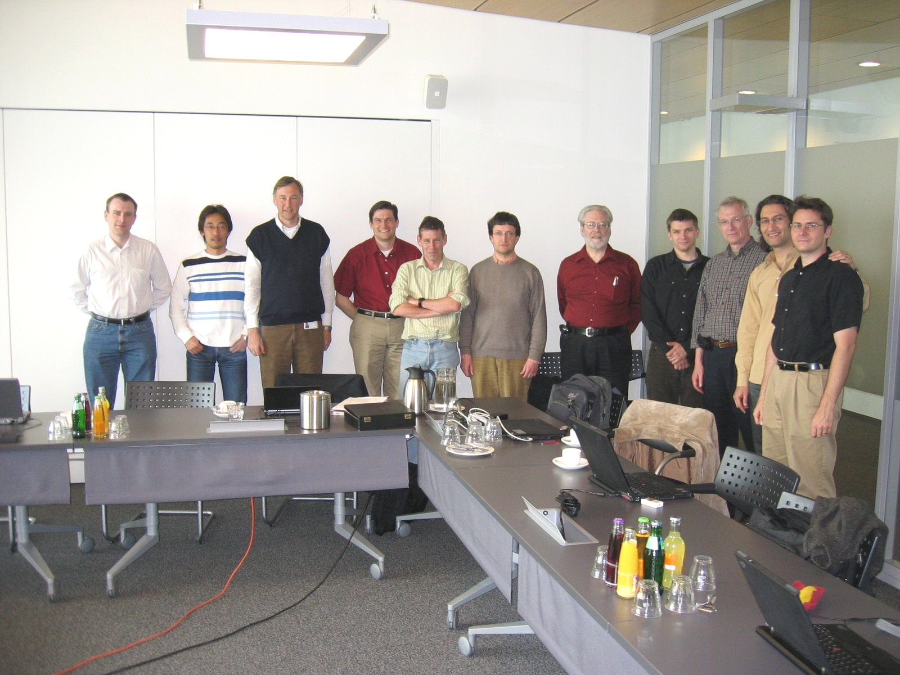

Participants

W. Steven Conner | Intel
Dee Denteneer | Philips
Guenael Strutt | Motorola
Michael Bahr | Siemens AG
Erik Schylander | Philips
Jan Kruys | Cisco
Guido R. Hiertz | Philips
Juan Carlos Zuniga | Inter Digital
Kazuyuki Sakoda | Sony
Jarkko Kneckt | Nokia
Donald Eastlake 3rd | Motorola

