IEEE P802.11
Wireless LANs
Comment on Improved STBC-SM Transmission Scheme (CID 3363)
Date: 2007-04-17
Author(s):
Name | Company | Address | Phone | email
Jeremy Gosteau | Motorola | Parc les Algorithmes de Saint Aubin  91193 Gif sur Yvette, France | +33 169 35 2564 | jeremy.gosteau@motorola.com
Marc de Courville | Motorola | Parc les Algorithmes de Saint Aubin  91193 Gif sur Yvette, France | +33 169 35 2518 | marc.de.courville@motorola.com
Stéphanie Rouquette Léveil | Motorola | Parc les Algorithmes de Saint Aubin  91193 Gif sur Yvette, France | +33 169 35 4824 | stephanie.rouquette@motorola.com
Abstract
This document comments on a proposal made in doc 11-07-0292-00-000n-improved-stbc-sm.doc that proposes a modification in the TGn draft 2.0 in relation to CID 3363. At the same time, the current document proposes a resolution to CID 3363.

Notice: This document has been prepared to assist IEEE 802.11. It is offered as a basis for discussion and is not binding on the contributing individual(s) or organization(s). The material in this document is subject to change in form and content after further study. The contributor(s) reserve(s) the right to add, amend or withdraw material contained herein.

Release: The contributor grants a free, irrevocable license to the IEEE to incorporate material contained in this contribution, and any modifications thereof, in the creation of an IEEE Standards publication; to copyright in the IEEE’s name any IEEE Standards publication even though it may include portions of this contribution; and at the IEEE’s sole discretion to permit others to reproduce in whole or in part the resulting IEEE Standards publication. The contributor also acknowledges and accepts that this contribution may be made public by IEEE 802.11.

Patent Policy and Procedures: The contributor is familiar with the IEEE 802 Patent Policy and Procedures <http:// ieee802.org/guides/bylaws/sb-bylaws.pdf>, including the statement "IEEE standards may include the known use of patent(s), including patent applications, provided the IEEE receives assurance from the patent holder or applicant with respect to patents essential for compliance with both mandatory and optional portions of the standard." Early disclosure to the Working Group of patent information that might be relevant to the standard is essential to reduce the possibility for delays in the development process and increase the likelihood that the draft publication will be approved for publication. Please notify the Chair <stuart@ok-brit.com> as early as possible, in written or electronic form, if patented technology (or technology under patent application) might be incorporated into a draft standard being developed within the IEEE 802.11 Working Group. If you have questions, contact the IEEE Patent Committee Administrator at <patcom@ieee.org>.

Introduction

Interpretation of a Motion to Adopt
A motion to approve this submission means that the editing instructions and any changed or added material are actioned in the TGn Draft. This introduction, is not part of the adopted material.

Editing instructions formatted like this are intended to be copied into the TGn Draft (i.e. they are instructions to the 802.11 editor on how to merge the TGn amendment with the baseline documents).

TGn Editor: Editing instructions preceded by “TGn Editor” are instructions to the TGn editor to modify existing material in the TGn draft. As a result of adopting the changes, the TGn editor will execute the instructions rather than copy them to the TGn Draft.

Summission Note: Notes to the reader of this submission are not part of the motion to adopt. These notes are there to clarify or provide context.

REVISION NOTES :

r0 – 07/04/17 –

CID :

Complete list:
3363

Suggested resolutions:

3363 | In the scheme in the TGn Draft version P802 11n D2.0, the  transmissions of STBC and SM are fixed on the corresponding transmit antennas, and do not cycle on each transmit antenna to employ the transmission style diversity and achieve futher diversity gain. So we advise TGn to discuss the current STBC and SM scheme. | There is a scheme to improve this problem, please refer to 11-07-0292-00-000n-improved-stbc-sm.doc. In this improved scheme, the transmission styles (i.e., STBC and SM) cycle on each transmit antenna, to achieve futher transmission style diversity gain and better performance. | Reject:  i) the method proposed in 11-07-0292-00-000n-improved-stbc-sm.doc multiplies by 3 the complexity of current draft STBC code for example in the Nss=2 Nsts=3 case since in the 3 time slots used to rotate the MIMO STC/SM code the equivalent channel matrix to invert for MMSE/ZF equalization changes over time on each carrier  ii) the simulation shown in contribution seems to indicate that not a full 11n PHY layer (including stream parsing and interleaving) was used since according to independant contribution 07/0545r0 when a more complete simulator is used no visible gain is visible on average on the proposed scheme.  Bottom line: the increase of complexity incurred by the proposed change is not reflected in a PER vs. SNR improvement and thus motivates the reject.

Rationale developments

Simulations have been run with the same parameters as those indicated in contribution 11-07-0292-00-000n-improved-stbc-sm.doc and do not show the improvements claimed in that contribution.
A complete simulation chain with the full 11n PHY layer has been used (including stream parsing and interleaving) in the results displayed in Figure 1. No visible gain can be achieved.
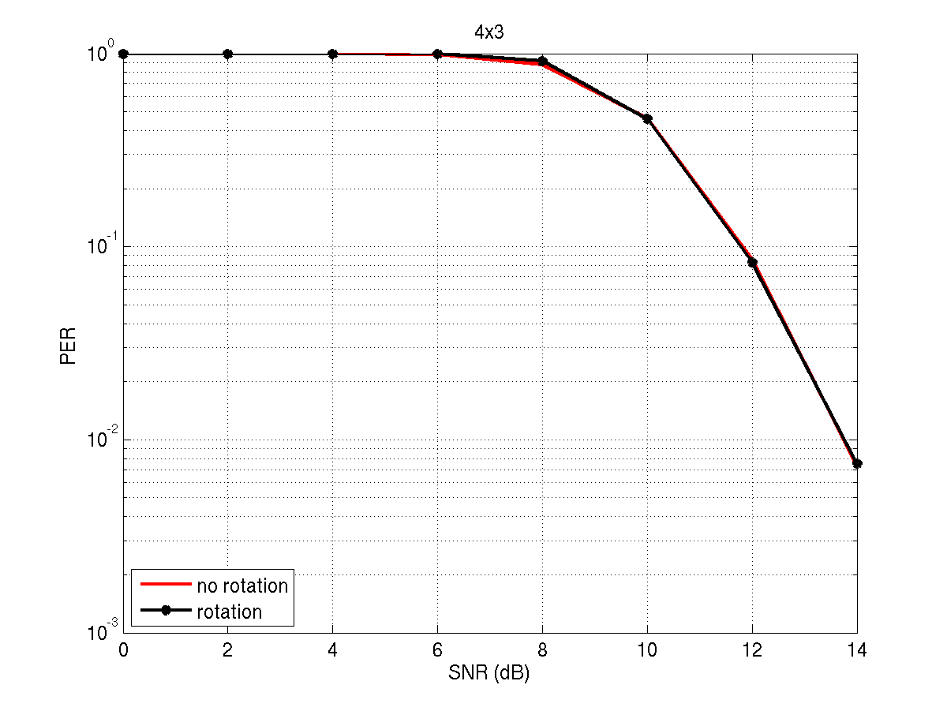
Figure 1 – Improvement brought by the rotating scheme proposed in 07/0292r0 (QPSK, coding rate 2/3, channel TGn D)
References:

IEEE TGn Draft 2.0, February 2007

