IEEE P802.11
Wireless LANs
Description of Public Credential Usage for Emergency Services
Date: 2007-03-12
Author(s):
Name | Company | Address | Phone | email
Matthew Gast | Trapeze Networks | 5753 W. Las Positas Blvd  Pleasanton, CA 94588 | +1 925 474 2273 | msg@trapezenetworks.com
Abstract
This submission describes how stations access the network for emergency services by using public credentials.
Notice: This document has been prepared to assist IEEE 802.11. It is offered as a basis for discussion and is not binding on the contributing individual(s) or organization(s). The material in this document is subject to change in form and content after further study. The contributor(s) reserve(s) the right to add, amend or withdraw material contained herein.

Release: The contributor grants a free, irrevocable license to the IEEE to incorporate material contained in this contribution, and any modifications thereof, in the creation of an IEEE Standards publication; to copyright in the IEEE’s name any IEEE Standards publication even though it may include portions of this contribution; and at the IEEE’s sole discretion to permit others to reproduce in whole or in part the resulting IEEE Standards publication. The contributor also acknowledges and accepts that this contribution may be made public by IEEE 802.11.

Patent Policy and Procedures: The contributor is familiar with the IEEE 802 Patent Policy and Procedures <http:// ieee802.org/guides/bylaws/sb-bylaws.pdf>, including the statement "IEEE standards may include the known use of patent(s), including patent applications, provided the IEEE receives assurance from the patent holder or applicant with respect to patents essential for compliance with both mandatory and optional portions of the standard." Early disclosure to the Working Group of patent information that might be relevant to the standard is essential to reduce the possibility for delays in the development process and increase the likelihood that the draft publication will be approved for publication. Please notify the Chair <stuart@ok-brit.com> as early as possible, in written or electronic form, if patented technology (or technology under patent application) might be incorporated into a draft standard being developed within the IEEE 802.11 Working Group. If you have questions, contact the IEEE Patent Committee Administrator at <patcom@ieee.org>.

Introduction

This submission provides an informative diagram for the frame exchange for use of public credentials with emergency services, and describes how the 802.11i security association is established.

Changes to TGu Draft 0.03:

Annex P

P.1.4 Emergency Call Services for Clients Only Having With Public Security Credentials
Replace existing section with the following, renumbering the figure as appropriate:

If a network requires authentication and encryption with RSN, a STA placing an emergency call must provide user credentials. If the STA has user credentials that allow it to use a particular network, the STA may authentication to the SSPN through the access network and place an emergency call. RSN keys will be supplied through the SSPN AAA system, and once they are distributed to the STA, it can place the call by exchanging higher-layer network packets.

Some networks may also offer emergency services to the public without subscriptions to any available SSPNs. This may be the case if an access network is required by regulation to be available for emergency calls to the public. To inform STAs of the credentials to use, the WLAN access network advertises the emergency services credentials necessary in the Default Emergency Services NAI element in transmitted Beacon frames. A STA that is requesting access to emergency services only will attempt RSN association with the user name specified in the Default Emergency Services NAI element.

Figure u23 shows the procedure that a STA will authenticate to the network using public credentials provided by the Default Emergency Services NAI. The presence of the Default Emergency Services NAI indicates that the SSID advertised by the AP can support the use of public credentials. The STA assocates with the AP in the normal manner, choosing an AP that has advertised an Emergency Services NAI. The first step in the EAPOL exchange is the EAP-Request/Identity frame. Rather than supplying any of the provisioned user accounts on the STA, a STA seeking emergency services should use the Default Emergency Services NAI. By asserting the advertised NAI, the STA is requesting emergency services, and the AP can attach the STA to a network designed specifically for that use. The AP may look up the VLAN ID to use against a AAA server, or it may have an emergency services VLAN configured. Similarly, it may also have other policies configured locally for quality of service parameters and network access restrictions, or it may also look them up through external authorization servers.

To complete the 802.11 security association, a PMK is necessary on both sides of the exchange. The exact procedure by which the PMK may be exchanged or derived is beyond the scope of 802.11, but may be based on an EAP method, a well-known passphrase, or direct exchange of the PMK in EAP messages. Once it has the PMK, the STA may proceed with the 4-Way Handshake to establish keys for the session.

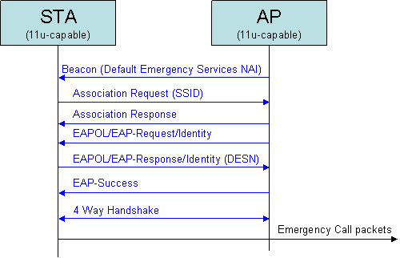
Figure u23: Emergency Services

When public credentials are used, the access network should be designed to restrict access to emergency call users. Methods of such restriction are beyond the scope of 802.11, but may include an isolated VLAN for emergency services, filtering rules in the AP or DS to limit network access to only network elements involved in emergency calls, and per-session bandwidth control to place an upper limit on resource utilization.

