IEEE P802.11
Wireless LANs
Improved STBC-SM Transmission Scheme
Date: 2007-03-06
Author(s):
Name | Company | Address | Phone | email
Yuli Yang | Huawei Technologies | Beijing, China | 86-10-82829016 | yangyuli@huawei.com
Hufei Zhu | Huawei Technologies | Shenzhen, China | 86-755-28972675 | zhuhufei@huawei.com
Yi Lu | Huawei Technologies | Shenzhen, China | 86-755-28972674 | jefflson@huawei.com
Abstract
This document proposes an improved STBC-SM scheme, which has better performance than the existing scheme in the draft D2.0.
Both capacity analysis and simulation results can prove the efficiency of the proposed scheme.
Notice: This document has been prepared to assist IEEE 802.11. It is offered as a basis for discussion and is not binding on the contributing individual(s) or organization(s). The material in this document is subject to change in form and content after further study. The contributor(s) reserve(s) the right to add, amend or withdraw material contained herein.

Release: The contributor grants a free, irrevocable license to the IEEE to incorporate material contained in this contribution, and any modifications thereof, in the creation of an IEEE Standards publication; to copyright in the IEEE’s name any IEEE Standards publication even though it may include portions of this contribution; and at the IEEE’s sole discretion to permit others to reproduce in whole or in part the resulting IEEE Standards publication. The contributor also acknowledges and accepts that this contribution may be made public by IEEE 802.11.

Patent Policy and Procedures: The contributor is familiar with the IEEE 802 Patent Policy and Procedures <http:// ieee802.org/guides/bylaws/sb-bylaws.pdf>, including the statement "IEEE standards may include the known use of patent(s), including patent applications, provided the IEEE receives assurance from the patent holder or applicant with respect to patents essential for compliance with both mandatory and optional portions of the standard." Early disclosure to the Working Group of patent information that might be relevant to the standard is essential to reduce the possibility for delays in the development process and increase the likelihood that the draft publication will be approved for publication. Please notify the Chair <stuart.kerry@philips.com> as early as possible, in written or electronic form, if patented technology (or technology under patent application) might be incorporated into a draft standard being developed within the IEEE 802.11 Working Group. If you have questions, contact the IEEE Patent Committee Administrator at <patcom@ieee.org>.

Comparison between existing scheme and proposed scheme

Table n70 — Constellation mapper output to spatial mapper input for STBC ( D2.0 Page 277 )

 | HT-SIG MCS field (bits 0-6 in HT-SIG1 ) |  | HT-SIG STBC field (bits 4–5 in HT-SIG2 ) |  | Space time stream in OFDM symbol (2m) | Space time stream in OFDM symbol (2m+1) | Space time stream in OFDM symbol (2m+2) | Space time stream in OFDM symbol (2m+3) | Space time stream in OFDM symbol (2m+4) | Space time stream in OFDM symbol (2m+5) | Space time stream in OFDM symbol (2m+6) | Space time stream in OFDM symbol (2m+7) | Space time stream in OFDM symbol (2m+8) | Space time stream in OFDM symbol (2m+9) | Space time stream in OFDM symbol (2m+10) | Space time stream in OFDM symbol (2m+11)
2 | 0-7 | 1 | 1 | 1 | $$d_{k,1,2m}$$ | $$d_{k,1,2m+1}$$
 |  |  |  | 2 | $$−d_{k,1,2m+1}^{}$$ | $$d_{k,1,2m}^{}$$
3 | 8-15, 33-38 | 2 | 1 | 1 | $$d_{k,1,2m}$$ | $$d_{k,1,2m+1}$$ | $$d_{k,2,2m+2}$$ | $$d_{k,2,2m+3}$$ | $$d_{k,1,2m+4}$$ | $$d_{k,1,2m+5}$$
 |  |  |  | 2 | $$−d_{k,1,2m+1}^{}$$ | $$d_{k,1,2m}^{}$$ | $$d_{k,1,2m+2}$$ | $$d_{k,1,2m+3}$$ | $$d_{k,2,2m+4}$$ | $$d_{k,2,2m+5}$$
 |  |  |  | 3 | $$d_{k,2,2m}$$ | $$d_{k,2,2m+1}$$ | $$−d_{k,1,2m+3}^{}$$ | $$d_{k,1,2m+2}^{}$$ | $$−d_{k,1,2m+5}^{}$$ | $$d_{k,1,2m+4}^{}$$
4 | 8-15 | 2 | 2 | 1 | $$d_{k,1,2m}$$ | $$d_{k,1,2m+1}$$
 |  |  |  | 2 | $$−d_{k,1,2m+1}^{}$$ | $$d_{k,1,2m}^{}$$
 |  |  |  | 3 | $$d_{k,2,2m}$$ | $$d_{k,2,2m+1}$$
 |  |  |  | 4 | $$−d_{k,2,2m+1}^{}$$ | $$d_{k,2,2m}^{}$$
4 | 16-23, 39, 41, 43, 46, 48, 50 | 3 | 1 | 1 | $$d_{k,1,2m}$$ | $$d_{k,1,2m+1}$$ | $$d_{k,1,2m+2}$$ | $$d_{k,1,2m+3}$$ | $$d_{k,1,2m+4}$$ | $$d_{k,1,2m+5}$$ | $$d_{k,2,2m+6}$$ | $$d_{k,2,2m+7}$$ | $$d_{k,3,2m+8}$$ | $$d_{k,3,2m+9}$$ | $$d_{k,2,2m+\text{10}}$$ | $$d_{k,2,2m+\text{11}}$$
 |  |  |  | 2 | $$−d_{k,1,2m+1}^{}$$ | $$d_{k,1,2m}^{}$$ | $$d_{k,2,2m+2}$$ | $$d_{k,2,2m+3}$$ | $$d_{k,2,2m+4}$$ | $$d_{k,2,2m+5}$$ | $$d_{k,1,2m+6}$$ | $$d_{k,1,2m+7}$$ | $$d_{k,1,2m+8}$$ | $$d_{k,1,2m+9}$$ | $$d_{k,3,2m+\text{10}}$$ | $$d_{k,3,2m+\text{11}}$$
 |  |  |  | 3 | $$d_{k,2,2m}$$ | $$d_{k,2,2m+1}$$ | $$−d_{k,1,2m+3}^{}$$ | $$d_{k,1,2m+2}^{}$$ | $$d_{k,3,2m+4}$$ | $$d_{k,3,2m+5}$$ | $$−d_{k,1,2m+7}^{}$$ | $$d_{k,1,2m+6}^{}$$ | $$d_{k,2,2m+8}$$ | $$d_{k,2,2m+9}$$ | $$d_{k,1,2m+\text{10}}$$ | $$d_{k,1,2m+\text{11}}$$
 |  |  |  | 4 | $$d_{k,3,2m}$$ | $$d_{k,3,2m+1}$$ | $$d_{k,3,2m+2}$$ | $$d_{k,3,2m+3}$$ | $$−d_{k,1,2m+5}^{}$$ | $$d_{k,1,2m+4}^{}$$ | $$d_{k,3,2m+6}$$ | $$d_{k,3,2m+7}$$ | $$−d_{k,1,2m+9}^{}$$ | $$d_{k,1,2m+8}^{}$$ | $$−d_{k,1,2m+\text{11}}^{}$$ | $$d_{k,1,2m+\text{10}}^{}$$

Appendix

In the Draft P802.11n D2.0, the existing schemes for transmissions of STBC and SM are fixed on the corresponding transmit antennas, which lose the opportunity to get further diversity gain from the independence between the fading channels.

In this document, an improved scheme is proposed, in which, the transmission styles (i.e., STBC and SM) are set cycling on every transmit antenna. Assuming the linear MMSE MIMO receiver, the instantaneous capacity of the resolution has a lower variance than that of the existing scheme, which is shown in Fig.1. This results in a more robust transmission for both open loop MIMO and closed loop MIMO. For example, in the closed loop MIMO system with CQI feedback, usually the CQI erasure rate cannot be neglected. When CQI erasure happens, the transmitter has to predict the current CQI from the past CQI report, and transmit data according to the predicted CQI. When the instantaneous capacity has lower variance, the mismatch between the predicted CQI and the actual CQI will be smaller.

And, the simulation results on BLER comparison between the existing scheme and the proposed scheme can prove that the proposed scheme has better performance than the existing scheme, which is shown in Fig.2. In the simulation, the open loop MIMO is assumed, i.e., there is no CQI feedback. The results are reported for QPSK system with 4 transmit- and 3 receive- antennas over rich-scattering and flat-fading channels. Here, LDPC is used with code rate of 2/3, and LDPC information and codeword block lengths are 1296 bits and 1944 bits, respectively. The linear MMSE MIMO receiver is employed. In each system realization, 20000 independent Monte Carlo runs are performed.

In addition, the proposed scheme has no more complexity than the existing scheme, for it can be realized by changing the permutation matrice in each period (for STBC, each period consists of two OFDM symbol duration).

In the case of and , the permutation matrices
, , and are used in the three coherent periods.

And, in the case of and , the permutation matrices
, , ,
, , and
are used in the six coherent periods.

For example, in the case of and , if the original transmitted information matrix is
, in the second periond the final inputs to the corresponding transmit antennas should be
.

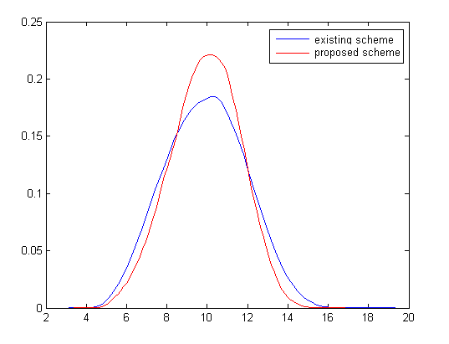
Fig.1 Probability distribution of the instantaneous capacity comparison between the existing scheme and the proposed scheme.

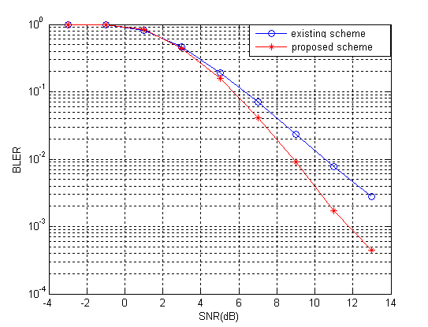
Fig.2 Simulation results on the Block Error Rate comparison between the existing scheme and the proposed scheme.

