IEEE P802.11
Wireless LANs
Normative Text for Using Existing Element Request for MDA
Date: 2007-01-17
Author(s):
Name | Company | Address | Phone | email
Christopher Hinsz | Motorola | 6480 Via Del Oro, San Jose, CA. 95119 | (408)528-2452 | Chris.Hinsz@gmail.com
Abstract
Proposed normative text to resolve LB93 CID 1856, use of existing request information element to request MDA parameters.
Notice: This document has been prepared to assist IEEE 802.11. It is offered as a basis for discussion and is not binding on the contributing individual(s) or organization(s). The material in this document is subject to change in form and content after further study. The contributor(s) reserve(s) the right to add, amend or withdraw material contained herein.

Release: The contributor grants a free, irrevocable license to the IEEE to incorporate material contained in this contribution, and any modifications thereof, in the creation of an IEEE Standards publication; to copyright in the IEEE’s name any IEEE Standards publication even though it may include portions of this contribution; and at the IEEE’s sole discretion to permit others to reproduce in whole or in part the resulting IEEE Standards publication. The contributor also acknowledges and accepts that this contribution may be made public by IEEE 802.11.

Patent Policy and Procedures: The contributor is familiar with the IEEE 802 Patent Policy and Procedures <http:// ieee802.org/guides/bylaws/sb-bylaws.pdf>, including the statement "IEEE standards may include the known use of patent(s), including patent applications, provided the IEEE receives assurance from the patent holder or applicant with respect to patents essential for compliance with both mandatory and optional portions of the standard." Early disclosure to the Working Group of patent information that might be relevant to the standard is essential to reduce the possibility for delays in the development process and increase the likelihood that the draft publication will be approved for publication. Please notify the Chair <stuart@ok-brit.com> as early as possible, in written or electronic form, if patented technology (or technology under patent application) might be incorporated into a draft standard being developed within the IEEE 802.11 Working Group. If you have questions, contact the IEEE Patent Committee Administrator at <patcom@ieee.org>.

7.3.2.12 Request information element

Change the text in 7.3.2.12 as shown:

This element is placed in a Probe Request frame or a unicast MDA action frame. When included in a Probe Request it is used to request that the responding STA include the requested information in the Probe Response frame. When included in an MDA action frame the receiver is required to broadcast its MDAOP advertisements using the MDAOP advertisements IE. The format of the information element shall be as shown in Figure 66.
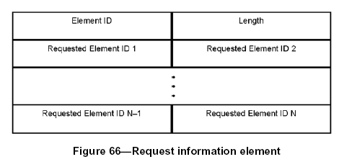
The Element ID of this information element shall be 10. The information element is variable in length. The
length of the information element is indicated in the Length field.

The Requested Element IDs are the list of elements that are to be included in the responding STA’s Probe
Response frame or MDAOP broadcast advertisement. The Requested Element IDs shall be listed in order of increasing element ID.

A STA shall return only those information elements that it supports. In an improperly formed Request information element, a STA may ignore the first information element requested that is not ordered properly
and all subsequent information elements requested. In theWhen this element is received in a probe responserequest frame, the STA shall return the requested information elements in the same order requested in the Request information element of the probe request frame.
References:
P802.11-REVma-D9.0-red-line-all-pages.pdf
Draft P802.11s_D1.0.pdf

