IEEE P802.11
Wireless LANs
Leader based Multicast Service Proposal
Date: 2007-03-15
Author(s):
Name | Company | Address | Phone | Email
Yongho Seok | LG Electronics | 16 Woomyeon-Dong, Seocho-Gu, Seoul 137-724, Korea | +8225264225 | yhseok@lge.com
Thierry Turletti  Diego Dujovne | INRIA | 2004, route des Lucioles, Sophia Antipolis, France | +33492387879 | turletti@sophia.inria.fr  ddujovne@sophia.inria.fr
Emily Qi | Intel Corporation | 2111 NE 25th Hillsboro OR 97124, USA | +15032647799 | Emily.h.qi@intel.com
Adrian Stephens | Intel Corporation | 15 JJ Thompson Avenue, Cambridge, CB 3 0FD,  United Kingdom | +441223763457 | adrian.p.stephens@intel.com
Alex Ashley | NDS Ltd | NDS Ltd, One London Road, Staines, Middlesex, TW18 4EX, UK | +441784848770 | aashley@nds.com
Menzo Wentink | Conexant | Oudegracht 3a, Utrecht, Netherlands | +31651836231 | Menzo.wentink@conexant.com
Pedro CUENCA | Universidad de Castilla-La Mancha | EPSA, Campus Universitario s/n., Albacete, Spain | +34967599200 | puenca@dsi.uclm.es
Abstract
This document contains proposed changes to the IEEE P802.11v Draft to address Req 2120 of the TGv Objectives. In particular, to enhance multicast data delivery, the proposed changes enable the utilization of leader-based transmission mechanisms. Such mechanisms aim to improve the throughput fairness between multicast connections and point-to-point connections and can optionally increase the reliability of multicast transmissions. Leader-based mechanisms consist of a leader election protocol and a multicast acknowledgement mechanism. The leader election protocol is responsible for electing the station, called leader, which generates an ACK frame for each successfully received multicast frame. If the AP does not receive an ACK frame, it carries out the binary exponential backoff mechanism as it is the case for point-to-point connections. Furthermore, the proposed leader-based mechanism can optionally retransmit multicast frames and use RTS/CTS exchange when multicast frames are exchanged.
The text is aligned with P802.11v-D0.08.
Notice: This document has been prepared to assist IEEE 802.11. It is offered as a basis for discussion and is not binding on the contributing individual(s) or organization(s). The material in this document is subject to change in form and content after further study. The contributor(s) reserve(s) the right to add, amend or withdraw material contained herein.

Release: The contributor grants a free, irrevocable license to the IEEE to incorporate material contained in this contribution, and any modifications thereof, in the creation of an IEEE Standards publication; to copyright in the IEEE’s name any IEEE Standards publication even though it may include portions of this contribution; and at the IEEE’s sole discretion to permit others to reproduce in whole or in part the resulting IEEE Standards publication. The contributor also acknowledges and accepts that this contribution may be made public by IEEE 802.11.

Patent Policy and Procedures: The contributor is familiar with the IEEE 802 Patent Policy and Procedures <http:// ieee802.org/guides/bylaws/sb-bylaws.pdf>, including the statement "IEEE standards may include the known use of patent(s), including patent applications, provided the IEEE receives assurance from the patent holder or applicant with respect to patents essential for compliance with both mandatory and optional portions of the standard." Early disclosure to the Working Group of patent information that might be relevant to the standard is essential to reduce the possibility for delays in the development process and increase the likelihood that the draft publication will be approved for publication. Please notify the Chair <stuart@ok-brit.com> as early as possible, in written or electronic form, if patented technology (or technology under patent application) might be incorporated into a draft standard being developed within the IEEE 802.11 Working Group. If you have questions, contact the IEEE Patent Committee Administrator at <patcom@ieee.org>.
- 3. Definitions
Insert the following new definitions:
3.v.5 Leader Based Multicast Service (LBMS): Leader Based Multicast Service aims to improve the throughput fairness between multicast connections and point-to-point connections and can optionally increase the reliability of multicast transmissions.

- Abbreviations and acronyms
Insert the following new acronyms in alphabetical order:
LBMS Leader Based Multicast Service

Change 7.3.2.22.11 as shown:

7.3.2.22.11 Multicast Diagnostics Report
The format of the Measurement Report field of a Multicast Diagnostics report is shown in Figure v11.

 | Measurement Start Time | Measurement Duration | Multicast MAC Address | Multicast Reporting Reason | Multicast Received MSDU Count | First Sequence Number | Last Sequence Number | Multicast Rate | LBMS Trigger Code
Octets: | 4 | 4 | 6 | 1 | 4 | 2 | 2 | 2 | 1
Figure v11—Measurement Report field format for a Multicast Diagnostics Report
The Measurement Start Time field is set to the value of the STA TSF timer at the time the measurement started. For a triggered Multicast Diagnostics report, this is the TSF value at the reporting STA when the trigger condition was met. For multicast performance measurement, the start time occurs after a multicast frame has been received, if at least one multicast frame was received during the measurement duration. When the reason for sending the report is Performance Measurement and the Multicast Received MSDU Count is non-zero, the Measurement Start Time field is set to the value of the STA TSF timer at the time of the first multicast MSDU received during the measurement interval.
The Measurement Duration field specifies the period over which the Multicast Diagnostic Report was generated. Table v1 defines which reports use the Measurement Duration field and how the field value is defined for those reasons.
Table v1—Measurement Duration Field

Multicast Diagnostic Report Reason | Measurement Duration Field
Performance Measurement | The number of beacon intervals, expressed in TUs that have occurred while the report was generated.
Report Timeout Trigger | Not used.

The Multicast MAC Address field contains the MAC address of the multicast traffic (the multicast group) to which the report relates.
The Multicast Reporting Reason field is a bit-field indicating the reason that the measuring STA sent the Multicast Diagnostics report. The Multicast Reporting Reason field is shown in Figure v12.

 | B0 | B1 | B2 | B7
 | Report Timeout Trigger | Performance Measurement | Reserved
Bits: | 1 | 1 | 6
Figure v12—Multicast Reporting Reason field
- The Report Timeout Trigger bit set to 1 indicates that Multicast Diagnostics Report was generated as a triggered report due to the Report Timeout trigger.
- The Performance Measurement bit set to 1 indicates that the Multicast Diagnostic Report was sent in response to a multicast diagnostic request. The report may be generated unsolicited by a non-AP STA or to request or in response to a request for performance measurement of the multicast stream.

The Multicast Received MSDU Count field contains the total number of multicast MSDUs for the Multicast MAC Address that were received during the Measurement Duration. For a triggered multicast diagnostics measurement this is the total number of frames received with the indicated Multicast MAC Address.
Except when the reason for sending the Report is Performance Measurement, in a requested Multicast STA Diagnostics Report, all bit-fields in the Reporting Reason field are set to 0.
The First Sequence Number field is the 802.11 sequence number of the first frame received during the measurement period. This field is used only if the multicast reporting reason is performance measurement, otherwise it is set to 0 on transmit and ignored upon receipt.
The Last Sequence Number field is the 802.11 sequence number of the last frame received during the measurement period. This field is used only if the multicast reporting reason is performance measurement, otherwise it is set to 0 on transmit and ignored upon receipt.
The First Sequence Number field and the Last Sequence Number field are set to 0 if the Multicast Received MSDU Count is 0.
The Multicast Rate field specifies the highest data rate at which the STA can reliably receive multicast frames. The Multicast Rate field is encoded with the MSB set to 1 to indicate that the data rate is in the basic rate set and the remaining 15 bit value is multiplied by 0.5 Mbit/s to indicate the data rate. If no value is provided by the STA, the Multicast Rate field is set to 0.
The LBMS Trigger Code specifies the information to initiate the Block Ack setup for the multicast stream as specified in Figure v13.

 | TID | ACK Policy | Retry Limit
Bit: | 0 – 3 | 4 | 5 – 7
Figure v13— LBMS Trigger Code
- TID specifies the TC or TS to which the multicast stream requiring the reliable multicast service belongs to.
- ACK Policy identifies the acknowledgement policy that is followed upon the delivery of the Multicast MPDU. The ACK Policy bit set to 1 indicates the Block Ack Policy for the LBMS. The ACK Policy bit set to 0 indicates the No Ack policy.
- Retry Limit is used to indicate the maximum retry limit of the multicast frames.

Change 7.3.2.49 as shown:

7.3.2.49 Wireless Network Management Capability information element
The Wireless Network Management Capability Information element contains information about the wireless network management capabilities of a STA as shown in Table v15.

 | Element ID | Length | Wireless Network Management Capabilities
Octets: | 1 | 1 | variable
Figure v15—Wireless Network Management Capability information element format
The Element ID field is equal to the Wireless Network Management Capability value in Table 26.
The value of the length field is variable and depends on the length of the Wireless Network Management Capabilities field. The minimum value of the Length field is 2.
The Wireless Network Management Capabilities field is a bit-field indicating the advertised management capabilities of the STA. The Wireless Network Management Capabilities field is shown in Table v16.

 | B0 | B1 | B2 | B3 | B4 | B5 | B6 | B7 | B8 | B15
 | Event Log | Diagnostics | Multicast Alert | Presence | FBMS | Proxy ARP Service | Co-located Interference Reporting | LBMS | Reserved
Bits: | 1 | 1 | 1 | 1 | 1 | 1 | 1 | 1 | 8
Figure v16—Wireless Network Management Capabilities
- The Event Log bit set to 1 indicates the STA supports Event Log as described in 11.15.2. The Event Log bit set to 0 indicates that the STA does not support this service.
- The Diagnostics bit set to 1 indicates the STA supports Diagnostics as described in 11.15.3. The Diagnostics bit set to 0 indicates that the STA does not support this service.
- The Multicast Alert bit set to 1 indicates the STA supports Multicast diagnostics as described in 11.15.11. The Multicast Alert bit set to 0 indicates that the STA does not support this service.
- The Presence bit set to 1 indicates that the STA supports Presence as described in 11.15.4. The Presence bit set to 0 indicates that the STA does not support this service.
- The FBMS bit set to 1 indicates the STA supports FBMS as described in 11.2.1.5. The FBMS bit set to 0 indicates the STA does not support FBMS.
- The Proxy ARP Service bit set to 1 indicates the AP is providing proxy ARP service. If Proxy ARP service is enabled, then the AP responds to broadcast ARP request on behalf of the STA. The Proxy ARP Service bit set to 0 indicates the AP is not providing proxy ARP service for any associated STA.
- The Co-located Interference Reporting bit set to 1 indicates the STA supports Co-located Interference Reporting as described in 11.15.9. The Co-located Interference Reporting bit set to 0 indicates that the STA does not support this service.
- The LBMS bit set to 1 indicates the STA supports the LBMS as described in 9.2.7.2. The LBMS bit set to 0 indicates the STA does not support the LBMS.
- All other bits are reserved, and are set to 0 on transmission and ignored on reception.
The lack of a Wireless Network Management Capability element is interpreted as the STA having no advertised Wireless Network Management Capabilities.

Change 7.4.8 as shown:

7.4.8 Wireless Network Management action details
Several Action frame formats are defined for Wireless Network Management purposes. An Action field, in the octet field immediately after the Category field, differentiates the formats. The Action field values associated with each frame format are defined in Table v49.
Table v49—Wireless Network Management Action field values
Action field value | Description
0 | Event Log Request
1 | Event Log Report
2 | Diagnostic Request
3 | Diagnostic Report
4 | Presence Request
5 | Presence Response
6 | Presence Configuration Request
7 | Presence Configuration Response
8 | BSS Transition Management Query
9 | BSS Transition Management Request
10 | BSS Transition Management Response
11 | FBMS Request
12 | FBMS Response
13 | Co-located Interference Request
14 | Co-located Interference Response
15 | LBMS Request
16 | LBMS Response
17-255 | Reserved

Insert the following after 7.4.8.15:

7.4.8.16 LBMS Request
The LBMS Request frame shall use the Action frame body format. The format of the LBMS Request frame body is shown in Figure v105.

 | Category | Action | Dialog Token | Length | Retransmission BSSID | FBMSID #1 | FBMSID #n
Octets: | 1 | 1 | 1 | 1 | 6 | 1 | 1
Figure v105—LBMS Request frame body format
The Category field is set to the value indicating the Wireless Network Management category, as specified in Table 24 in 7.3.1.11.
The Action field is set to the value indicating LBMS Request frame, as specified in Table v49 in 7.4.8.
The Dialog Token field is set to a non-zero value chosen by the STA sending the LBMS Request to identify the request/response transaction. If the LBMS Request corresponds to the unsolicited LBMS Request, the Dialog Token field is set to zero. The unsolicited LBMS request does not contain the FBMSIDs, because it is used only to inform the retransmission BSSID.
The Length field is set to n+1, where n indicates the total number of all FBMSIDs.
The Retransmission BSSID is set to a virtual BSSID. The BSSID of all retransmitted multicast frames shall be set to the Retransmission BSSID. Then, a non-AP STA that does not support the LBMS discards the retransmitted multicast frame because it does not associated with the Retransmission BSSID.
The FBMSID fields are set to the FBMSID corresponding to the multicast streams to lead. The non-AP STA is requested to become the leader for each of these multicast stream.

7.4.8.17 LBMS Response
The LBMS Response frame shall use the Action frame body format. The format of the LBMS Response frame body is shown in Figure v106.

 | Category | Action | Dialog Token | Length | Status Code #1 | Status Code #n
Octets: | 1 | 1 | 1 | 1 | 2 | 2
Figure v106—LBMS Response frame body format
The Category field is set to the value indicating the Wireless Network Management category, as specified in Table 24 in 7.3.1.11.
The Action field is set to the value indicating LBMS Response frame, as specified in Table v49 in 7.4.8.
The Dialog Token field is set to the value in any corresponding LBMS Request frame. If the LBMS Response corresponds to the unsolicited LBMS Response, the Dialog Token field is set to zero.
The Length field is set to 2n+1, where n indicates the total number of all status codes.
The Status Code field (shown in Figure v107) is a bit field with the following bits defined:

 | Reserved | Decision Code | ACK Policy | Retry Limit | FBMSID
Bit: | 0 | 1 - 2 | 3 - 4 | 5 – 7 | 8 – 15
Figure v107— Status Code field
Table v50—Decision Code Definitions
Value | Description
0 | Accept
1 | Reject – Unspecified reject reason
2 | Reject – Withdrawn multicast group
3 | Reject – Insufficient available resource

- Decision code filed contains whether the leadership for the multicast group is accepted or not as defined in Table v50.
- ACK Policy identifies the acknowledgement policy that is followed upon the delivery of the Multicast MPDU. The interpretation of these 2 bits is given in Table 6.
- Retry Limit is used to indicate the maximum retry limit of the multicast frames.
- FBMSID is used to indicate the multicast stream corresponding to this status code.
In order to inform the AP of its leadership acceptation (or rejection), the non-AP STA that receives the LBMS Request frame shall send back to the AP a LBMS Response frame with a status code for each multicast stream specified in the LBMS Request frame received.

Change 9.2.7 as shown:

9.2.7 Broadcast and multicast MPDU transfer procedure
In the absence of a PCF, when broadcast or multicast MPDUs are transferred from a STA with the ToDS bit clear, only the basic access procedure shall be used except when the LBMS is used, see section 9.2.7.2. Regardless of the length of the frame, no RTS/CTS exchange shall be used. In addition, no ACK shall be transmitted by any of the recipients of the frame. However, when the LBMS is used, the ACK frame shall be transmitted by a selected receiver and RTS/CTS exchange can be used as an option. Any broadcast or multicast MPDUs transferred from a STA with a ToDS bit set shall, in addition to conforming to the basic access procedure of CSMA/CA, obey the rules for RTS/CTS exchange, because the MPDU is directed to the AP. The broadcast/multicast message shall be distributed into the BSS. The STA originating the message shall receive the message as a broadcast/multicast message. Therefore, all STAs shall filter out broadcast/multicast messages that contain their address as the source address. Broadcast and multicast MSDUs shall be propagated throughout the ESS.
There is no MAC-level recovery on broadcast or multicast frames, except for those frames sent with the ToDS bit set and with the LBMS enabled. As a result, the reliability of this traffic is reduced, relative to the reliability of directed traffic, due to the increased probability of lost frames from interference, collisions, or time-varying channel properties.An AP that supports a leader-based multicast mechanism shall indicate this capability using the Wireless Network Management Capability information element. A non-AP STA shall inform the AP that it supports this functionality by using the Wireless Network Management Capability information element.

Insert the following after 9.2.7.1:

9.2.7.2 Leader Based Multicast Service (LBMS)
An AP that supports a LBMS shall indicate this capability using the Wireless Network Management Capability information element. A non-AP STA shall inform the AP that it supports this functionality by using the Wireless Network Management Capability information element.

9.2.7.2.1 Leader Election Protocol
The algorithm to select the non-AP STA to become a leader for a multicast stream is out of scope of this specification. The leader may dynamically change according to varying channel conditions or group membership changes. For example, the leader may be selected based on packet error rate statistics; the packet error rate of multicast receivers may be obtained through the Multicast Diagnostic Reports as specifed in 11.15.1.1. This specification describes the mechanism used by the AP to elect a non-AP STA (called selected leader) within the multicast stream as a leader for this multicast stream.
Two management action frames, specified in 7.4.8, have been defined on this purpose: the LBMS Request frame and the LBMS Response frame.
To elect a new leader for one or several multicast stream(s), the AP shall send a LBMS Request frame containing the FBMSID of the corresponding multicast stream to the selected leader. Upon reception of the LBMS Request frame, the selected leader shall inform the AP of its leadership acceptation (or rejection), by sending back to the AP a LBMS Response frame indicating the status code for each multicast stream specified in the received LBMS Request frame.
If there is already a leader for the multicast stream(s) specified in this leader election, the AP shall indicate to the previous leader that it is no longer leader for these multicast streams. On this purpose, the AP shall send to the previous leader a LBMS Request frame without containing the FBMSID of the corresponding multicast stream to stop acknowledging frames under normal ack policy, before electing a new leader.
The selected leader may resign the leadership or update the multicast policy by sending an unsolicited LBMS Response frame to the AP with the updated status code. The AP should ensure that the current leader is still in the BSS and trigger a new leader election in case for example some number of consecutive ACKs is missing.

9.2.7.2.2 Multicast Acknowledgement Mechanism
The leader is responsible of acknowledging each multicast frame successfully received for the multicast streams it has the leadership. The AP shall only elect one leader for a particular multicast stream. The selected leader shall send an ACK frame after waiting SIFS upon successful reception of a data frame for this multicast stream. If the AP does not receive the ACK frame from the leader during the ACK timeout, the AP shall increase the contention window by using the binary exponential backoff medium access mechanism defined in 9.1. The acknowledgements can also be used by the AP to adapt the PHY transmission rate of multicast frames and/or to improve the reliability of multicast transmission with retransmission, see section 9.2.7.2.3.

9.2.7.2.3 Multicast Retransmission Mechanism
When the LBMS is used, an optional retransmission mechanism is possible. The AP can disable multicast retransmission by forcing a retry limit of 0. If multicast retransmission is enabled, possibly duplicated multicast frames should be filtered out within the multicast receiver MAC as defined in 9.2.9.
When a STA that does not support the LBMS is associated in BSS, the retransmission BSSID that is assigned by the AP shall be used to retransmit the corresponding multicast frames in order to prevent the duplicated multicast frames. The BSSID of the received multicast frames is validated to ensure that the multicast originated from a STA in the BSS of which the receiving STA is a member.

9.2.7.2.4 Multicast RTS/CTS Mechanism
The AP should initiate a (unicast) RTS/CTS sequence prior to a multicast transmission, to avoid collisions. The receiver address of the RTS frame may be set to the MAC address of any active station, rather than using the multicast address of the pending multicast transmission. The RTS may be sent at a non-basic rate if used as a collision detect and not as a protection frame. The duration may be set to cover until the end of the CTS in this case.

Insert the following after 9.10.5:

9.10.6 Block Ack Setup and Operation for the LBMS
In order to support the Block Ack mechanism, the LBMS provides two solutions to initiate the Block Ack setup.
First, when the the AP supports the FBMS, the multicast receiver should transmit the unsolicited LBMS response frame to the AP. The Ack Policy field in the unsolicited LBMS response frame shall be set to the block ack policy. Then, the AP finds the status codes with the block ack policy in the unsolicited LBMS response frame.
The AP shall transmit the unsolicited LBMS request frame to the corresponding multicast receiver, in oder to inform the retransmission BSSID. Then, for initiating the Block Ack setup, the AP shall send the ADDBA Request frame under normal ack policy. After receiving the ADDBA Request frame, the corresponding multicast receiver shall transmit the ADDBA Response frame to the AP.
Second, when the the AP does not supports the FBMS, the multicast receiver can initiate the Block Ack setup by transmiting the multicast diagnostics report frame with the LBMS Trigger Code. The Ack Policy field of the LBMS Trigger Code in the multicast diagnostics report frame shall be set to the block ack policy.
After receiving the multicast diagnostics report frame, the AP shall transmits the unsolicited LBMS request frame to the corresponding multicast receiver, in order to inform the retransmission BSSID. Then, the ADDBA Request/Response transaction should be started to initiate the Block Ack setup.
In order to tear down the Block Ack session, the AP shall send the DELBA frame to the receiver of the corresponding Block Ack session.
The AP may transmit a block of QoS Broadcast/Multicast data frames seprateed by SIFS period. Then, the AP requests acknowledgement of outstanding QoS Broadcast/Multicast data frames by sending a BlockAckReq frame. The BlockAckReq frame shall be transmitted to the leader that needs reliability for the corresponding multicast stream.
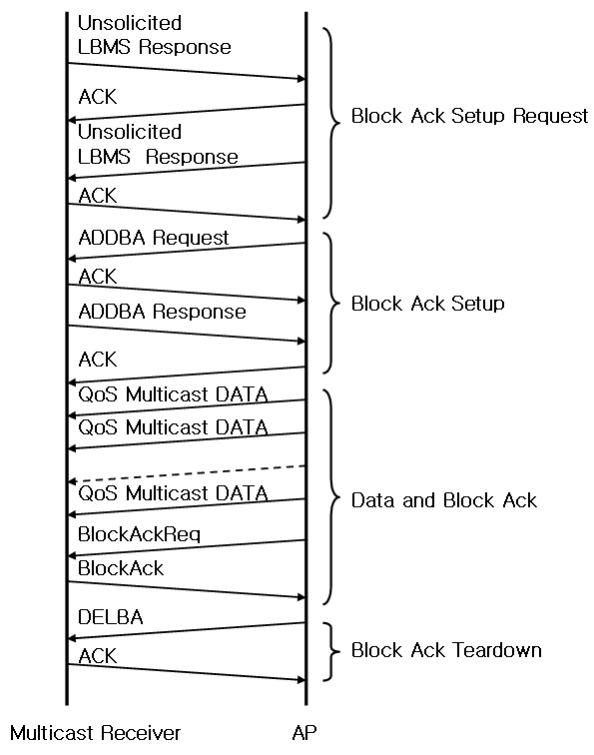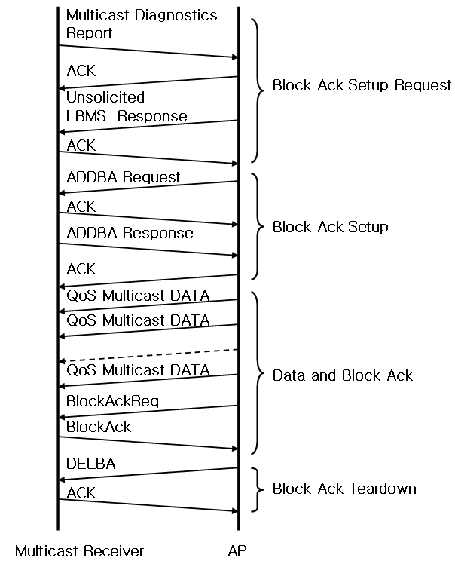
(a) when the AP supports the FBMS (b) when the AP does not support the FBMS
Figure v112—Message sequence chart for Block Ack mechanism in the LBMS
Figure v112 illustrates the complete message sequence chart for two block ack mechanisms in the LBMS.

Insert the following after 10.3.52

10.3.53 LBMS Request

This set of primitives supports the initialization of the leader election for the specific multicast streams between peer SMEs. Figure v113 depicts the Leader Management process using the LBMS Request and LBMS Response. The figure is only example and therefore is not meant to be exhautive of all possible protocol uses.
- 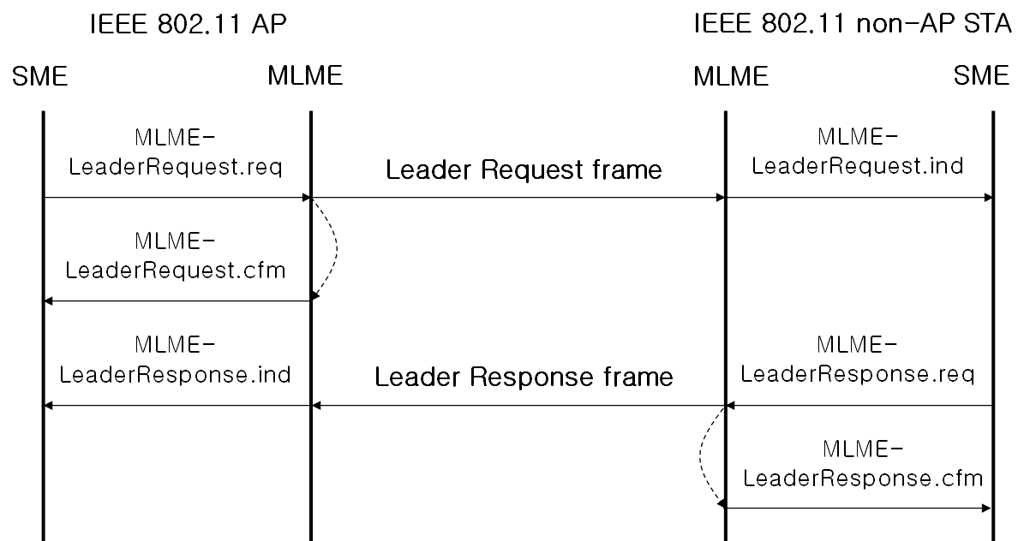
Figure v113—Leader Management Process

10.3.53.1 MLME-LeaderRequest.request

10.3.53.1.1 Function

This primitive requests the transmission of a LBMS Request frame to a peer entity.

10.3.53.1.2 Semantics of the service primitive

The primitive parameters are as follows:
MLME-LeaderRequest.request (
Peer MAC Address,
Dialog Token,
Length,
Retransmission BSSID,
FBMSID
)

Name | Type | Valid Range | Description
Peer MAC Address | MAC Address | Any valid individual MAC Address | The address of the peer MAC entity to which the LBMS Request frame shall be sent.
Dialog Token | Integer | 0 – 255 | The dialog token to identify the LBMS Request/Response transaction.
Length | Integer | 0 – 255 | The total length of the FBMSIDs.
Retransmission BSSID | MAC Address | Any valid individual MAC Address | The virtual BSSID for the retransmitted multicast frame
FBMSID | Integer | 0 – 255 | The FBMSID of the multicast stream for which the peer entity is requested to become the leader.

10.3.53.1.3 When generated

This primitive is generated by the SME to request that a LBMS Request frame be sent to a peer entity to convey an indication that the peer entity is selected as the leader transmiting the ACK frame for the multicast frames.

10.3.53.1.4 Effect of receipt
On receipt of this primitive, the MLME constructs a LBMS Request frame containing the FBMSID of the specified multicast stream to lead. This frame is then scheduled for transmission.

10.3.53.2 MLME-LeaderRequest.confirm

10.3.53.2.1 Function

This primitive reports the request result of a LBMS Request.

10.3.53.2.2 Semantics of the service primitive

The primitive parameters are as follows:
MLME-LeaderRequest.confirm (
Dialog Token,
Result Code
)

Name | Type | Valid Range | Description
Dialog Token | Integer | 0 – 255 | The dialog token to identify the LBMS Request/Response transaction.
Result Code | Enumeration | SUCCESS,  INVALID PARAMETERS, or UNSPECIFIED FAILURE | Reports the outcome of a request to send a LBMS Request frame.

10.3.53.2.3 When generated

This primitive is generated by the MLME when the request to transmit a LBMS Request frame completes.

10.3.53.2.4 Effect of receipt

On receipt of this primitive, the SME evaluates the result code.

10.3.53.3 MLME-LeaderRequest.indication

10.3.53.3.1 Function

This primitive indicates that a LBMS Request frame has been received requesting a LBMS Request/Response transaction.

10.3.53.3.2 Semantics of the service primitive

This primitive parameters are as follows:
MLME-LeaderRequest.indication (
Peer MAC Address,
Dialog Token,
Length,
Retransmission BSSID,
FBMSID
)

Name | Type | Valid Range | Description
Peer MAC Address | MAC Address | Any valid individual MAC Address | The address of the peer MAC entity from which the LBMS Request was sent.
Dialog Token | Integer | 0 – 255 | The dialog token to identify the LBMS Request/Response transaction.
Length | Integer | 0 – 255 | The total length of the multicast stream addresses.
Retransmission BSSID | MAC Address | Any valid individual MAC Address | The virtual BSSID for the retransmitted multicast frame
FBMSID | Integer | 0 – 255 | The FBMSID of the multicast stream for which this station is requested to become the leader.

10.3.53.3.3 When generated

This primitive is generated by the MLME when a valid LBMS Request frame is received.

10.3.53.3.4 Effect of receipt

On receipt of this primitive, the SME either rejects the request or decides whether to accept or reject the LBMS Request.

10.3.54 LBMS Response

This set of primitives supports the response to a request for the leader election between peer SMEs.

10.3.54.1 MLME-LeaderResponse.request

10.3.54.1.1 Function

This primitive requests the transmission of a LBMS Response frame to a peer entity.

10.3.54.1.2 Semantics of the service primitive

The primitive parameters are as follows:
MLME-LeaderResponse.request (
Peer MAC Address,
Dialog Token,
Length,
Status Code
)

Name | Type | Valid Range | Description
Peer MAC Address | MAC Address | Any valid individual MAC Address | The address of the peer MAC entity to which the LBMS Response frame shall be sent.
Dialog Token | Integer | 0 – 255 | The dialog token to identify the LBMS Request/Response transaction.
Length | Integer | 0 – 255 | The total length of the status codes.
Status Code | Integer | As specified in 7.4.8.17 | Indicates the result response to the LBMS Request from the peer MAC entity.

10.3.54.1.3 When generated

This primitive is generated by the SME to request that a LBMS Response frame be sent to a peer entity to convey a response to a LBMS Request.

10.3.54.1.4 Effect of receipt
On receipt of this primitive, the MLME constructs a LBMS Response frame containing the status code for the leadership acceptance of the specified multicast stream. This frame is then scheduled for tranmission.

10.3.54.2 MLME-LeaderResponse.confirm

10.3.54.2.1 Function

This primitive reports the request result of a LBMS Response.

10.3.54.2.2 Semantics of the service primitive

The primitive parameters are as follows:
MLME-LeaderResponse.confirm (
Dialog Token,
Result Code
)

Name | Type | Valid Range | Description
Dialog Token | Integer | 0 – 255 | The dialog token to identify the LBMS Request/Response transaction.
Result Code | Enumeration | SUCCESS,  INVALID PARAMETERS, or UNSPECIFIED FAILURE | Reports the outcome of a request to send a LBMS Response frame.

10.3.54.2.3 When generated

This primitive is generated by the MLME when the request to transmit a LBMS Response frame completes.

10.3.54.2.4 Effect of receipt

On receipt of this primitive, the SME evaluates the result code.

10.3.54.3 MLME-LeaderResponse.indication

10.3.54.3.1 Function

This primitive indicates that a LBMS Response frame has been received requesting an LBMS Request/Response transaction.

10.3.54.3.2 Semantics of the service primitive

The primitive parameters are as follows:
MLME-LeaderResponse.indication (
Peer MAC Address,
Dialog Token,
Length,
Status Code
)

Name | Type | Valid Range | Description
Peer MAC Address | MAC Address | Any valid individual MAC Address | The address of the peer MAC entity from which the LBMS Response was sent.
Dialog Token | Integer | 0 – 255 | The dialog token to identify the LBMS Request/Response transaction.
Length | Integer | 0 – 255 | The total length of the status codes.
Status Code | Integer | As specified in 7.4.8.17 | Indicates the result response to the LBMS Request from the peer MAC entity.

10.3.54.3.3 When generated

This primitive is generated by the MLME upon reception of a valid LBMS Response frame.

10.3.54.3.4 Effect of receipt

On receipt of this primitive, the SME either rejects the response or commences the LBMS as described in 9.2.7.2.

Insert the following new rows into A.4.15:

A.4.16 Wireless Network Management extensions
Item | Protocol Capability | References | Status | Support
RME11 | Leader Based Multicast Service | 9.2.7.2 | CFv:O | Yes, No, N/A
RME11.1 | LBMS Request | 7.4.6.16 | CFv:M | Yes, No, N/A
RME11.2 | LBMS Response | 7.4.6.17 | CFv:M | Yes, No, N/A

